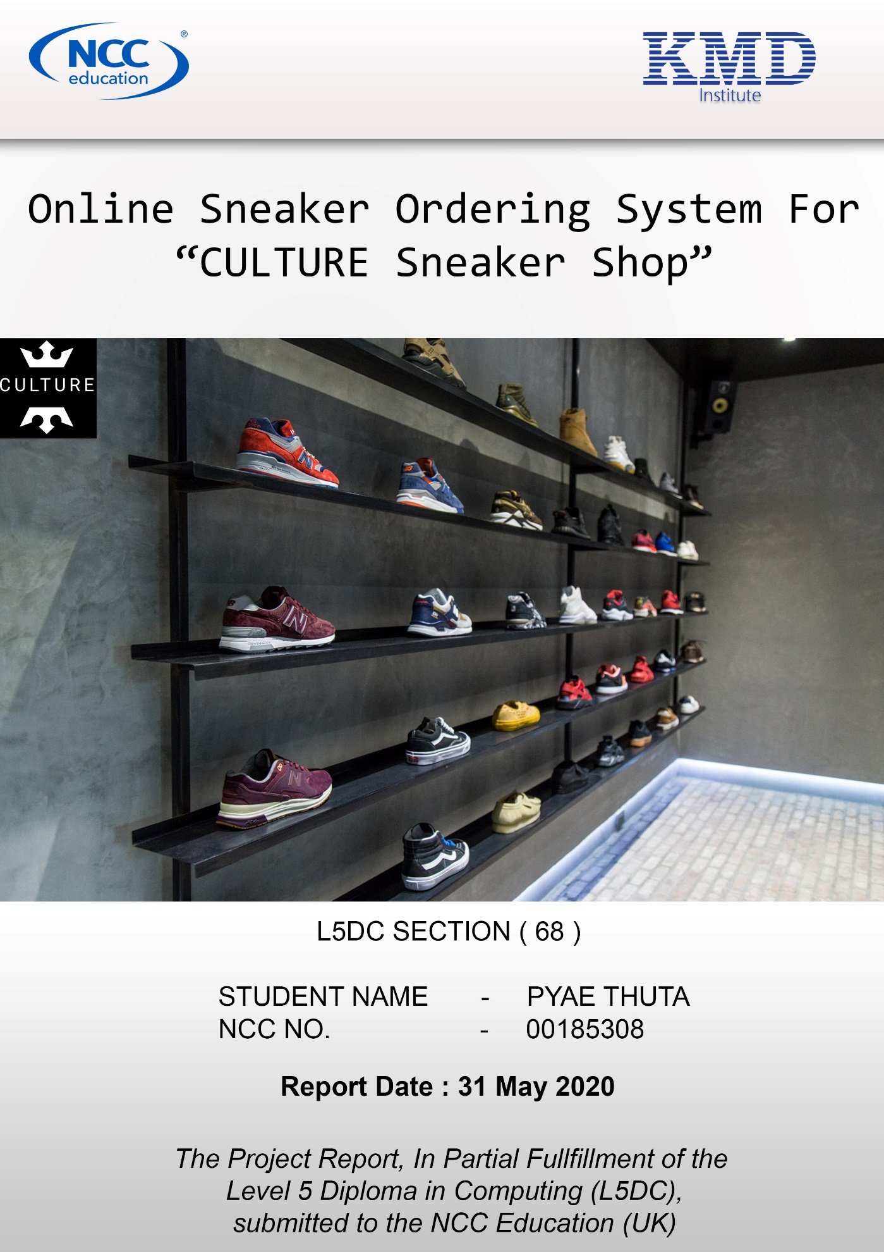

Online Sneakers Ordering System for “CULTURE Sneaker Shop”

Student ID: 00185308

Student Name: PYAE THUTA

Section: L5DC 68

Contents

Project Proposal 2

1.1 Overview 2

1.2 Current Business History 2

1.3 Current Business Process 2

1.4 Current Business Issues 2

1.5 Proposed System Scope 2

1.6 Aims and Objectives 2

1.6.1 Aims 2

1.6.2 Objectives 2

1.7 Estimate Cost and Duration 2

1.7.1 Hardware Cost 2

1.7.2 Software Cost 2

1.7.3 Development Cost 2

1.7.4 Summary Cost 2

1.8 Project Plan (Gantt chart) 2

Chapter (1) Introduction 2

1.1 Background of the current system 2

1.2 Current Business Process 2

1.3 Current Business Issues 2

1.4 SWOT Analysis 2

1.5 Proposed System Scope 2

1.6 Aims & Objectives of the Project 2

1.6.1 Aims 2

1.6.2 Objectives 2

1.7 Short overview of the remaining chapters 2

Chapter (2) Similar Product Comparison 2

2.1 Similar Product Introduction 2

2.2 Functional Comparison 2

2.3 Non-Functional Comparison 2

2.4 Comparison Result 2

2.5 Evaluation (Pyin) 2

Chapter (3) Feasibility Study (Literature Review) 2

3.1 Technical Feasibility 2

3.1.1 Methodologies 2

3.1.2 Programming Languages 2

3.1.3 Databases 2

3.2 DSDM Feasibility 2

3.2.1 Principle 1 - Focus on the business need 2

3.2.2 Principle 2 - Deliver on time 2

3.2.3 Principle 3 – Collaborate 2

3.2.4 Principle 4 - Never Compromise quality 2

3.2.5 Principle 5 - Build incrementally form firm foundation 2

3.2.6 Principle 6 - Develop iteratively 2

3.2.7 Principle 7 - continuously and clearly 2

3.2.8 Principle 8 - Demonstrate Control 2

3.3 What is UML 2

3.4 Possible LESP (Legal, Ethical, Social and Professional) Issues 2

Chapter (4) Foundation 2

4.1 Target User 2

4.2 Functional Requirement 2

4.3 MOSCOW Prioritization 2

4.4 Non-Functional Requirements 2

4.4.1 Usability 2

4.4.2 Security 2

4.4.3 Performance 2

4.4.4 Operational 2

4.4.5 Portability 2

4.4.6 Maintainability 2

4.4.7 Safety 2

4.4.8 Recovery 2

4.5 Time box Plan 2

Time box 1: Manage Purchase Process 2

Time box 2: Manage Order Process 2

Time box 3: Manage Delivery Process 2

4.6 Risk Management 2

4.6.1 Identification of Possible Risks 2

4.6.2 Critical Success Factors for current project 2

4.6.3 Risk Matrix 2

4.7 Detail class diagram for whole system 2

4.8 Use Case for whole system 2

Chapter (5) Exploring and Engineering 2

5.1 Time-box 1: Managing Purchase Process Time-box Development 2

5.1.1 Project Plan for Time Box 1 2

5.1.2 Functional Requirements 2

5.1.3 Use Case Diagrams 2

5.1.4 Screen Design 2

5.1.5 Iteration for Screen Design 2

5.1.6 Class Diagrams 2

5.1.7 Sequence Diagrams for Purchase Process 2

5.1.8 Functional Testing 2

5.1.9 Usability Testing 2

5.1.10 teration for Usability Testing 2

5.1.10 Time Box Summary 2

5.2 Time-box 2: Managing Order Process Time-box Development 2

5.2.1 Project Plan for Time Box 2 2

5.2.2 Functional Requirements 2

5.2.3 Use Case Diagram 2

5.2.4 Screen Design 2

5.2.5 Iteration for Screen Design 2

5.2.6 Class Diagrams 2

5.2.7 Sequence Diagram for Order Sneaker Process 2

5.2.8 Functional Testing 2

5.2.9 Usability Testing 2

5.2.10 Iteration for Usability Testing 2

5.2.11 Time box Summary 2

5.3 Time-box (3): Managing Delivery Time-box Development 2

5.3.1 Project Plan for Time Box 3 2

5.3.2 Functional Requirements 2

5.3.3 Use Case Diagram 2

5.3.4 Screen Design 2

5.3.5 Iteration for Screen Design 2

5.3.6 Class Diagram 2

5.3.7 Sequence Diagram for Manage Delivery Process 2

5.3.8 Functional Testing 2

5.3.9 Usability Testing 2

5.3.10 Iteration for Usability Testing 2

5.3.11 Time box Summary 2

Chapter (6) Deployment 2

6.1 Deployment Diagram 2

6.1.1 Explanation for diagram 2

6.2 Data Migration 2

6.2.1 Data to Migrate 2

6.2.2 Plan 2

6.3 Training 2

6.3.1 Training plan 2

6.3.2 User Manual 2

CHAPTER – 7 2

CONCLUSION 2

& 2

EVALUATION 2

Chapter (7) Conclusion & Evaluation 2

7.1 Evaluation against Aim & Objectives 2

7.1.1 Aim 2

7.1.2 Objectives 2

7.2 Evaluation Against Similar System 2

7.3 Evaluation against Justification Made 2

7.4 Evaluation against Time Box Plan 2

7.5 Personal Evaluation 2

7.6 Strength & Weakness 2

7.7 Future Amendment 2

APPENDIX 2

Appendix 2

Section A: Use Case Descriptions 2

Timebox 1: Manage Purchase Process Timebox Development 2

Timebox 2: Manage Order Process Timebox Development 2

Timebox 3: Manage Delivery Process Timebox Development 2

Section B: Detailed Class Definitions 2

Timebox 1: Managing Purchase Process Time Box Development 2

Timebox 2: Managing Order Process Time Box Development 2

Timebox 3: Managing Delivery Process Time Box Development 2

Section C: Coding 2

Section D: Test Scripts 2

Timebox 1: Managing Purchase Process Time Box Development 2

Timebox 2: Managing Order Process Time Box Development 2

Timebox 3: Managing Delivery Process Time Box Development 2

Section E: Interview Scripts 2

References 2

References List 2

**Project Proposal**

# Project Proposal

## 1.1 Overview

“Culture Sneaker Shop” is facing with many issues especially in recording and retrieving data. The administrators of “Culture Sneaker Shop” decided to use a new information system that can solve the issues that the business is currently facing.

## 1.2 Current Business History

“Culture Sneaker Shop” was firstly founded in 2017. The shop is located in Thingangyun, Township, Yangon, Myanmar. The shop purchases sneakers from various suppliers. Culture is distributing various sneakers and shoes overall country with a delivery system. The shop provides customers with excellent sneaker brands such as, Nike, ERKE and so on. It is running with about 30 staffs, distributers and delivery system. Customers can order sneakers online through the Culture website. The shop will deliver the items to the customers within one week. Customer can purchase with online payment system. There are also discounted items for customers with membership cards. Every customer will become member of Culture Sneaker Shop after buying every 3 items.

## 1.3 Current Business Process

Firstly, the company purchases sneakers from various suppliers. Customers must have an account to buy sneakers. customers can choose and order the desired items online. The company will deliver sneakers to the customers’ address. They can purchase the sneakers with online payment system with Visa, Amex or Discover.

1. Record Suppliers
2. Purchase Sneakers
3. Manage Staffs
4. Record Sneakers
5. Manage Customers
6. Manage Orders
7. Make Payment
8. Deliver Sneakers
9. Give salary
10. Exchange error sneakers

* **Record Suppliers**

Culture purchase various sneakers from respective suppliers for different brands. Then, the information of suppliers that the sneakers are purchased from are recorded.

* + - **Purchase Sneakers**

The staffs in “CULTURE” purchase sneakers from various suppliers for each respective brand. The detail information of every purchase is recorded.

* + - **Manage Staff**

There are about 30 staffs in “CULTURE” Sneaker Shop. The manger manages roles and details information of each staff working at “CULTURE Sneaker Shop.

* + - **Record Sneakers**

Staffs record the detail information of the sneakers such as color, brand, prices and descriptions that are purchased from various suppliers.

* + - **Manage Customers**

Customers can register account in order to order sneakers. The manager recorded the details information of registered customers and their membership information.

* + - **Manage Customers**

After a customer ordered an item, the staffs record the detail about orders such as customer name, order date, address, total price, etc.

* + - **Make Payment**

Customers can make payment online with online payment system.

* **Deliver Sneaker**

There are delivery staffs in this company. After payment and purchasing is done, the delivery staffs will deliver to the customers according to their addresses within one week.

* **Give salary**

The administrators of “CULTURE” give salary to staffs every month.

* **Exchange Error Sneakers**

Sometimes, the delivered sneakers may have errors. At that times, the staffs have to exchange the error sneakers with new sneakers.

## 1.4 Current Business Issues

* **Issues in Managing Staffs**

Some staffs do not have much knowledge about the sneakers, and they get less interest in the business system. Recording staffs’ data can face with some issues such as lack of information and wrong information.

* **Issues in Recording Sneakers**

Recording information about sneakers with traditional methods takes too much time. It is not much professional and there is also loss of data about the sneakers. Using traditional method is not a safe way for business data.

* **Issues in Managing Customers**

Recording customers is also done by traditional methods. Therefore, there are data duplication and data loss. Moreover, security is not strong enough to ensure that the customers’ data are safe.

* **Issues in Managing Orders**

There are also issues in managing orders. If customer orders a sneaker, the staffs have to written down to record. So, there are data duplication and data loss.

* **Issues in Making Payment**

Customers can make payment online with online payment system. There is not enough security for customers to make payment.

* **Issues in Purchasing Sneakers**

Purchasing is done by a staff according to the management of the manager. Sometimes, it takes too much time to make a purchasing and there is loss of records for purchased items. If time consuming is too much in purchasing, there will be problems in delivering sneakers.

* **Issues in Delivering Sneaker**

Sometimes, the delivery staff does not have the correct or enough information about the customer. Information means name, address and phone number.

* **Issues in Giving salary**

Recording for salary giving has an issue of losing data. It is a dangerous risk for business. If the recorded data is lost, the business will need to double-give the salary.

## 1.5 Proposed System Scope

The current business system of “CULTURE” is facing with many issues. So, the business system is going to be changed into a computerized system in order to make it more efficient and secure. The proposed scopes for the new system are

* More efficient account of recording data which is the business’s largest problem currently. The new system should provide easier and more efficient account of recording data.
* The new system should be friendly to users being a point of sale system. Users should not be confused about the processes and functions of the new system.
* The developers need to make sure that customers’ information is safe. There will be order and payment system in this website. Therefore, the payment information should also be recorded safely.
* There should be a shopping cart function in order process. This shopping cart function can help customers to shop within the website easily.
* Staffs pages must have access control to make sure that manager’s tasks cannot be perform by other staffs. Access control can prevent business from future business’s problems.
* Error prevention is also required for a website. There should be functions which prevent user error in register form and upload forms.

## 1.6 Aims and Objectives

### 1.6.1 Aims

The aims of developing the new system are

* To have more efficient account of recording data about staffs, customers and orders.
* To be easier to access recorded data and to have more reliable account of retreating data.
* To have better security for data and to make sure that customers’ data are safe.
* The new system should be user friendly and reliable for user.

Being a point of sale system, the purchase system must be simple for customers. The administrators of “CULTURE” expect the new system will be a solution for their day-to-day problems and issues.

### 1.6.2 Objectives

**Analysis**

Before Starting the planning and coding, it is important to understand the transaction and daily processes of the business. Therefore, analysis should be made with the all stakeholders with “CULTURE”. The direct interview and surveys should be made. Making appropriate analysis can help in carrying out the project.

**Design**

Being a Point of sale system, the website for “CULTURE Sneaker Shop” must be friendly with users and the aim of the business must be obvious. Users should be easily understand and process through the website.

**Coding**

Coding need more time than other processes during the project development. During coding, it is important to make sure all the codes are written systematically in order to make future development and iteration.

**Testing**

To be sure that the system has no error, testing must be done for every text boxes and button of pages. Functional testing and non-functional testing should be done for whole website. Making sufficient testing can prevent website’s future problems and users’ error.

**Training**

When the website is error clear there should be a training for staffs who will directly process with the website. Staffs should be explained about the process and functions of the website in detail. Moreover, user manual can also be a solution for staffs who don’t understand the website’s function.

**Evaluation**

When all the tasks are completed, evaluations should be done. Personal evaluation and evaluation through the completed project must be done. Performing evaluation can help to view how well the project is done.

## 1.7 Estimate Cost and Duration

### 1.7.1 Hardware Cost

|  |  |  |  |  |  |
| --- | --- | --- | --- | --- | --- |
| No | Item | Description | Unit Price | Quantity | Sub-Total |
| 1 | [Monitor](https://www.amazon.com/ASUS-C624AQH-1920x1080-Ergonomic-Back-lit/dp/B07YN8VCPC/ref=sr_1_1?crid=3SLMNUFRKFLJV&keywords=monitor&qid=1585796392&sprefix=monitor%2Caps%2C428&sr=8-1) | **ASUS PRO C624AQH23.8" Full HD 1920x1080 IPS DP HDMI DVI VGA Ergonomic Back-lit LED Monitor**  Industry leading 3 years warranty  ASUS Eye Care technology | $ 109.99 | 5 | $ 549.95 |
| 2 | Keyboard | **Universal Keyboard 0.025mm**  Fully Covered  Excellently suited for clean workspace | $14.99 | 5 | $ 74.95 |
| 3 | Mouse | **BOSOS Wireless mouse**  2.4G Bluetooth Dual mode  Noiseless click  Rechargeable | $ 8.85 | 5 | $ 44.25 |
| 4 | Desktop | **KKE upgrade 2020 Inspiron**  9th Gen Core i3-9100  8GB RAM | 256GB M.2 SATA SDD + 1TB HDD  Window 10 Home | $ 509.00 | 5 | $ 2545.0 |
| 5 | Laptop | **HP 14” Touchscreen**  8GB RAM, 128GB M.2 SDD  Window 10 | $ 519.0 | 3 | $ 1557.00 |
| 6 | External Hard Drive | **Portable External Hard Drive 1TB**  Type C | $ 29.9 | 10 | $ 299.00 |
| 7 | USB Flash Drive | **PNY Turbo 32GB**  Life-time warranty | $ 6.92 | 5 | $ 34.6 |
| 8 | Wi-Fi Router | **4G Wi-Fi Router 300Mbsp** | $ 159.00 | 5 | $ 795.00 |

### 1.7.2 Software Cost

|  |  |  |  |
| --- | --- | --- | --- |
| **No** | **Item** | **Description** | **Price** |
| 1 | Microsoft SQL Standard server + CAL | * SQL standard server for core data management. Its Business intelligence is capable for non-critical word load. * Hosting already included.   (Anon., 2020) | $ 931 |
| 2 | NORTON 360 Ultimate plus | This version of NORTON 360 provides   * Real-time Threat Protection * Secure VPN * Password manager * 500GB Cloud Backup * Unlimited Devices * Banks and Credit Card Activity alert   These make sure that NORTON is suitable for protection of PCs and devices in the business.  (Anon., 2002) | $ 299.99 |

### 1.7.3 Development Cost

*(All the following costs are calculated on the average cost for normal website developments.)*

|  |  |  |  |
| --- | --- | --- | --- |
| **No** | **Item** | **Description** | **Unit Price** |
| 1 | Design and Building website | This is average price for hiring web developers to build and design a website. | $ 3950 |
| 2 | Training | When the web development is finished, the staff needs a training to use the website and process the data. | $ 450 |
| 3 | Maintenance | Maintenance is very important for a web-based business. If there is a break down within business, it can be a dangerous risk. | $ 450 |

### 1.7.4 Summary Cost

|  |  |
| --- | --- |
| **Category** | **Cost** |
| Software | $ 1230.00 |
| Hardware | $ 5899.15 |
| Development | $ 4850 |
| **Total** | $ 11979.15 |

## 1.8 Project Plan (Gantt chart)

**Project Proposal**

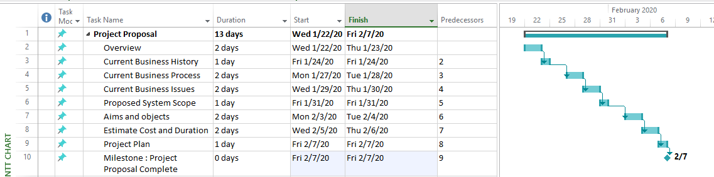

Project proposal starts 22 January 2020 and ends at 10 February 2020 (13 days).

**Chapter (1) Introduction**

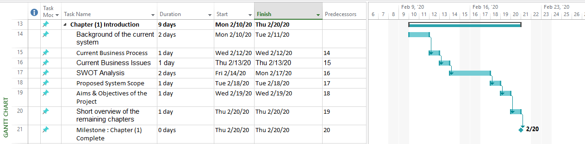

Chapter (1) starts February 10, 2020 and ends at February 20, 2020 (9 days).

**Chapter (2) Similar Product Comparison**

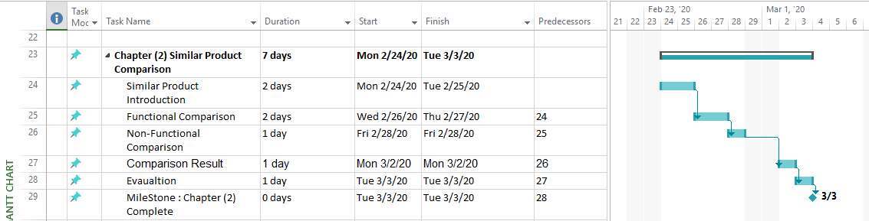

Chapter (2) starts February 24, 2020 and ends at March 3, 2020 (7 days).

**Chapter (3) Feasibility Study**

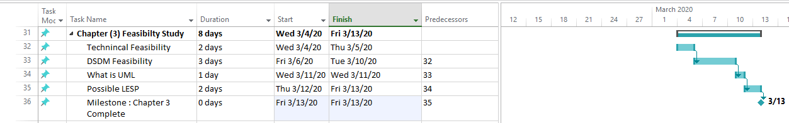

Chapter (3) starts March 4, 2020 and ends at March 13, 2020 (8 days).

**Chapter (4) Foundation**

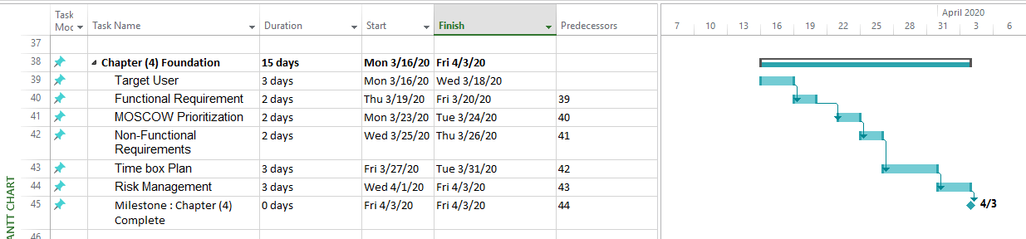

Chapter (4) starts March 16, 2020 and ends at April 3, 2020 (15 days).

**Chapter (5) Exploring and Engineering**

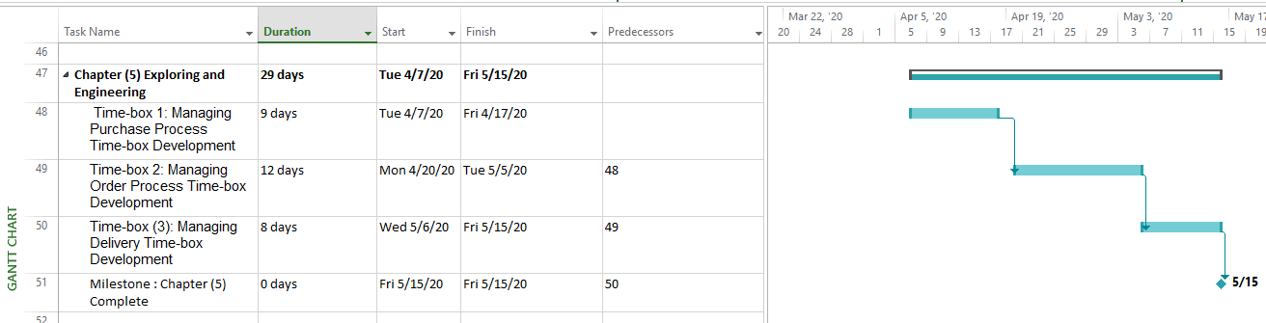

Chapter (5) starts April 7, 2020 and ends at May 15, 2020 (29 days).

**Chapter (6) Deployment**

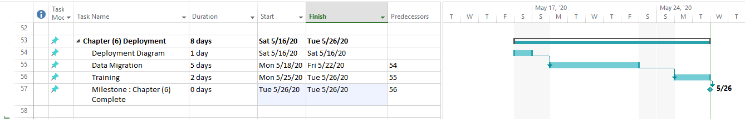

Chapter (6) starts May 16, 2020 and ends at May 26, 2020 (8 days).

**Chapter (7) Conclusion and Evaluation**

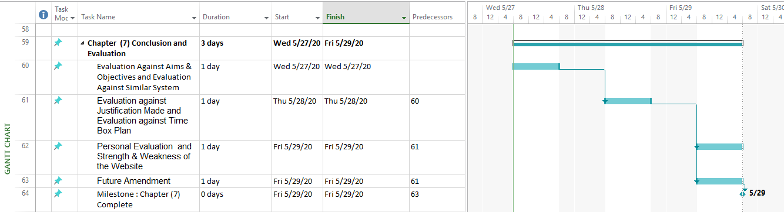

Chapter (7) starts May 27, 2020 and ends at May 29, 2020 (3 days).

Chapter-1

Introduction

# Chapter (1) Introduction

## Background of the current system

“Culture Sneaker Shop” was firstly founded in 2017. The shop is located in Bahan Township, Yangon, Myanmar. The shop purchases sneakers from various suppliers. It is distributing various sneakers and shoes the whole country with a delivery system having 15 delivery staffs. The shop provides customers with excellent sneaker brands such as Adidas, Nike, ERKE and so on. It also has promotion duration every 3 months. Most of the customers enjoy shopping in Culture Sneaker Shop. It is running with about 30 staffs, distributers and delivery system. Customers can order sneakers. The shop will deliver the items to the customers within one week. Customer can purchase with online payment system with card system (Visa, Amex or Discover). There are also discounted items for customers with membership cards. Every customer will become member of Culture Sneaker Shop after buying every 3 items.

## 1.2 Current Business Process

Firstly, the company purchases sneakers from various suppliers. Customers must have an account to buy sneakers. customers can choose and order the desired items online. The company will deliver sneakers to the customers’ address. They can purchase the sneakers with online payment system with Visa, Amex or Discover.

1. record Suppliers or Brand
2. Purchase Sneakers
3. Manage Staffs
4. Record Sneakers
5. Manage Customers
6. Manage Orders
7. Make Payment
8. Deliver Sneakers
   * + **Record Suppliers**

Culture purchase various sneakers from respective suppliers for each brand. Then, the information of suppliers that the sneakers are purchased from are recorded.

* + - **Purchase Sneakers**

The staffs in “CULTURE” purchase sneakers from various suppliers for each respective brand. The detail information of every purchase is recorded.

* + - **Manage Staff**

There are about 30 staffs in “CULTURE” Sneaker Shop. The manger manages roles and details information of each staff working at “CULTURE Sneaker Shop.

* + - **Record Sneakers**

Staffs record the detail information of the sneakers such as color, brand, prices and descriptions that are purchased from various suppliers.

* + - **Manage Customers**

Customers can register account in order to order sneakers. The manager recorded the details information of registered customers and their membership information.

* + - **Manage Customers**

After a customer ordered an item, the staffs record the detail about orders such as customer name, order date, address, total price, etc.

* + - **Make Payment**

Customers can make payment online with online payment system.

* **Deliver Sneaker**

There are delivery staffs in this company. After payment and purchasing is done, the delivery staffs will deliver to the customers according to their addresses within one week.

## 1.3 Current Business Issues

Business issues occurred mainly in recording data and information. Recording data has 4 parts such as recording suppliers, recording sneakers, recording customers and recording orders. These processes are not very secure in this current business system. So, the new system will have stronger security for the recorded data. Moreover, it takes too much time to process recording data in current business system. The developed system will provide more efficient account of processing to the users. The system will be easy to use and more friendly with users (staffs).

## 1.4 SWOT Analysis

**Strength**

Culture Sneaker Shop is one of the popular sneaker shops in Yangon.

* It has a lot of customers. So, it is easy to communicate with customers and easy to make interview for user involvement.
* Staffs are active in work and they learnt too much about the business. So, staff can help in the development of new system as stakeholders.
* The administrators of “Culture” can provide enough money for this project.

**Weakness**

* Most of the staffs in Culture Sneaker Shop are not experienced in using computers devices. Therefore, there will be delay in business if web system is started. So, a training is needed for staffs to handle computer devices.
* Staff will also be need to have good typing skill since staffs will need to reply and record orders, feedbacks and
* Time constraint is also an issue for Culture Sneaker Shop since it doesn’t have too much time for development of the new system.
* So, developers need to handle time boxes carefully.

**Opportunities**

* CULTURE is popular between young people and in social media. And Culture has good communication with its customers. Therefore, it is easy to make analysis about the business requirements.
* Whenever a customer posts with the sneakers form “CULTURE”, the popularity of “CULTURE” is raised. Therefore, it is

**Threats**

* The weather condition in the city and economic condition in the country may be the threats for this business IT system. The weather condition can affect the network condition of an IT department.
* Now, according to the COVID-19 disease, it hard to make analysis about the business. It is hard to make direct interview to the staffs and admins of the business.
* Most of the staffs are not familiar with IT system. Therefore, it may be uncomfortable to them during interviews.

## 1.5 Proposed System Scope

The current business system of “CULTURE” is facing with many issues. So, the business system is going to be changed into a computerized system in order to make it more efficient and secure. The proposed scopes for the new system are

* More efficient account of recording data which is the business’s largest problem currently. The new system should provide easier and more efficient account of recording data.
* The new system should be friendly to users being a point of sale system. Users should not be confused about the processes and functions of the new system.
* The developers need to make sure that customers’ information is safe. There will be order and payment system in this website. Therefore, the payment information should also be recorded safely.
* There should be a shopping cart function in order process. This shopping cart function can help customers to shop within the website easily.
* Staffs pages must have access control to make sure that manager’s tasks can not be perform by other staffs. Access control can prevent business from future business’s problems.
* Error prevention is also required for a website. There should be functions which prevent user error in register form and upload forms.

## Aims & Objectives of the Project

### Aims

The aims of developing the new system are

* To have more efficient account of recording data about staffs, customers and orders.
* To be easier to access recorded data and to have more reliable account of retreating data.
* To have better security for data and to make sure that customers’ data are safe.
* The new system should be user friendly and reliable for user.

Being a point of sale system, the purchase system must be simple for customers. The administrators of “CULTURE” expect the new system will be a solution for their day-to-day problems and issues.

### Objectives

Analysis

Before Starting the planning and coding, it is important to understand the transaction and daily processes of the business. Therefore, analysis should be made with the all stakeholders with “CULTURE”. The direct interview and surveys should be made. Making appropriate analysis can help in carrying out the project.

Design

Being a Point of sale system, the website for “CULTURE Sneaker Shop” must be friendly with users and the aim of the business must be obvious. Users should be easily understand and process through the website.

Coding

Coding need more time than other processes during the project development. During coding, it is important to make sure all the codes are written systematically in order to make future development and iteration.

Testing

To be sure that the system has no error, testing must be done for every text boxes and button of pages. Functional testing and non-functional testing should be done for whole website. Making sufficient testing can prevent website’s future problems and users’ error.

Training

When the website is error clear there should be a training for staffs who will directly process with the website. Staffs should be explained about the process and functions of the website in detail. Moreover, user manual can also be a solution for staffs who don’t understand the website’s function.

Evaluation

When all the tasks are completed, evaluations should be done. Personal evaluation and evaluation through the completed project must be done. Performing evaluation can help to view how well the project is done.

## 1.7 Short overview of the remaining chapters

CHAPTER (2) Similar Product Comparison

* This chapter need to make researches about the similar websites and similar companies.
* The comparison should be done with Functional Comparison and Non-functional Comparison.
* Then evaluation between these similar websites must be made.

CHAPTER (3) Feasibility Study

* During this chapter, the comparisons between methodologies, programming languages and databases should be made. The strengths and weaknesses of theses must be made.

CHAPTER (4) Foundation

* Target users must be tested with the completed program. Testing should have at least 5 target users, 3 staffs and 2 customers.
* Then, MOSCOW and Time box must be drawn with tables.
* For each time box, testing and screenshots for screen design must be shown.
* Risk management should be included for each time boxes.

CHAPTER (5) Exploring and Engineering

* During this chapter, Class Diagrams, Use Case Diagrams and screen designs for each time box must be shown.
* Functional testing Non-functional testing and iteration must be included in this chapter.

CHAPTER (6) Deployment

* During this chapter, data migration must be done with a time plan.
* Training for staff must be included too. Training must be done by a training plan including venue and duration.
* To assist training, user manual should be included in this chapter.

CHAPTER (7) Conclusion and evaluation

* This is the final chapter of the project.
* During this chapter, evaluation the website against similar system must be done.
* Evaluation for programming language, database and strength, weakness should be made.

**Chapter-2**

Similar Product Comparison

# Chapter (2) Similar Product Comparison

## 2.1 Similar Product Introduction

The function and non-functional comparison between two websites must be done in this chapter. The following two websites are chosen to be compared. Both of these websites have product displaying function and online payment system.

* **City mall site**

**City mall site** is a free online shop and delivery website. This website provides customers with various items such as foods, electrical devices, cosmetics, kitchen or households and so on. Customers can browse items by different categories. Customers must have an account to order items form this website. After ordering, customers can make payment online or cash on delivery.

* **Shop.com.mm**

**Shop.com.mm** is also a free online shop and delivery website. It provides various items too. But in this website, users can also sell their products with 0% commercial. Payment method can be done by online payment system with Visa or cash on delivery.

## 2.2 Functional Comparison

|  |  |  |
| --- | --- | --- |
| **Function** | **City mall site** | **Shop.com.mm** |
| Log In | This is the log in form of CityMall site.  This page can be reached from main page by clicking log in button.The users can choose two options ( Mobile number & Email ) to log in. Users can not view the password input. | This is the log in form of “Shop.com.mm”.  Customer can log in with either Phone Number or Password in the same text box. Customer can view password by clicking peek button. |
| Sign Up | This “Sign Up” page contains text boxes for logging in. There are text boxes for both Phone Number and email. Customers will receive verification code after the phone number is input. Customer can view the password input by clicking peek button. By signing up, the privacy policy is auto agreed. | This page also contains text boxes. But the policy is not auto agreed. User name is divided into two text boxes (First name and last name). And there is also a combo box for choosing title. Users can not view password but there is another text box for confirming password. To Sign Up customers must check to confirming terms and conditions. |
| Search bars | This is the search bar in City Mall site. Users can search the name of products. | This is the search bar in “Shop.com.mm”. Users can search the name of products and categories. |
| Services links | This footer has links to the other pages  Through the links provided here users can contact the service center. There is no about link for the organization. | This footer also has links. But this allows customers to sell their items. And there is also about link. |
| **Product displaying** | By clicking on the products shown here, users can reach to shop form and order products. Users can also review the detail information of product. | Once the product is selected, it will be added to shopping cart. The customers can review the product before ordering. |

## 2.3 Non-Functional Comparison

Non-functional comparison is done against 7 Design Guidelines of Nielsen.

The 7 Design Guidelines of Nielsen include

* Visibility of System Status
* Match between system and real world
* Consistency and standard
* Help and Documentation
* Aesthetic and Minimalist Design
* Error Prevention

|  |  |
| --- | --- |
| **City Mall site** | **Shop.com** |
| At the top of the main page, there is a slide bar displaying all trending products.  Below that slide bar, the discounted products are listed with their names. The discounted price and original price are displayed together. This website displays information of the products and prices up to date. | There is an image slider displaying current promotion at the top of the main page. Customers can view products by category.  The original price and discounted prices are displayed together below the product. The up to date information about products are displayed by categories. |
| This is login and sign up form of city mall place. The form design is familiar to most users. There are also guide words for users how to create account and how to login. The words used here are simple and most users can easily understand. But there is no use of icons to indicate users what to perform. | This is the sign-up form of shop.com. The design of the form is simple and familiar to most users. There is an obvious large button for signing up. There are also Facebook icon and google icon to sign up. |
| After clicking on the desired product, customers will reach product detail page. Customers can zoom the product by putting pointer on the product. The information such as price, rating and detail facts are displayed clearly. Users can easily understand how to choose quantity because the choose of quantity can be done by clicking on plus and minus sign. | This product display page is a bit complex because it displays not only prices and information about the product but also buying and delivery information. Customers may face with the problem of not knowing what to do. |
| City mall site has FAQs section where users can learn how to register or how to order products. | This pages guide users how to buy in this website and how to browse within website. |
| This footer has icons before each links. The usage of icons make this footer more friendly and more aesthetic. | This footer show links only with texts without displaying icons. |

## 2.4 Comparison Result

The following table show the result form functional and non-functional comparison made above.

|  |  |  |
| --- | --- | --- |
| **Criteria** | **City Mall site** | **Shop.com** |
| Functional Comparison result | * Less functional than shop.com. * Can only register with phone number or email. | * Shop.com contains social login and registration system. * Provide more function for users. * Contain show password function in all password text box |
| Non-functional comparison result | * “City Mall Site” is more friendly to users. * The UI design is more aesthetic than “Shop.com.mm”. * More icons usage and colorful theme. | * The UI design is a bit complex and not much friendly for users. * Less icons usage. |

## 2.5 Evaluation

According to the above comparison result, the following evaluation is made.

* Passwords text boxes should have showing password function.
* There should be social login function.
* There should be all functions that a point of sale system should have.
* The website should have icons and guidelines for users to be user friendly. Using appropriate icons and images make easier navigation for users.
* The website should have appropriate color usage and appropriate font style/size. Font size 11-20 is suitable for normal texts.
* When users click an action button, there should be a message box which means “Error prevention”. Containing error preventions helps business to avoid further problems and conflicts with clients.

**Functional Evaluation**

|  |  |  |
| --- | --- | --- |
|  | **Rating (1-5)** | |
| **Criteria** | **City Mall site** | **Shop.com** |
| Log In | **2** | **4** |
| Sign Up | **3** | **3** |
| Search bars | **2** | **2** |
| Services links | **2** | **4** |
| Product displaying | **3** | **3** |

**Non-Functional Evaluation**

|  |  |  |
| --- | --- | --- |
|  | **Rating (1-5)** | |
| **Criteria** | **City Mall site** | **Shop.com** |
| Visibility of System Status | **3** | **2** |
| Match between system and real world | **3** | **3** |
| Consistency and standard | **3** | **3** |
| Help and Documentation | **4** | **3** |
| Aesthetic and Minimalist Design | **3** | **3** |
| Error Prevention | **3** | **2** |

According to above comparison result, City Mall Site has better User interface and meet non-functional requirements. But Shop.com offers more functions meeting the website’s functional requirement.

Chapter-3

Feasibility Study

# Chapter (3) Feasibility Study (Literature Review)

## Technical Feasibility

### 3.1.1 Methodologies

The following two methodologies are chosen for this project.

* Agile
* Waterfall

#### Definition

**Agile**

In Agile methodology, a project is broken up into several stages and processed by team work. This methodology is a people-oriented methodology (focus on users’ requirements). So, it ensures user involvement in the developing the system. When the project is started, stakeholders in the whole things cycle the processes through planning, executing, evaluating, designing and testing. The processes are done according to the users’ requirements and suggestion. It is also iterative in that planning for the work of one iteration to be improved upon in subsequent iterations. Using agile enforces to have better communication and it make sure that the system meets the users’ requirements.

(Anon., 2019)

**Waterfall**

Waterfall methodology is the step by step method for developing a system. In this methodology, the development is done by 5 steps.

Analysis – All aspects and requirements of the system are analyzed and defined.

Design – The analyzed aspects are designed to meet the requirements.

Implementation – The existing system is changed into the new system while comparison between the two are being made.

Testing – The developed methods are tested to ensure it is lack of error and is efficient.

Maintenance – The errors found in the testing stage are maintained in this stage.

(Anon., 2019)

#### Strength and Weakness of each Methodology

|  |  |  |
| --- | --- | --- |
|  | Agile | Waterfall |
| Strengths | * Agile is iterative * Being people-oriented, agile has great user involvement. * Enable Team Work * Break up into several stages and perform with team. | - Perform steps by steps  - Testing is performed continuously in each stage.  - Easy to measure projects by referring the objectives at each stage. |
| Weakness | * Only one testing when the system is developed completely. * Difficult to measure projects. * **Difficult planning** at early stages | * No Iteration * Less user involvement. * Does not support Team Work. * Required Formalized Documentation. |

(Kukhnavets, 2019)

#### Comparison of Methodologies

|  |  |  |
| --- | --- | --- |
| Criteria | Agile | Waterfall |
| Time Consuming | Less time consuming. | Need one year and above. |
| User Involvement | Agile provide greater user involvement. | User involvement is only at start and end of project. |
| Reliable | Agile is reliable because it is iterative. | Waterfall is also reliable because testing is perform step by step in agile. |
| Measuring completed projects | Hard to measure project because tasks are break up into several stages. | Easy to measure project. |
| Iteration | Agile is iterative | Waterfall process step by step |

#### Recommendation for Methodology

Agile methodology is recommended for this project.

* Agile methodology is iterative while waterfall method has no iteration. So, it is more efficient to use Agile method.
* Moreover, waterfall method is more detail and take more time. It takes at least 1 year and above to develop a system with waterfall method. There is not too much time for developing the system.
* The system must deal with staffs and customers. So, user involvement is important in this system. Agile has greater user involvement since the users involves in the whole development.

According to above reasons, Agile methodology is recommended to use in developing this system.

### 3.1.2 Programming Languages

#### a) Definition

**PHP**

PHP (Hypertext Preprocessor) is a programming language that is designed for developing websites. It is a popular high-level programming language. PHP is very effective in developing dynamic websites. The tools, features and code snippets in PHP helps developers to accelerate on their works. Moreover, PHP language is easy to understand, and developers can perform testing efficiently.

**Python**

Python is an interpreted, high-level programming language with dynamic semantics released in 1991. Python can not only be used for web application but also for developing complex scientific applications. (Anon., 2019). The Python language is simple and readable making it easier to learn. Therefore, it reduces the cost of maintenance. Moreover, it is highly productive as it’s run-time typing.

#### b) Strength and Weakness of each Programming Languages

|  |  |  |
| --- | --- | --- |
|  | PHP | Python |
| Strength | * Easy to use compared to other scripting languages. * A function in which generate waring or error notice is contained. * It is faster compared to other scripting languages. * Runs well on Window, OS X and Linux and installation is very easy. | * More secure compared to other scripting languages. * Simple and easy to learn. * Free and Open Source |
| Weakness | - Php doesn’t have great security.  - Not appropriate for large and complex systems. | - Installing python on window can take a bit of work.  - Memory Consumption  - Runtime Errors.  - Python is a bit slower than other programming languages. |

(Anon., 2019)

#### c) Comparison of Programming Languages

|  |  |  |
| --- | --- | --- |
| **Criteria** | **PHP** | **Python** |
| Speed | PHP is faster than other programming languages. | Slower than PHP. |
| Easy to learn | PHP easy to learn and use. | Python is simple also easy to use. |
| Reliable at work | PHP does not have runtime errors. | Have runtime errors. |
| Security | Php doesn’t provide great security. | Python is more secure compared to other scripting languages. |
| Error Handling | Warning sign make error handling easier. | Python also provide easy account of error handling. |

#### Recommendation for Programming Language

PHP is recommended for this project

* Warning sign enabling developers to find errors easily and fix the problems on time.
* PHP is easy to learn and apply.
* Being a POS website, security is not very important.
* PHP is faster than other languages.
* Since, the organization will process with windows, PHP is more efficient to use.

According to these criteria, PHP is recommended for developing this system.

### 3.1.3 Databases

#### a) Definition

**Microsoft SQL Server**

SQL (Structured Query Language) is a kind of programming language that is designed for management of the data in relation database. Microsoft SQL Server is a relational data management system produced by Microsoft. SQL enables users to perform various operations on the data like inserting new data, updating the existing data, deleting data and selecting and reviewing data. It is widely used by many business systems and in offices to store and process data.

**Microsoft Access**

Microsoft Access is a database management system produced by Microsoft. It is a common information management tool used in many business systems. It helps users to analyze large amount of information and to process more efficiently with the data. Users can install the retail version on desktop without purchasing. It allows developers to create database for the business and distribute to various end-users.

#### b) Strength and Weakness of each Databases

|  |  |  |
| --- | --- | --- |
|  | Microsoft SQL Server | Microsoft Access |
| Strength | * Work well on window and it is easy to install. * Can be used in large business to store a large amount of data. * More functionable. * Have more specification that user can perform. * SQL server provides users with automatic backup procedures to a media disk. | * MS Access can be installed and work on window easily. * Easy to use and understand |
| Weakness | * It is hard to understand. * Need experienced user to access the database. | * Lower specification since it is traditionally used for small business. |

(Lysis, 2019)

#### c) Comparison of Databases

|  |  |  |
| --- | --- | --- |
| **Criteria** | Microsoft SQL Server | Microsoft Access |
| Ease of installation | Easy to install and work well on window. | MS Access is also easy to install. |
| Storage space | Provide 16 terabytes storage space. | Provide only 2 gigabytes. |
| Performance | More functionable than other database systems. | Less and simple function. |
| Easy to use | SQL is a bit complex and hard to understand. | Simple and understandable functions. |
| Recovery of data | Provide automatic backup. | Lower specification for backing up data. |

#### Recommendation for Programming Language

Microsoft SQL server is more efficient for this business.

* Since the records of the sneakers and information of customers and staffs must be stored, the database must have large data storage.
* Microsoft SQL server has 16 terabytes while Microsoft access has only 2 gigabytes. The database must be able to store data with a strong security.
* The accidently lost data must be automatically back up by SQL Server.
* Moreover, SQL server has a better performance since it has more functions and specifications than MS Access.

Therefore, Microsoft SQL Server is recommended for developing this system.

## **3.2 DSDM Feasibility**

### 3.2.1 Principle 1 - Focus on the business need

The team should focus the project to meet the requirements of the business such as user involvement, reliability and security. The developer team must understand those priorities of the project. Every decision made by the team must achieve the goal of project.

### 3.2.2 Principle 2 - Deliver on time

The developer team must manage their time by using Moscow and timebox planning techniques. The time for certain tasks such as analysis and implementation must be arranged by having deadlines. Since the development of the new information system (Culture Sneaker) doesn’t have too much time, the developer team must focus to complete the project on time.

### 3.2.3 Principle 3 – Collaborate

DSDM teams need collaboration and team spirit. Teams should work out together instead of working individually because collaboration ensure work to have higher performance and encourage understanding. The developer teams must collaborate with not only team members but also with the targeted users to make the system more user friendly.

### 3.2.4 Principle 4 - Never Compromise quality

The teams must complete work in time according to the time box plans. The quality of final project must not be less than the quality expected or decided. Since the website needs to have users’ attraction, the final project must not be a low-quality project.

### 3.2.5 Principle 5 - Build incrementally form firm foundation

The DSDM teams must ensure to perform each step completely. The completed steps must not have errors and the solution must be built incrementally.

### 3.2.6 Principle 6 - Develop iteratively

The steps are not created perfectly first time in DSDM. And the administrators may give feedbacks and complains on the completed steps of the project. The developers can work iteratively according to testing and feedbacks. Iteration improve the quality of the final project.

### 3.2.7 Principle 7 - continuously and clearly

The DSDM team needs a good communication for better quality of final product. Developers should improve communication by holding meeting, making survey and interviews. Since the final project needs to be user friendly, surveys and interviews are important for this project. The results are very important and efficient in developing the project.

### 3.2.8 Principle 8 - Demonstrate Control

Developers must keep control of the project by testing the functions by a schedule. Using time box can help in controlling project and viewing who is doing what and when.

(Buehring, 2019)

## 3.3 What is UML

UML (Unified Modeling Language) is a standard developmental language for modelling in the software engineering field. It includes a set of diagrams which are important for developing the system by reducing the time required for analysis. It is very efficient in helping the developers to specify, visualize, construct and document the system. UML is very important for developing object-oriented software because it represents the system with its main actors, roles, actions and processes. Developers can easily understand the flow of business by using UML. Therefore, it is very efficient in making analysis about the business requirements before a project is started.

## 3.4 Possible LESP (Legal, Ethical, Social and Professional) Issues

When a new system for business is started, common issues can be faced. These issues can be very dangerous for the business. The administrators and developers need to handle these issues.

The common issues are

* Legal issue
* Ethical issue
* Social issue
* Professional issue

**Legal**

When running a business, legal issue is the most important. It can give the business too much side effects. Administrators and developers of “Culture” needs to care about the following legal issues.

License

Licensing is the requirements of government for businesses. The cost of license fee is depending on the operation of business. So, before starting the web development, the administrators need to make sure that “CULTURE” is registered business.

Trademarks

It is important the website have trademarked i.e. the usages and themes of website must be unique from other websites. Developers need to make plenty research about getting trademark for a website.

There are many other legal issues such as misclassification, employee’s termination and so on.

(Anon., 2020)

**Ethical**

Ethical issues can be found in the business when the processes and daily activities of a business conflict with the principles of a society. Ethical issues in the business also depends on the honesty of the administrators and staffs in the business. Property right and copy are one of the common ethical issues. These conflicts are legally dangerous for the IT system sometimes. (Anon., 2020) Therefore, developers need to make sure that the activities and processes of the website do not have any conflict with the society’s principles.

**Social**

A social issue is occurred when there is a problem with influence of society on the business. Today, it is becoming the most common problems for business. Most common social issues include

* The Social responsibility

The social responsibilities include respect for rules of the law, accountability, respect for human rights, etc. Social responsibility is one of the most dangerous social issues. So, the administrators of “CULTURE” should be aware of these factors. (Anon., 2020)

* Safety of data

The business has a lot of customers and processes containing payment system. Therefore, there will be issues when the personal data of the customers are not safety. The new system should be made sure that customers information and payment information are safe.

**Professional**

Professional issues can be found between new IT systems and users after being implemented. If there is software and hardware update, users will not have enough knowledge of these updates. If users do not have enough about IT system, there can be dangerous risks. These issues can be prevent by proper training to staffs after implementation of the new IT system.

Chapter-4

Foundations

# Chapter (4) Foundation

## 4.1 Target User

Target Users are the person who will directly process with the new system after implementation of the new IT system.

|  |  |  |  |  |
| --- | --- | --- | --- | --- |
| **Name of User** | **Age** | **Computer skill / IT Literacy** | **Language skill**  **(especially English skill)** | **Role** |
| Kyaw Zay Linn | 18 | Good | Moderate | Customer |
| San Min Paing | 19 | Moderate | Moderate | Customer |
| Nawal Merrouch | 25 | Good | Excellent | Staff |
| Hsu Myat | 21 | Excellent | Excellent | Staff |
| Martina Staviarova | 24 | Good | Good | Admin |

## 4.2 Functional Requirement

**Manage Purchase Process**

**Manage Staff**

* Register Staff
* Update Staff
* Delete Staff
* View Staff

**Manage Brand**

* Register Brand
* Update Brand
* Delete Brand
* View Brand

**Manage Category**

* Register Category
* Update Category
* Delete Category
* View Category

**Manage Supplier**

* Register Supplier
* Update Supplier
* Delete Supplier
* View Supplier

**Manage Purchase**

* Confirm purchase
* View Purchase

**Manage Order Process**

**Manage Customer**

* Register Customer
* Update Customer
* Delete Customer
* View Customer

**Manage Brand**

* Register Brand
* Update Brand
* Delete Brand
* View Brand

**Manage Category**

* Register Category
* Update Category
* Delete Category
* View Category

**Manage Sneaker**

* Register Sneaker
* Update Sneaker
* Delete Sneaker
* Search Sneaker

**Manage Order**

* Record Order
* Confirm Order
* Delete Order

**Manage Delivery Process**

**Manage Staff**

* Register Staff
* Update Staff
* Delete Staff
* View Staff

**Manage Order**

* View Order
* Remove order

**Manage Delivery**

* Confirm Delivery

## 4.3 MOSCOW Prioritization

|  |  |
| --- | --- |
| **Must** | **Justification** |
| Purchase Sneakers | This process must be done because they are the most important and basic processes of this business system. The shop must purchase sneakers from various suppliers. The purchased sneakers must be sold and delivered to customers. Customers must make payment. |
| Sell Sneakers |
| Make Payment |
| Deliver |

|  |  |
| --- | --- |
| **Should/Could** | **Justification** |
| Cancel Orders | These processes are not day-to-day processes or main processes of the business. But these are also essential for the business. Sometimes, customers can cancel orders after ordering. If the sneakers have an error, the business has to deliver the sneakers again. If customers forget their orders and forget to make payment, the staffs have to contact them. The staffs need to be given salary every month. |
| Give salary to staffs |
| Contact Customers |
| Exchange error product |

|  |  |
| --- | --- |
| **Won’t** | **Justification** |
| Advertise the business on social media | These processes are not necessary for the business. This can be ignored if the main processes are not completed. |
| Promote sneakers |

## Non-Functional Requirements

### 4.4.1 Usability

The website needs appropriate font style and color. Usage of font-style means a lot for a website. Users should understand the words and instructions easily. Developers should choose color that will attract user. The navigations should be displayed with icons or signs for more user friendly.

### Security

The website should be secured enough for users form hackers. Password hashing methods should be used when registering and logging in accounts. Security codes should be provided before ordering and delivering sneakers.

### Performance

All the functions provided by the website should be work for better performance.

### Operational

There should be functions that staffs can be able to communicate with users. Contact us section should be included to offer users with better communication option.

### Portability

The website or application should be portable for every device and responsive to width of the devices.

### Maintainability

The developer team should be able to maintain the programs in the future. The coding on the functions of the websites should be rewrite easily.

### Safety

“Culture” will need to store information of sneakers, staffs, suppliers and customers. The website should be ensured that all information is safe and disable to copy.

### Recovery

The data stored should be recovered when it is lost. This should be done by choosing right database and right programming language.

## Time box Plan

### Time box 1: Manage Purchase Process

|  |  |  |  |
| --- | --- | --- | --- |
| **Time box Name** | | Manage Purchase process | |
| **Start Date** | | April 7, 2020 | |
| **End Date** | | April 17, 2020 | |
| **Task** | **Duration** | **Start Date** | **End Date** |
| **Functional Requirement** | 1 day | April 7, 2020 | April 7, 2020 |
| **Use Case Diagram** | 1 day | April 8, 2020 | April 8, 2020 |
| **Class Design** | 1 day | April 8, 2020 | April 8, 2020 |
| **Sequence Diagram** | 1 day | April 8, 2020 | April 8, 2020 |
| **High Level & Low-Level Prototype** | 1 day | April 9, 2020 | April 9, 2020 |
| **Coding** | 3 days | April 10, 2020 | April 12, 2020 |
| **Functional Testing** | 2 days | April 13, 2020 | April 14, 2020 |
| **Usability Testing** | 2 days | April 15, 2020 | April 16, 2020 |
| **Time Box Summary** | 1 day | April 17, 2020 | April 17, 2020 |
| **Key Deliverables (Output)**  **Design**   * Use Case Diagram for Purchase process * Class Diagram for Purchase process   **Coding**   * **EditStaff.php** * **StaffLogin.php** * **EditBrand.php** * **EditCategory.php** * **Purchase.php**   **Testing**   * Unit Test Document * Usability Test Document * Test Cases | | | |

### Time box 2: Manage Order Process

|  |  |  |  |
| --- | --- | --- | --- |
| **Time box Name** | | Manage Order process | |
| **Start Date** | | April 18, 2020 | |
| **End Date** | | May 3, 2020 | |
| **Task** | **Duration** | **Start Date** | **End Date** |
| **Functional Requirement** | 1 day | April 18, 2020 | April 18, 2020 |
| **Use Case Diagram** | 1 day | April 19, 2020 | April 19, 2020 |
| **Class Design** | 1 day | April 20, 2020 | April 20, 2020 |
| **Sequence Diagram** | 1 day | April 21, 2020 | April 21, 2020 |
| **High Level & Low-Level Prototype** | 1 day | April 22, 2020 | April 22, 2020 |
| **Coding** | 5 days | April 23, 2020 | April 27, 2020 |
| **Functional Testing** | 3 days | April 28, 2020 | April 30, 2020 |
| **Usability Testing** | 2 days | May 1, 2020 | May 2, 2020 |
| **Time Box Summary** | 1 day | May 3, 2020 | May 3, 2020 |
| **Key Deliverables (Output)**  **Design**   * Use Case Diagrams for customer order process * Class Diagrams for customer order process   **Coding**   * **Register.php** * **Login.php** * **Home.php** * **SingleItem.php** * **ShoppingCart.php** * **CheckOutForm.php**   **Testing**   * Unit Test Document * Usability Test Document * Test Cases | | | |

### Time box 3: Manage Delivery Process

|  |  |  |  |
| --- | --- | --- | --- |
| **Time box Name** | | Manage Delivery process | |
| **Start Date** | | May 5, 2020 | |
| **End Date** | | May 15, 2020 | |
| **Task** | **Duration** | **Start Date** | **End Date** |
| **Functional Requirement** | 1 day | May 5, 2020 | May 5, 2020 |
| **Use Case Diagram** | 1 day | May 6, 2020 | May 6, 2020 |
| **Class Design** | 1 day | May 6, 2020 | May 6, 2020 |
| **Sequence Diagram** | 1 day | May 7, 2020 | May 7, 2020 |
| **High Level & Low-Level Prototype** | 1 day | May 8, 2020 | May 8, 2020 |
| **Coding** | 3 days | May 9, 2020 | May 12, 2020 |
| **Functional Testing** | 1 days | May 13, 2020 | May 13, 2020 |
| **Usability Testing** | 1 days | May 14, 2020 | May 14, 2020 |
| **Time Box Summary** | 1 day | May 15, 2020 | May 15, 2020 |
| **Key Deliverables (Output)**    **Design**   * Use Case Diagrams for delivery process * Class Diagrams for delivery process   **Coding**   * Stafflogin.php * Editorder.php * ManageDelivery.php   **Testing**   * Unit Test Document * Usability Test Document * Test Cases | | | |

## Risk Management

### 4.6.1 Identification of Possible Risks

Risks can be occurred when developing the project. These can disturb the development of project and may cause delay. The following are the common risks that can be occurred during this project development.

**Language issues** – The users do not know or understand the language used in the website and unable to navigate/process.

**Less knowledge about project** – The developer does not understand much the project and the processes of the business.

**Not enough time** – Developing a project may need the developer may not has enough time to develop the program.

**Not enough money** – The developer can face with the financial issues when he does not have enough money for the project.

**Data loss** – If the developer does not make backing up, there may be loss of data while developing the project.

**Risk of hardware devices** – the brake down of hardware devices can cause loss of data and unsaved our works.

**Attack of virus** – the hardware devices can be break down by virus attack. This may cause breaking down of hardware devices and loss of data.

**Lack of users’ experience** – the staffs in “CULTURE” are not familiar with computer devices. So, there may be delay when the new system is implemented.

### Critical Success Factors for current project

During website development, risks can disturb the project. To complete this project successfully, the following factors are important.

1. The developers should choose language that is appropriate with the users and region where the business is located. They should use not only appropriate language but also icons and photos that can help users for easier navigation.
2. Before starting the project, all the members of developer team should try to understand the aims and objectives of the project. The final project should perfectly meet the requirements of the business.
3. Time constraint can be an issue for developing new information system. So, developers should handle time with time boxes.
4. Planning the project before starting is very effective way to avoid further problems. Drawing ERD and use case diagrams can also help in planning the project.
5. It is very important to choose devices which are suitable for the business. And the devices should be error clear too.
6. Antivirus software should be implemented in the devices to avoid the data losing and devices’ break down.

### 4.6.3 Risk Matrix

|  |  |  |  |  |
| --- | --- | --- | --- | --- |
| **Risk** | **Probability** | **Impact** | **Proactive Action** | **Reactive Action** |
| Language issues | Medium | High | Use language which is suitable for the region where the business is located and use icon and image for easier navigation. | Discuss with users and development team to solve this issue and changing the language used in the website. |
| Less knowledge about project | Low | Medium | All members of the developer team should learn about the project before starting the project. | The developers can make analysis and interviews with stakeholders or discuss with administrators. |
| Not enough time | Medium | Medium | Developers team should handle the time by the use of time boxes and planning before the project development is started. | Developers should ask the business owner if they can have more time or reducing time by using more developers. |
| Not enough money | Low | Medium | The administrators of the business should provide sufficient amount of money to the developer team. Report about all the hardware and software cost must be given to the business owners. | Developers should discuss with business owners to provide more money. Developers can also reduce the cost by not purchasing unnecessary items. |
| Data loss | Medium | High | Developers should back up every data during the project. The devices for backing up data should be prepared for this condition. | Developers team should discuss about all the ways to get the lost data. |
| Risk of hardware devices | Medium | Medium | The devices used must be suitable with the business requirement. The devices should have warranty in order to have no break down during development. | The developers should contact hardware engineers or devices retailer to repair as soon as possible. |
| Attack of virus | Medium | High | The devices implemented in the business should install antivirus software which can protect the devices from the attack of virus and data loss. | The developers should contact hardware engineers to repair as soon as possible. |
| Lack of users’ experience | Medium | Low | The staffs should be trained to use the website before the website is started to use. The staffs should be explained about the website clearly. | Discuss with the business owners to make a training again or employ the staffs who are familiar with the computer devices. |

## Detail class diagram for whole system

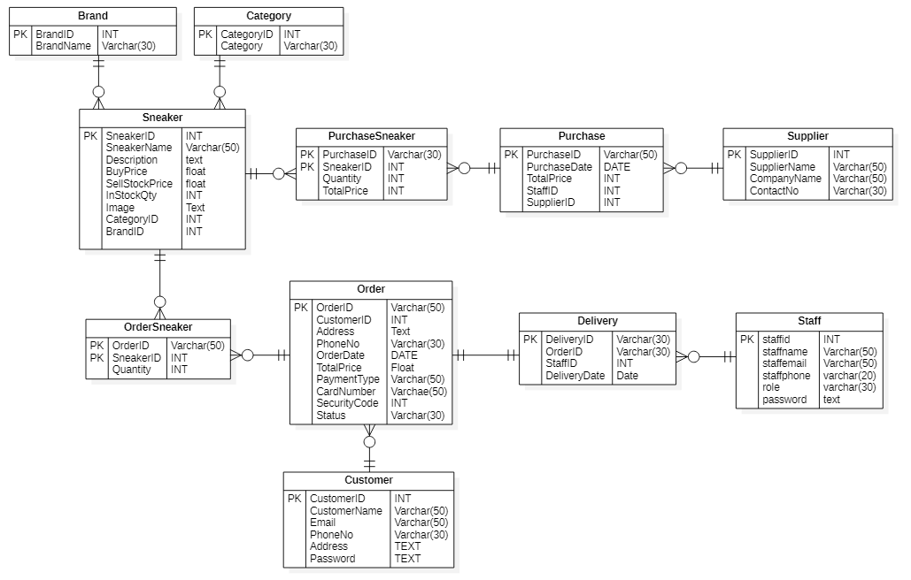 **Detail Class Definitions**

|  |  |
| --- | --- |
| **Class Name** | brand |
| **Attributes** | Brand ID, Brand Name |
| **Operation** | Record (), Cancel (), AutoID (), Update (), Delete (). |
| **Description** | The **Brand** class is used to Record brand name of the sneakers. |

For remaining, see Appendix.

## Use Case for whole system



**Use Case Description**

|  |  |
| --- | --- |
| **Use Case Name** | Register Staff |
| **Actor** | Manager |
| **Flow of Event** | Admins and managers can fill the staff information in Staff Register Page. Register button is clicked to confirm registering to register an account. |

For Remaining, See Appendix.

Chapter-5

Exploration & Engineering

# Chapter (5) Exploring and Engineering

## 5.1 Time-box 1: Managing Purchase Process Time-box Development

### 5.1.1 Project Plan for Time Box 1

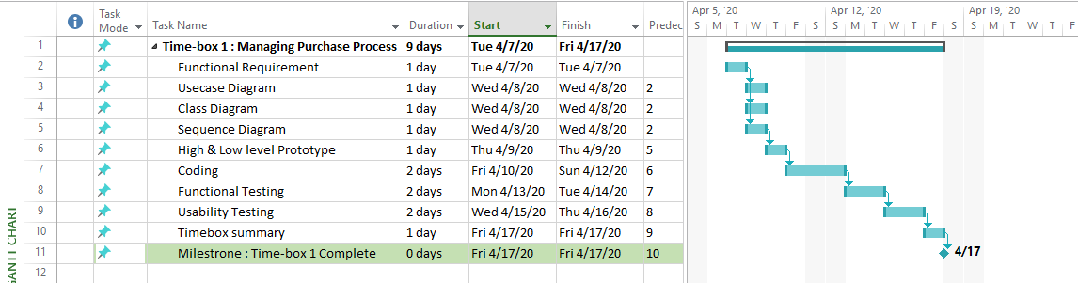

Project plan for Time-box (1) start April 7, 2020 and end at April 17, 2020. (9 days)

### 5.1.2 Functional Requirements

**Manage Purchase Process**

**Manage Staff**

* Register Staff
* Update Staff
* Delete Staff
* View Staff

**Manage Brand**

* Register Brand
* Update Brand
* Delete Brand
* View Brand

**Manage Category**

* Register Category
* Update Category
* Delete Category
* View Category

**Manage Supplier**

* Register Supplier
* Update Supplier
* Delete Supplier
* View Supplier

**Manage Purchase**

* Confirm purchase
* View Purchase

### 5.1.3 Use Case Diagrams

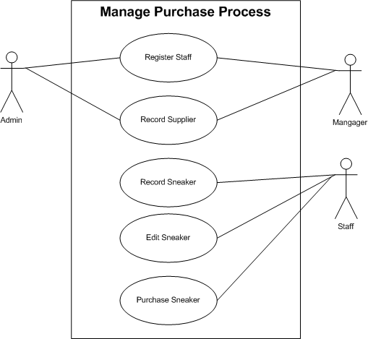

**Use Case Description**

|  |  |
| --- | --- |
| **Use Case Name** | Register Staff |
| **Actor** | Admin, Manager |
| **Flow of Event** | * Admins and managers can fill the staff information in Staff Register Page. Register button is clicked to confirm registering to register an account. |

For Remaining, See Appendix.

### 5.1.4 Screen Design

1. **Staff Register Form**

Fig 1) Low Level Prototype for Staff Registration

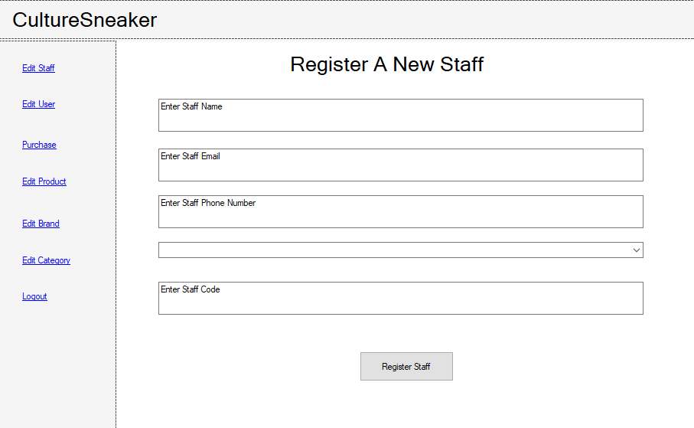

Fig 2) High Level Prototype for Staff Registration

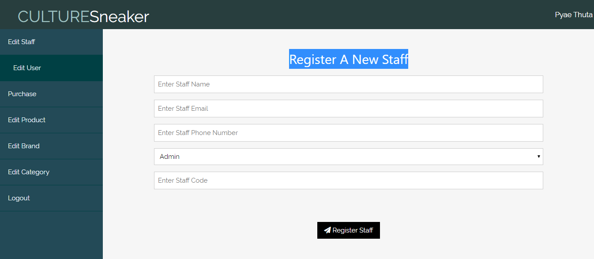

1. **Staff Login Form**

Fig 3) Low Level Prototype for Staff Login Form

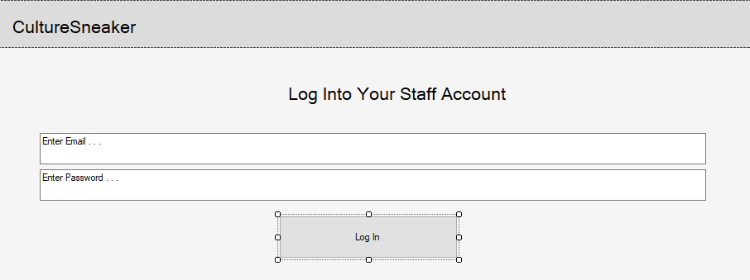

Fig 4) High Level Prototype for Staff Login Form

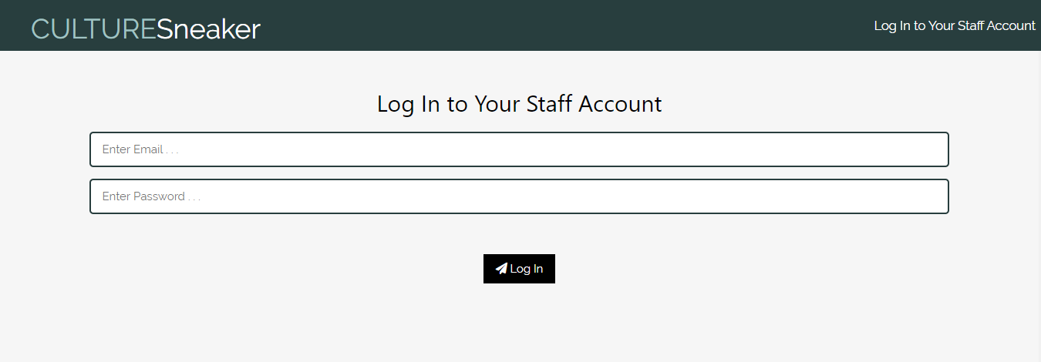

1. **Sneaker Input Form**

Fig 5) Low Level Prototype for Product Input Form

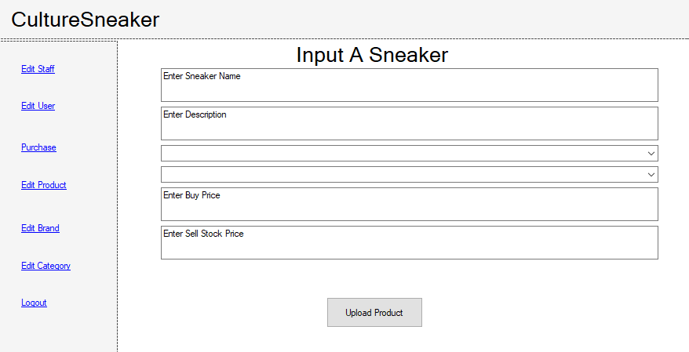

Fig 6) High Level Prototype for Product Input Form

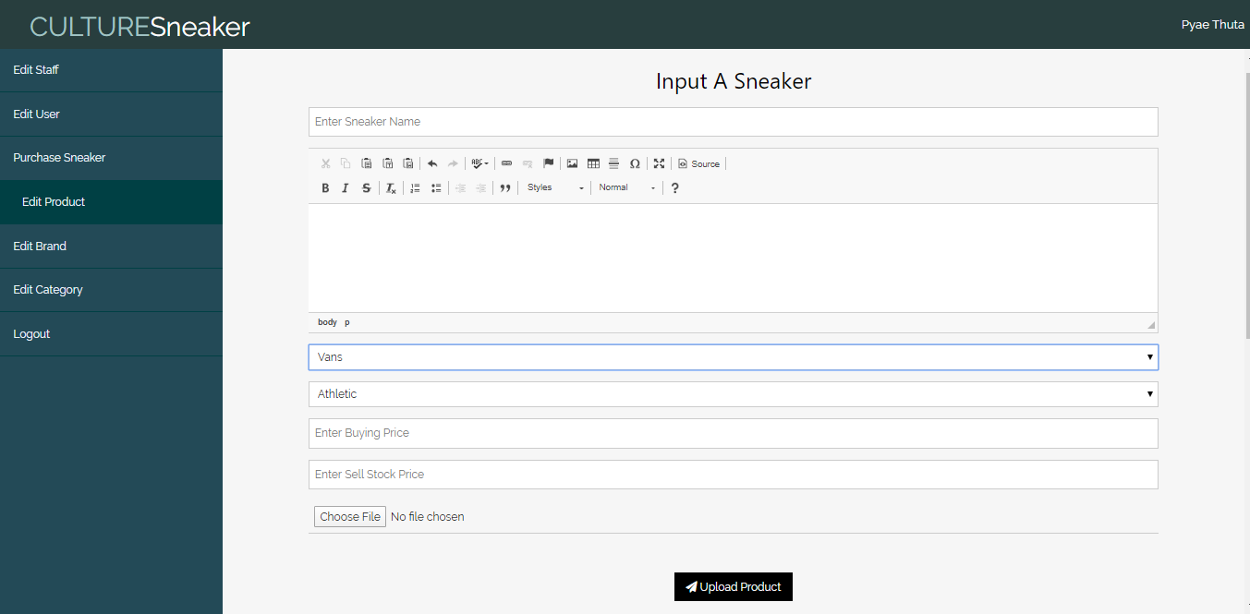

1. **Sneaker Display Form**

Fig 7) Low Level Prototype for Sneaker Display Section

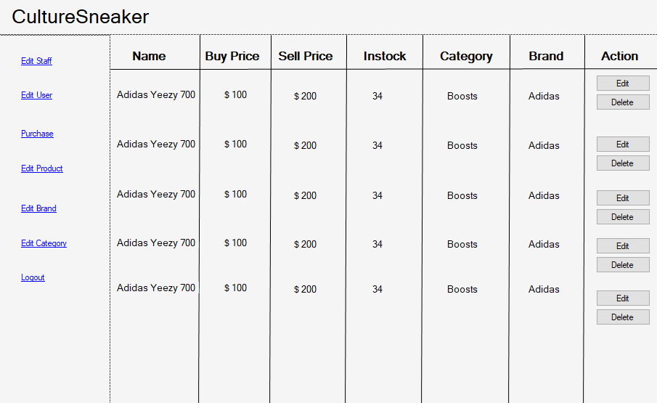

Fig 8) High Level Prototype for Sneaker Display Section

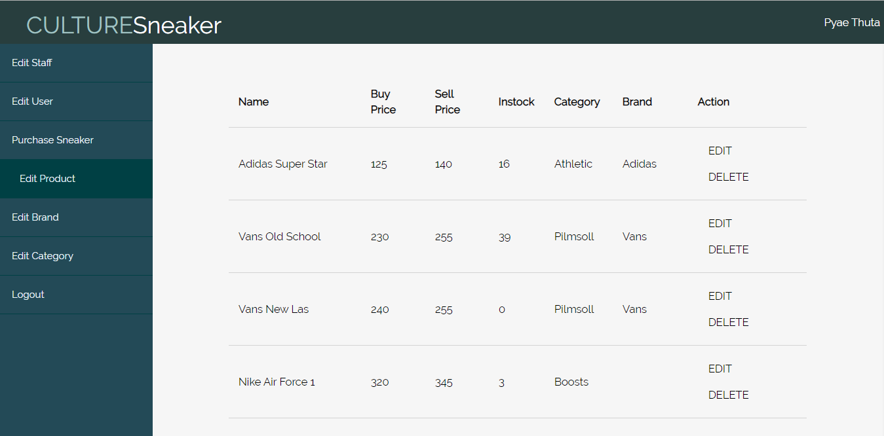

1. **Sneaker Purchase Form**

Fig 9) Low Level Prototype for Sneaker Purchase Section

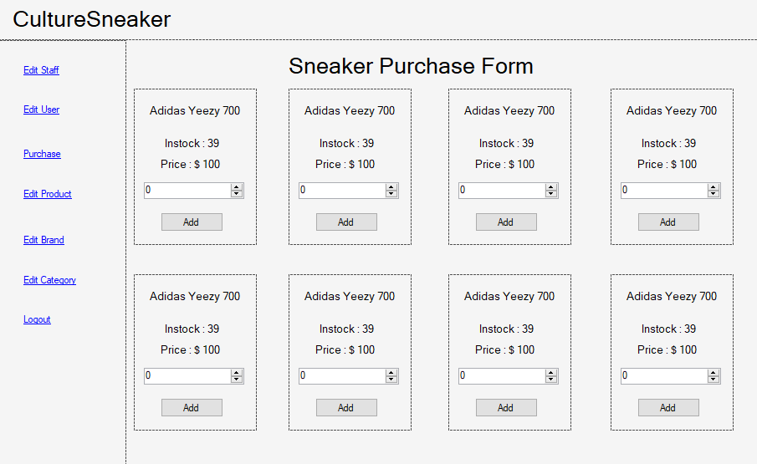

Fig 10) High Level Prototype for Sneaker Purchase Section

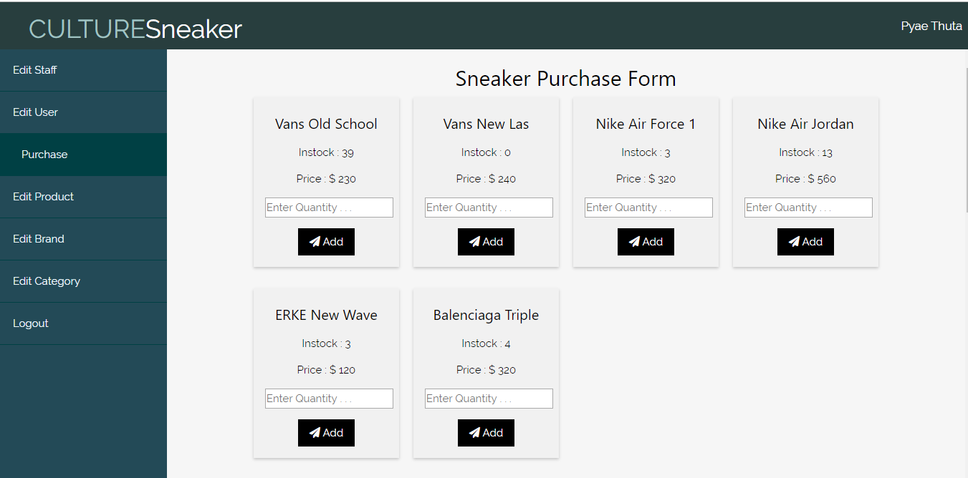

1. **Purchase Cart**

Fig 11) Low Level Prototype for Sneaker Purchase Cart

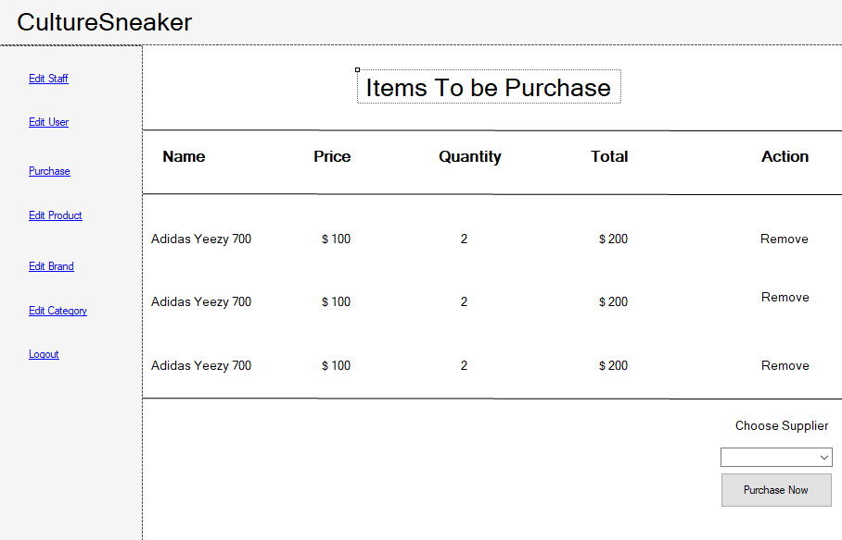

Fig 12) High Level Prototype for Sneaker Purchase Cart

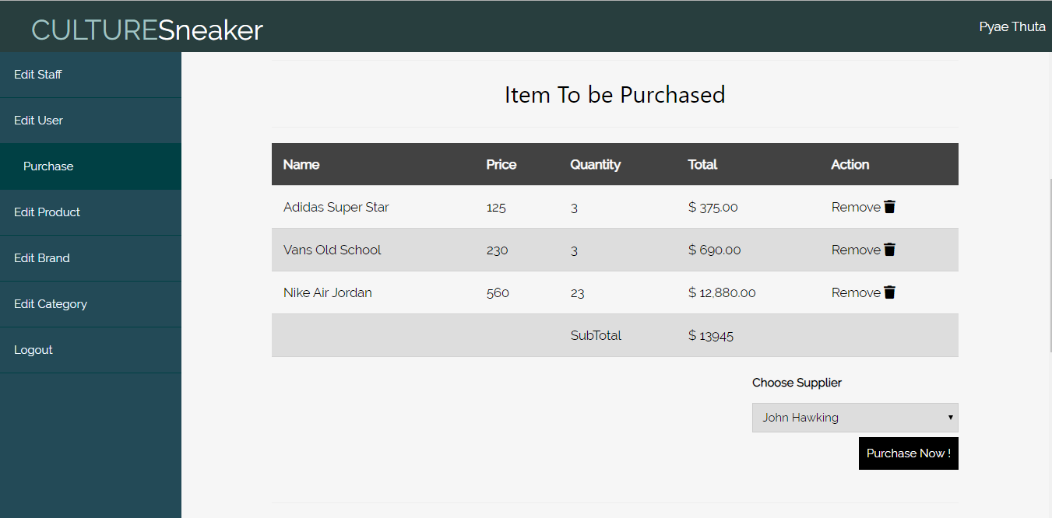

1. **Purchase History Form**

Fig 13) Low Level Prototype for Purchase History Form

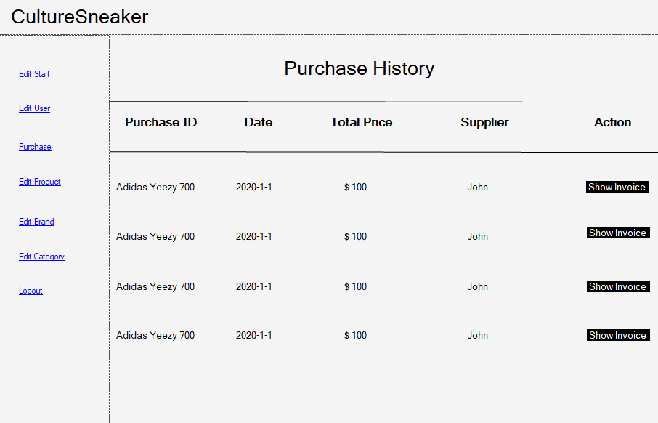

Fig 14) High Level Prototype for Purchase History Form

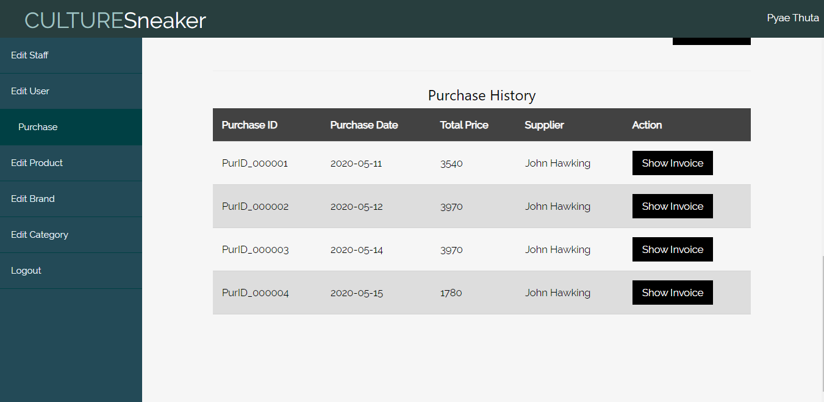

1. **Invoice Page**

Fig 15) Low Level Prototype for Invoice Page

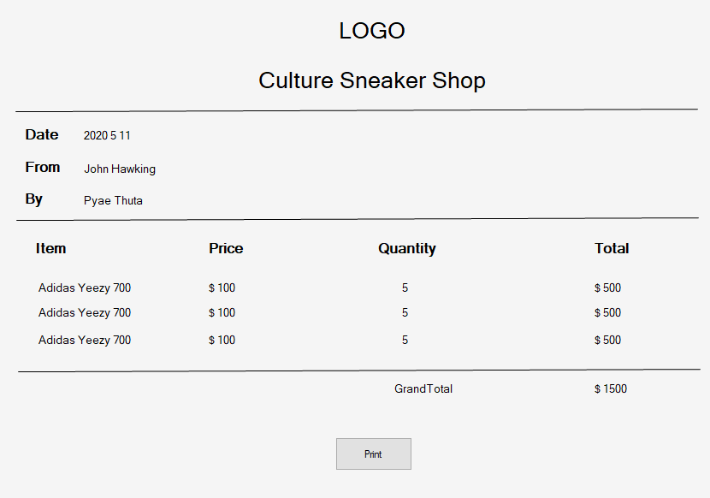

Fig 16) High Level Prototype for Invoice Page

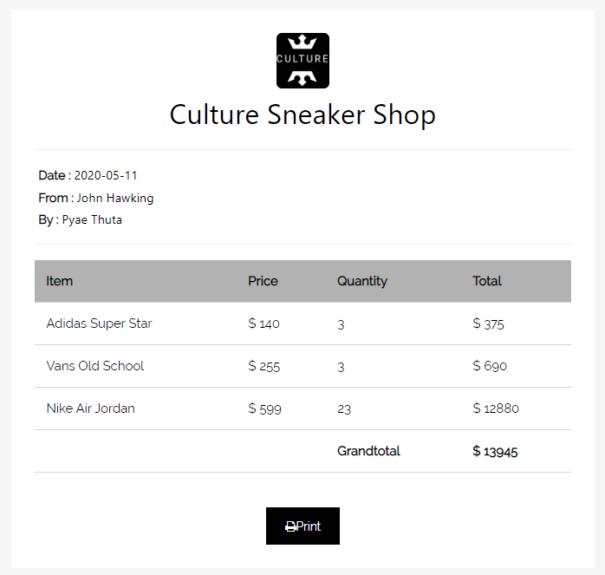

### 5.1.5 Iteration for Screen Design

#### Iteration 1

Users tell that there should be a section where logged in staff name is displayed. Therefore, a section to display staff name is added in navigation bar.

(Iteration 1) Screen Design for Staff name Display Section

**Before Iteration**

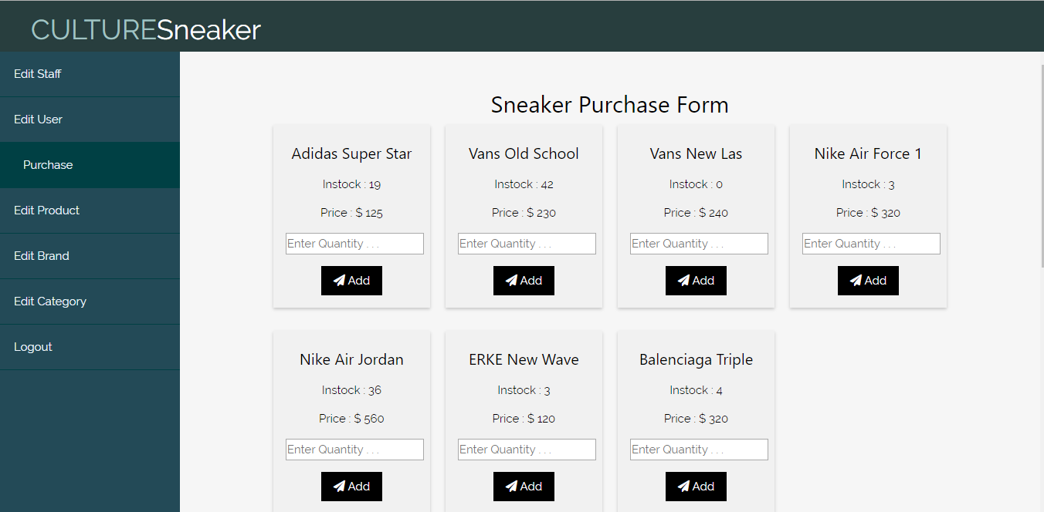

**After Iteration**

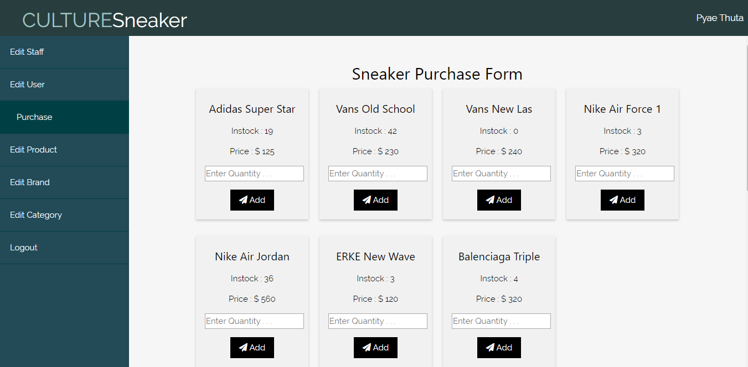

#### *Iteration 2*

Users tell that staffs should be able to see in stock quantity of sneakers before purchase them from suppliers. This can help staffs to decide how many items to purchase. So, a label that display in stock of each sneaker is added.

**(Iteration 2) Screen Design for Purchase Form**

**Before Iteration**

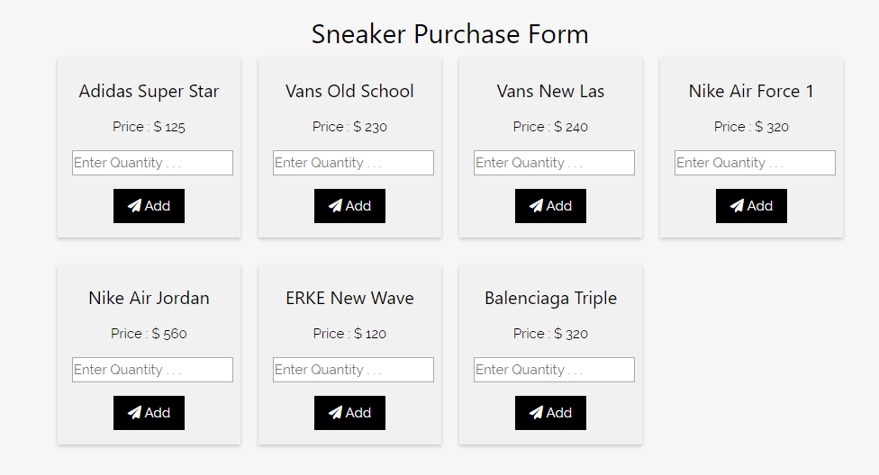

**After Iteration**

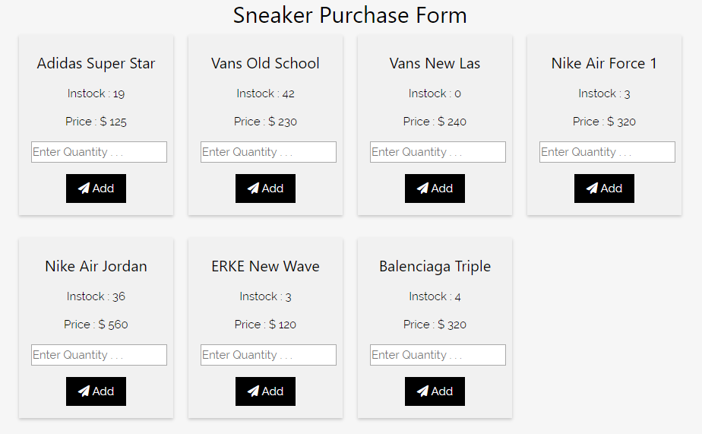

#### Iteration 3

Users tell that there should be a logo at the invoice form to obvious business’s image. Therefore, a logo is added at the top of invoice page.

(Iteration 3) Screen Design for Purchase Form

**Before Iteration**

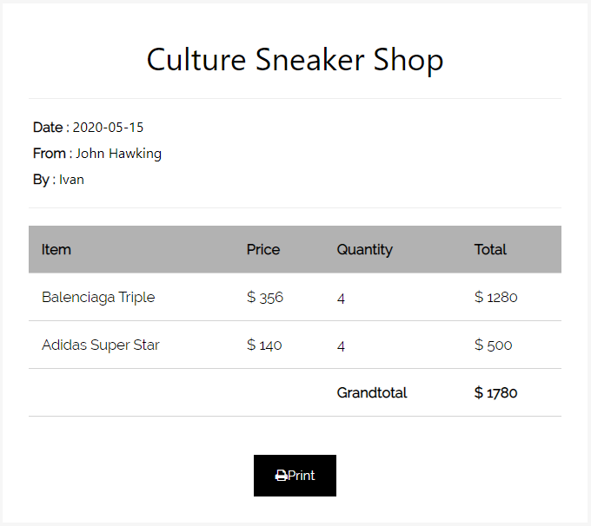

**After Iteration**

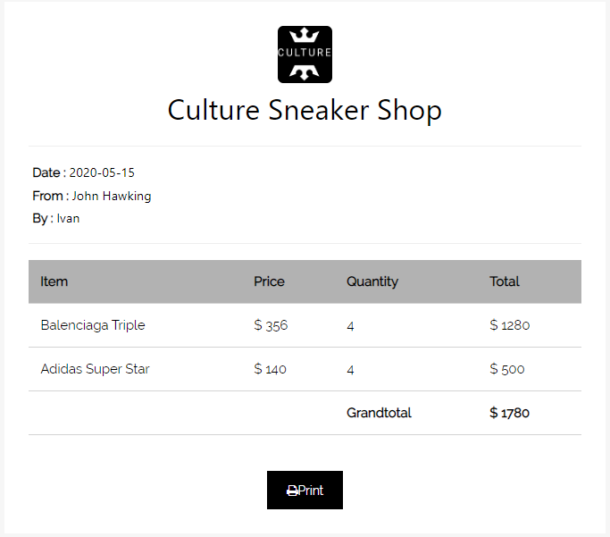

### 5.1.6 Class Diagrams

#### Initial Class Diagram

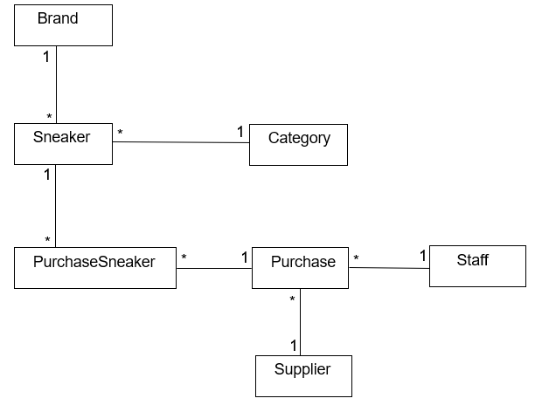

#### Detailed Class Diagram

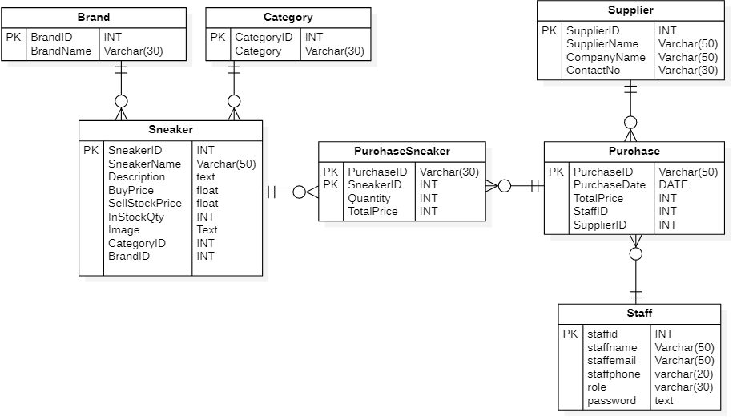

**Detail Class Definitions**

|  |  |
| --- | --- |
| **Class Name** | brand |
| **Attributes** | Brand ID, Brand Name |
| **Operation** | Record (), Cancel (), AutoID (), Update (), Delete (). |
| **Description** | The **Brand** class is used to Record brand name of the sneakers. |

For Remaining, see appendix.

### 5.1.7 Sequence Diagrams for Purchase Process



**(Fig.5.1.7.1) Sequence Diagram for registering staff and supplier**

**Sequence Diagram Description for (Fig.5.1.7.1)**

|  |  |
| --- | --- |
| Actor | Manager |
| Sequence of process | * Login to manager account and go to register page. * Manager can register staff, update staff information and delete staff. * Manager can register supplier information by filling supplier information, update supplier and delete supplier. * For every tasks, successfully message is returned. |
|  |  |



**(Fig.5.1.7.2) Sequence Diagram for purchase sneaker process**

**Sequence Diagram Description for (Fig.5.1.7.2)**

|  |  |
| --- | --- |
| Actor | Staff |
| Sequence of process | * Login to staff account and go to edit sneaker page. * Staffs can record sneakers, edit sneakers and remove sneakers. * Staffs can choose sneakers and purchase in purchase sneaker page. * Staffs can view purchase history and print invoice. |

### 5.1.8 Functional Testing

**Module 1: Registering Staff Accounts**

|  |  |  |  |
| --- | --- | --- | --- |
| Test Script | Description | Date | Tester |
| 1.1 | Test “Staff Name” text box | April 13, 2020 | Pyae Thuta |
| 1.2 | Test “Staff Email” text box | April 13, 2020 | Pyae Thuta |
| 1.3 | Test “Staff Phone Number” text box. | April 13, 2020 | Pyae Thuta |
| 1.4 | Test “Staff password”. | April 13, 2020 | Pyae Thuta |
| 1.5 | Test “Confirm Staff password”. | April 13, 2020 | Pyae Thuta |
| 1.6 | Test “Unmatched Password” Message box. | April 13, 2020 | Pyae Thuta |
| 1.7 | Test “Successful Registration”. | April 13, 2020 | Pyae Thuta |

|  |  |  |  |  |
| --- | --- | --- | --- | --- |
| **Unit Test 1** | | **Test Case:** Testing Staff Registering process in Staff Edit Form. | **Designed by:** Pyae Thuta | |
| **Data Source:** Staff Register Page | | **Objective**: To test “Staff Name” test box. | **Tester**: Pyae Thuta | |
| **Test Case** | **Description** | **Test Procedure** | **Expected Result** | **Actual Results** |
| 1.1 | Testing if alert is shown when “Staff Name” Text box is not filled with data. | “Register” button is clicked when “Staff Name” text box is not filled with data. | Show ‘Please fill out this field’ message. | See Fig.1.1.2 |

Before Testing

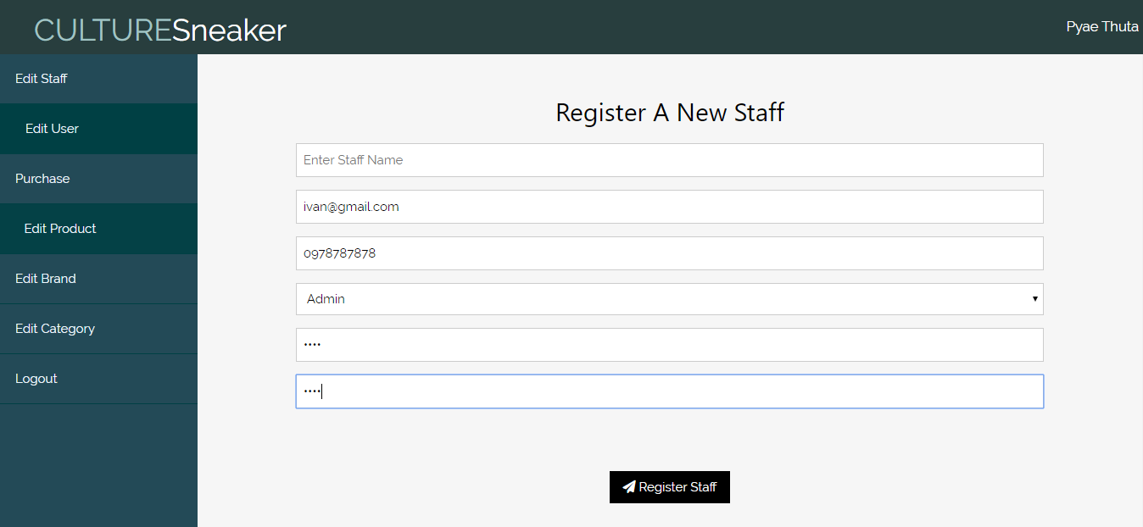

Fig.1.1.1

**After Testing**

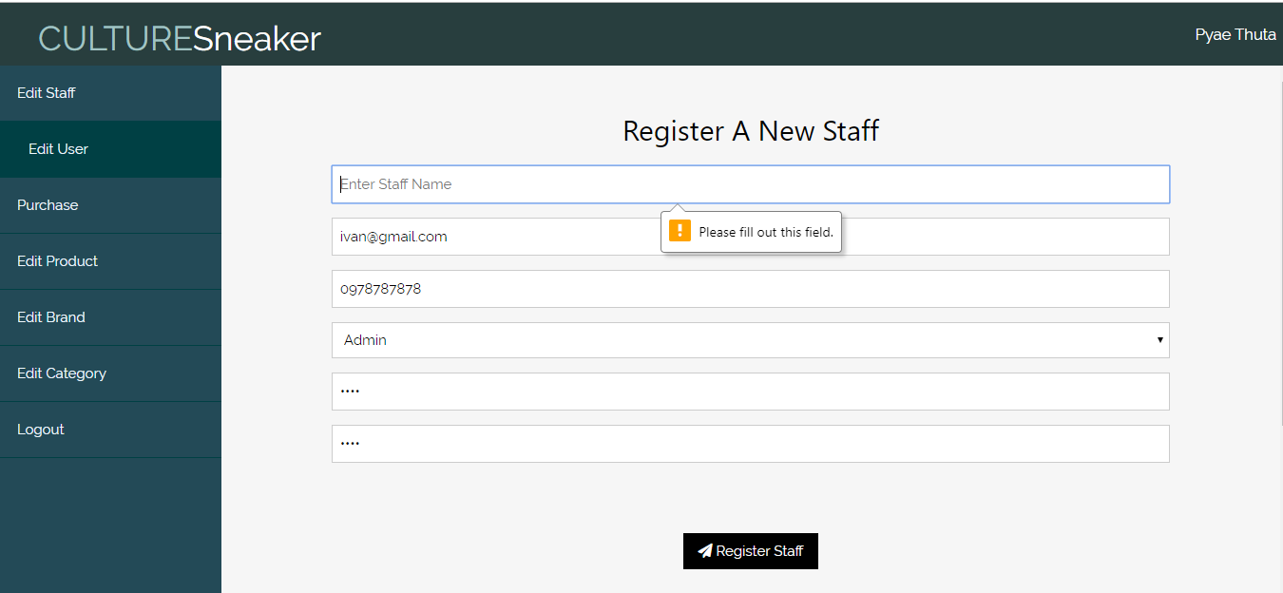

Fig.1.1.2

For remaining, see Appendix

### 5.1.9 Usability Testing

#### Visibility of System Status

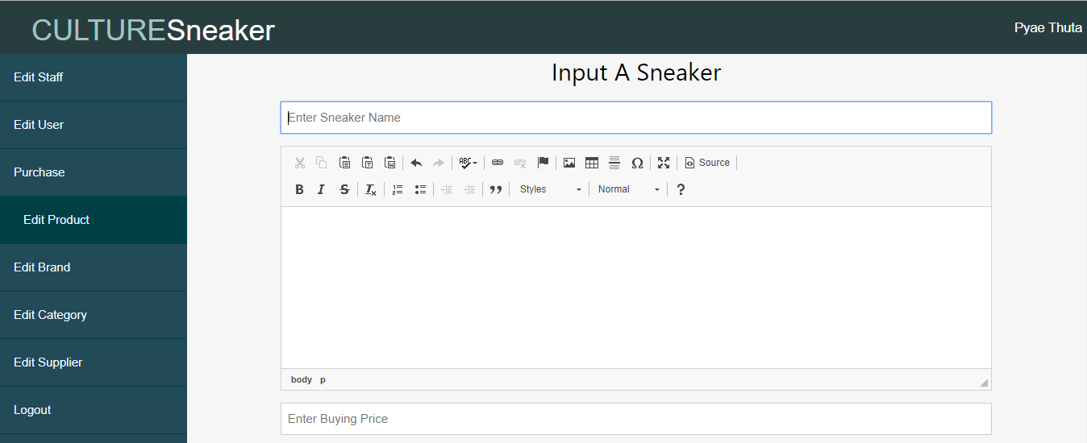

Different Tab color.

Text box is with different Color

(Fig.5.1.8.1)

The texts boxes’ border color will be changed if users focus on it. Moreover, There is a different color and different style tab which is the tab for current page. So, users can easily realize current page.

#### Match between System and Real World

Usage of Logo

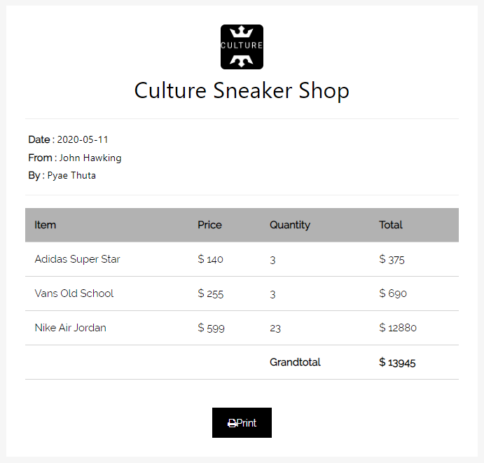

Simple Design

(Fig.5.1.8.2)

The invoice form provides users with simple design that is easy to understand. This style of invoice is also friendly to most users and users are able to print the invoice page.

#### Aesthetic and Minimalist Design

The use of icons

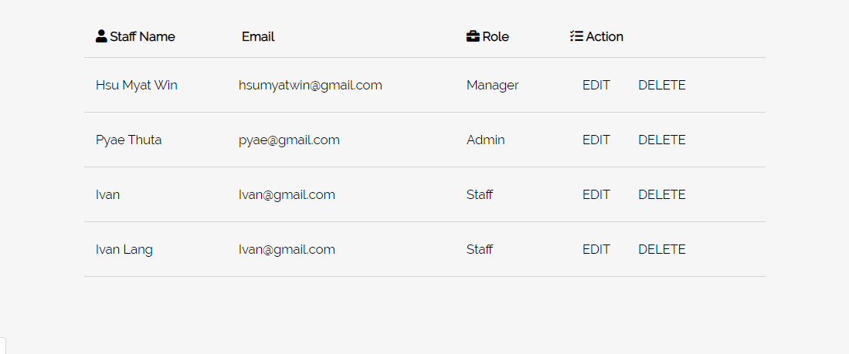

(Fig.5.1.8.3)

There are the use of relavent icons at the display tables. The language used is normal and easy to understand for being more user friendly. These things helps in website’s ***Aesthetic and Minimalist Design.*** *See**(Fig.5.1.8.3)*

#### Consistency and standard

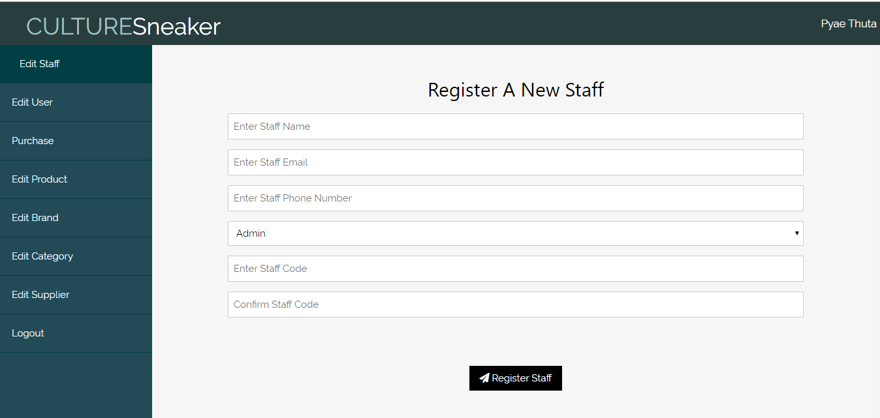

Light grey Background with dark green navigation.

(Fig.5.1.8.4)

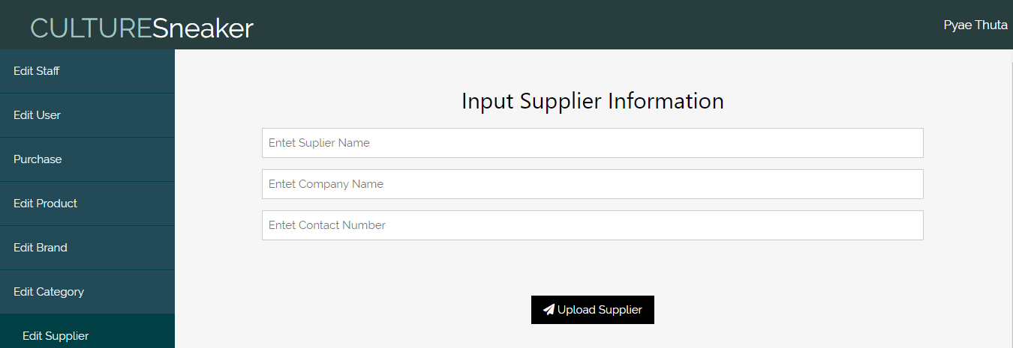

Light grey Background with dark green navigation.

(Fig.5.1.8.5)

All admin pages have same background color and same navigation bar. All text boxes and button in admin page have same design. The font-size of heading, links, and text boxes are in relaevent size helping the website’s ***Consistency and Standard***.

(See Fig.5.1.8.4 & Fig.5.1.8.5 )

***Error Prevention***

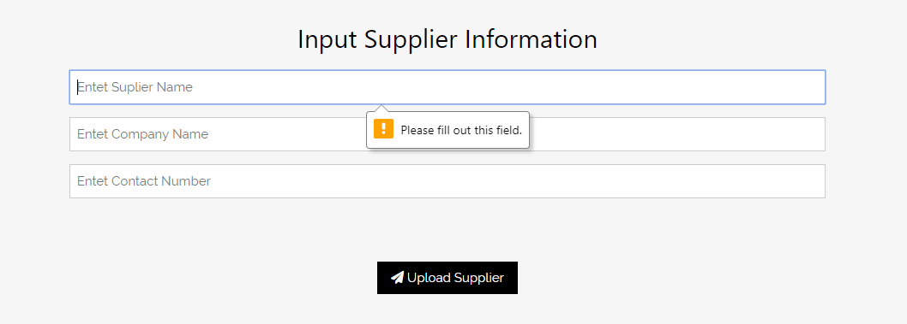

Preventing Null Value.

(Fig.5.1.8.6)

All neccessary text boxes in website have “Required” function which prevent users’ error or recording NULL value of data.

#### Help and Documentation



Text boxes having guidelines.

(Fig.5.1.8.6)

All text boxes have respective palceholders which guide users what data to input. Users may not be confused about the text boxes because of these placeholders making website’s ***Help and Documentation.***

### 5.1.10 iteration for Usability Testing

**Iteration 4**

**Iteration for Aesthetic and Minimalistic design**

Users tell that the display tables are too simple that they are not interesting. Therefore, relevant icons are added to the table header. These icons make table more aesthetic.

Before Iteration

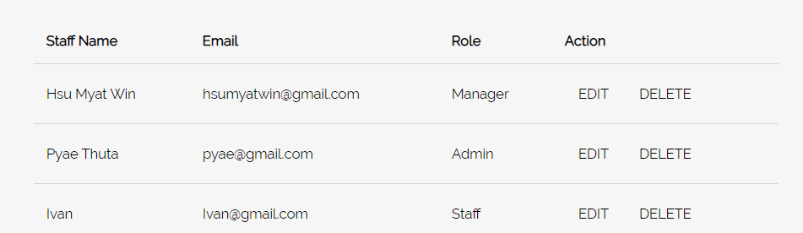

After Iteration

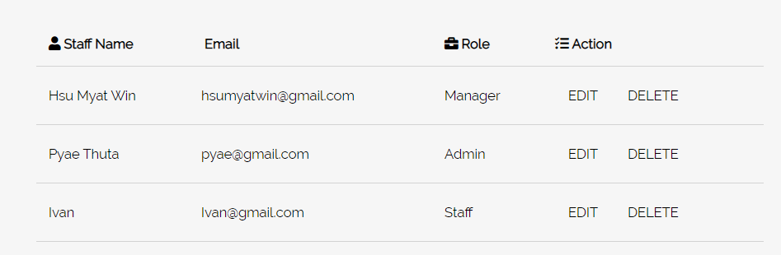

### 5.1.10 Time Box Summary

Time box (1) is for purchasing sneakers form different suppliers. It takes 11 days to complete coding, testing and diagrams for time box 1. Iterations for screen design and usability are done according to users’ suggestions. Use case diagrams and class diagrams are included for time box (1). Coding takes only 3 days because most of the page have similar function but purchase form has a different style of UI. During coding, the permission accesses had to be taken carefully. Coding for purchase cart has most problems since it has a unique style of display and function. Time box (1) can be better if there is a hashing method in staff password. But there is no hashing method since the time is not enough.

## 5.2 Time-box 2: Managing Order Process Time-box Development

### 5.2.1 Project Plan for Time Box 2

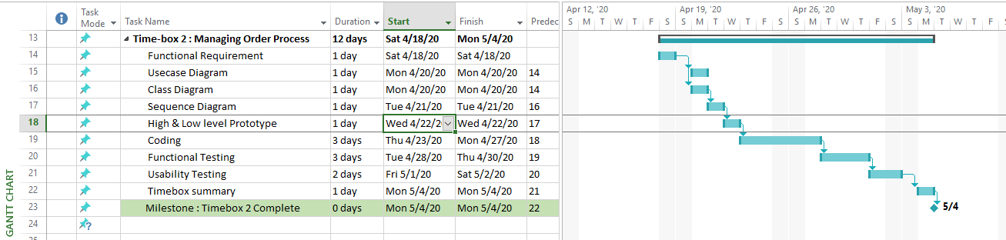

Project plan for Time-box (2) start April 18, 2020 and end at May 4, 2020. ( 12 days)

### 5.2.2 Functional Requirements

**Manage Order Process**

**Manage Customer**

* Register Customer
* Update Customer
* Delete Customer
* View Customer

**Manage Brand**

* Register Brand
* Update Brand
* Delete Brand
* View Brand

**Manage Category**

* Register Category
* Update Category
* Delete Category
* View Category

**Manage Sneaker**

* Register Sneaker
* Update Sneaker
* Delete Sneaker
* Search Sneaker

**Manage Order**

* Record Order
* Confirm Order
* Delete Order

### 5.2.3 Use Case Diagram



**Use Case Description**

|  |  |
| --- | --- |
| **Use Case Name** | Register Account |
| **Actor** | Customer |
| **Flow of Event** | * Fill information in Register Page and click register button. |

For remaining, see Appendix.

### Screen Design

1. **Customer Register Form**

Fig 1) Low Level Prototype for Customer Registration

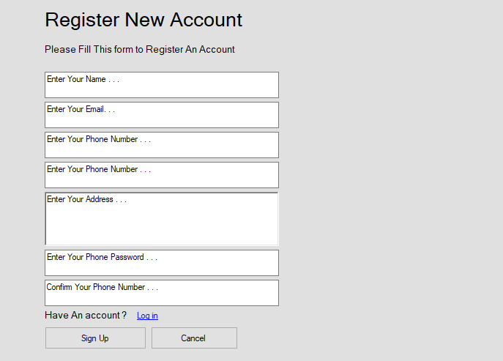

Fig (2) High Level Prototype for Customer Registration

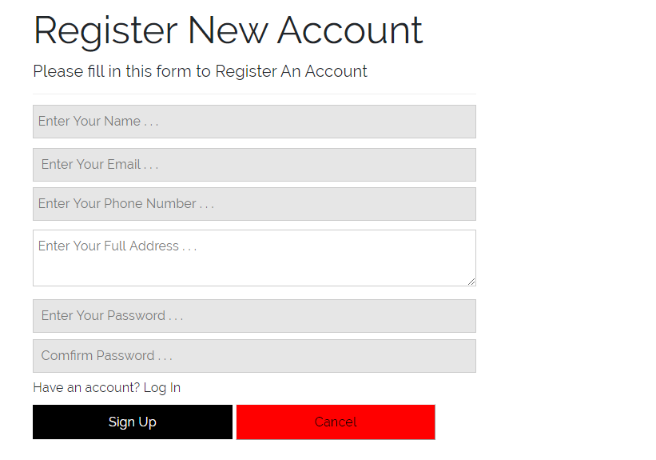

1. **Customer Login Form**

Fig (3) Low Level Prototype for Customer Login Form

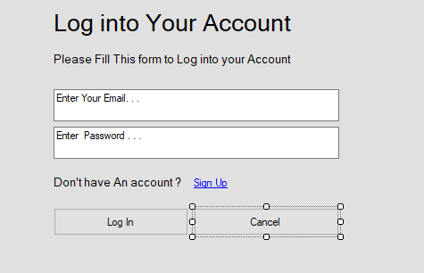

Fig (4) High Level Prototype for Customer Login form

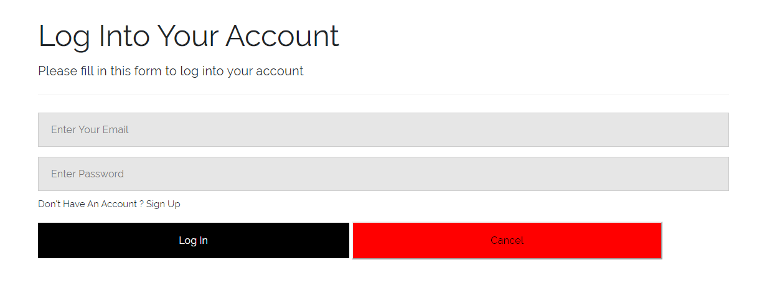

**Customer Home Page**

Fig (5) Low Level Prototype for Customer Home Page

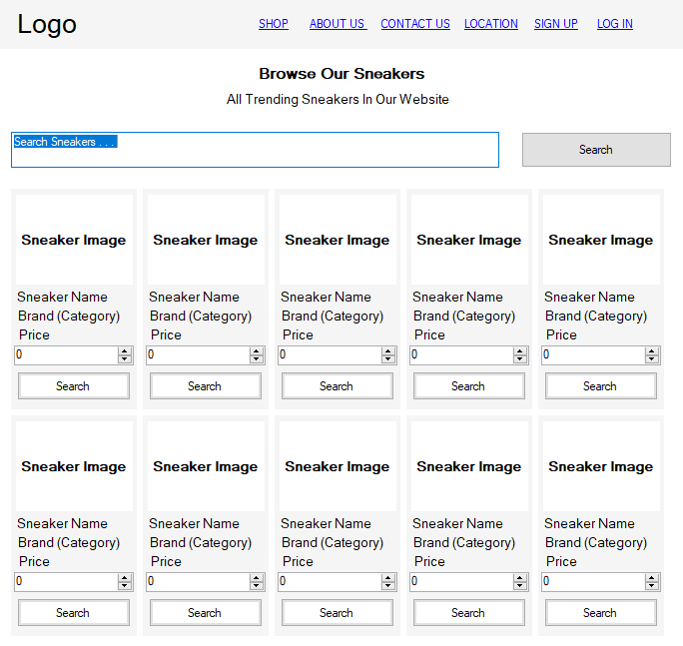

Fig (6) High Level Prototype for Customer Home Page

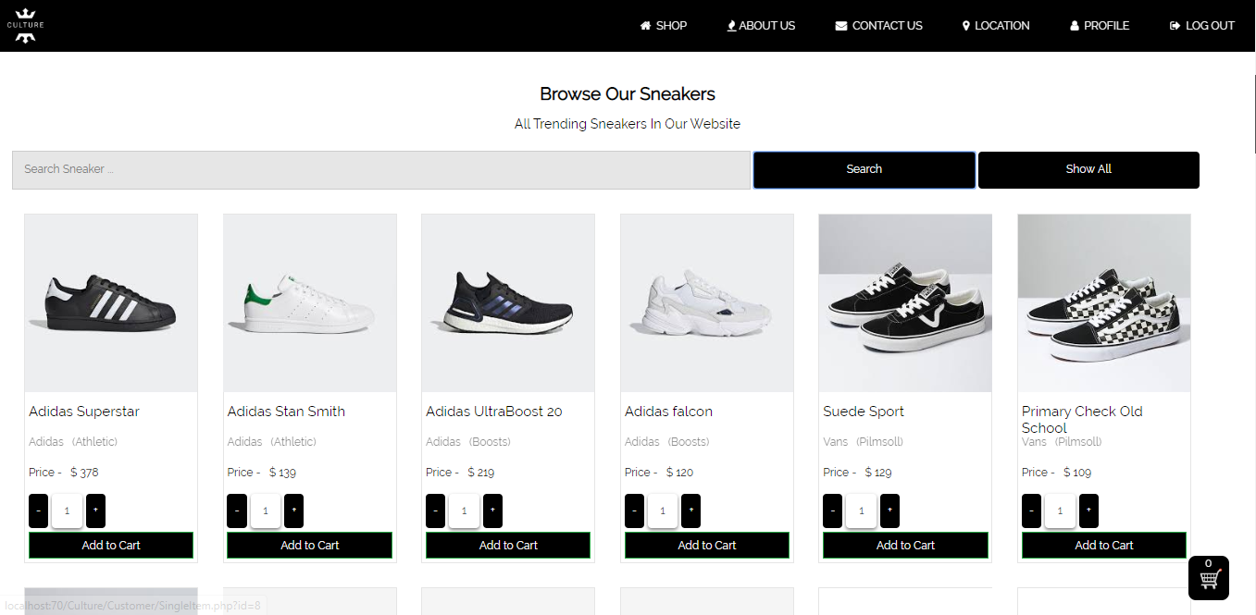

1. **Shopping Cart Page**

Fig (7) Low Level Prototype for Shopping Cart Page

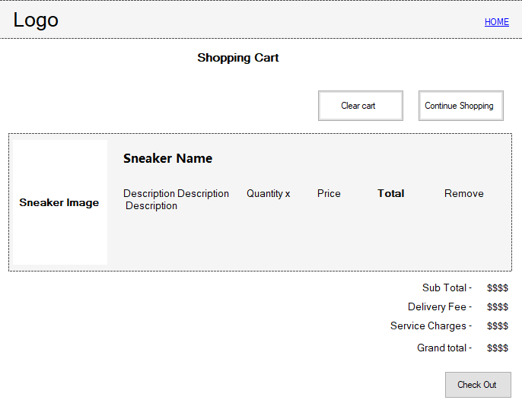

Fig (8) High Level Prototype for Shopping Cart Page

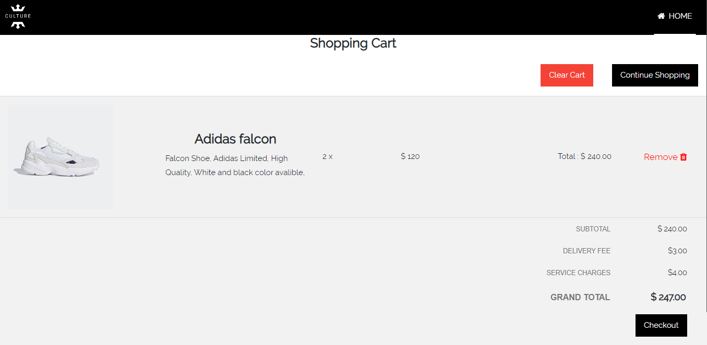

1. **Check Out Page**

Fig (9) Low Level Prototype for Check Out Page

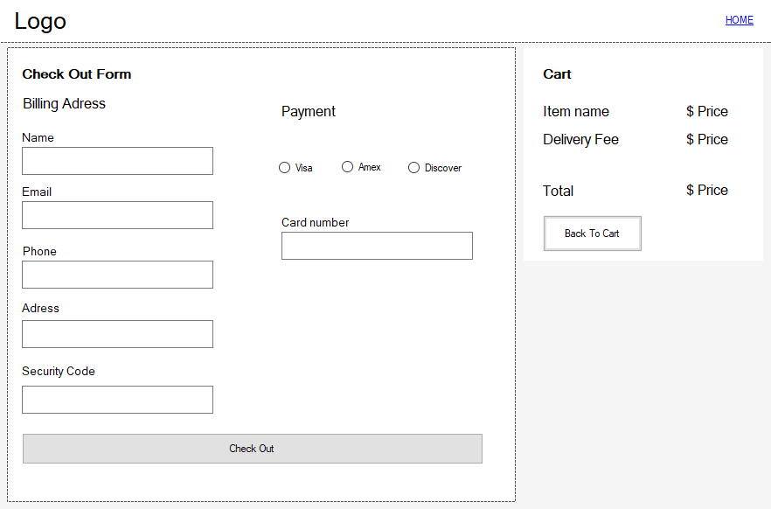

Fig (10) High Level Prototype for Check Out Page

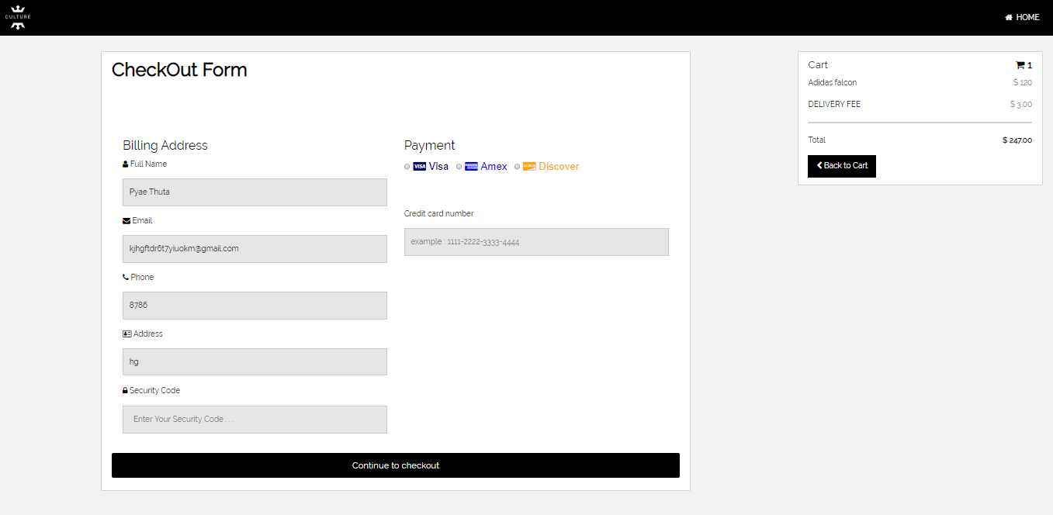

### 5.2.5 Iteration for Screen Design

#### Iteration 1

Users tell that password confirmation box is required in user register page. So, password confirmation text box is added under password text box. A password validation script is also added to User register page.

(Iteration 1) Screen Design for Customer Register Form

**Before Iteration**

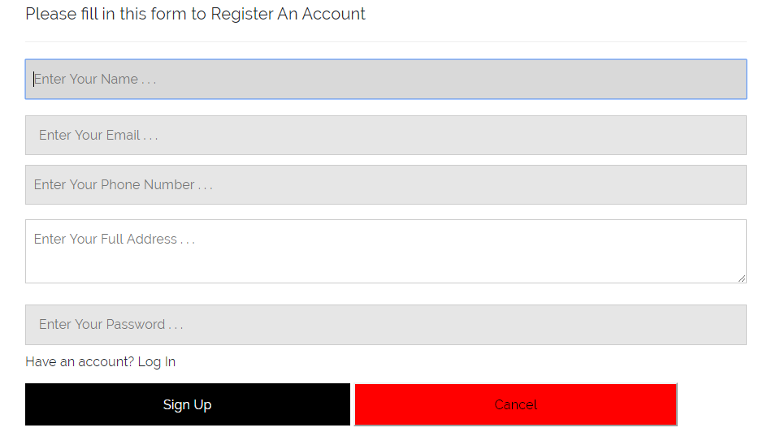

**After Iteration**

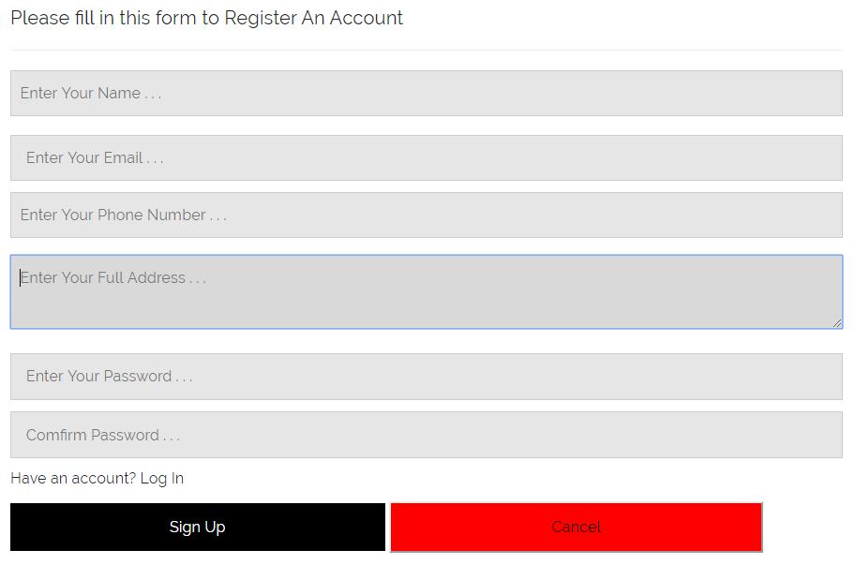

#### Iteration 2

Users want a logo at the navigation bar of Home page. So, a logo for the business is drawn and added to the navigation bar. A link button to “About Us” section is also added in the banner section.

(Iteration 2) Screen Design for Home page

**Before Iteration**

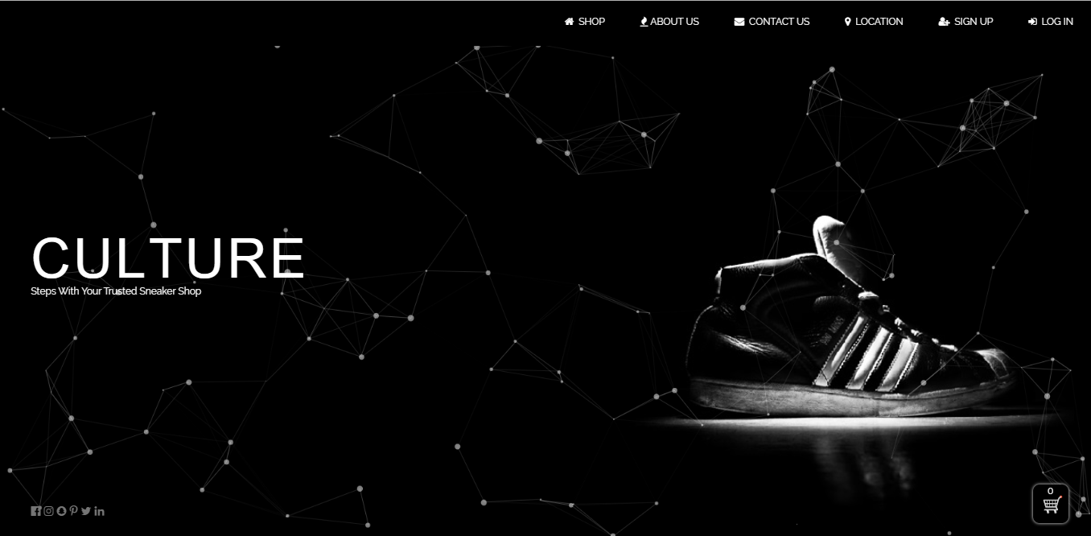

**After Iteration**

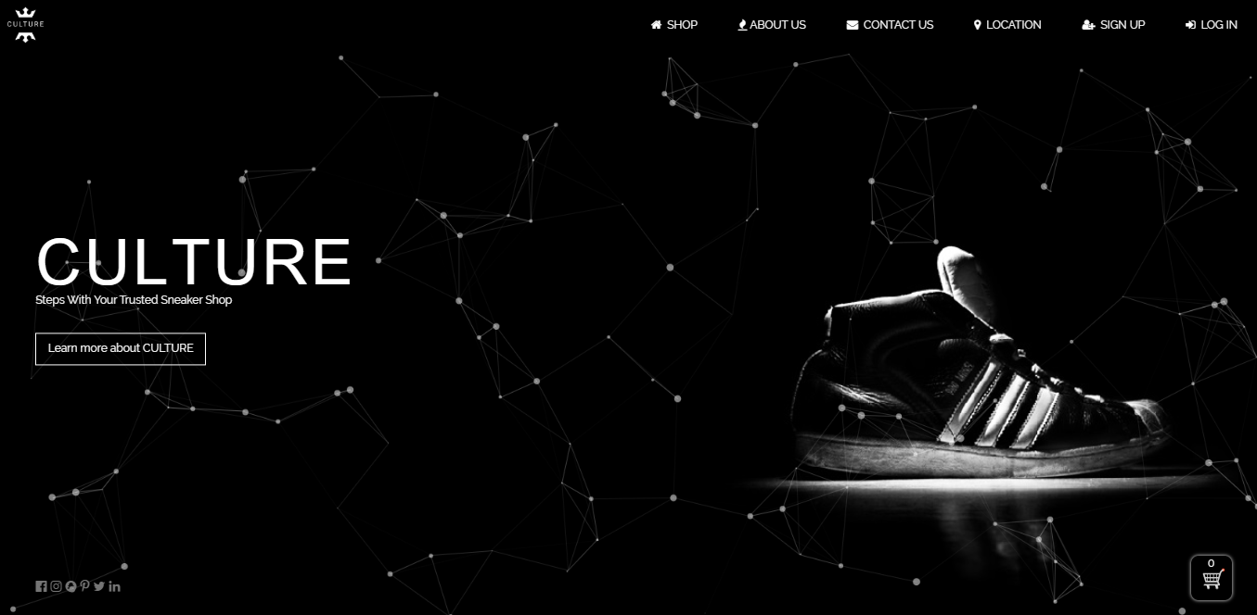

#### *Iteration 3*

Users tell there should be a section which display all the products added to the cart in the check out page. So, a section that display chosen sneakers is added in the checkout page.

(Iteration 3) Screen Design for Check out form

**Before Iteration**

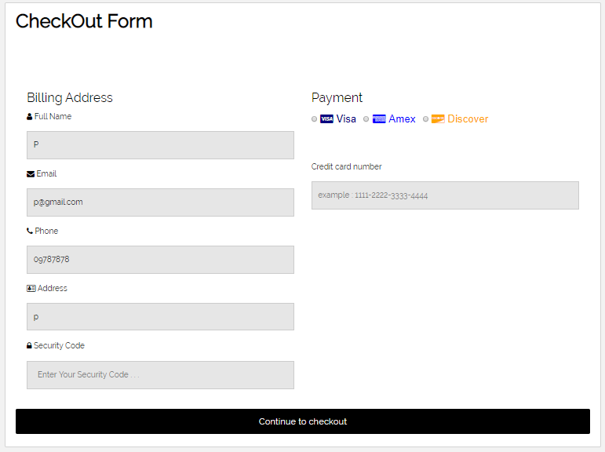

**After Iteration**

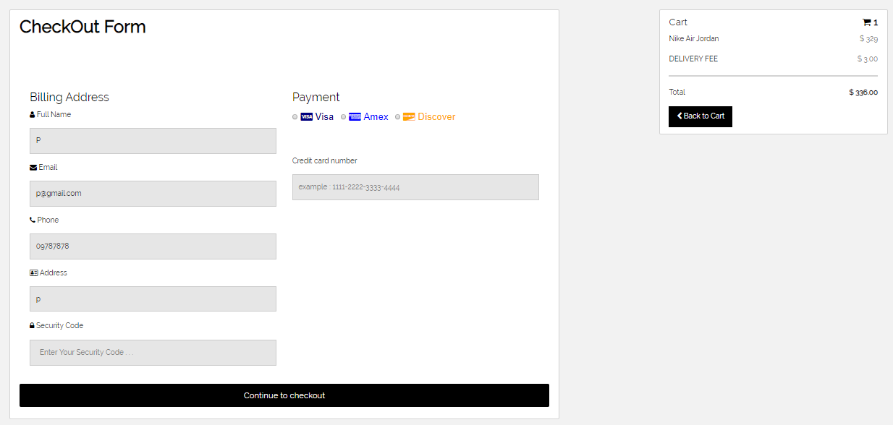

### 5.2.6 Class Diagrams

#### Initial Class Diagram

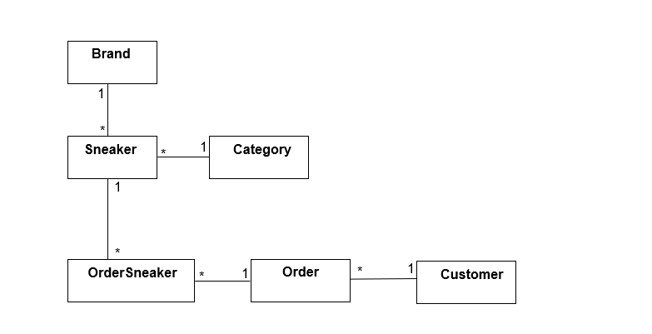

#### Detailed Class Diagram

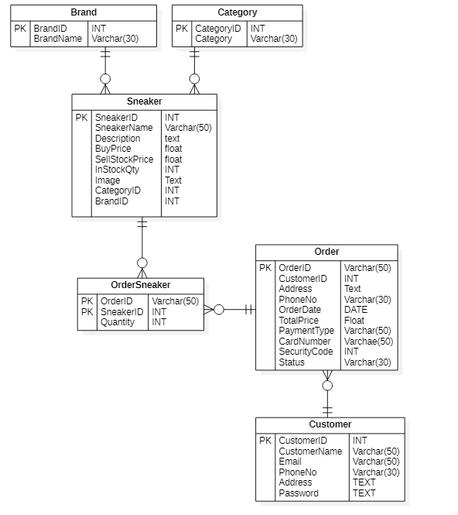

**Detail Class Definitions**

|  |  |
| --- | --- |
| **Class Name** | brand |
| **Attributes** | Brand ID, Brand Name |
| **Operation** | Record (), Cancel (), AutoID (), Update (), Delete (). |
| **Description** | The **Brand** class is used to Record brand name of the sneakers. |

For remaining, see Appendix.

### 5.2.7 Sequence Diagram for Order Sneaker Process



**Sequence Diagram Description**

|  |  |
| --- | --- |
| Actor | Customer |
| Sequence of process | * Login to customer account and reach home page. * Add sneakers to cart. Customers can also clear cart after choosing items. * Fill payment information and order sneakers. * View purchase history in profile and print voucher. |

### 5.2.8 Functional Testing

**Module 8: Register Customer Account**

|  |  |  |  |
| --- | --- | --- | --- |
| Test Script | Description | Date | Tester |
| 8.1 | Test “User Name” text box | April 28, 2020 | Pyae Thuta |
| 8.2 | Test “Email” text box | April 28, 2020 | Pyae Thuta |
| 8.3 | Test “Phone Number” text box. | April 28, 2020 | Pyae Thuta |
| 8.4 | Test “Address” text box. | April 28, 2020 | Pyae Thuta |
| 8.5 | Test “Password” text box. | April 28, 2020 | Pyae Thuta |
| 8.6 | Test “Password Validation” script. | April 28, 2020 | Pyae Thuta |
| 8.7 | Test “Confirm Password” text box. | April 28, 2020 | Pyae Thuta |
| 8.8 | Test unmatched password. | April 28, 2020 | Pyae Thuta |
| 8.9 | Test Successful registering. | April 28, 2020 | Pyae Thuta |

|  |  |  |  |  |
| --- | --- | --- | --- | --- |
| **Unit Test 1** | | **Test Case:** Testing Customer Registering process in Register Page. | **Designed by:** Pyae Thuta | |
| **Data Source:** Register Page | | **Objective**: To test “User Name” test box. | **Tester**: Pyae Thuta | |
| **Test Case** | **Description** | **Test Procedure** | **Expected Result** | **Actual Results** |
| 8.1 | Testing if alert is shown when “User Name” Text box is not filled with data. | “Sign Up” button is clicked and “User Name” Text box is not filled with data. | Show ‘Please fill out this field’ message. | See Fig.8.1.2 |

Before Testing

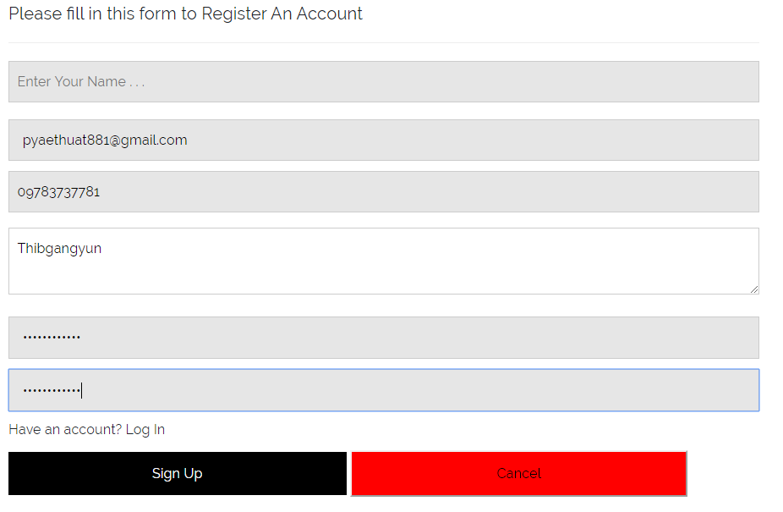

Fig.8.1.1

After Testing

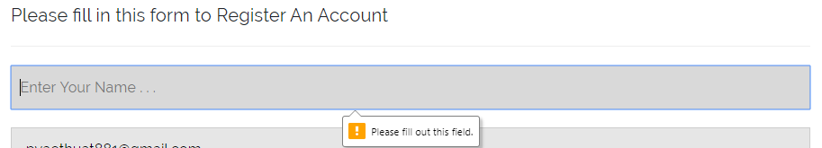

Fig.8.1.2

For remaining, see Appendix.

### 5.2.9 Usability Testing

#### Visibility of System Status

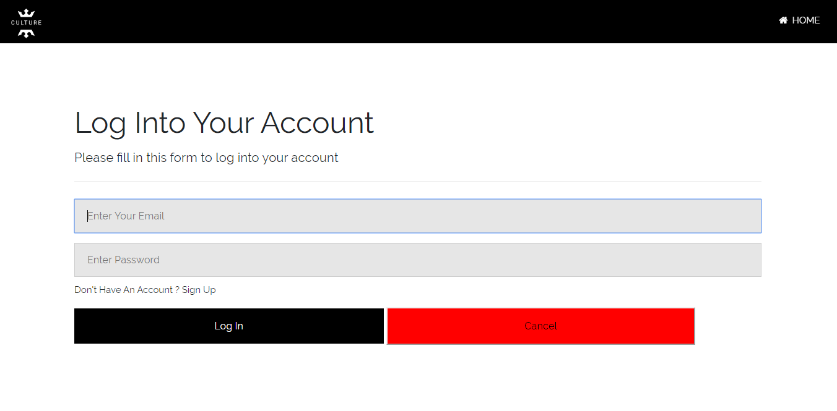

Can see text box with different color on focus.

Fig.5.1

Whenever users focus on a text box, the background color of the text box will change and the text box will have a border which help website’s greater visibility. *See (Fig.5.1)*

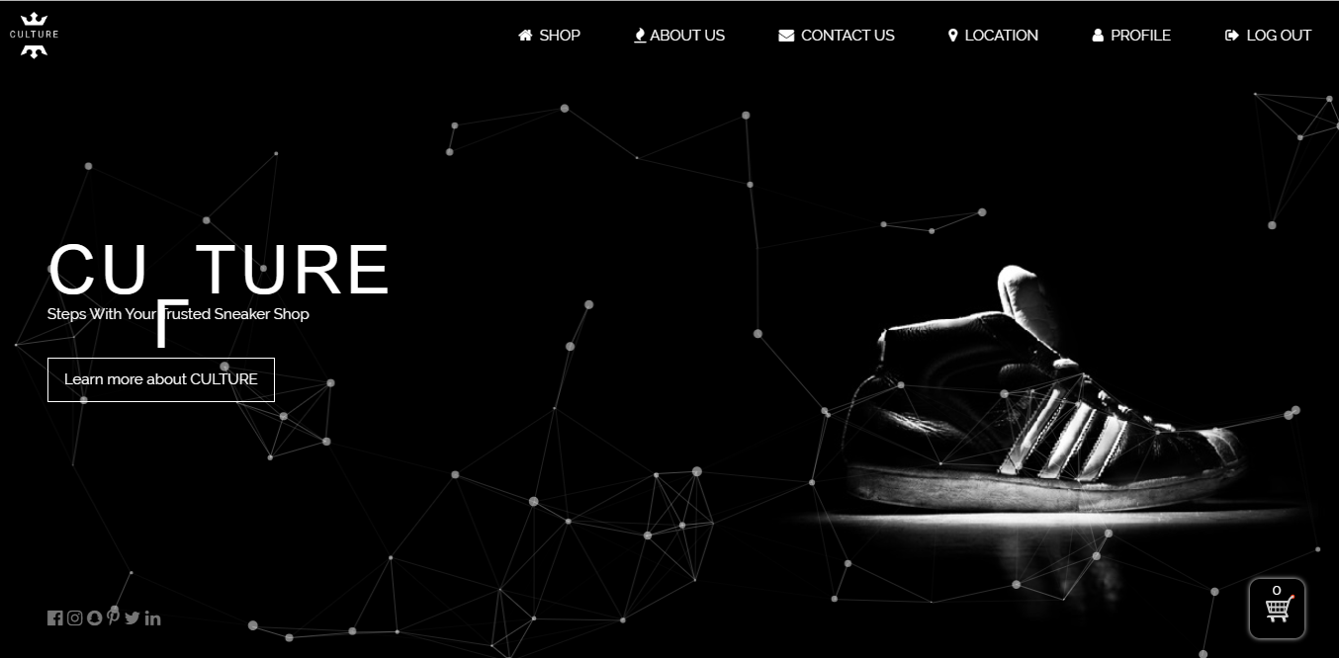

Can see website’s main purpose and all sections in banner.

Fig.5.2

At the banner section of the home page, there is the background image that obviously indicate the purpose of website. There are also links in navigation bar showing all the sections in the website. There is also shopping cart icon indicating the website in on the point of sale. Users can know the sections of the website, the processes of the website, logo and purpose of the website just looking at the banner section. *See (Fig.5.2)*

#### Match between System and Real World

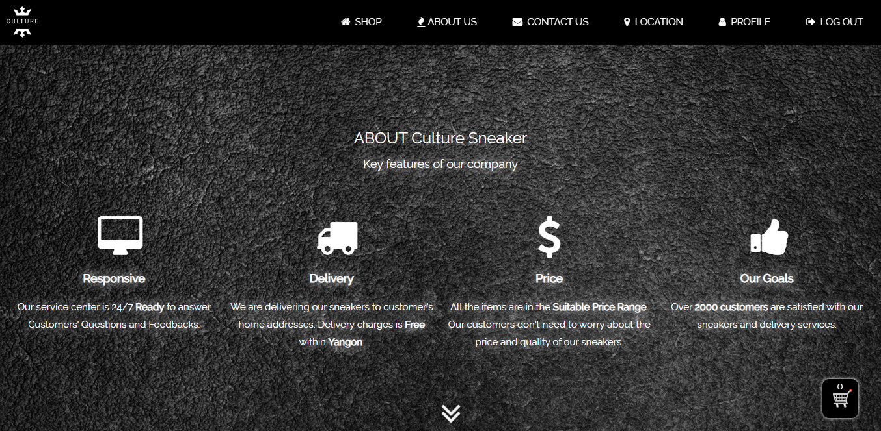

Can see Logo and simple description

**Fig.5.3**

These comparison style make user to understand easily

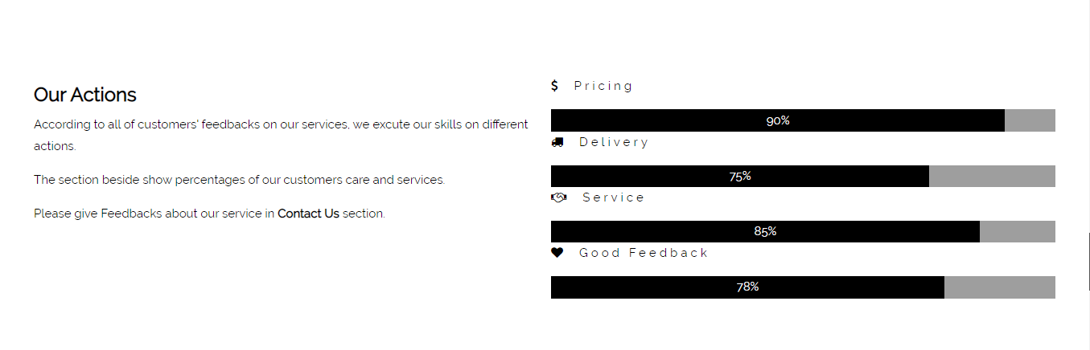

**Fig.5.4**

At the “About Us” section in home page, there are icons and descriptions for the information about the website. The language used is normal and easy to understand making the website familiar to customers. *See (Fig.5.3)*

There is also a section showing the actions and services of website. The rating lines make the about section more interesting and more understandable. *See (Fig.5.4)*

#### Aesthetic and Minimalist Design

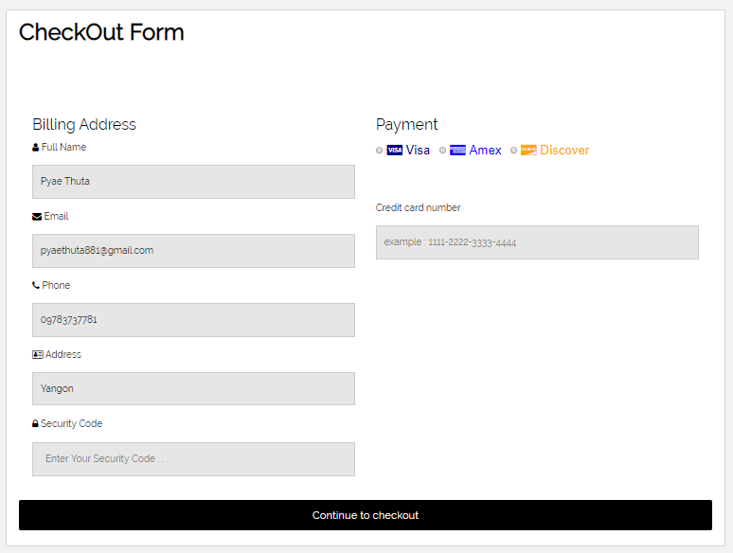

Can see the usage of icons

These card icons make users to know which card to be used.

**Fig.5.5**

There are usages of relevant icons before every text box making the webpage more aesthetic. When user chooses card to make payment, there are not only card names but also card logos to prevent wrong choice of card.

#### Consistency and standard

White back ground with black banner and light grey section

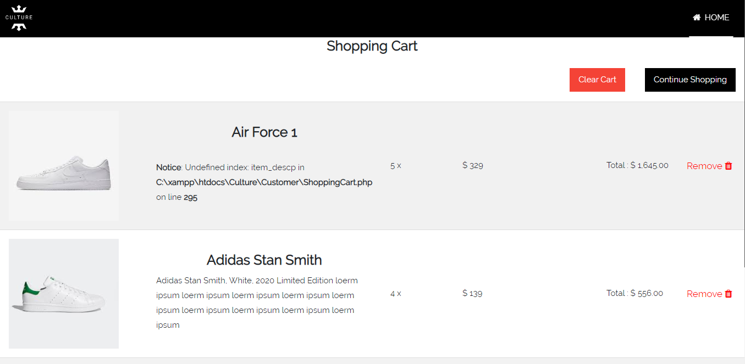

**Fig.5.5**

White background with black navigation and light grey section



**Fig.5.6**

Most of the pages are in the black and pure white color. All text boxes are with light grey background color and black text color. Users can see all the interface design of pages are uniform. Heading, links and text boxes have respective font sizes. Texts in all pages are in the font style of “RALEWAY, SANS-SERIF”. *See (Fig.5.5 & Fig.5.6)*

#### Error Prevention

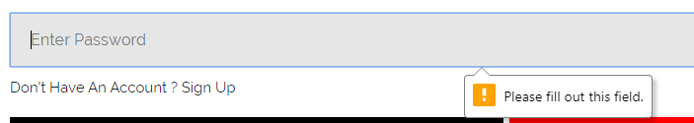

Fig.5.7

Every necessary text boxe in website has (required) function that can prevent users from making error of Null Data.

#### Help and Documentation



Documentations in this section help users to know about website and processes of website.

### 5.2.10 Iteration for Usability Testing

**Iteration 4**

Users tell that there should be use of icons before the text boxes in Check out form. So, appropriate uses of icons are added to the text boxes of Check out form. This helps website’s Aesthetic and Minimalist Design.

**(Iteration 4) Iteration For Aesthetic and Minimalist Design**

**Before Iteration**

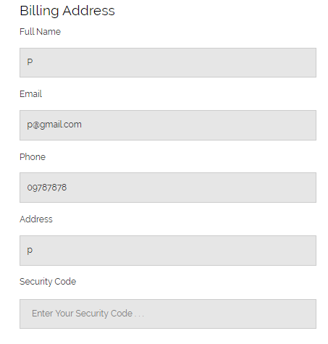

**After Iteration**

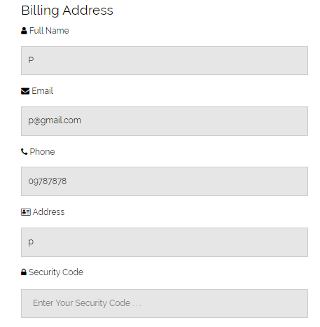

**Iteration 5**

Users tell that there should be error prevention for Null Data. So, “REQUIRED” method is added to every necessary text box in website.

**(Iteration 5) Iteration For Error Prevention**



### 5.2.11 Time box Summary

Time box (2) takes totally 16 days for coding, testing and diagrams. Time box (2) is for managing customer order process. Coding takes most of the time for time box (2). Diagrams include Use case diagrams, initial and detail class diagram and sequence diagrams. There were some problems when coding shopping cart because it is more complex than other section. During had to stop for a while because of some server error. Most text boxes have REQUIRED function to prevent users’ error. The UI design of customer home page is tried to be friendly and aesthetic for customers. Iterations for screen design and usability are done according to users’ recommendation. Functional and non-functional requirements are tested carefully because these pages will be directly faced with users.

### 

## Time-box (3): Managing Delivery Time-box Development

### 5.3.1 Project Plan for Time Box 3

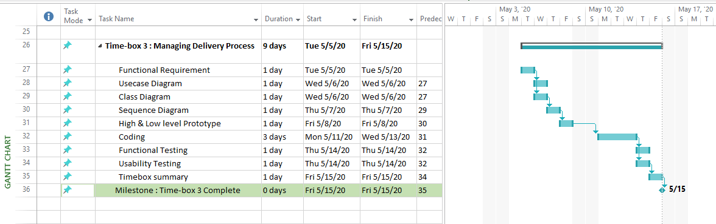

Project plan for Time-box (3) start May 5, 2020 and end at May 15, 2020. (9 days)

### 5.3.2 Functional Requirements

**Manage Delivery Process**

**Manage Staff**

* Register Staff
* Update Staff
* Delete Staff
* View Staff

**Manage Order**

* View Order
* Remove order

**Manage Delivery**

* Confirm Delivery

### 5.3.3 Use Case Diagram



**Use Case Description**

|  |  |
| --- | --- |
| **Use Case Name** | Order Sneaker |
| **Actor** | Customer |
| **Flow of Event** | Choose sneakers to the cart. Fill payment information in Check out page and click “Check out Now” button to order. |

For remaining, see Appendix.

### 5.3.4 Screen Design

Fig (1) Low Level Prototype for Edit Order Page

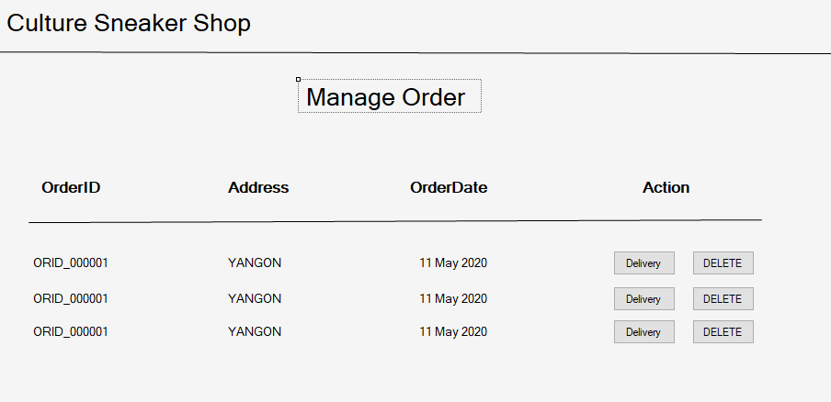

Fig (2) High Level Prototype for Edit Order Page

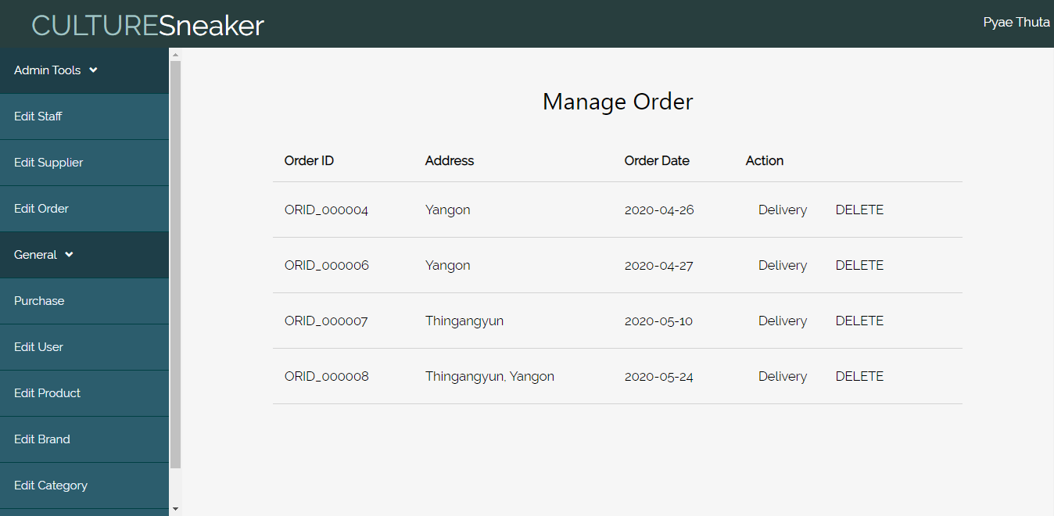

Fig (3) Low Level Prototype for Manage Delivery Page

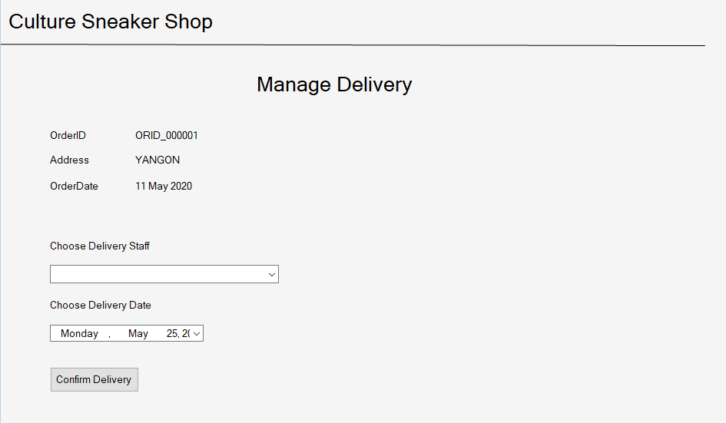

Fig (4) High Level Prototype for Manage Delivery Page

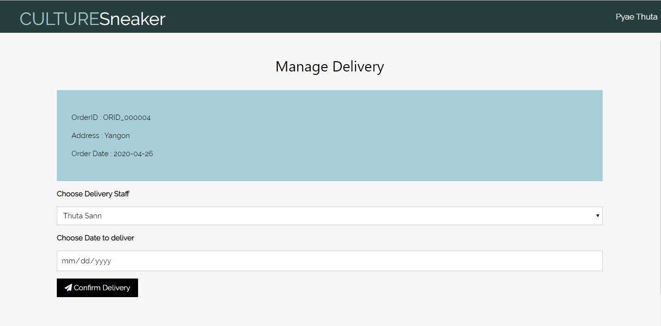

### 5.3.5 Iteration for Screen Design

#### Iteration 1

Admins tell that there should be a button for manager to remove or cancel the order if order is not acceptable. So, DELETE button is added to the table that display orders.

Before Iteration

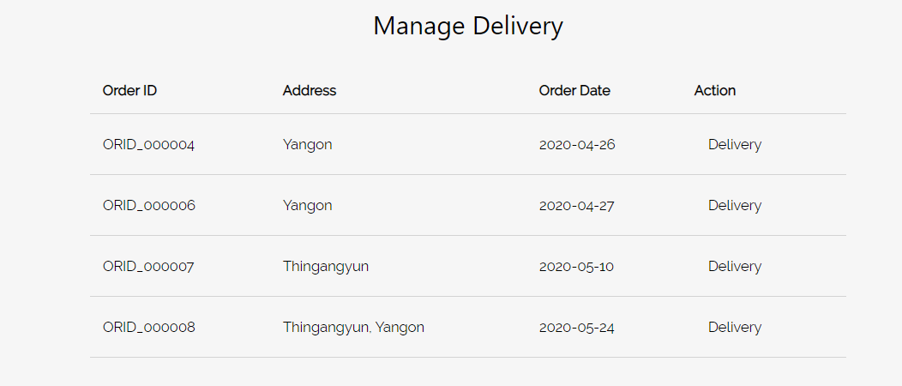

After Iteration

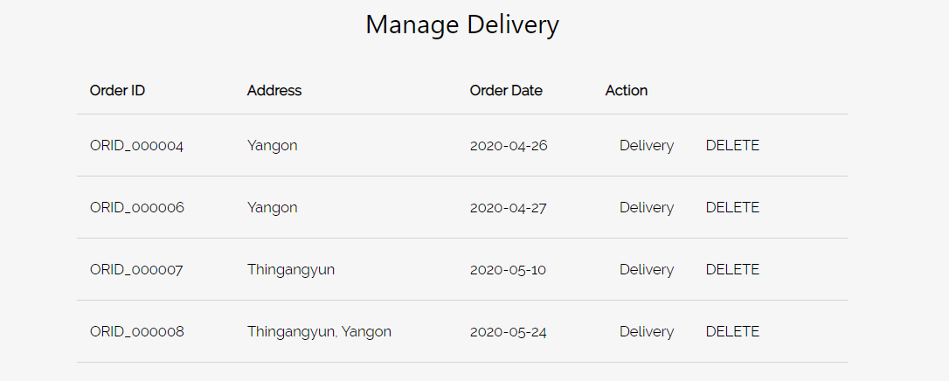

#### Iteration 2

Users tell that there should be a section that display information of order in the manage delivery page. Therefore, a section displaying order information is added to the Delivery page in different background color.

Before Testing

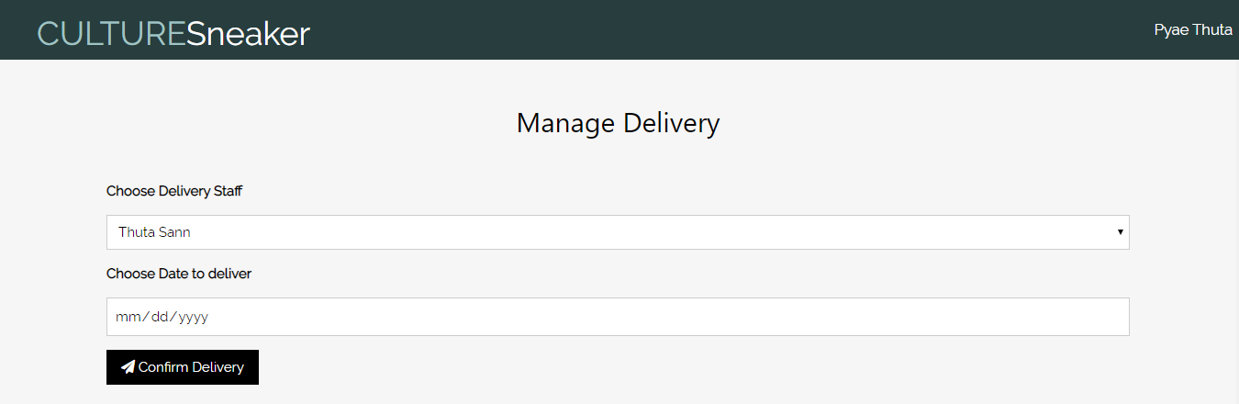

After Iteration

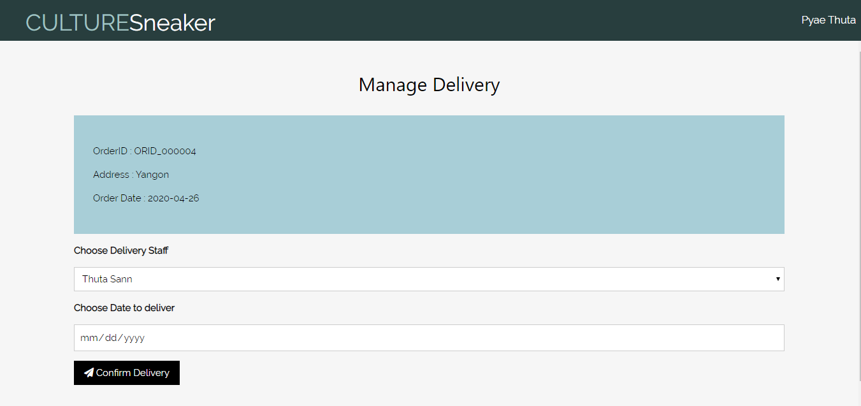

### 5.3.6 Class Diagram

#### Initial Class Diagram

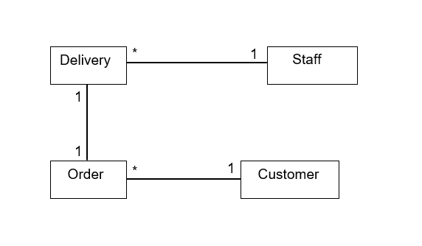

#### Detailed Class Diagram

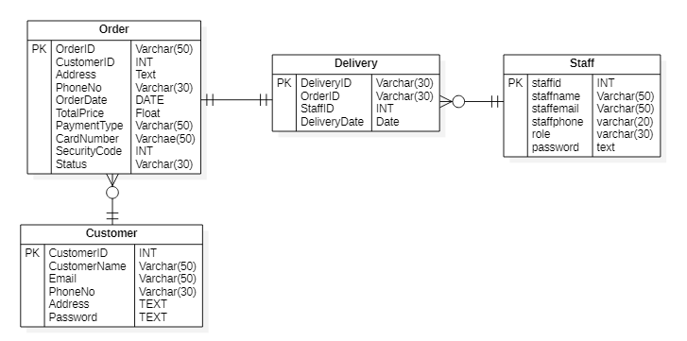

**Detail Class Definitions**

|  |  |
| --- | --- |
| **Class Name** | Delivery |
| **Attributes** | Delivery ID, Order ID, Staff ID, Delivery Date |
| **Operation** | Record (), View () |
| **Description** | The **Delivery** class is used to record delivery information when manager confirm delivery. |

For remaining, see Appendix.

### 5.3.7 Sequence Diagram for Manage Delivery Process



**Sequence Diagram Description**

|  |  |
| --- | --- |
| Actor | Manager |
| Sequence of process | * Login to staff account and reach manage order page. * Manager can delete order or manage delivery for order. * Choose delivery staff and assign delivery for order. |

### 5.3.8 Functional Testing

**Module 15: Edit Order Process**

|  |  |  |  |
| --- | --- | --- | --- |
| Test Script | Description | Date | Tester |
| 15.1 | Test “Delete” button. | May 13, 2020 | Pyae Thuta |
| 15.2 | Test “Delivery” button. | May 13, 2020 | Pyae Thuta |

Test Script (1)

|  |  |  |  |  |
| --- | --- | --- | --- | --- |
| **Unit Test 1** | | **Test Case:** Edit Order Process | **Designed by:** Pyae Thuta | |
| **Data Source:** Edit Order Page | | **Objective**: Test “DELETE” button. | **Tester**: Pyae Thuta | |
| **Test Case** | **Description** | **Test Procedure** | **Expected Result** | **Actual Results** |
| 15.1 | Testing if message box is shown and order is removed when “DELETE” button is clicked. | Click “DELETE” button beside the order. | Message box is shown and order is removed. | See Fig.15.1.2 |

Before Testing



Fig.15.1.1

After Testing

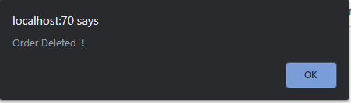

Fig.15.1.2

For remaining, see appendix.

### 5.3.9 Usability Testing

#### Visibility of System Status

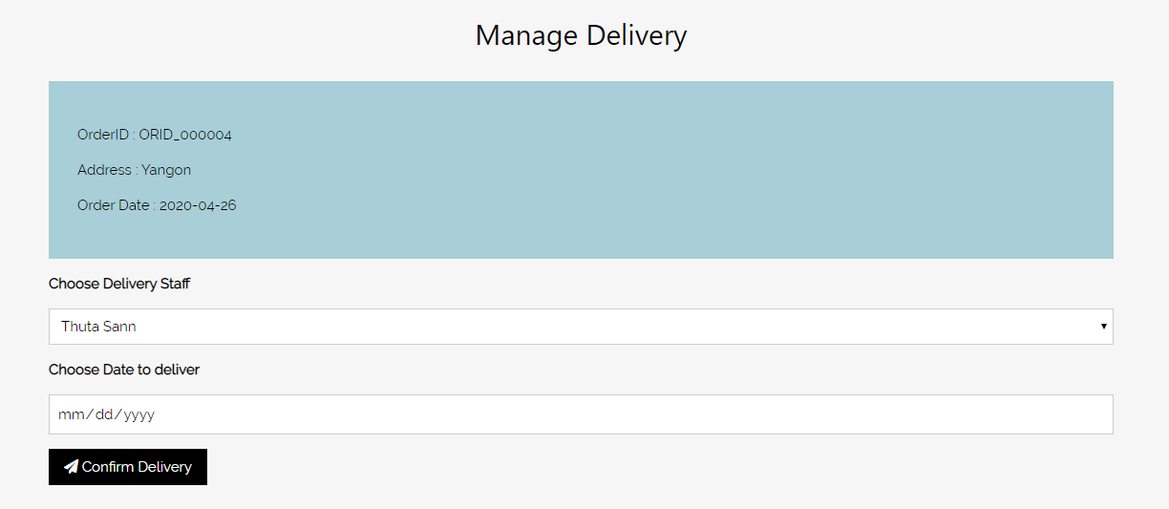

Section with different background color

Fig.5.3.8.1

There is a section with different background color displaying order information. Users can easily realize the order information by the use of different color helping website’s **Visibility of System Status.**

#### Match between System and Real World

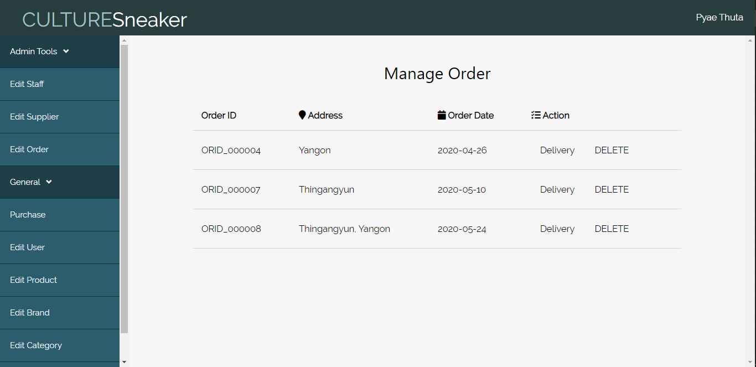

Simple design and color

Business name

Fig.5.3.8.2

The pages provide users with simple design that is easy to understand. This style of table and display style is also friendly to most users helping website’s **Match between System and Real World.**

***Aesthetic and Minimalist Design***



The use of icons

Fig.5.3.8.3

There are the use of relavent icons at the display tables. The language used is normal and easy to understand for being more user friendly. These things helps in website’s ***Aesthetic and Minimalist Design.***

#### Consistency and standard



Fig.5.3.8.4

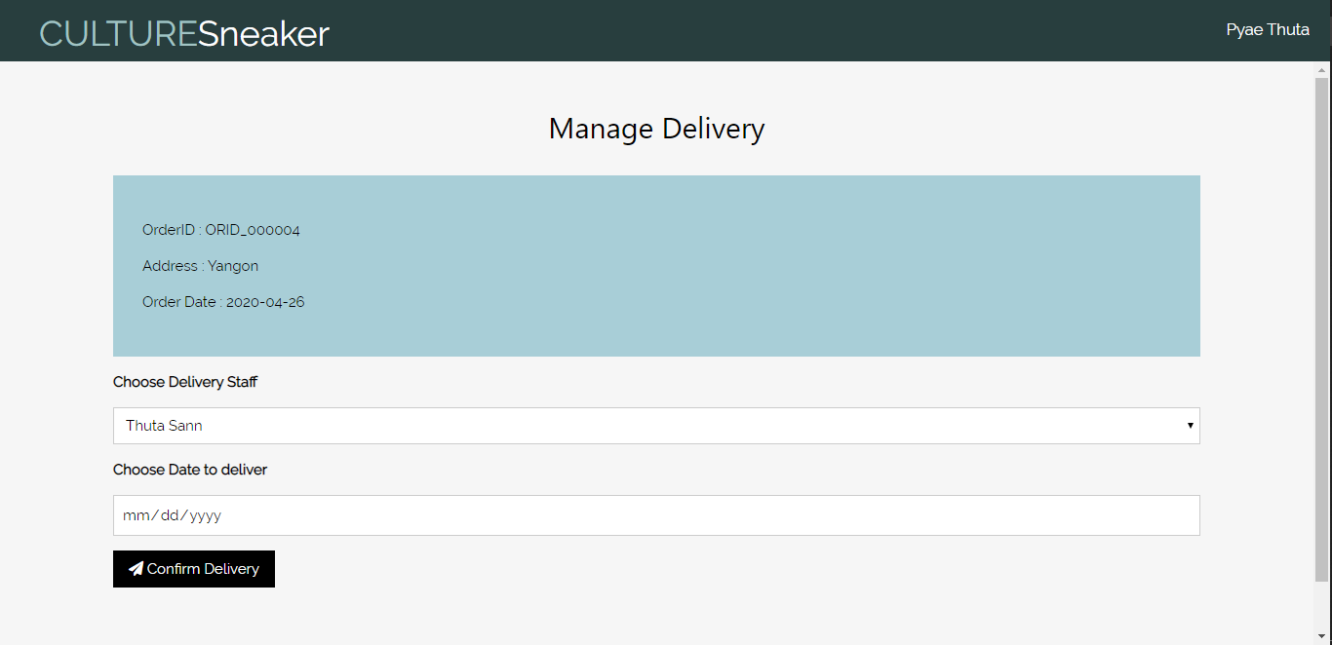

Fig.5.3.8.5

All Order Manage pages have same background color and same navigation bar. The font-size of heading, links, and text boxes are in relaevent size helping the website’s ***Consistency and Standard***.

#### Error Prevention

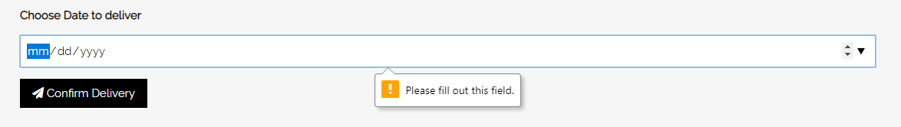

Fig.5.3.8.5

All neccessary text boxes in website have “Required” function which prevent error of recording NULL value of data.

#### Help and Documentation

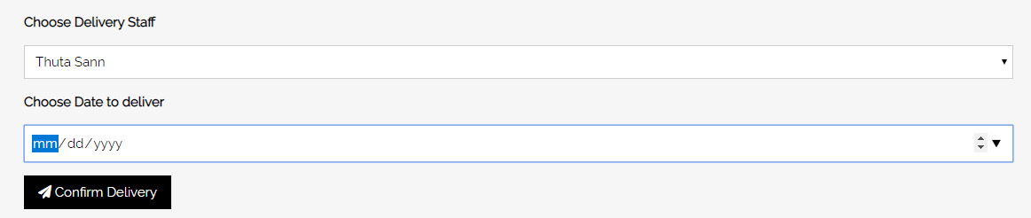

Fig.5.3.8.6

There are relevant captions before the text boxes in manage order page. These help users to easily realize the text boxes’ requirement. This help websites **Help and Documentation**.

### 5.3.10 Iteration for Usability Testing

#### Iteration 2

Users tell that the display table design is too simple and users want icon usages at the tabs of the table for Aesthetic and Minimalistic Design. Therefore, relevant icons are added to the tabs of the table.

**(Iteration 2) Iteration for Aesthetic and Minimalistic Design**

Before Iteration

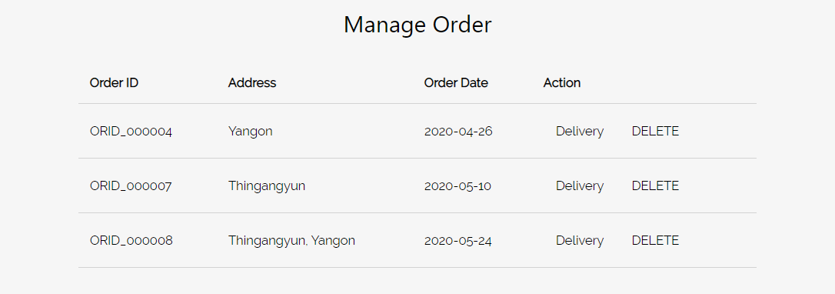

After Iteration

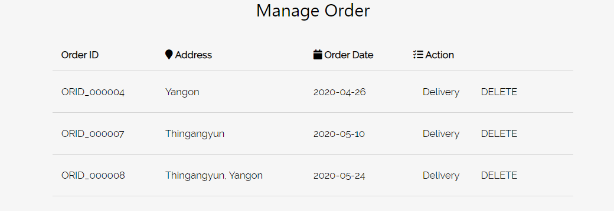

### 5.3.11 Time box Summary

It took totally (11) days for coding, testing and diagrams for timebox (3). Timebox 3 have less process than other timeboxes. Diagrams include Use case diagrams, initial and detail class diagrams and sequence diagram. Coding takes only (3) days and testing takes (2) days. Overall, time box 3 is done successfully within desired duration.

CHAPTER – 6

Deployment

# Chapter (6) Deployment

## 6.1 Deployment Diagram

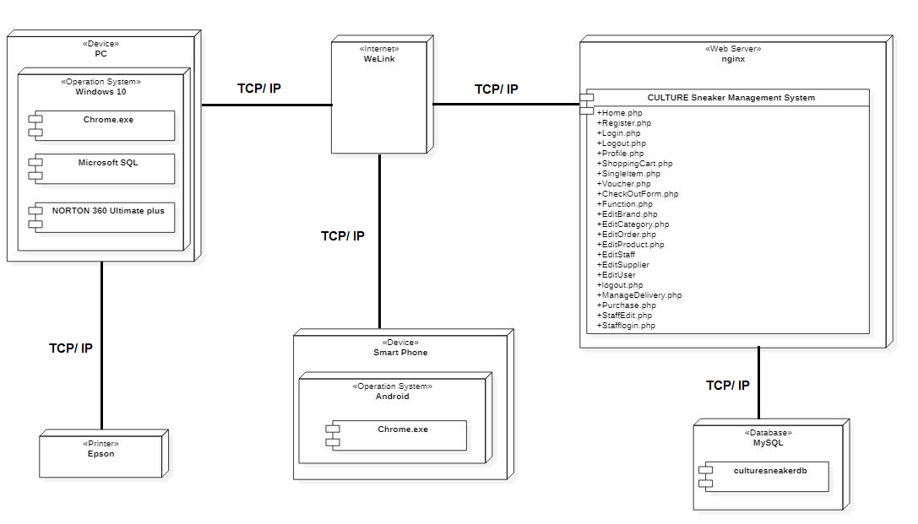

### 6.1.1 Explanation for diagram

This deployment diagram shown above demonstrate the deployment of the devices and network use within the business.

* Internet is used WeLink and all other network devices are connected through the internet.
* Web server is NGINX and “CULTURE”’s all processes are worked through the server.
* Database used is MySQL and all the business’s data (culturesneakerdb) are stored in the database.
* Business uses Window 10 PCs and these PCs are connected to the database through internet.

## 6.2 Data Migration

### 6.2.1 Data to Migrate

|  |  |  |
| --- | --- | --- |
| Time Box | Master Data | Transaction Data |
| **Time Box 1: Manage Purchase Process** | Staff, Customer, Sneaker, Category, Brand | Purchase |
| **Time Box 2: Manage Order Process** | Customer, Sneaker, Brand, Category | Order |
| **Time Box 3: Manage Delivery Process** | Staff, Order, Sneaker | Delivery |

### 6.2.2 Plan

|  |  |  |  |  |  |
| --- | --- | --- | --- | --- | --- |
| Time Box | Data to Migrate | Duration | Start Date | End Date | Responsible person |
| **Time Box 1: Manage Purchase Process** | * Customer * Staff * Sneaker * Category * Brand | 2 days | 17 May 2020 | 18 May 2020 | Manager, Staff |
| **Time Box 2: Manage Order Process** | * Staff * Customer * Sneaker * Category * Brand | 2 days | 19 May 2020 | 20 May 2020 | Customer, Staff |
| **Time Box 3: Manage Delivery Process** | * Staff * Order * Sneaker | 1 Day | 21 May 2020 | 21 May 2020 | Manager, Delivery Staff |

## 6.3 Training

### 6.3.1 Training plan

|  |  |  |  |  |  |  |
| --- | --- | --- | --- | --- | --- | --- |
| No | Contact | Trainer | Start Date | End Date | Venue | Time |
| 1 | Time Box 1   * Customer * Staff * Sneaker * Category * Brand | Manager/ Admin | 22 May 2020 | 22 May 2020 | “CULTURE” manager Room. | 1 pm – 5 pm |
| 2 | Time Box 2   * Staff * Customer * Sneaker * Category * Brand | Manager/ Admin | 23 May 2020 | 23 May 2020 | “CULTURE” manager Room. | 2 pm – 5 pm |
| 3 | Time Box 3   * Staff * Order * Sneaker | Manager/ Admin | 24 May 2020 | 24 May 2020 | “CULTURE” manager Room. | 5 pm – 7 pm |

### 6.3.2 User Manual

#### Admin pages

**EditStaff.php**

Fill Staff Name

These tools can only be seen by admin

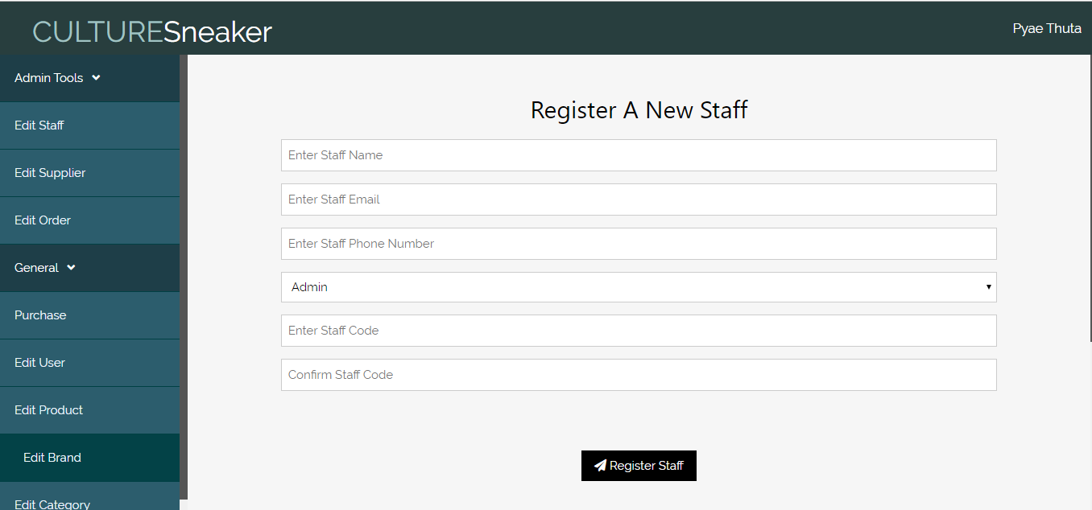

Confirm Staff Code

Fill Staff Phone

Choose Staff Role

Fill Staff Code

Fill Staff Email

Click this button to confirm registering

These tools are general and can also be seen by general staffs

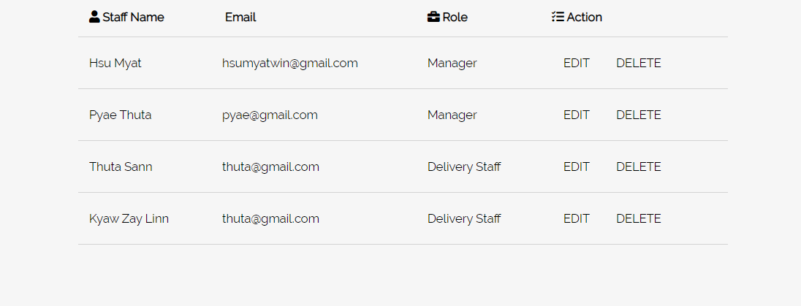**EditSupplier.php**

Delete Staff data

Edit Staff data

List of Registered Staffs

Fill Supplier Name

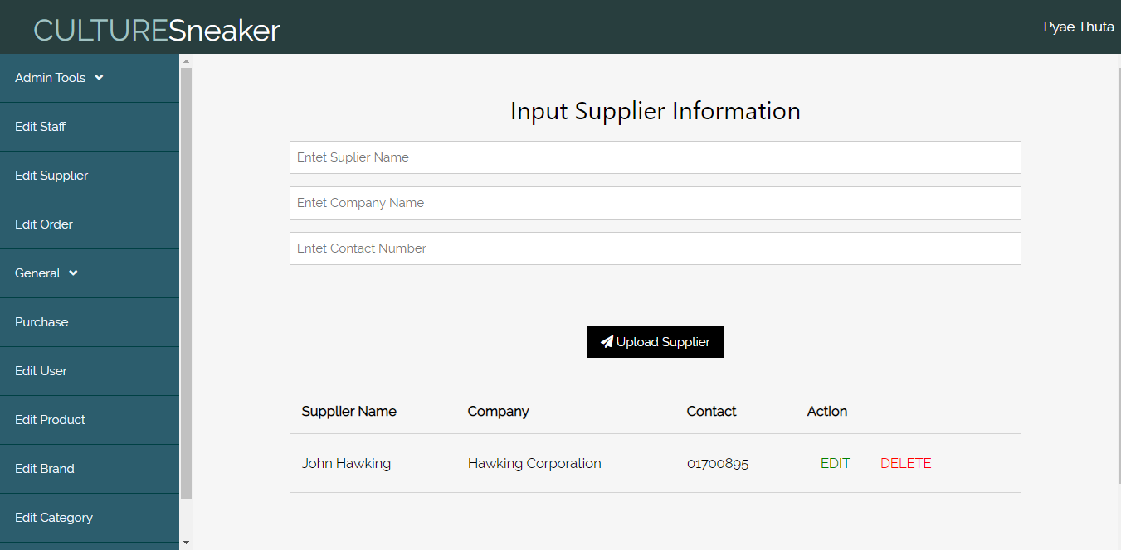

Click to Delete Supplier

Click to Edit Supplier

Click to confirm upload

Fill Supplier Company

Fill Supplier Contact No

**EditOrder.php**

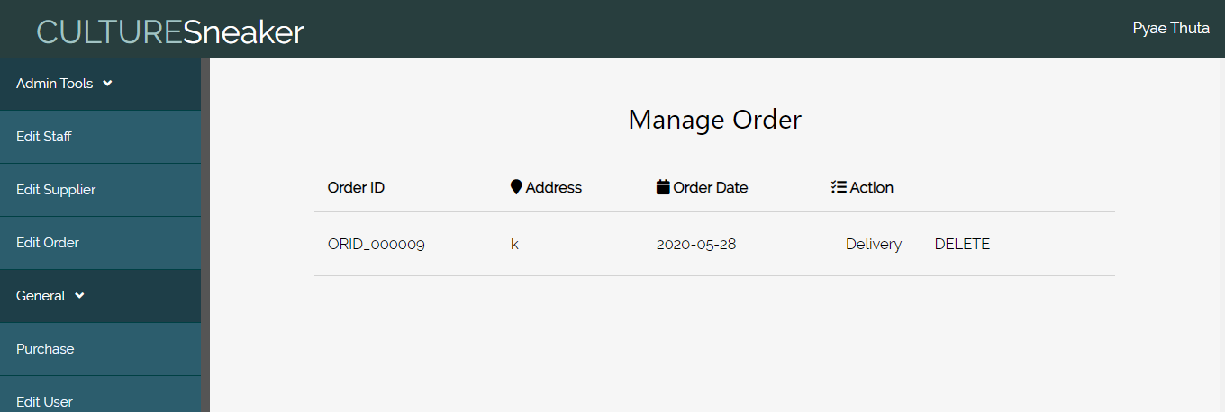

Click to Delete Order

Click to Manage Delivery

**EditUser.php**

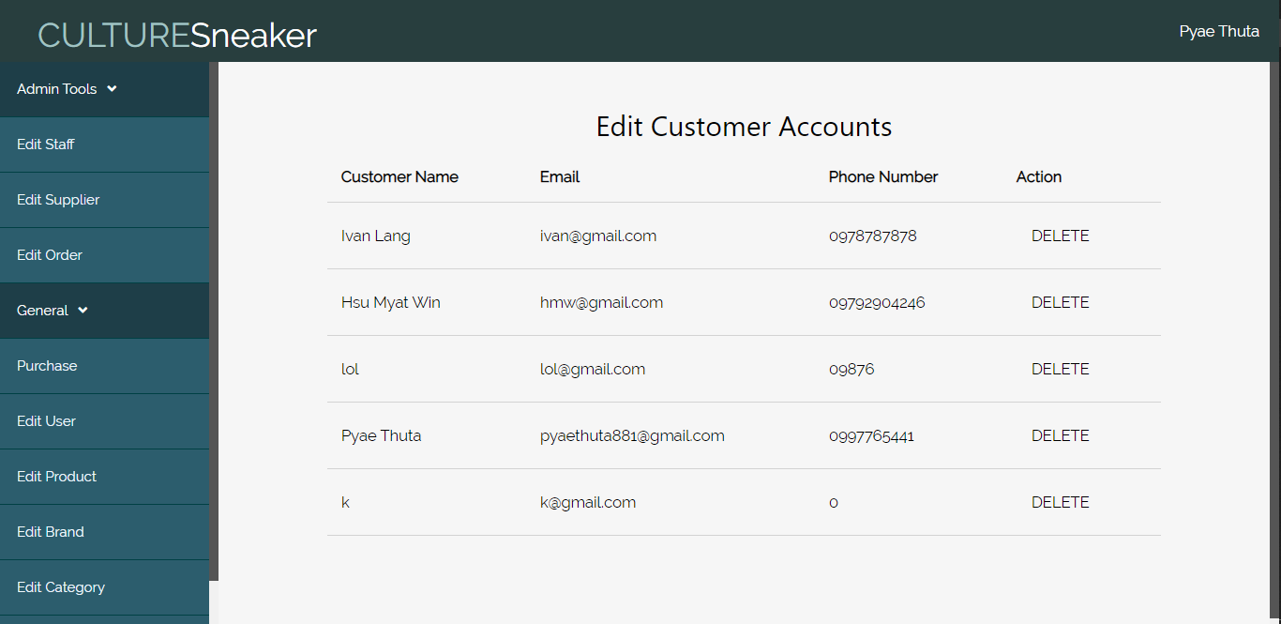

Click to Delete Customer Account

**EditSneaker.php**

Fill Sneaker Name

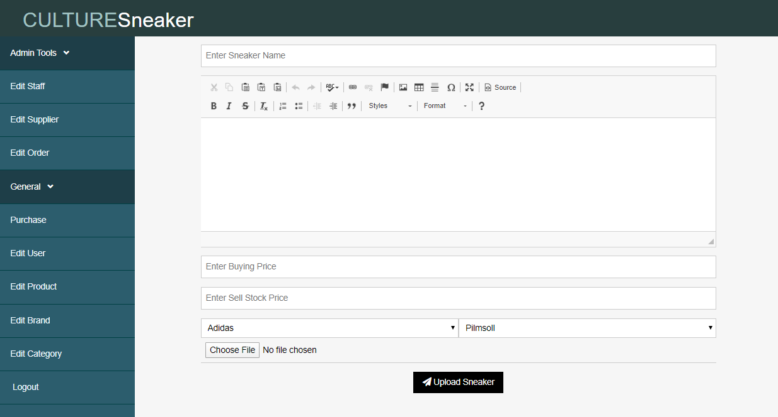

Click to confirm Upload

Choose Image

Choose Brand

Sell Stock Price

Choose Category

Fill Description

Fill Buy Price

Fill Description

**EditBrand.php**

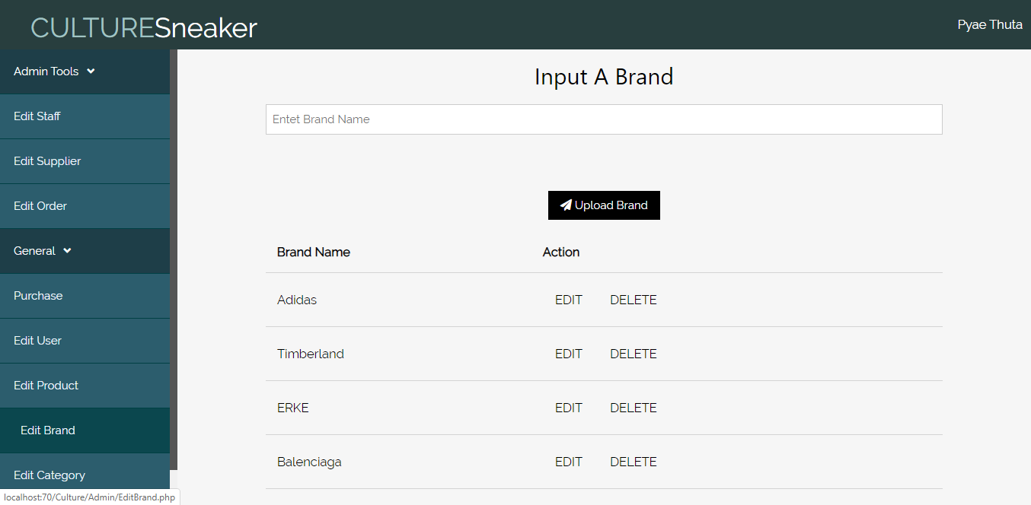

Click to Update Brand

Click to Delete Brand

Click to confirm Upload

Fill Brand Name

**EditCategory.php**

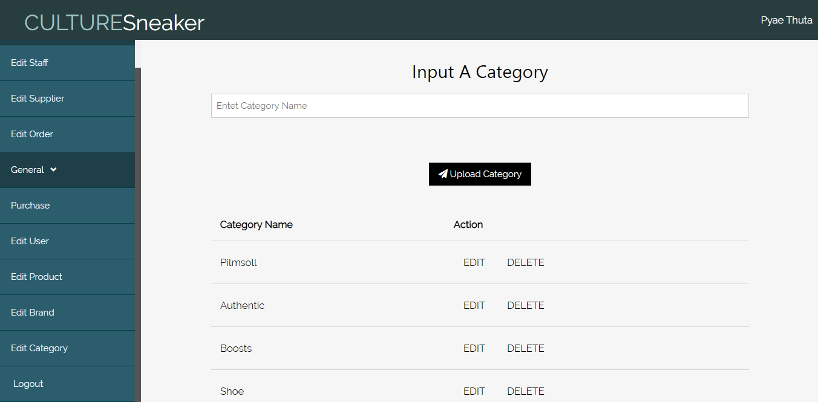

Click to Delete Category

Fill Category Name

Click to confirm Upload

Click to Update Category

**Purchase.php**

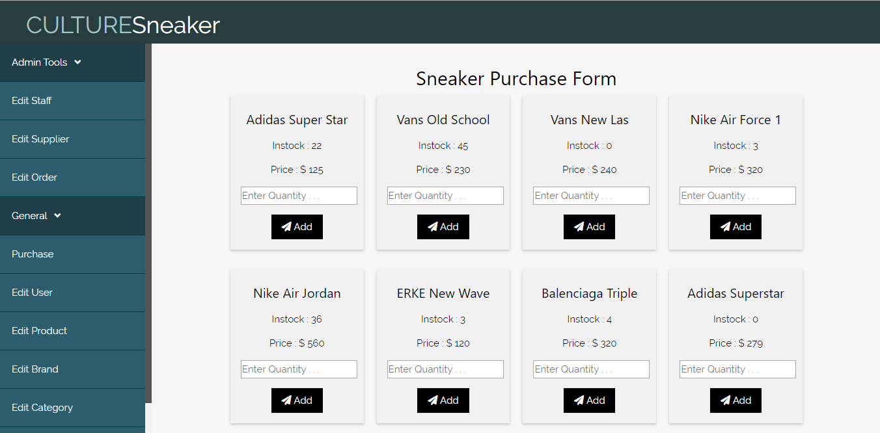

Click this button to add to cart

Choose Quantity

Price

In stock Quantity

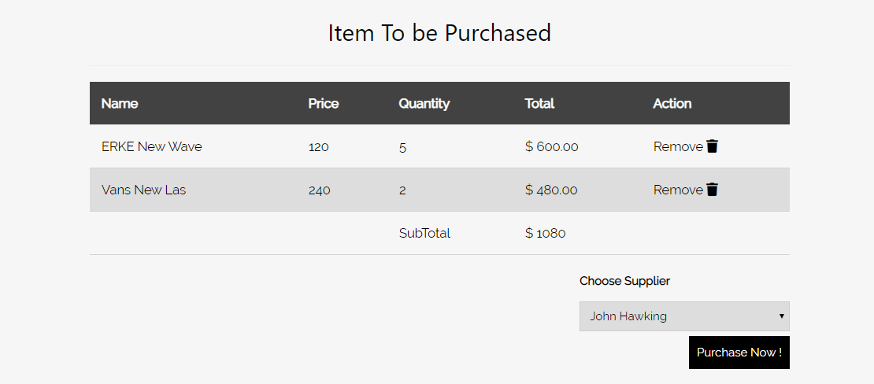

Click to confirm Purchase

Choose Supplier Name

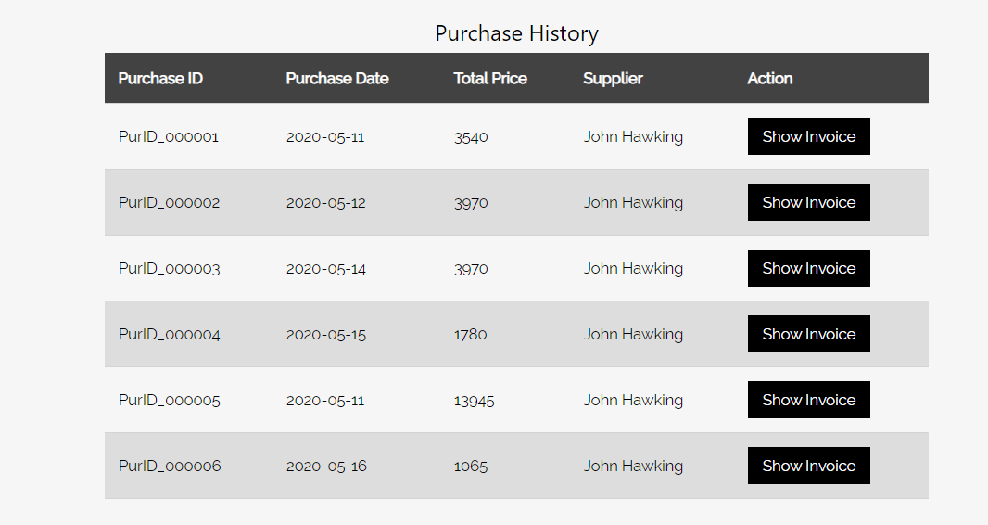

Click to See invoice

**ManageDelivery.php**

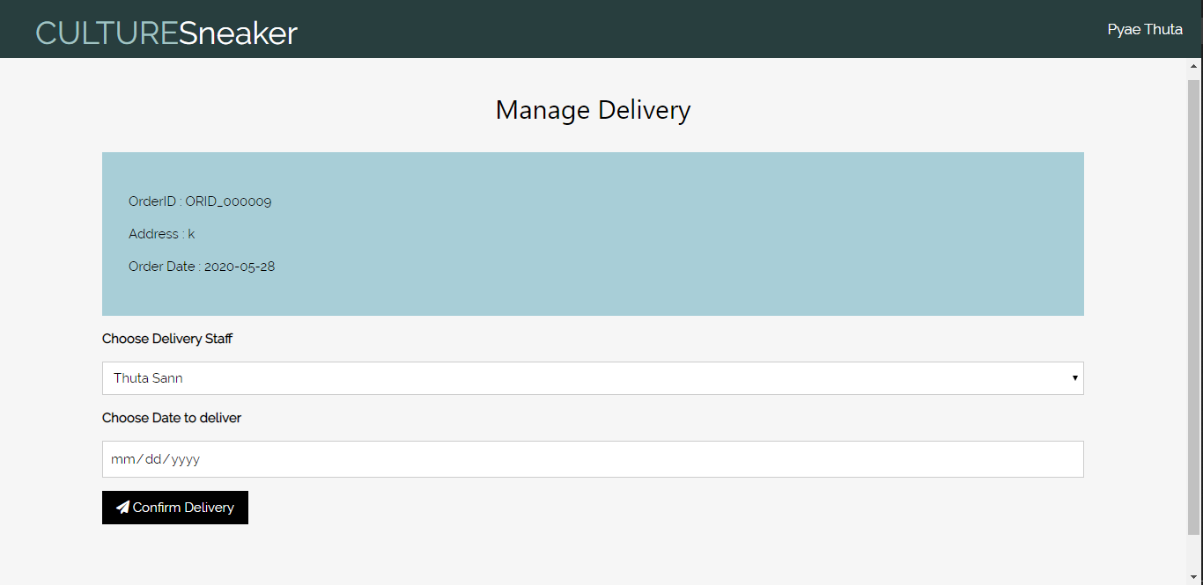

Click to confirm Delivery

Choose Delivery Date

Choose Delivery Staff

Order Detail

**StaffLogin.php**

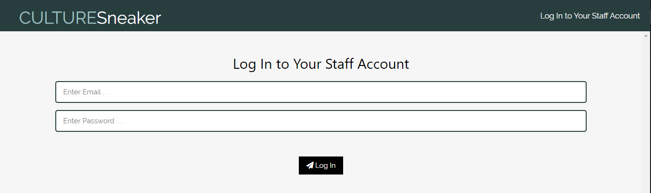

Fill Staff code (Password)

Fill Staff Email

**Customer Pages**

Click to view all sneaker

Click to search sneaker

**Home.php**

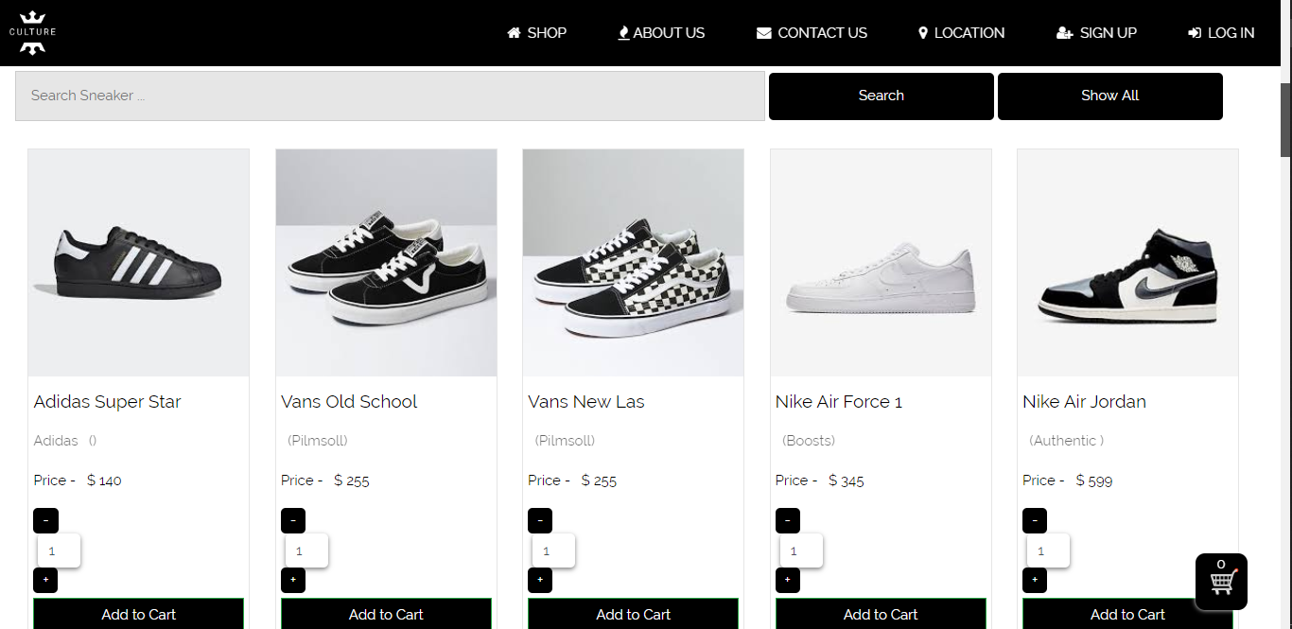

Click to view items in shopping cart

Click this button to add to cart sneaker

Choose Quantity

Enter Sneaker name

Click to reach Single item page

**SingleItem.php**

Click to zoom

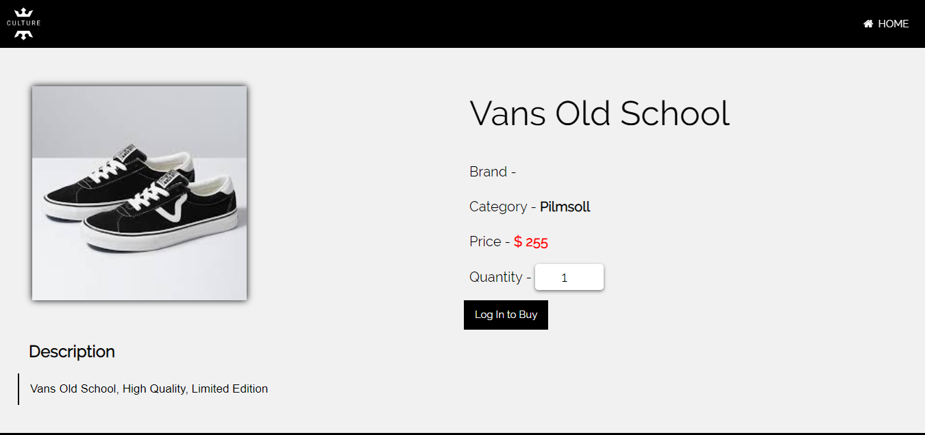

Click to Login Or add to cart

Chose Quantity

**Login.php**

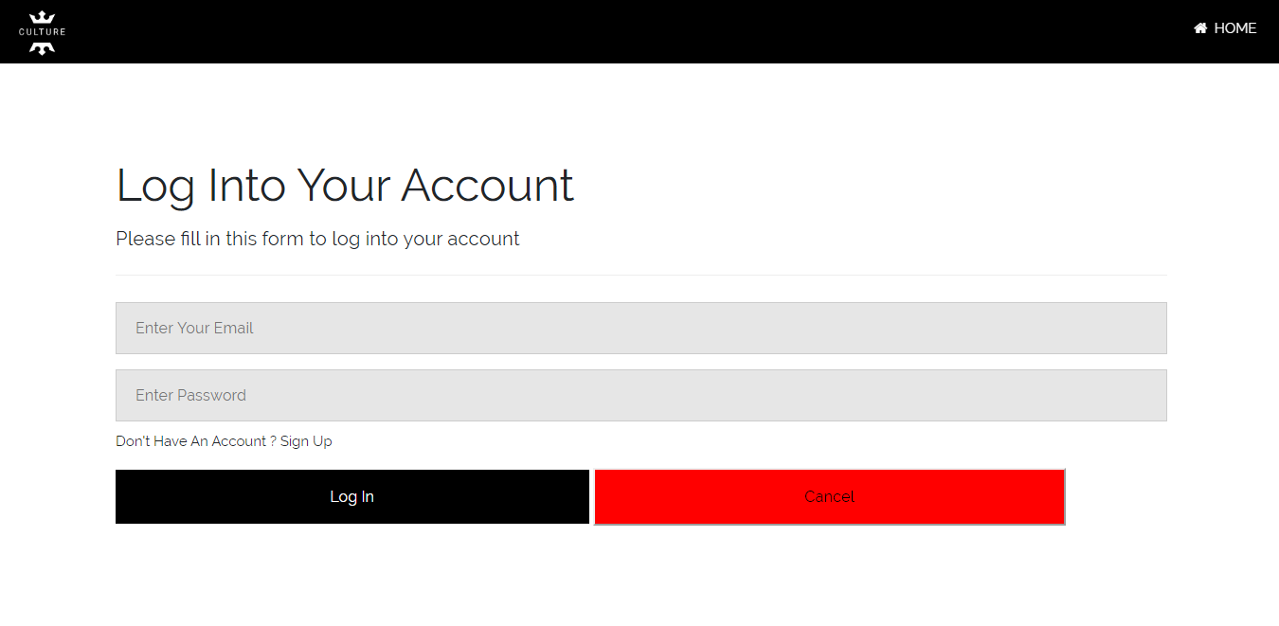

Click to confirm Login

Enter Password

Enter Customer Email

**Register.php**

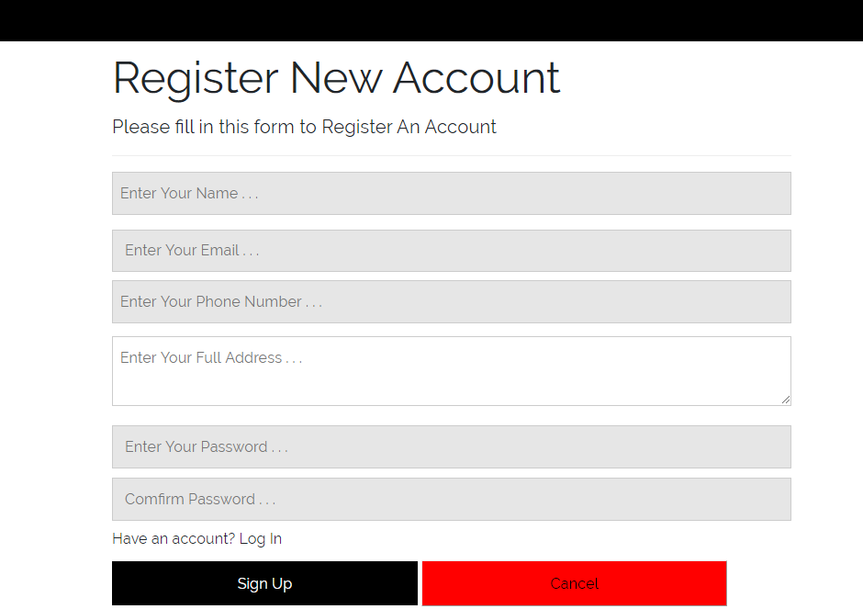

Click to confirm Sign up

Click to confirm Sign up

Confirm Password

Enter Password

Enter Address

Enter Email

Enter Phone Number

Enter Name

Click to Reach Login Page

**Shoppingcart.php**

Click to continue Shopping

Click to clear cart

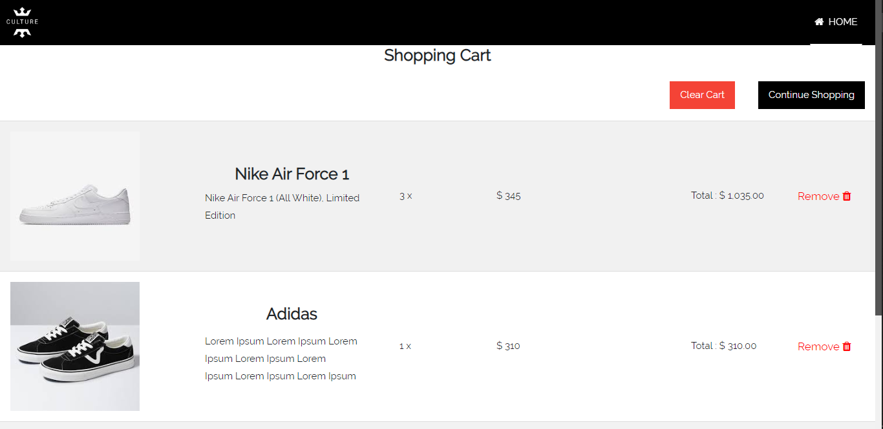

Click to remove item

**CheckoutForm.php**

Choose one of the cards

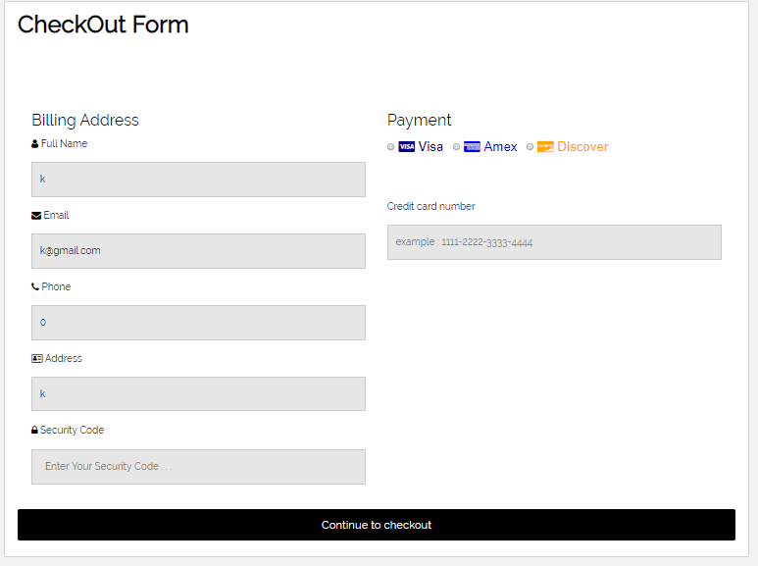

Click to confirm Checkout

Enter Card number

Enter Security Code

**Profile.php**

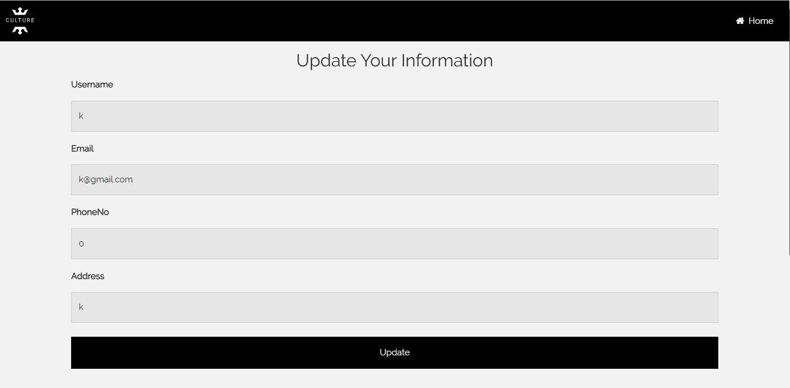

Click to confirm update

Update Address

Update Phone Number

Update email

Update User name

### CHAPTER – 7

### CONCLUSION

### &

### EVALUATION

# Chapter (7) Conclusion & Evaluation

## 7.1 Evaluation against Aim & Objectives

### 7.1.1 Aim

The new system is quite friendly to users because the designs used are simple and understandable. The usages of icons and logos make users to realize the processes of the website. For recording data, users will have alert after making a confirmation or saving data. The use of database can help faster account of recording and retrieving data. This can also prevent data loss which is a great problem for the business.

### 7.1.2 Objectives

**Analysis**

Analysis is done by interviewing business managers and staffs. The surveys are taken from the staffs who are working currently. The analysis results help a lot in developing the project. The current problems and processes are got form these survey results. The only problems in making analysis is that the manager and staffs are always busy and some are

**Design**

The design of the new system is said to be friendly to users because of the use of captions, icons and logos. Users can easily browse and order sneakers through customer pages. Staffs can also realize the process they are currently carrying out by just checking at the captions. The white background color is chosen for most customer page and there is a banner displaying “CULTURE” aims at home page of customers. The analysis results also help in designing the website.

**Coding**

Coding takes most of the time for all the timeboxes. The code of all pages is written in PHP and some java script also included. Writing java scripts have a problem because of the less java knowledge. Moreover, if there is more time, there should be more PHP functions in the website.

**Testing**

Functional and non-functional testing are done through all the pages. The website is said to be error clear because of sufficient testing. Functional testing is done by 16 modules containing test scripts and screenshots. There is enough functional and non-functional testing for this project.

**Training**

There is training plans for staffs. Training is done by manager and admin in Manager Room of “CULTURE”. Training has some problems because most of the staffs are not friendly with computer devices.

## 7.2 Evaluation Against Similar System

|  |  |  |
| --- | --- | --- |
| No | My System | Sneak Avenue |
| 1 | Visibility of System Status    The system status of the focused text box is done by changing the border color. | Visibility of System Status    The system status of the focused text box is done by changing the background color of the website. |
| 2 | Match between System and Real World   There is business logo, business name and also business description in banner section. | Match between System and Real World   There is no banner but business name and logo at the top of the webpage. |
| 3 | ***Aesthetic and Minimalist Design***    There are uses of logo in almost all pages making the website more user friendly. | ***Aesthetic and Minimalist Design***    This contact section have icons describing the websites sociality. |
| 4 | Consistency and standard   All the customer pages have same navigation and same theme. Language used is simple but user can’t change website’s language. | Consistency and standard   Most of the pages of this website are in same theme. There is a function users can choose up to 9 languages. |
| 5 | ***Error Prevention***    All the necessary text boxes have REQUIRED function to prevent NULL data error. | ***Error Prevention***    There is a script that show users the text box with NULL data. Moreover, there is yes or no script before making a confirmation. |
| 6 | Help and Documentation   There are guidelines and information of the business at about us section. But there is no guideline for Privacy and Policies. | Help and Documentation   There are guidelines and privacy policies for users. The placeholders in the text boxes help users to realize the processes easily. |

## 7.3 Evaluation against Justification Made

#### *7.3.1 Method*

Using agile is much comfortable for this project since agile provide iteration. During coding and designing, iteration had to be done according users’ recommendation. Agile method also provides greater account of user involvement and it makes better way for a point of sale system. Using agile does not provide stage by stage testing. But it didn’t make a great problem because of iteration.

#### *7.3.2 Language*

PHP is chosen for programming language in this project. Since PHP has warning sign to find and fix error easily, it is much reliable for error handling. Moreover, PHP is easy to learn and efficient for window. There is only a problem writing Function for shopping cart process because it is a bit more difficult than others.

#### *7.3.3 Database*

Microsoft SQL server is chosen for database in this project. Since SQL server provides large data storage for recording information about sneakers, staffs and customers. Since SQL server also has data recovery function, data can be safely recorded. But there may be problems with staffs who don’t understand the complex function of SQL server. To prevent this problem, staff must be trained carefully to use SQL server.

## 7.4 Evaluation against Time Box Plan

#### *Time Box 1: Manage Purchase Process*

When planning time box (1), the end date for timebox 1 is April 17, 2020. The coding, iteration and testing for timebox 1 is completed before end date. So, the end date for timebox 1 was match with time box plan.

#### Time Box 2: Mange Order Process

The End date for time box 2 is set May 3, 2020 when timebox planning. The coding, iteration and all the task cases is completed 1 day late because of too much coding. Therefore, the end date for timebox 2 did not match with time box plan.

#### Time Box 3: Mange Delivery Process

The End date for time box 3 is set April 15, 2020 when timebox planning. The coding, iteration and all the task cases is completed 1 day before the end date. Therefore, the end date for timebox 2 was matched with time box plan.

## 7.5 Personal Evaluation

I got a lot of business knowledge from this project. I did not know how to make payment and shopping cart function before this project. During coding, I made some coding researches from w3c schools (Anon., 2020). Some new java scripts codes are learnt for navigation and design. I also got knowledge about how to manage time during project. I manage project time with schedules and time box plans. This is a bit hard to manage time because this is my first-time managing time constraint for a website development. Moreover, new methodologies for system development are learnt when choosing method for this project. The strength, weakness and functions of programming languages are known from choosing programming language. It is quite satisfying during coding because I had to applied all the skills I learnt in this project. The benefits of using Microsoft SQL server is known and the requirements of a good database system is learnt when researching databases for this system. I most knowledge I got from this project is coding and designing. Being a point of sale system, the design of the website had to be taken carefully. The benefits of using icons and using business logo is known. For data security, some researches had to be made and md5 method is used for encrypting customers’ data and payment information.

Overall, I got

* Business Knowledge
* Some new coding skill
* Time managing skills form this project.

## 7.6 Strength & Weakness

**Strength**

It is obvious that the main strength of the “CULTURE” website is User Interface design. Users may be interested in browsing website because its UI design is unique. The banner section and about us section display the customers with all information of the website and aesthetic design. The user friendliness of the website is also the strength of website. The usage of icons, placeholders in text boxes and captions for the process can prevent users form getting confuse with the function of the website. Moreover, this website provides users with a good security system that the password and payment information of the users are encrypted. Users can be confidently shop in “CULTURE Sneaker Shop” that their information are safe. The design and language used is very simple but aesthetic to draw customers’ attention. For admin pages, there are access control function that managers’ pages are safe. Therefore, the strengths of this website are

* Simple and aesthetic UI design
* User friendliness
* Strong security of customers’ information.

**Weakness**

There is not much functions in the website. There is no special account for communication between customers and staffs. There should be rating system for the sneakers and contact section for customers. Moreover, there is no page for privacy and policies for this website. There should be a form showing privacy and policies of the website. Therefore, the weaknesses of the “CULTURE” website are

* Less function
* No rating system
* No customer communication

## 7.7 Future Amendment

If there is more time for this project, the following functions are wanted to add to the website.

**For Design**

* There should more icon usages and descriptions before every text box.
* There should be more colorful themes in product displaying section.

**Functions**

* The Contact Us section should be added. This section will provide a good communication between customers and staffs. It is obvious that Contact Us function will attract customers more.
* There should be a system where users can give rating to the sneakers of the website. This can help the business stock control and handling best-selling sneakers.

**New pages**

* A new page is wanted to add in admin page which is admin’s dashboard. Admins and managers can access all the pages through dashboard. This dashboard can help users to manage pages and website will have better accesses control.
* There should be a page displaying Privacy and Policies of the website. Privacy and policies page are also a requirement for a website.

**Security**

* There should be a function which lock the login page down when a user submits wrong email or password more than 3 times. This can help website having better security and safety of users’ information.

### 

### APPENDIX

# Appendix

## Section A: Use Case Descriptions

### Timebox 1: Manage Purchase Process Timebox Development

|  |  |
| --- | --- |
| **Use Case Name** | Record Supplier |
| **Actor** | Admin, Manager |
| **Flow of Event** | * Admins and managers can upload different suppliers in Edit Supplier page. |

|  |  |
| --- | --- |
| **Use Case Name** | Record Sneaker |
| **Actor** | Staff |
| **Flow of Event** | * Staffs can upload new sneakers in Edit Sneaker page by filling information and clicking “Upload” button. |

|  |  |
| --- | --- |
| **Use Case Name** | Edit Sneaker |
| **Actor** | Staff |
| **Flow of Event** | * Staffs can Purchase sneakers form different suppliers by choosing to the cart and clicking purchase button. |

|  |  |
| --- | --- |
| **Use Case Name** | Purchase Sneaker |
| **Actor** | Staff |
| **Flow of Event** | * Staffs can Edit sneakers information in Staff Edit page. |

### Timebox 2: Manage Order Process Timebox Development

|  |  |
| --- | --- |
| **Use Case Name** | Edit Account |
| **Actor** | Customer |
| **Flow of Event** | * Change information in Register Page and click edit button. |

|  |  |
| --- | --- |
| **Use Case Name** | Order Sneaker |
| **Actor** | Customer |
| **Flow of Event** | * Choose Sneakers in home page. * View Chosen sneakers in Shopping Cart page. * Click “Order Now” button. |

|  |  |
| --- | --- |
| **Use Case Name** | Remove Order |
| **Actor** | Staff |
| **Flow of Event** | * View customers’ orders in Edit order Page. * Click “Delete” button to remove order. |

### Timebox 3: Manage Delivery Process Timebox Development

|  |  |
| --- | --- |
| **Use Case Name** | Remove Order |
| **Actor** | Manager |
| **Flow of Event** | View all pending orders in Edit Order page and click “Delete” button beside the order. |

|  |  |
| --- | --- |
| **Use Case Name** | Record Staff |
| **Actor** | Manager |
| **Flow of Event** | Fill staff information and click Upload Staff button in Edit staff page. |

|  |  |
| --- | --- |
| **Use Case Name** | Manage Order |
| **Actor** | Manager |
| **Flow of Event** | Click “Manage” button beside the order in Edit Order page.  Choose a delivery staff, choose delivery date and click “Confirm Delivery” button in Delivery page. |

## Section B: Detailed Class Definitions

### Timebox 1: Managing Purchase Process Time Box Development

|  |  |
| --- | --- |
| **Class Name** | category |
| **Attributes** | Category ID, Category |
| **Operation** | Record (), Cancel (), AutoID (), Update (), Delete (). |
| **Description** | The **Brand** class is used to Record Category name of the sneakers. |

|  |  |
| --- | --- |
| **Class Name** | sneaker |
| **Attributes** | SnaekerID, sneaker Name, Description, Price, Image, Category ID, Brand ID |
| **Operation** | Record (), Cancel (), AutoID (), Update (), Delete (). |
| **Description** | The **sneaker** class is used to Record sneaker name and detail information of the sneakers. |

|  |  |
| --- | --- |
| **Class Name** | Purchase |
| **Attributes** | PurchaseID, PurchaseDate, TotalPrice, StaffID, SupplierID |
| **Operation** | Record (), AutoID (), View (). |
| **Description** | The **purchase** class is used to Record purchases made and retrieve data to make invoice. |
| **Class Name** | PurchaseSneaker |
| **Attributes** | PurchaseID, SneakerID, Quantity, TotalPrice |
| **Operation** | Record (), AutoID (), View (). |
| **Description** | The **PurchaseSneaker** class is dummy table for **Purchase** and **Sneaker** table. |

|  |  |
| --- | --- |
| **Class Name** | Staff |
| **Attributes** | staffid, staffname, staffemail, staffphone, role, password |
| **Operation** | Record (), AutoID (), View (), Update (). Delete (). |
| **Description** | The **Staff** class is used to record staff’s information and to retrieve and update data. |

|  |  |
| --- | --- |
| **Class Name** | Supplier |
| **Attributes** | SupplierID, SupplierName, CompanyName, ContactNo |
| **Operation** | Record (), AutoID (), View (), Update (). Delete (). |
| **Description** | The **Supplier** class is used to record Supplier’s information and to retrieve and update data. |

### Timebox 2: Managing Order Process Time Box Development

|  |  |
| --- | --- |
| **Class Name** | category |
| **Attributes** | Category ID, Category |
| **Operation** | Record (), Cancel (), AutoID (), Update (), Delete (). |
| **Description** | The **Brand** class is used to Record Category name of the sneakers. |

|  |  |
| --- | --- |
| **Class Name** | sneaker |
| **Attributes** | SnaekerID, sneaker Name, Description, Price, Image, Category ID, Brand ID |
| **Operation** | Record (), Cancel (), AutoID (), Update (), Delete (). |
| **Description** | The **sneaker** class is used to Record sneaker name and detail information of the sneakers. |

|  |  |
| --- | --- |
| **Class Name** | ordersneaker |
| **Attributes** | OrderID, SnaekerID, Quantity |
| **Operation** | Record (), Delete (). |
| **Description** | The **ordersneaker** class is a dummy table for sneaker and order table. |
| **Class Name** | order |
| **Attributes** | OrderID, Address, PhoneNo, CustomerID, OrderDate, TotalPrice, PaymentType, Card Number, SecurityCode |
| **Operation** | Record (), Cancel (), Delete (). |
| **Description** | The **order** class is used to record order and detail information of an order after an order is made. |

|  |  |
| --- | --- |
| **Class Name** | customer |
| **Attributes** | CustomerID, CustomerName, Email, PhoneNo, Address, Password |
| **Operation** | Record (), Cancel (), AutoID (), Update (), Delete (). |
| **Description** | The customer class is used to record information of customers. |

### Timebox 3: Managing Delivery Process Time Box Development

|  |  |
| --- | --- |
| **Class Name** | Staff |
| **Attributes** | Staff ID, Staff Name, Staff Email, Staff Phone, role, password |
| **Operation** | Record (), View (), Update (), Delete () |
| **Description** | The **Staff** class is used to record staff information when manager record staff. |

|  |  |
| --- | --- |
| **Class Name** | Order |
| **Attributes** | Order ID, Customer ID, Address, Phone No, Order Date, Total Price, Payment Type, Card Number, Security Code, Status |
| **Operation** | Record (), View (), Update (), Delete () |
| **Description** | The **Order** class is used to record order information when customer make an order. |

|  |  |
| --- | --- |
| **Class Name** | Customer |
| **Attributes** | Customer ID, Customer Name, Email, Address, Phone No, password |
| **Operation** | Record (), View (), Update (), Delete () |
| **Description** | The **Customer** class is used to record customer information when customer make an account registration. |

## Section C: Coding

|  |  |  |
| --- | --- | --- |
| Form | Function | Purpose |
| Customer Register, Staff Register, Checkout form, Supplier Entry, Product Entry, Brand Entry, Category Entry, Manage Delivery Form, Purchase Form | Save () | To save the data from the forms into the database. “Upload or Confirm” button is clicked to save input data into variables and inserting into database using SQL Statements. |
| User Profile page, Checkout Form, Purchase Form, Manage Delivery page | Update () | To update the data from the forms into the database. “Update or Confirm” button is clicked save the data into variables and update the respective data in the database using SQL statements. |
| Supplier Entry, Product Entry, Brand Entry, Category Entry, Manage Order page, Edit Customer page, | Delete () | To Delete the data from the database. “Delete” button is clicked and data is deleted in the database by using SQL statements. |
| Shopping cart page  Purchase Sneaker page  Single Item Page | Add to cart () | To add desired items to the cart temporarily. “Add” button is clicked and the respective information of items are stored temporarily in an array and session called shopping_cart and purchase_cart. |
| Shopping cart page  Purchase Sneaker page | Remove form cart () | To remove items from the shopping cart. “Remove” button is clicked and the id of the item is stored in the array and removed by unset function. |
| Shopping cart page  Purchase Sneaker page  Checkout Page | Clear_cart () | To remove all the selected items, form the cart. Click “Clear Cart” button and the items form the session shopping_cart is removed by unset function. |
| Checkout Form  Purchase Form | AutoID () | To increase ID of the registered data automatically. Whenever, the data in the forms are saved to database the ID of these data will be increase automatically by 1. |

## Section D: Test Scripts

### Timebox 1: Managing Purchase Process Time Box Development

|  |  |  |  |  |
| --- | --- | --- | --- | --- |
| **Unit Test 2** | | **Test Case:** Testing Staff Registering process in Staff Edit Form. | **Designed by:** Pyae Thuta | |
| **Data Source:** StaffRegister Page | | **Objective**: To Test “Staff Email” text box | **Tester**: Pyae Thuta | |
| **Test Case** | **Description** | **Test Procedure** | **Expected Result** | **Actual Results** |
| 1.2 | Testing if alert is shown when “Staff Email” Text box is not filled with data. | “Register” button is clicked when “Staff Email” text box is not filled with data. | Show ‘Please fill out this field’ message. | See Fig.1.2.2 |

Before Testing

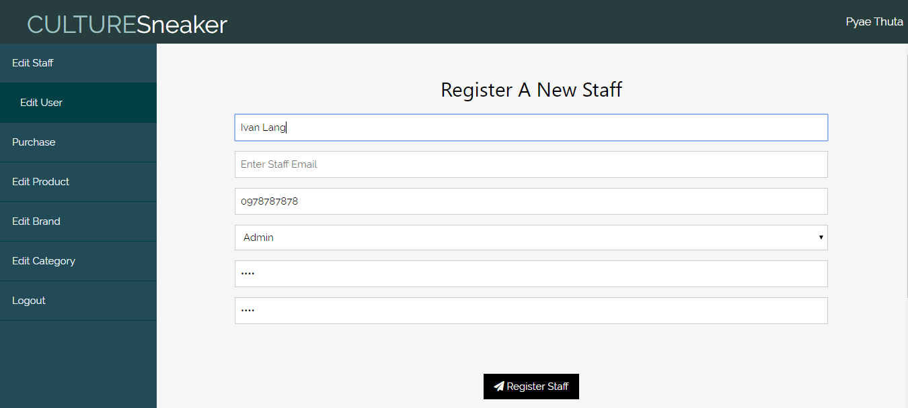

Fig.1.2.1

**After Testing**

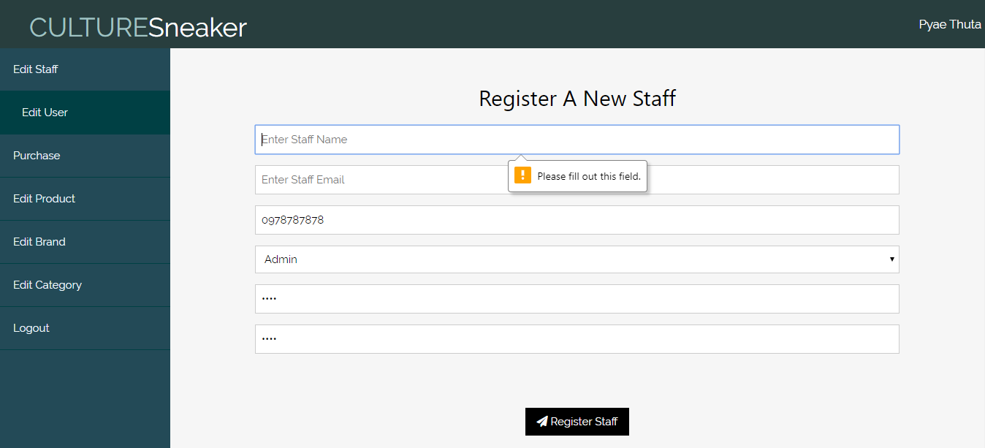

Fig.1.2.2

|  |  |  |  |  |
| --- | --- | --- | --- | --- |
| **Unit Test 3** | | **Test Case:** Testing Staff Registering process in Staff Edit Form. | **Designed by:** Pyae Thuta | |
| **Data Source:** Staff Register Page | | **Objective**: To Test “Staff Phone Number” text box | **Tester**: Pyae Thuta | |
| **Test Case** | **Description** | **Test Procedure** | **Expected Result** | **Actual Results** |
| 1.3 | Testing if alert is shown when “Staff Phone Number” Text box is not filled with data. | “Register” button is clicked when “Staff Phone Number” text box is not filled with data. | Show ‘Please fill out this field’ message. | See Fig.1.3.2 |

**Before testing**

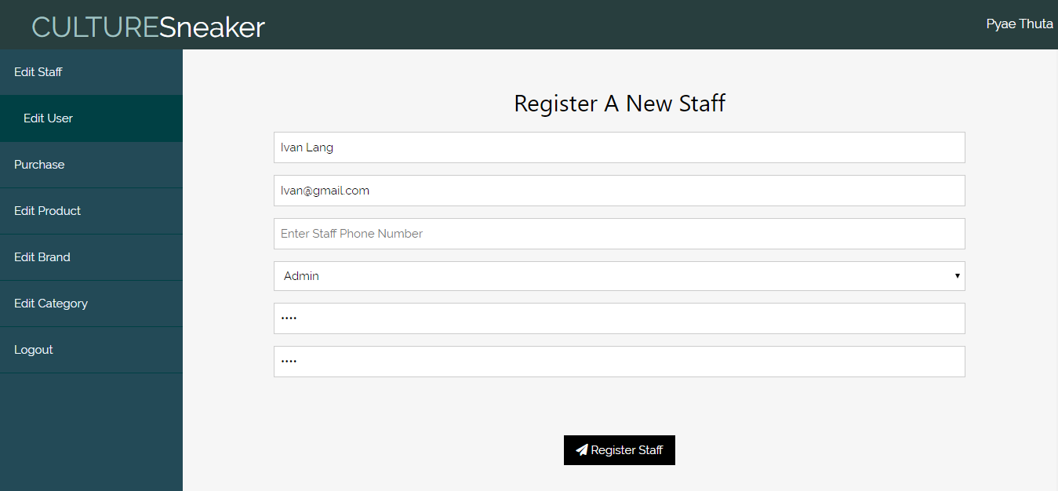

Fig.1.3.1

**After testing**

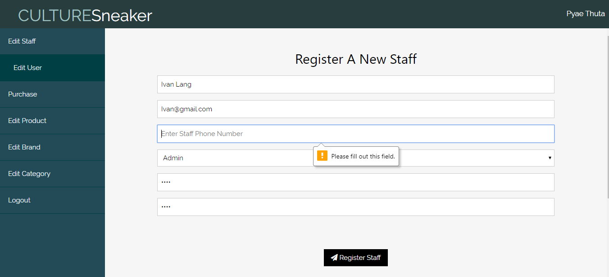

Fig.1.3.2

|  |  |  |  |  |
| --- | --- | --- | --- | --- |
| **Unit Test 4** | | **Test Case:** Testing Staff Registering process in Staff Edit Form. | **Designed by:** Pyae Thuta | |
| **Data Source:** Staff Register Page | | **Objective**: To Test “Staff Code” text box. | **Tester**: Pyae Thuta | |
| **Test Case** | **Description** | **Test Procedure** | **Expected Result** | **Actual Results** |
| 1.4 | Testing if alert is shown when “Staff Code” Text box is not filled with data. | “Register” button is clicked when “Staff Code” text box is not filled with data. | Show ‘Please fill out this field’ message. | See Fig.1.4.2 |

**Before Testing**

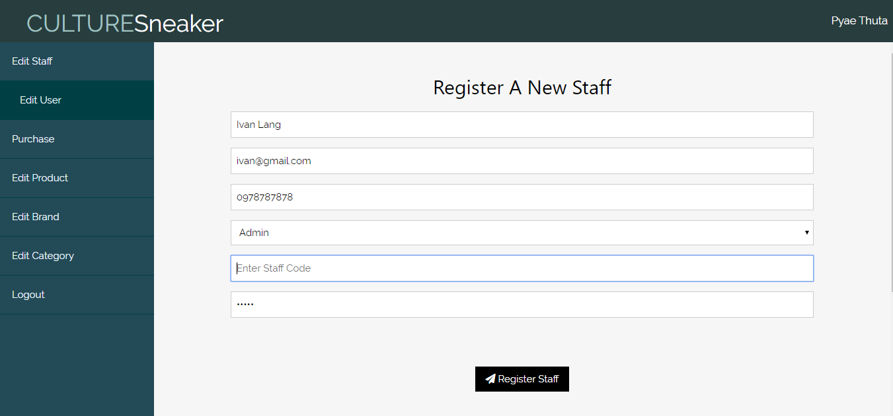

Fig.1.4.1

**After Testing**

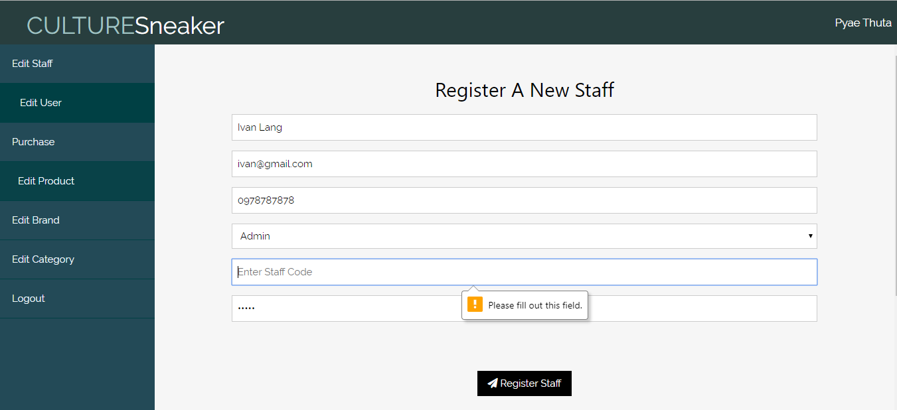

Fig.1.4.2

|  |  |  |  |  |
| --- | --- | --- | --- | --- |
| **Unit Test 5** | | **Test Case:** Testing Staff Registering process in Staff Edit Form. | **Designed by:** Pyae Thuta | |
| **Data Source:** Staff Register Page | | **Objective**: To Test “Confirm Staff Code” text box. | **Tester**: Pyae Thuta | |
| **Test Case** | **Description** | **Test Procedure** | **Expected Result** | **Actual Results** |
| 1.5 | Testing if alert is shown when “Confirm Staff Code” Text box is not filled with data. | “Register” button is clicked when “Confirm Staff Code” text box is not filled with data. | Show ‘Please fill out this field’ message. | See Fig.1.5.2 |

**Before Testing**

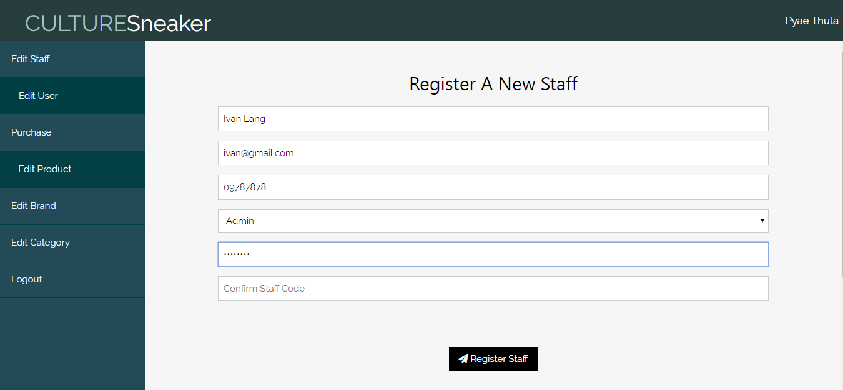

Fig.1.5.1

**After Testing**

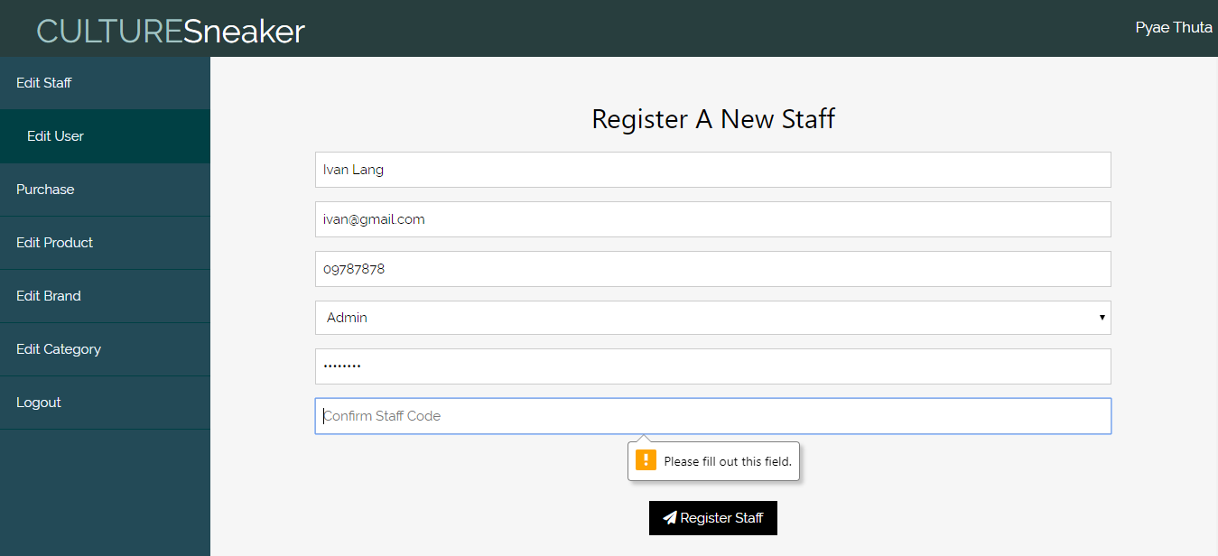

Fig.1.5.2

|  |  |  |  |  |
| --- | --- | --- | --- | --- |
| **Unit Test 6** | | **Test Case:** Testing Staff Registering process in Staff Edit Form. | **Designed by:** Pyae Thuta | |
| **Data Source:** Staff Register Page | | **Objective**: To Test “Unmatched Password” Message box. | **Tester**: Pyae Thuta | |
| **Test Case** | **Description** | **Test Procedure** | **Expected Result** | **Actual Results** |
| 1.6 | Testing if alert is shown when the data in “Password” text box and “Confirm Password” text box are not match. | “Register” button is clicked when “Password” text box and “Confirm Password” text boxes are filled with different data. | Show “The codes are not matched” message. | See Fig.1.6.2 |

**Before Testing**

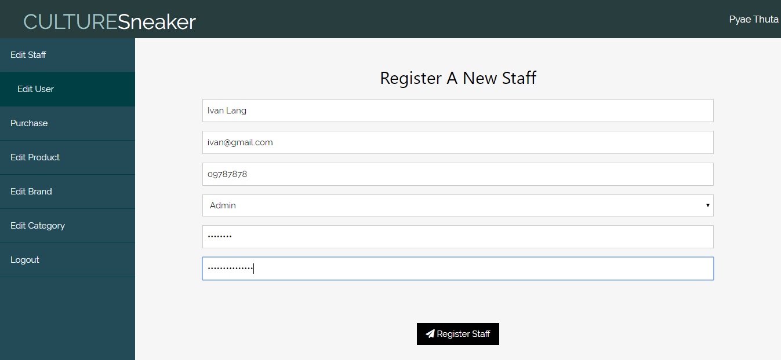

Fig.1.6.1

**After Testing**

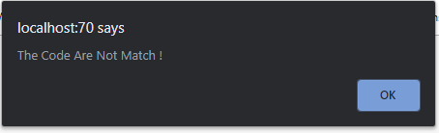

Fig.1.6.2

|  |  |  |  |  |
| --- | --- | --- | --- | --- |
| **Unit Test 7** | | **Test Case:** Testing Staff Registering process in Staff Edit Form. | **Designed by:** Pyae Thuta | |
| **Data Source:** Staff Register Page | | **Objective**: To Test Successful registration. | **Tester**: Pyae Thuta | |
| **Test Case** | **Description** | **Test Procedure** | **Expected Result** | **Actual Results** |
| 1.7 | Testing if alert is shown and data are saved into the database if registration is successful. | “Register” button is clicked when all text boxes are filled with correct data. | Alert is shown and data are saved into the database. | See Fig.1.7.2 & Fig.1.7.3 |

**Before Testing**

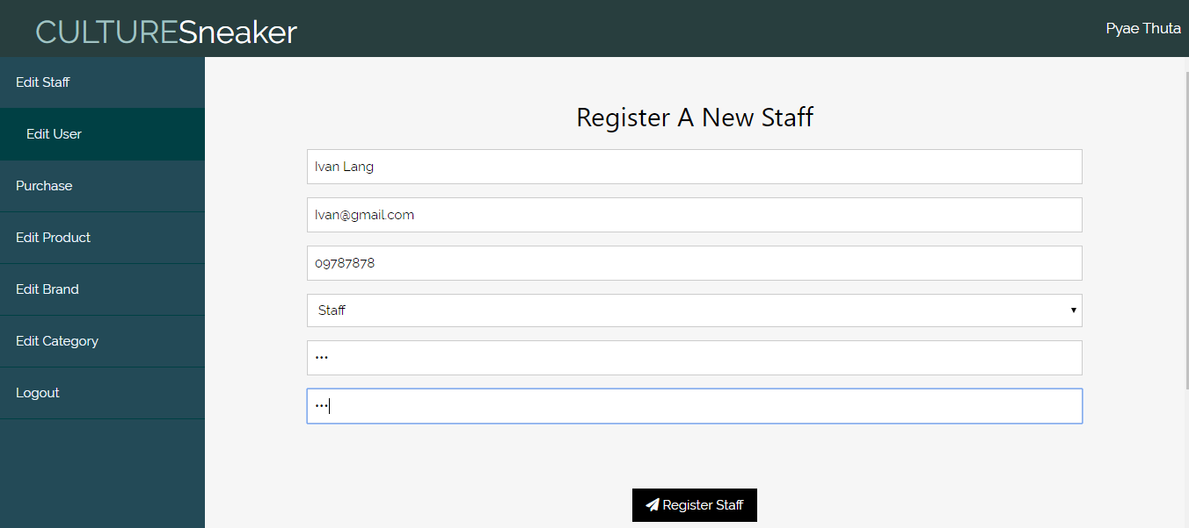

Fig.1.7.1

**After Testing**

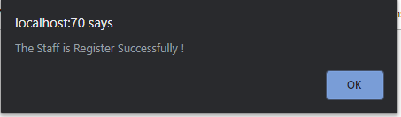

Fig.1.7.2

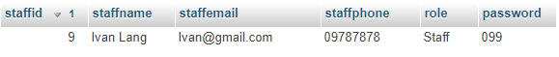

Fig.1.7.3

**Module 2: Logging into Staff Accounts**

|  |  |  |  |
| --- | --- | --- | --- |
| Test Script | Description | Date | Tester |
| 2.1 | Test “Email” text box | April 13, 2020 | Pyae Thuta |
| 2.2 | Test “Password” text box | April 13, 2020 | Pyae Thuta |
| 2.3 | Test “Unmatched Email and password” message box. | April 13, 2020 | Pyae Thuta |
| 2.4 | Test “Successful Login”. | April 13, 2020 | Pyae Thuta |

|  |  |  |  |  |
| --- | --- | --- | --- | --- |
| **Unit Test 1** | | **Test Case:** Testing Staff Log In process in Login Page. | **Designed by:** Pyae Thuta | |
| **Data Source:** Staff Login Page | | **Objective**: To test “Staff Email” test box. | **Tester**: Pyae Thuta | |
| **Test Case** | **Description** | **Test Procedure** | **Expected Result** | **Actual Results** |
| 2.1 | Testing if alert is shown when “Email” Text box is not filled with data. | “Login” button is clicked when “Staff Email” text box is not filled with data. | Show ‘Please fill out this field’ message. | See Fig.2.1.2 |

**Before Testing**

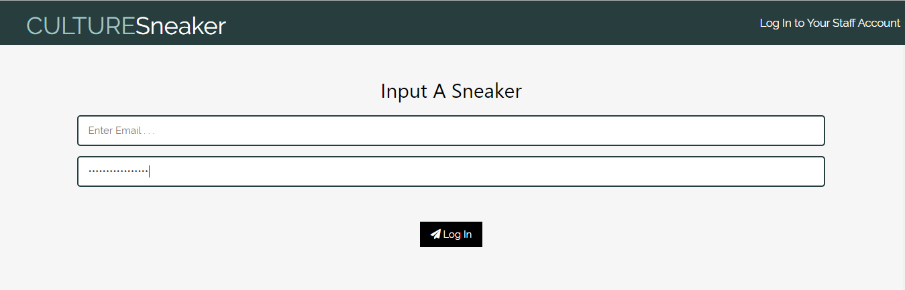

Fig.2.1.1

**After Testing**

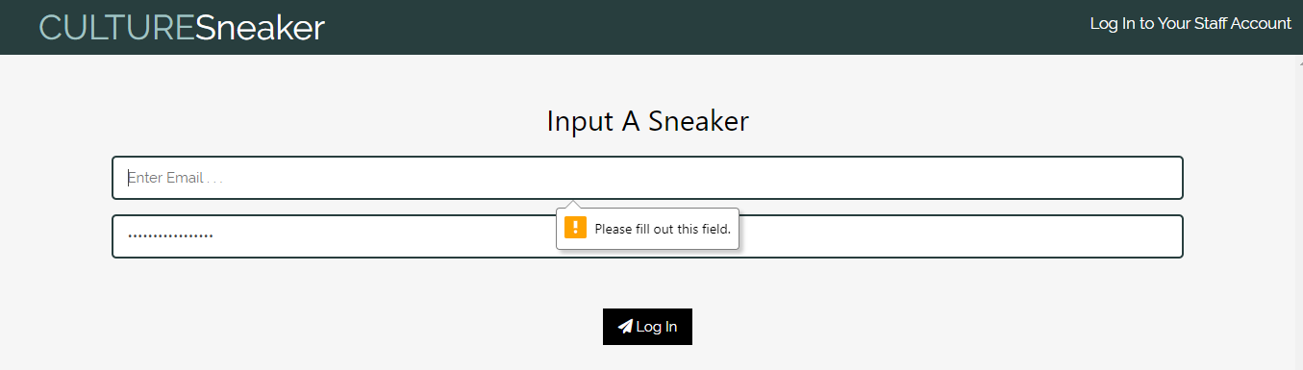

Fig.2.1.2

|  |  |  |  |  |
| --- | --- | --- | --- | --- |
| **Unit Test 2** | | **Test Case:** Testing Staff Log In process in Login Page. | **Designed by:** Pyae Thuta | |
| **Data Source:** Staff Login Page | | **Objective**: To test “Password” test box. | **Tester**: Pyae Thuta | |
| **Test Case** | **Description** | **Test Procedure** | **Expected Result** | **Actual Results** |
| 2.2 | Testing if alert is shown when “Password” Text box is not filled with data. | “Login” button is clicked when “Password” text box is not filled with data. | Show ‘Please fill out this field’ message. | See Fig.2.2.2 |

**Before Testing**

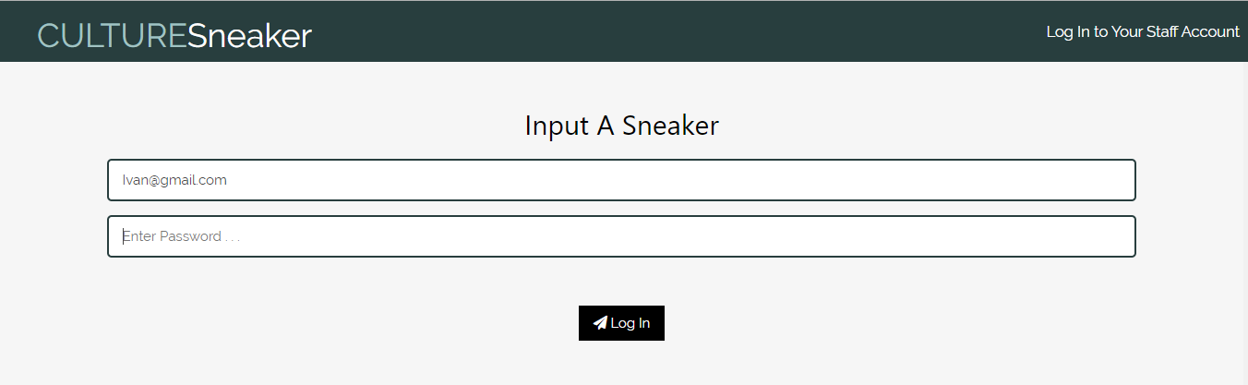

Fig.2.2.1

**After Testing**

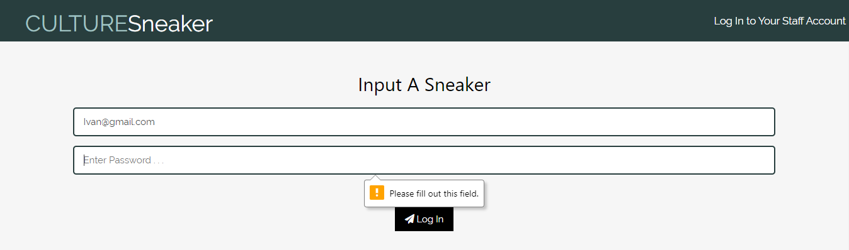

Fig.2.2.2

|  |  |  |  |  |
| --- | --- | --- | --- | --- |
| **Unit Test 3** | | **Test Case:** Testing Staff Log In process in Login Page. | **Designed by:** Pyae Thuta | |
| **Data Source:** Staff Login Page | | **Objective**: To test “Unmatched Email and password” message box. | **Tester**: Pyae Thuta | |
| **Test Case** | **Description** | **Test Procedure** | **Expected Result** | **Actual Results** |
| 2.3 | Testing if error message is shown when email and password are not matched. | “Login” button is clicked when text boxes are filled with wrong data. | Show error message box. | See Fig.2.3.2 |

**Before testing**

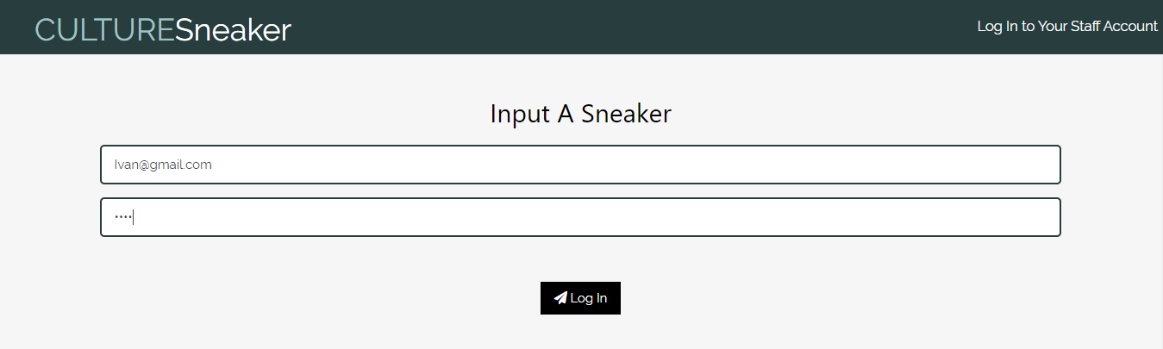

Fig.2.3.1

**After testing**

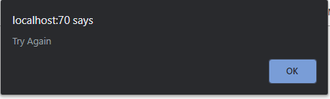

Fig.2.3.2

|  |  |  |  |  |
| --- | --- | --- | --- | --- |
| **Unit Test 4** | | **Test Case:** Testing Staff Log In process in Login Page. | **Designed by:** Pyae Thuta | |
| **Data Source:** Staff Login Page | | **Objective**: To test successful log in process. | **Tester**: Pyae Thuta | |
| **Test Case** | **Description** | **Test Procedure** | **Expected Result** | **Actual Results** |
| 2.4 | Testing if successful message is shown when input data are correct. | “Login” button is clicked when text boxes are filled with correct data. | Show successful message box. | See Fig.2.4.2 |

**Before Testing**

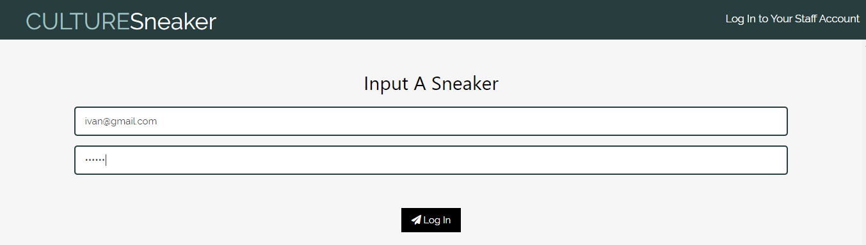

Fig.2.4.1

After Testing

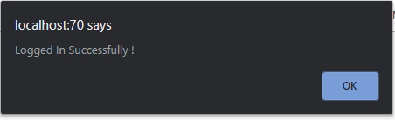

Fig.2.4.2

**Module 3: Sneaker Input Form**

|  |  |  |  |
| --- | --- | --- | --- |
| Test Script | Description | Date | Tester |
| 3.1 | Test “Sneaker Name” text box. | April 13, 2020 | Pyae Thuta |
| 3.2 | Test “Description” text box. | April 13, 2020 | Pyae Thuta |
| 3.3 | Test “Buying Price” text box. | April 13, 2020 | Pyae Thuta |
| 3.4 | Test “Sell stock price” text box. | April 13, 2020 | Pyae Thuta |
| 3.5 | Test “Choose File” text box. | April 13, 2020 | Pyae Thuta |
| 3.6 | Test “Upload Sneaker” button. | April 13, 2020 | Pyae Thuta |

|  |  |  |  |  |
| --- | --- | --- | --- | --- |
| **Unit Test 1** | | **Test Case:** Testing Sneaker Upload process in Edit Sneaker Page. | **Designed by:** Pyae Thuta | |
| **Data Source:** Edit Sneaker Page | | **Objective**: To test “Sneaker Name” text box. | **Tester**: Pyae Thuta | |
| **Test Case** | **Description** | **Test Procedure** | **Expected Result** | **Actual Results** |
| 3.1 | Testing if alert is shown if “Sneaker name” text box is not filled with data. | “Upload Sneaker” button is clicked when “Sneaker Name” text box is not filled with data. | Show “Please Fill Out of This Field” alert. | See Fig.3.1.2 |

**Before testing**

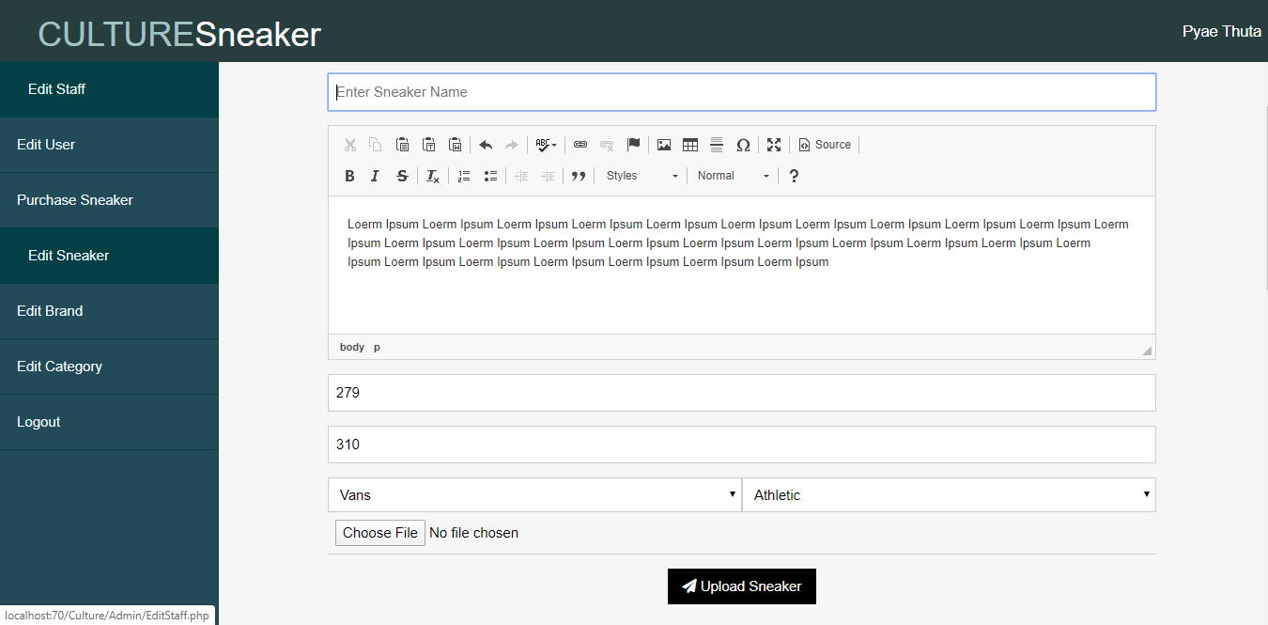

Fig.3.1.1

**After testing**

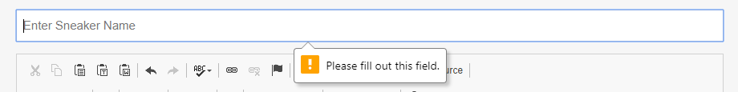

Fig.3.1.2

|  |  |  |  |  |
| --- | --- | --- | --- | --- |
| **Unit Test 2** | | **Test Case:** Testing Sneaker Upload process in Edit Sneaker Page. | **Designed by:** Pyae Thuta | |
| **Data Source:** Edit Sneaker Page | | **Objective**: To test “Description” text box. | **Tester**: Pyae Thuta | |
| **Test Case** | **Description** | **Test Procedure** | **Expected Result** | **Actual Results** |
| 3.2 | Testing if it is focused if “Description” text box is not filled with data. | “Upload Sneaker” button is clicked when “Description” text box is not filled with data. | Auto focus in “Description” text box. | See Fig.3.2.2 |

**Before Testing**

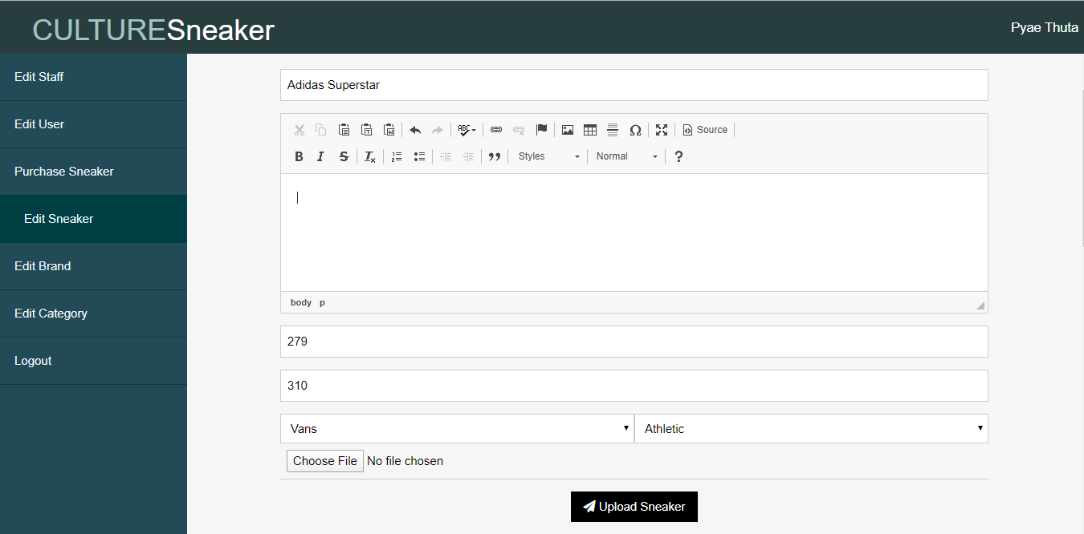

Fig.3.2.1

**After testing**



Fig.3.2.2

|  |  |  |  |  |
| --- | --- | --- | --- | --- |
| **Unit Test 3** | | **Test Case:** Testing Sneaker Upload process in Edit Sneaker Page. | **Designed by:** Pyae Thuta | |
| **Data Source:** Edit Sneaker Page | | **Objective**: To test “Buying price” text box. | **Tester**: Pyae Thuta | |
| **Test Case** | **Description** | **Test Procedure** | **Expected Result** | **Actual Results** |
| 3.3 | Testing if alert is shown if “Buying price” text box is not filled with data. | “Upload Sneaker” button is clicked when “Buying Price” text box is not filled with data. | Show “Please Fill Out of This Field” alert. | See Fig.3.3.2 |

**Before Testing**

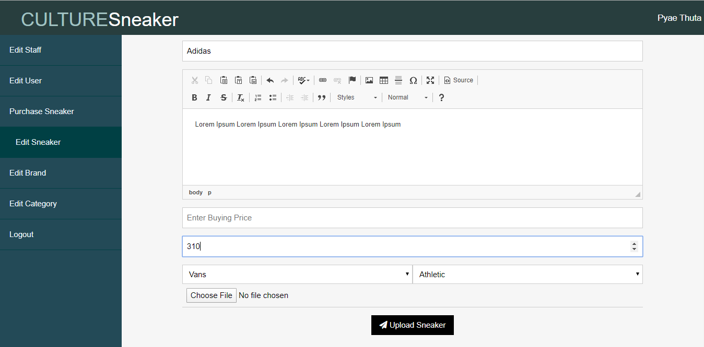

Fig.3.3.1

After testing

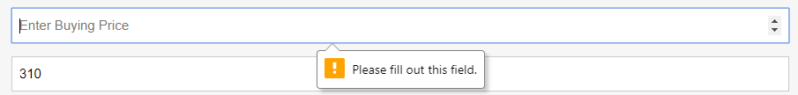

Fig.3.3.2

|  |  |  |  |  |
| --- | --- | --- | --- | --- |
| **Unit Test 4** | | **Test Case:** Testing Sneaker Upload process in Edit Sneaker Page. | **Designed by:** Pyae Thuta | |
| **Data Source:** Edit Sneaker Page | | **Objective**: To test “Sell Stock price” text box. | **Tester**: Pyae Thuta | |
| **Test Case** | **Description** | **Test Procedure** | **Expected Result** | **Actual Results** |
| 3.4 | Testing if alert is shown if “Sell Stock price” text box is not filled with data. | “Upload Sneaker” button is clicked when “Sell Stock Price” text box is not filled with data. | Show “Please Fill Out of This Field” alert. | See Fig.3.4.2 |

**Before Testing**

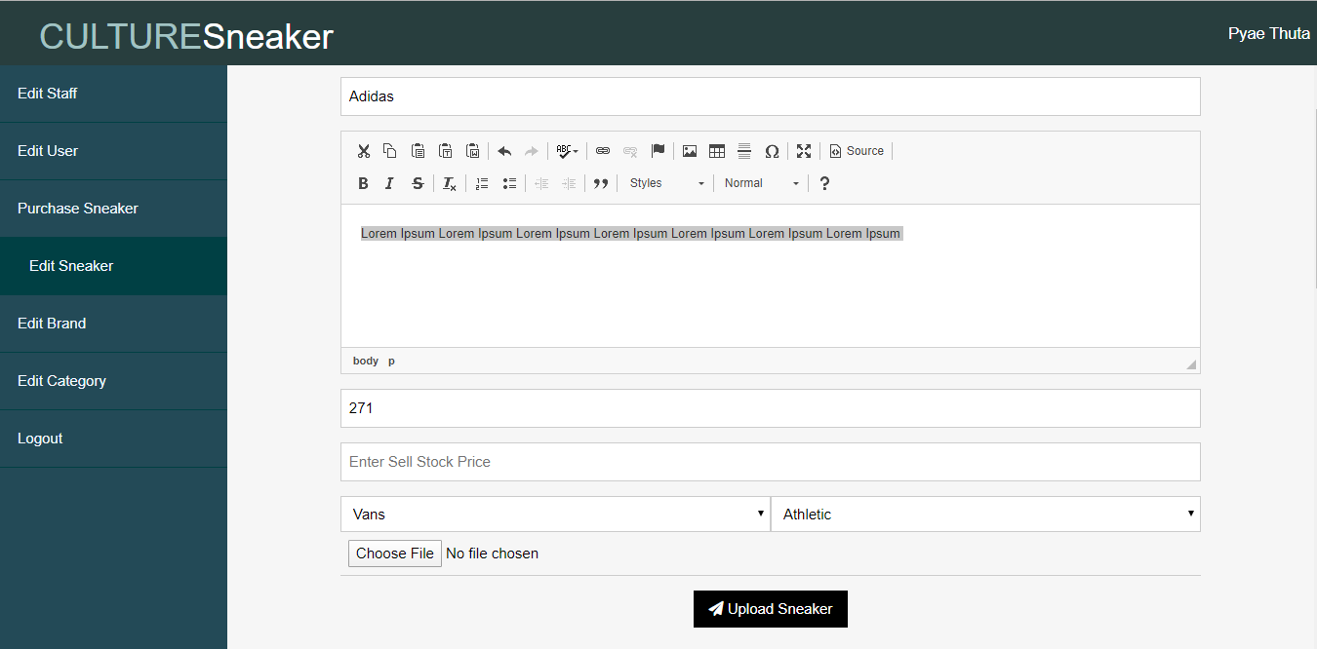

Fig.3.4.1

**After testing**

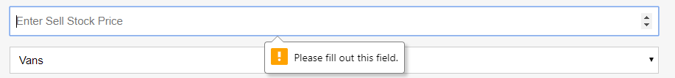

Fig.3.4.2

|  |  |  |  |  |
| --- | --- | --- | --- | --- |
| **Unit Test 5** | | **Test Case:** Testing Sneaker Upload process in Edit Sneaker Page. | **Designed by:** Pyae Thuta | |
| **Data Source:** Edit Sneaker Page | | **Objective**: To test “Choose File” text box. | **Tester**: Pyae Thuta | |
| **Test Case** | **Description** | **Test Procedure** | **Expected Result** | **Actual Results** |
| 3.5 | Testing if alert is shown if “Choose File” text box is not filled with data. | “Upload Sneaker” button is clicked when no image is chosen in “Choose File” box. | Show “Please Fill Out of This Field” alert. | See Fig.3.5.2 |

**Before Testing**

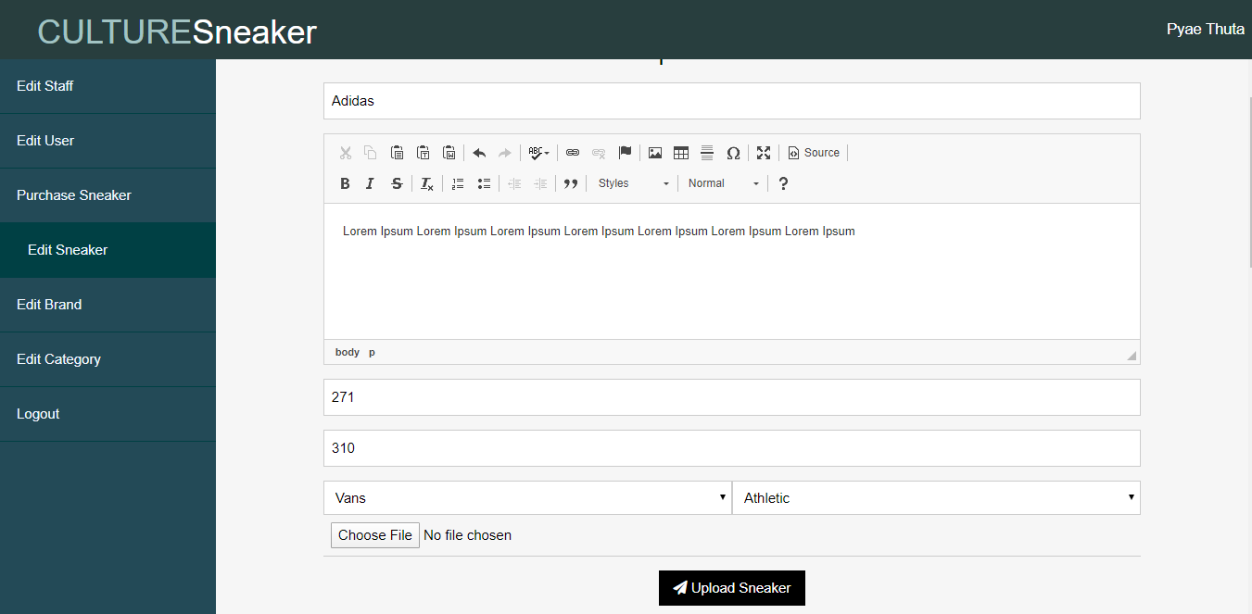

Fig.3.5.1

**After Testing**

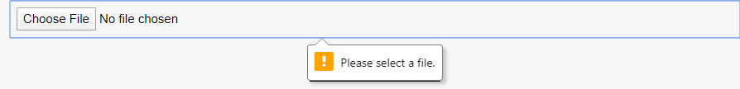

Fig.3.5.2

|  |  |  |  |  |
| --- | --- | --- | --- | --- |
| **Unit Test 6** | | **Test Case:** Testing Sneaker Upload process in Edit Sneaker Page. | **Designed by:** Pyae Thuta | |
| **Data Source:** Edit Sneaker Page | | **Objective**: To test “Upload Sneaker” button. | **Tester**: Pyae Thuta | |
| **Test Case** | **Description** | **Test Procedure** | **Expected Result** | **Actual Results** |
| 3.6 | Testing if message box is shown and data are saved if “Upload Sneaker” button is clicked. | “Upload Sneaker” button is clicked when all text boxes are filled with correct data. | Show successful message box. | See Fig.3.6.2 |

**Before Testing**

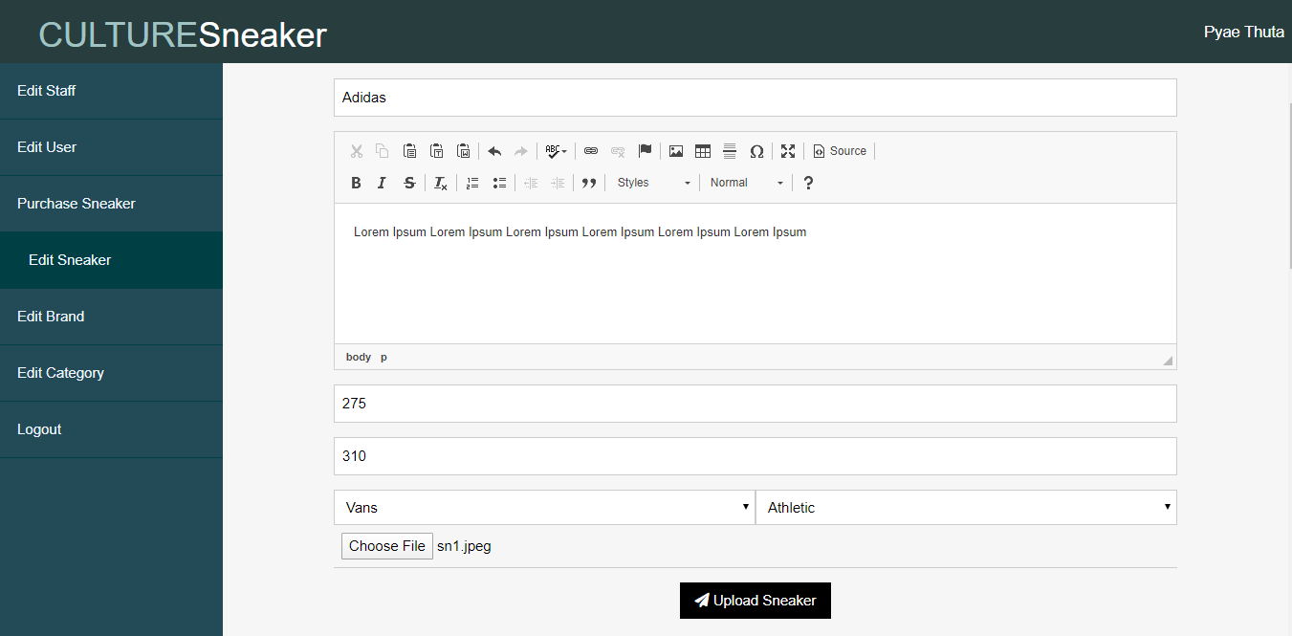

Fig.3.6.1

**After testing**

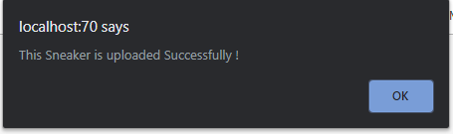

Fig.3.6.2

**Module 4: Brand Input Form**

|  |  |  |  |
| --- | --- | --- | --- |
| Test Script | Description | Date | Tester |
| 4.1 | Test “Brand Name” text box. | April 13, 2020 | Pyae Thuta |
| 4.2 | Test “Upload Brand” button. | April 13, 2020 | Pyae Thuta |
| 4.2 | Test “Delete Brand” button. | April 13, 2020 | Pyae Thuta |

|  |  |  |  |  |
| --- | --- | --- | --- | --- |
| **Unit Test 1** | | **Test Case:** Testing Brand Upload process in Edit Brand Page. | **Designed by:** Pyae Thuta | |
| **Data Source:** Edit Brand Page | | **Objective**: To test “Brand Name” text box. | **Tester**: Pyae Thuta | |
| **Test Case** | **Description** | **Test Procedure** | **Expected Result** | **Actual Results** |
| 4.1 | Testing if message box is shown if “Brand Name” text box is not filled with data. | “Upload Brand” button is clicked when “Brand Name” text box is not filed with data. | Show “Please Fill Out this filed” message. | See Fig.4.1.2 |

**Before Testing**

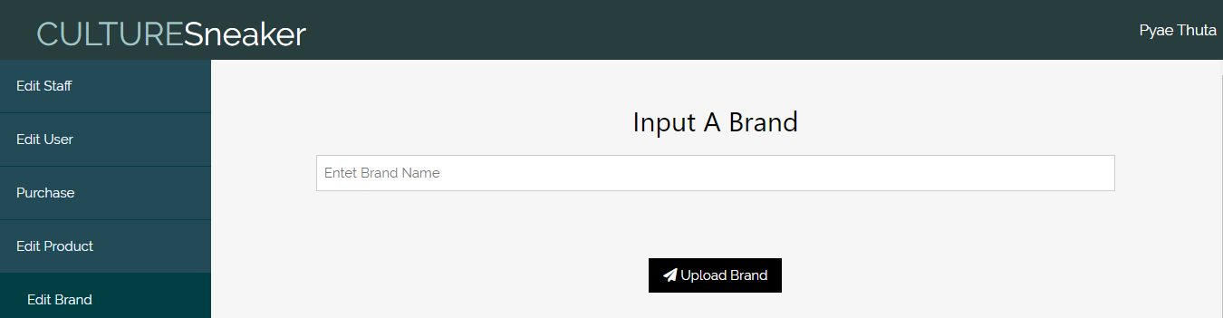

Fig.4.1.1

**After Testing**

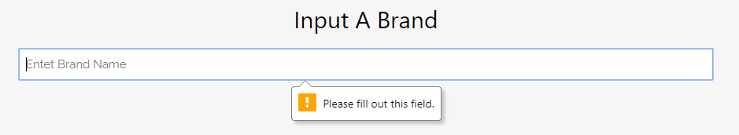

Fig.4.1.2

|  |  |  |  |  |
| --- | --- | --- | --- | --- |
| **Unit Test 2** | | **Test Case:** Testing Brand Upload process in Edit Brand Page. | **Designed by:** Pyae Thuta | |
| **Data Source:** Edit Brand Page | | **Objective**: To test “Upload Brand” button | **Tester**: Pyae Thuta | |
| **Test Case** | **Description** | **Test Procedure** | **Expected Result** | **Actual Results** |
| 4.2 | Testing if message box is shown and data is saved if text box is filled with data. | “Upload Brand” button is clicked when “Brand Name” text box is filed with data. | Show successful message. | See Fig.4.2.2 |

**Before testing**

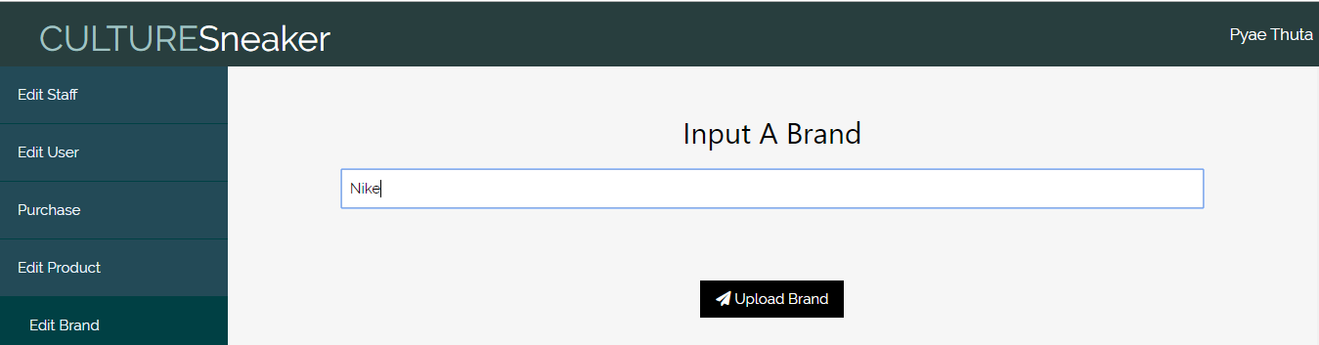

Fig.4.2.1

**After testing**

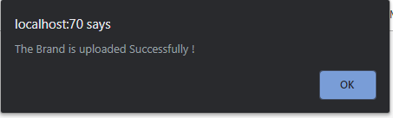

Fig.4.2.2

|  |  |  |  |  |
| --- | --- | --- | --- | --- |
| **Unit Test 3** | | **Test Case:** Testing Brand Delete process in Edit Brand Page. | **Designed by:** Pyae Thuta | |
| **Data Source:** Edit Brand Page | | **Objective**: To test “Delete Brand” button | **Tester**: Pyae Thuta | |
| **Test Case** | **Description** | **Test Procedure** | **Expected Result** | **Actual Results** |
| 4.3 | Testing if message box is shown and brand is deleted if “Delete Brand” button is clicked. | “Delete Brand” button is clicked. | Show “Deleted Successfully” message. | See Fig.4.3.2 |

**Before testing**

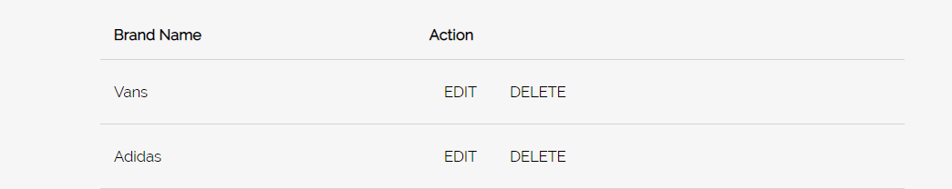

Fig.4.3.1

**After testing**

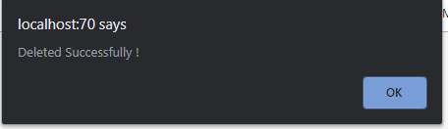

Fig.4.3.2

**Module 5: Category Input Form**

|  |  |  |  |
| --- | --- | --- | --- |
| Test Script | Description | Date | Tester |
| 5.1 | Test “Category Name” text box. | April 13, 2020 | Pyae Thuta |
| 5.2 | Test “Upload Category” button. | April 13, 2020 | Pyae Thuta |
| 5.3 | Test “Delete Category” button. | April 13, 2020 | Pyae Thuta |

|  |  |  |  |  |
| --- | --- | --- | --- | --- |
| **Unit Test 1** | | **Test Case:** Testing Category Upload process in Edit Category Page. | **Designed by:** Pyae Thuta | |
| **Data Source:** Edit Category Page | | **Objective**: To test “Category Name” text box. | **Tester**: Pyae Thuta | |
| **Test Case** | **Description** | **Test Procedure** | **Expected Result** | **Actual Results** |
| 5.1 | Testing if message box is shown if “Category Name” text box is not filled with data. | “Upload Category” button is clicked when “Category Name” text box is not filed with data. | Show “Please Fill Out this filed” message. | See Fig.5.1.2 |

**Before testing**

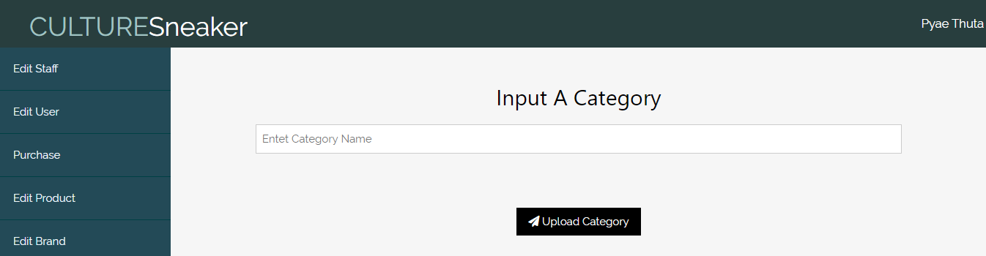

Fig.5.1.1

**After testing**

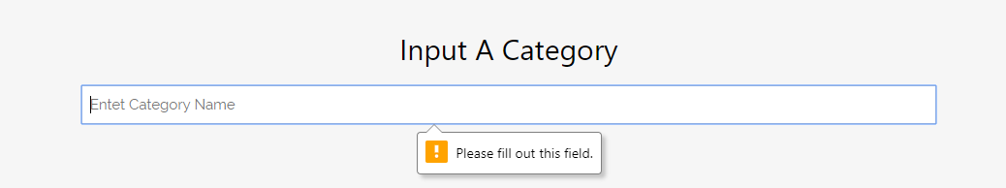

Fig.5.1.2

|  |  |  |  |  |
| --- | --- | --- | --- | --- |
| **Unit Test 2** | | **Test Case:** Testing Category Upload process in Edit Category Page. | **Designed by:** Pyae Thuta | |
| **Data Source:** Edit Category Page | | **Objective**: To test “Upload Category” button | **Tester**: Pyae Thuta | |
| **Test Case** | **Description** | **Test Procedure** | **Expected Result** | **Actual Results** |
| 5.2 | Testing if message box is shown and data is saved if text box is filled with data. | “Upload Category” button is clicked when “Category Name” text box is filed with data. | Show successful message. | See Fig.5.2.2 |

**Before testing**

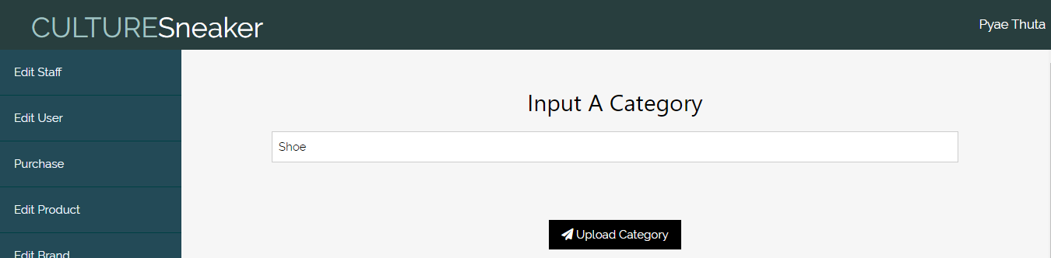

Fig.5.2.1

**After Testing**

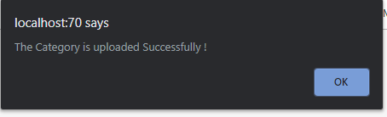

Fig.5.2.2

|  |  |  |  |  |
| --- | --- | --- | --- | --- |
| **Unit Test 3** | | **Test Case:** Testing Category Delete process in Edit Category Page. | **Designed by:** Pyae Thuta | |
| **Data Source:** Edit Category Page | | **Objective**: To test “Delete Category” button | **Tester**: Pyae Thuta | |
| **Test Case** | **Description** | **Test Procedure** | **Expected Result** | **Actual Results** |
| 5.3 | Testing if message box is shown and Category is deleted if “Delete Category” button is clicked. | “Delete Category” button is clicked. | Show “Category Deleted Successfully” message. | See Fig.5.3.2 |

**Before testing**

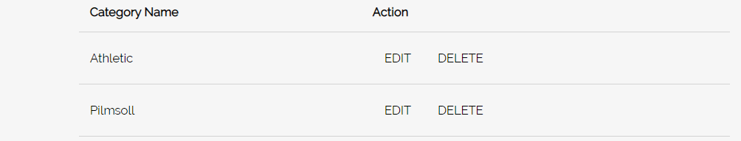

Fig.5.3.1

**After Testing**

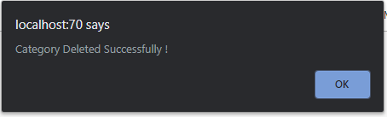

Fig.5.3.2

**Module 6: Supplier Input Form**

|  |  |  |  |
| --- | --- | --- | --- |
| Test Script | Description | Date | Tester |
| 6.1 | Test “Supplier Name” text box. | April 13, 2020 | Pyae Thuta |
| 6.2 | Test “Company Name” text box. | April 13, 2020 | Pyae Thuta |
| 6.3 | Test “Contact Number” text box. | April 13, 2020 | Pyae Thuta |
| 6.4 | Test “Supplier Upload” button. | April 13, 2020 | Pyae Thuta |
| 6.5 | Test “Delete Supplier” button. | April 13, 2020 | Pyae Thuta |

|  |  |  |  |  |
| --- | --- | --- | --- | --- |
| **Unit Test 1** | | **Test Case:** Testing Supplier Upload process in Edit Supplier Page. | **Designed by:** Pyae Thuta | |
| **Data Source:** Edit Supplier Page | | **Objective**: To test “Supplier Name” text box. | **Tester**: Pyae Thuta | |
| **Test Case** | **Description** | **Test Procedure** | **Expected Result** | **Actual Results** |
| 6.1 | Testing if message box is shown if “Supplier Name” text box is not filled with data. | “Upload Supplier” button is clicked when “Supplier Name” text box is not filed with data. | Show “Please Fill Out this filed” message. | See Fig.6.1.2 |

**Before testing**

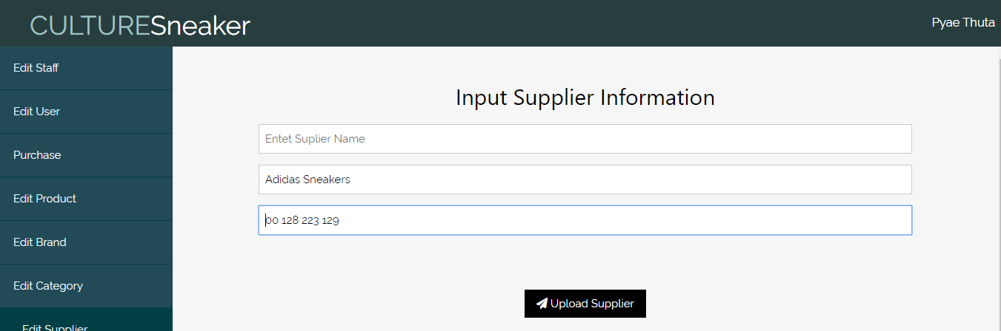

Fig.6.1.1

**After Testing**

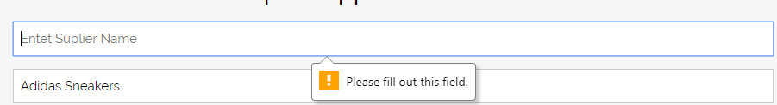

Fig.6.1.2

|  |  |  |  |  |
| --- | --- | --- | --- | --- |
| **Unit Test 2** | | **Test Case:** Testing Supplier Upload process in Edit Supplier Page. | **Designed by:** Pyae Thuta | |
| **Data Source:** Edit Supplier Page | | **Objective**: To test “Company Name” text box. | **Tester**: Pyae Thuta | |
| **Test Case** | **Description** | **Test Procedure** | **Expected Result** | **Actual Results** |
| 6.2 | Testing if message box is shown if “Company Name” text box is not filled with data. | “Upload Supplier” button is clicked when “Company Name” text box is not filed with data. | Show “Please Fill Out this filed” message. | See Fig.6.2.2 |

**Before Testing**

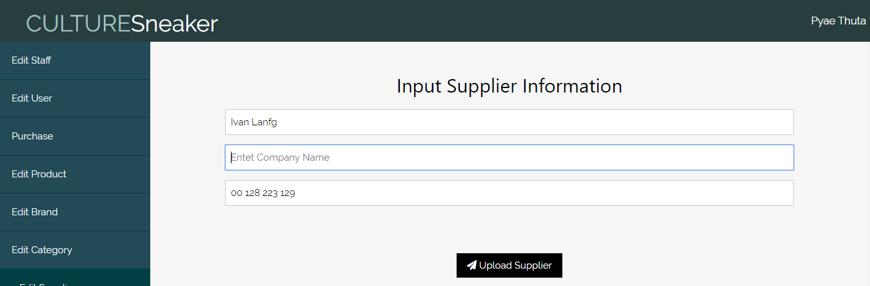

Fig.6.2.1

**After Testing**

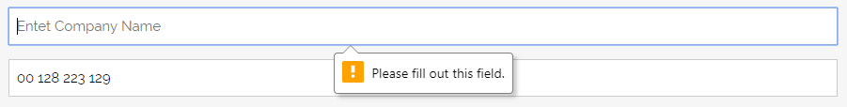

Fig.6.2.2

|  |  |  |  |  |
| --- | --- | --- | --- | --- |
| **Unit Test 3** | | **Test Case:** Testing Supplier Upload process in Edit Supplier Page. | **Designed by:** Pyae Thuta | |
| **Data Source:** Edit Supplier Page | | **Objective**: To test “Contact Number” text box. | **Tester**: Pyae Thuta | |
| **Test Case** | **Description** | **Test Procedure** | **Expected Result** | **Actual Results** |
| 6.3 | Testing if message box is shown if “Contact Number” text box is not filled with data. | “Upload Supplier” button is clicked when “Contact Number” text box is not filed with data. | Show “Please Fill Out this filed” message. | See Fig.6.3.2 |

**Before Testing**

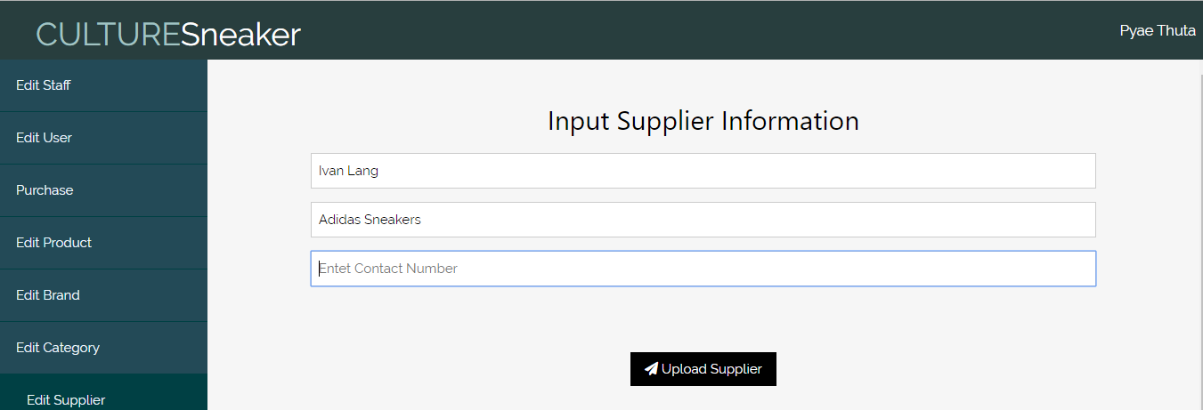

Fig.6.3.1

**After Testing**

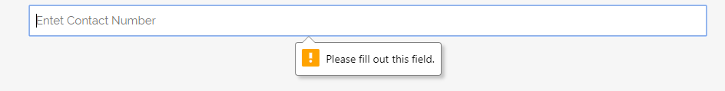

Fig.6.3.2

|  |  |  |  |  |
| --- | --- | --- | --- | --- |
| **Unit Test 4** | | **Test Case:** Testing Supplier Upload process in Edit Supplier Page. | **Designed by:** Pyae Thuta | |
| **Data Source:** Edit Supplier Page | | **Objective**: To test “Supplier Upload” button. | **Tester**: Pyae Thuta | |
| **Test Case** | **Description** | **Test Procedure** | **Expected Result** | **Actual Results** |
| 6.4 | Testing if message box is shown and supplier is recorded if all text boxes are filled with data. | “Upload Supplier” button is clicked when all text boxes are filled with correct data. | Show successful message box. | See Fig.6.4.2 |

**Before Testing**

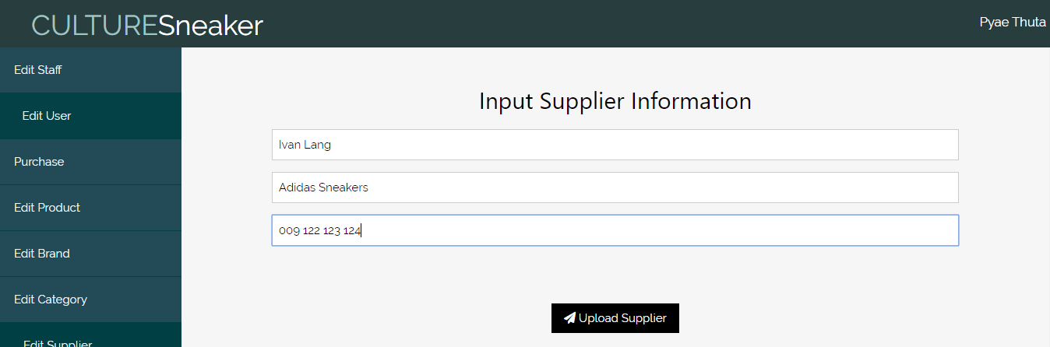

Fig.6.4.1

**After testing**

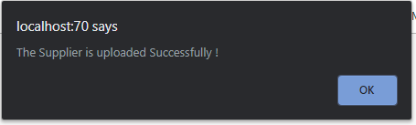

Fig.6.4.2

|  |  |  |  |  |
| --- | --- | --- | --- | --- |
| **Unit Test 5** | | **Test Case:** Testing Supplier Upload process in Edit Supplier Page. | **Designed by:** Pyae Thuta | |
| **Data Source:** Edit Supplier Page | | **Objective**: To test “Supplier Delete” button. | **Tester**: Pyae Thuta | |
| **Test Case** | **Description** | **Test Procedure** | **Expected Result** | **Actual Results** |
| 6.5 | Testing if message box is shown and supplier is deleted if “Delete Supplier” button is clicked. | “Delete Supplier” button is clicked. | Show “Supplier Deleted Successfully!” message box. | See Fig.6.5.2 |

**Before testing**

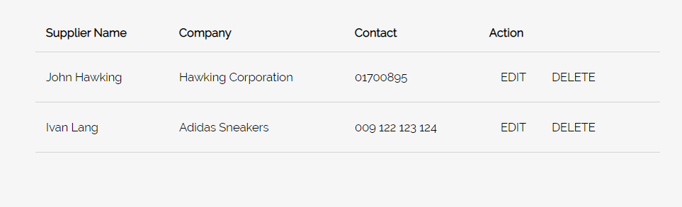

Fig.6.5.1

**After testing**

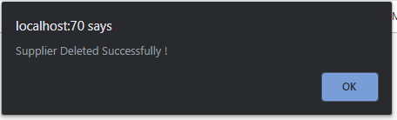

Fig.6.5.2

**Module 7: Purchase Sneaker Process**

|  |  |  |  |
| --- | --- | --- | --- |
| Test Script | Description | Date | Tester |
| 7.1 | Test “Quantity” number text box. | April 14, 2020 | Pyae Thuta |
| 7.2 | Test “Add” button. | April 14, 2020 | Pyae Thuta |
| 7.3 | Test “Remove Form Cart” button. | April 14, 2020 | Pyae Thuta |
| 7.4 | Test “Purchase Now” button. | April 14, 2020 | Pyae Thuta |
| 7.5 | Test “Show Invoice” button. | April 14, 2020 | Pyae Thuta |
| 7.6 | Test “Print” button. | April 14, 2020 | Pyae Thuta |

|  |  |  |  |  |
| --- | --- | --- | --- | --- |
| **Unit Test 1** | | **Test Case:** Testing Purchase Sneaker process. | **Designed by:** Pyae Thuta | |
| **Data Source:** Purchase Page. | | **Objective**: To test “Quantity” number text box. | **Tester**: Pyae Thuta | |
| **Test Case** | **Description** | **Test Procedure** | **Expected Result** | **Actual Results** |
| 7.1 | Testing if message box is shown if “Quantity” number box is not filled. | Click “Add” button when “Quantity” number box is not filled with data. | Show “Please Fill Out This Field” message. | See Fig.7.1.2 |

**Before Testing**

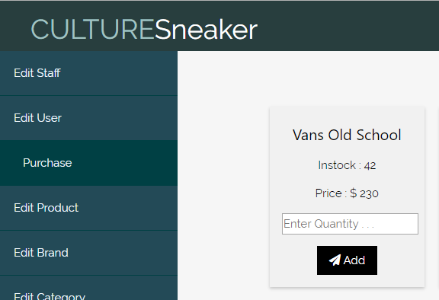

Fig.7.1.1

**After Testing**

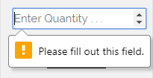

Fig.7.1.2

|  |  |  |  |  |
| --- | --- | --- | --- | --- |
| **Unit Test 2** | | **Test Case:** Testing Purchase Sneaker process. | **Designed by:** Pyae Thuta | |
| **Data Source:** Purchase Page. | | **Objective**: To test “Add” button. | **Tester**: Pyae Thuta | |
| **Test Case** | **Description** | **Test Procedure** | **Expected Result** | **Actual Results** |
| 7.2 | Testing if sneaker is added to cart and removed from the list when “Add” button is clicked. | Click “Add” button when “Quantity” number box is filled with data. | Sneaker is added to cart and removed from the list. | See Fig.7.2.2 & Fig.7.2.3 |

**Before Testing**

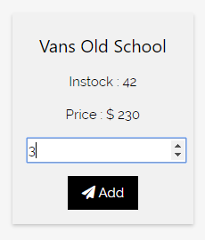

Fig.7.2.1

**After Testing**

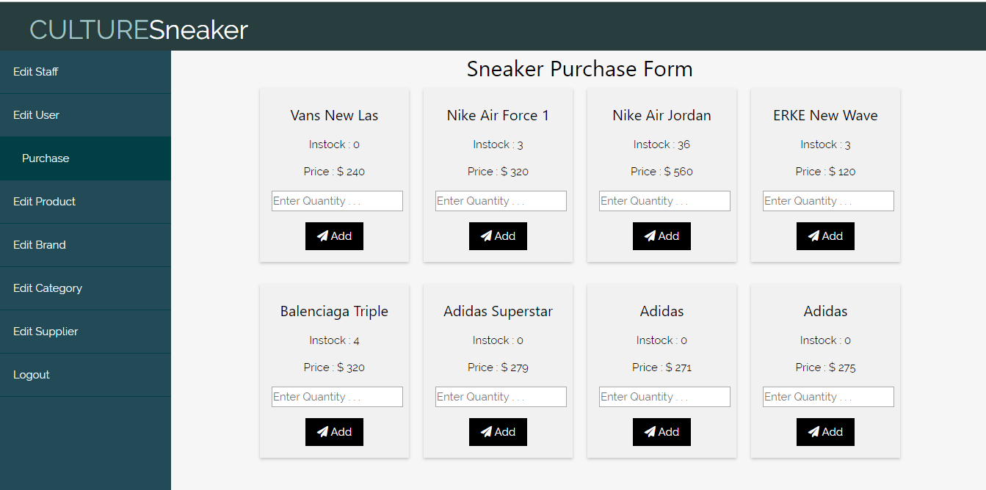

Fig.7.2.2 (*Sneaker Is removed from the list.*)

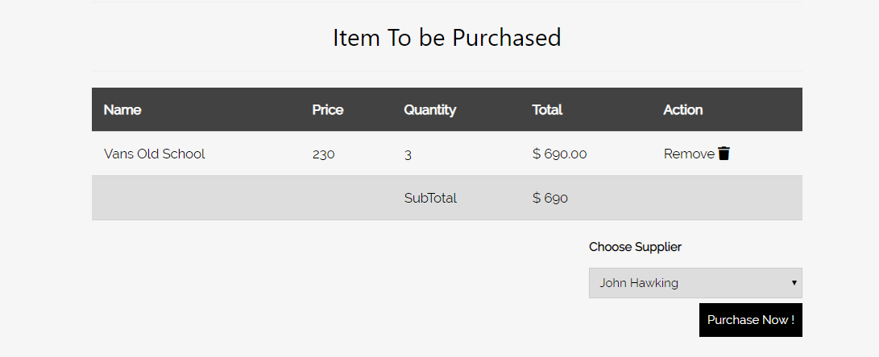

Fig.7.2.3

|  |  |  |  |  |
| --- | --- | --- | --- | --- |
| **Unit Test 3** | | **Test Case:** Testing Purchase Sneaker process. | **Designed by:** Pyae Thuta | |
| **Data Source:** Purchase Page. | | **Objective**: To test “Remove Form Cart” button. | **Tester**: Pyae Thuta | |
| **Test Case** | **Description** | **Test Procedure** | **Expected Result** | **Actual Results** |
| 7.3 | Testing if sneaker is removed from the cart and returned to the list when “Remove” button is clicked. | Click “Remove” button in the cart. | Sneaker is removed from the cart and returned to the list. | See Fig.7.3.2 & Fig.7.3.3 |

**Before Testing**

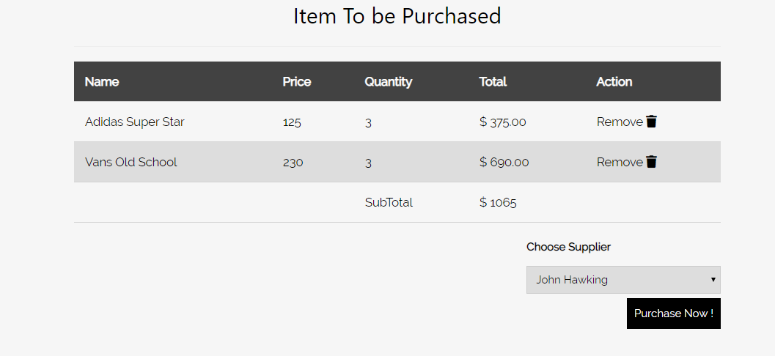

Fig.7.3.1

**After Testing**

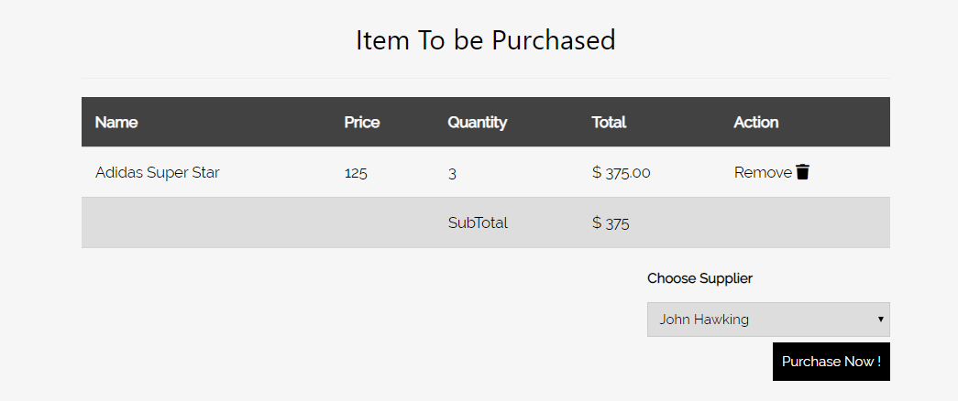

Fig.7.3.2 (*Item removed.*)

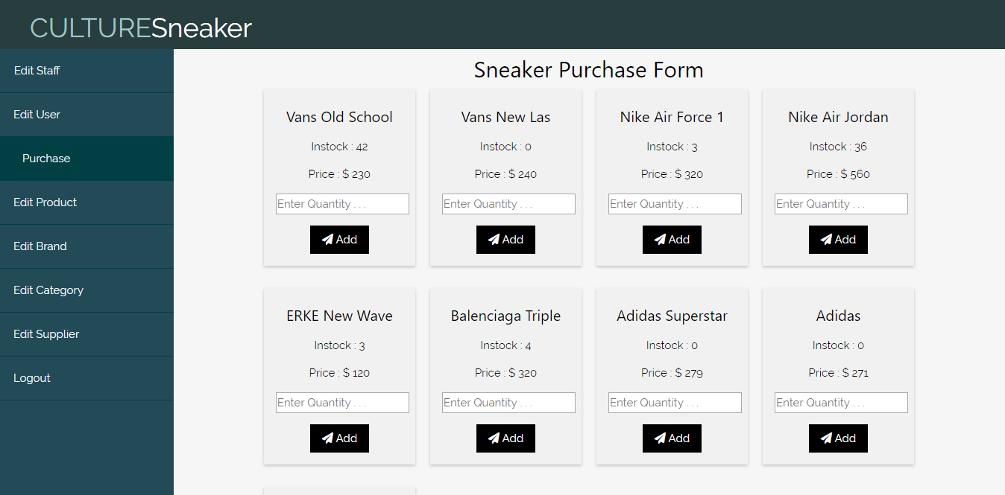

Fig.7.3.3

|  |  |  |  |  |
| --- | --- | --- | --- | --- |
| **Unit Test 4** | | **Test Case:** Testing Purchase Sneaker process. | **Designed by:** Pyae Thuta | |
| **Data Source:** Purchase Page. | | **Objective**: To test “Purchase Now” button. | **Tester**: Pyae Thuta | |
| **Test Case** | **Description** | **Test Procedure** | **Expected Result** | **Actual Results** |
| 7.4 | Testing if Message box is shown and data are saved if “Purchase Now” button is clicked. | Click “Purchase Now” button. | Message box is shown and purchase data are saved. | See Fig.7.4.2 & Fig.7.4.3 |

**Before Testing**

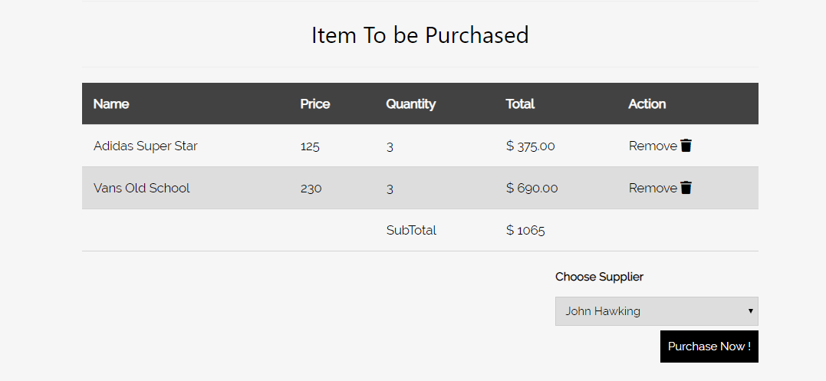

Fig.7.4.1

**After testing**

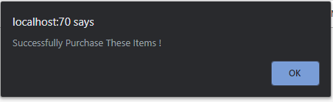

Fig.7.4.2

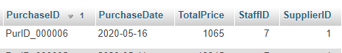

Fig.7.4.3

|  |  |  |  |  |
| --- | --- | --- | --- | --- |
| **Unit Test 5** | | **Test Case:** Testing Purchase Sneaker process. | **Designed by:** Pyae Thuta | |
| **Data Source:** Purchase Page. | | **Objective**: To test “Show Invoice” button. | **Tester**: Pyae Thuta | |
| **Test Case** | **Description** | **Test Procedure** | **Expected Result** | **Actual Results** |
| 7.5 | Testing if Invoice Page is reached if “Show Invoice” button is clicked. | Click “Show Invoice” button. | Invoice Page is reached. | See Fig.7.5.2 |

**Before Testing**

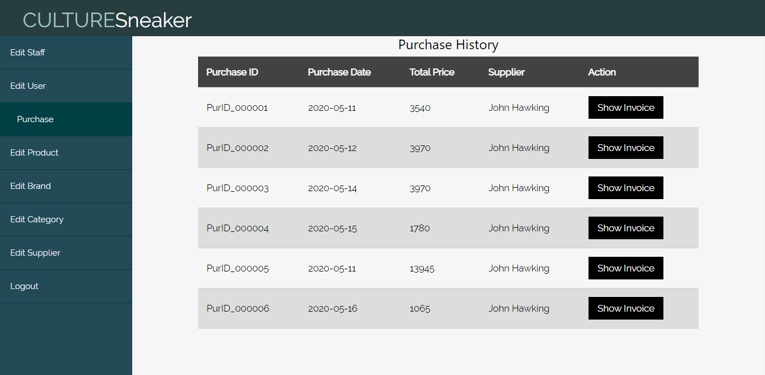

Fig.7.5.1

**After Testing**

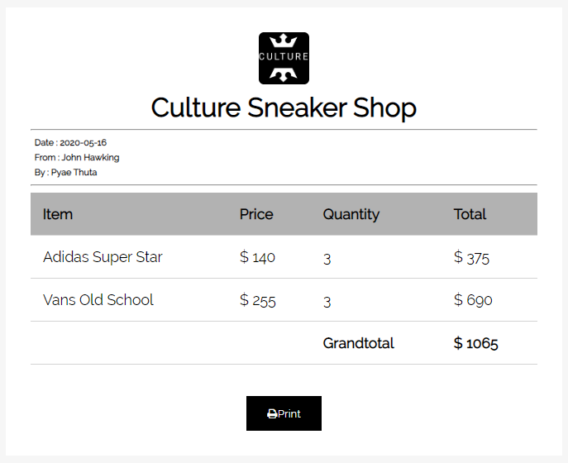

Fig.7.5.2

|  |  |  |  |  |
| --- | --- | --- | --- | --- |
| **Unit Test 6** | | **Test Case:** Testing Purchase Sneaker process. | **Designed by:** Pyae Thuta | |
| **Data Source:** Invoice Page. | | **Objective**: To test “Print” button. | **Tester**: Pyae Thuta | |
| **Test Case** | **Description** | **Test Procedure** | **Expected Result** | **Actual Results** |
| 7.6 | Testing if “Print” button is work. | Click “Print” button in invoice page. | Print dialogue box is shown | See Fig7.6.2 |

**Before Testing**

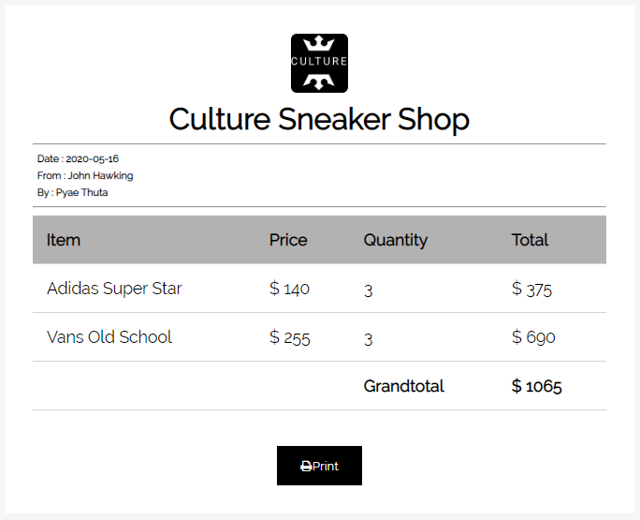

Fig7.6.1

**After Testing**

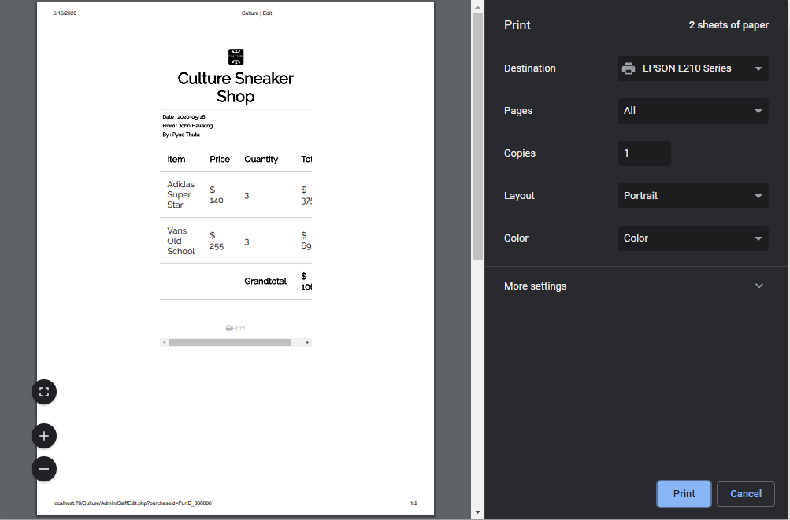

Fig7.6.2

### Timebox 2: Managing Order Process Time Box Development

|  |  |  |  |  |
| --- | --- | --- | --- | --- |
| **Unit Test 2** | | **Test Case:** Testing Customer Registering process in Register Page. | **Designed by:** Pyae Thuta | |
| **Data Source:** Register Page | | **Objective**: Test “Email” text box. | **Tester**: Pyae Thuta | |
| **Test Case** | **Description** | **Test Procedure** | **Expected Result** | **Actual Results** |
| 8.2 | Testing if alert is shown when “Email” Text box is not filled with data. | “Sign Up” button is clicked and “Email” Text box is not filled with data. | Show alert and ‘Please fill out this field’ message. | See Fig.8.2.2 |

Before Testing

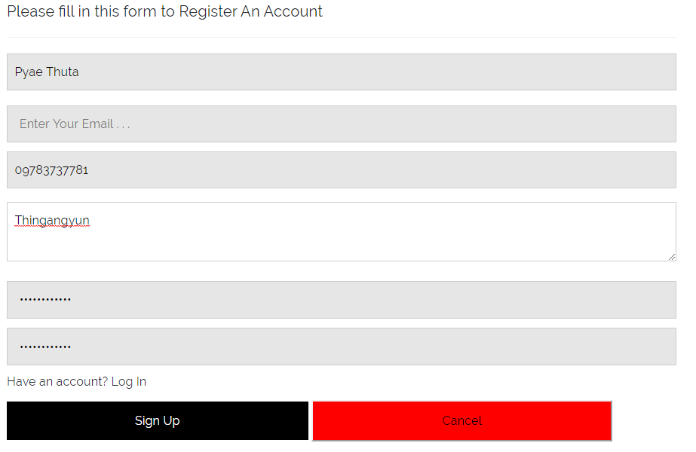

Fig.8.2.1

After testing

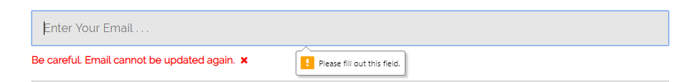

Fig.8.2.2

|  |  |  |  |  |
| --- | --- | --- | --- | --- |
| **Unit Test 3** | | **Test Case:** Testing Customer Registering process in Register Page. | **Designed by:** Pyae Thuta | |
| **Data Source:** Register Page | | **Objective**: Test “Phone Number” text box. | **Tester**: Pyae Thuta | |
| **Test Case** | **Description** | **Test Procedure** | **Expected Result** | **Actual Results** |
| 8.3 | Testing if alert is shown when “Phone Number” Text box is not filled with data. | “Sign Up” button is clicked and “Phone Number” Text box is not filled with data. | Show ‘Please fill out this field’ message. | See Fig.8.3.2 |

Before Testing

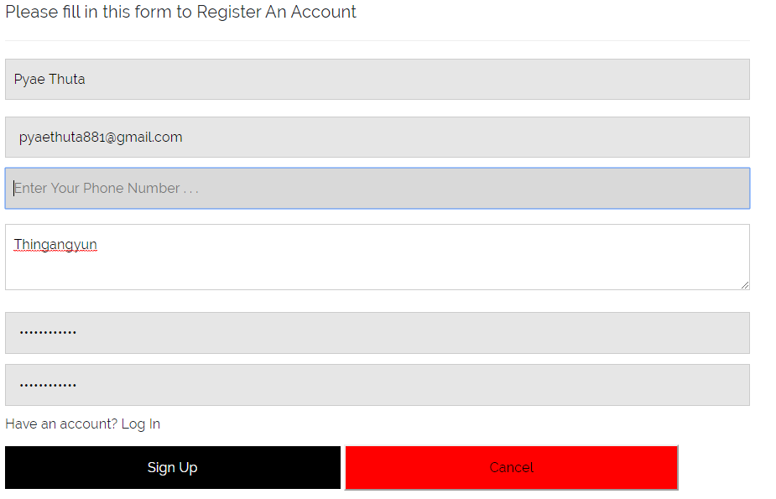

Fig.8.3.1

After testing

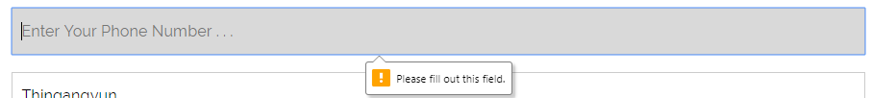

Fig.8.3.2

|  |  |  |  |  |
| --- | --- | --- | --- | --- |
| **Unit Test 4** | | **Test Case:** Testing Customer Registering process in Register Page. | **Designed by:** Pyae Thuta | |
| **Data Source:** Register Page | | **Objective**: Test “Address” text box. | **Tester**: Pyae Thuta | |
| **Test Case** | **Description** | **Test Procedure** | **Expected Result** | **Actual Results** |
| 8.4 | Testing if alert is shown when “Address” Text box is not filled with data. | “Sign Up” button is clicked and “Address” Text box is not filled with data. | Show ‘Please fill out this field’ message. | See Fig.8.4.2 |

Before Testing

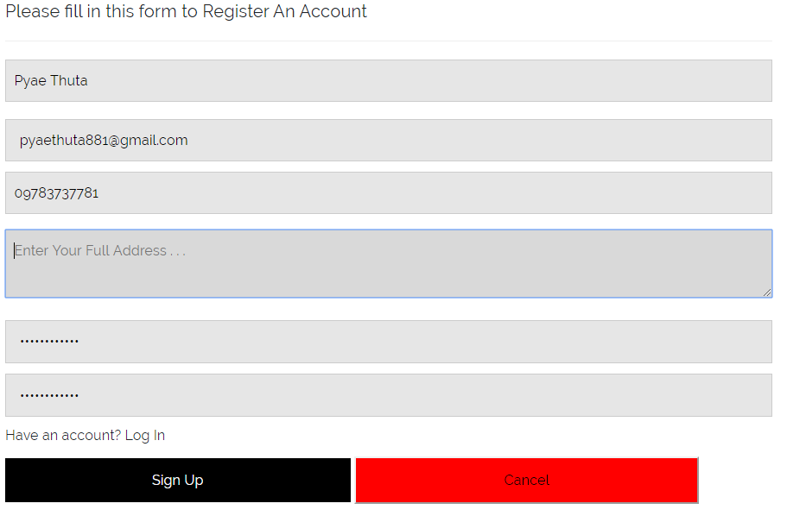

Fig.1.4.1

After Testing

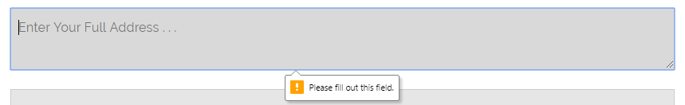

Fig.1.4.2

|  |  |  |  |  |
| --- | --- | --- | --- | --- |
| **Unit Test 5** | | **Test Case:** Testing Customer Registering process in Register Page. | **Designed by:** Pyae Thuta | |
| **Data Source:** Register Page | | **Objective**: Test “Password” text box. | **Tester**: Pyae Thuta | |
| **Test Case** | **Description** | **Test Procedure** | **Expected Result** | **Actual Results** |
| 8.5 | Testing if alert is shown when “Password” Text box is not filled with data. | “Sign Up” button is clicked and “Password” Text box is not filled with data. | Show ‘Please fill out this field’ message. | See Fig.8.5.2 |

Before testing

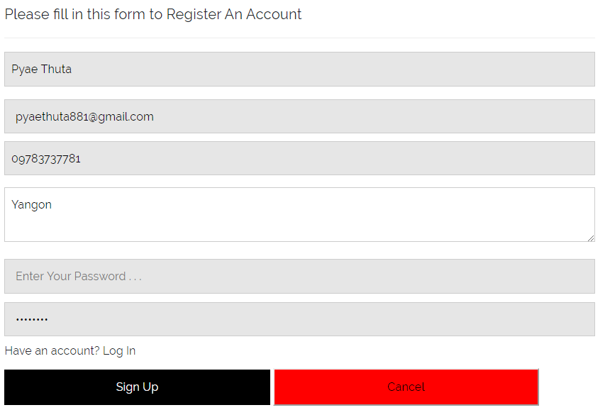

Fig.8.5.1

After testing

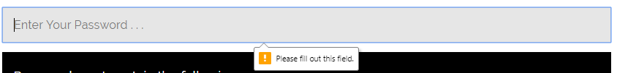

Fig.8.5.2

|  |  |  |  |  |
| --- | --- | --- | --- | --- |
| **Unit Test 6** | | **Test Case:** Testing Customer Registering process in Register Page. | **Designed by:** Pyae Thuta | |
| **Data Source:** Register Page | | **Objective**: Test “Password Validation” script. | **Tester**: Pyae Thuta | |
| **Test Case** | **Description** | **Test Procedure** | **Expected Result** | **Actual Results** |
| 8.6 | Testing if “Password validation form” is shown when password text box is focused. | Focus on “Password” text box. | Show ‘Password validation” Form. | See Fig.8.6.2 |

Before Testing

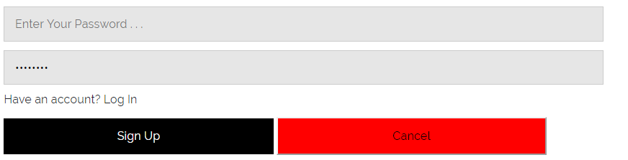

Fig.8.6.1

After testing

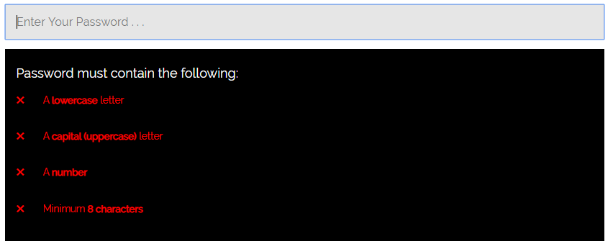

Fig.8.6.2

|  |  |  |  |  |
| --- | --- | --- | --- | --- |
| **Unit Test 7** | | **Test Case:** Testing Customer Registering process in Register Page. | **Designed by:** Pyae Thuta | |
| **Data Source:** Register Page | | **Objective**: Test “Confirm Password” text box. | **Tester**: Pyae Thuta | |
| **Test Case** | **Description** | **Test Procedure** | **Expected Result** | **Actual Results** |
| 8.7 | Testing if alert is shown when “Confirm Password” Text box is not filled with data. | “Sign Up” button is clicked and “Confirm Password” Text box is not filled with data. | Show ‘Please fill out this field’ message. | See Fig.8.7.2 |

Before Testing

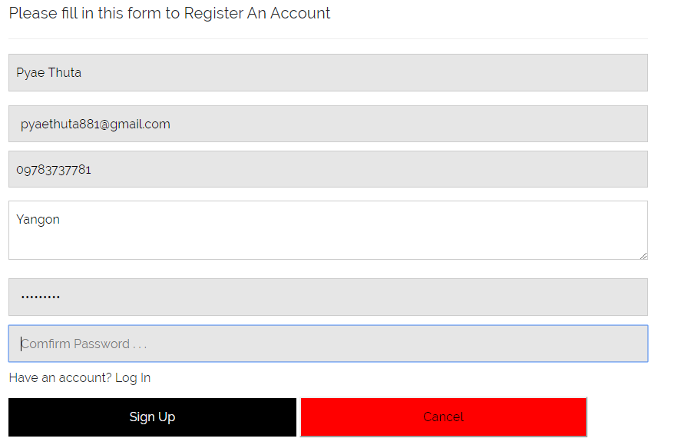

Fig.8.7.1

After Testing

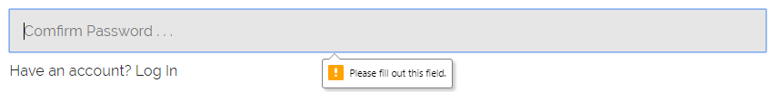

Fig.8.7.2

|  |  |  |  |  |
| --- | --- | --- | --- | --- |
| **Unit Test 8** | | **Test Case:** Testing Customer Registering process in Register Page. | **Designed by:** Pyae Thuta | |
| **Data Source:** Register Page | | **Objective**: Test unmatched password. | **Tester**: Pyae Thuta | |
| **Test Case** | **Description** | **Test Procedure** | **Expected Result** | **Actual Results** |
| 8.8 | Testing if error message box is shown when passwords are not match. | “Sign Up” button is clicked and input different passwords in password and confirm password text boxes. | Show error massage box. | See Fig.8.8.2 |

Before testing

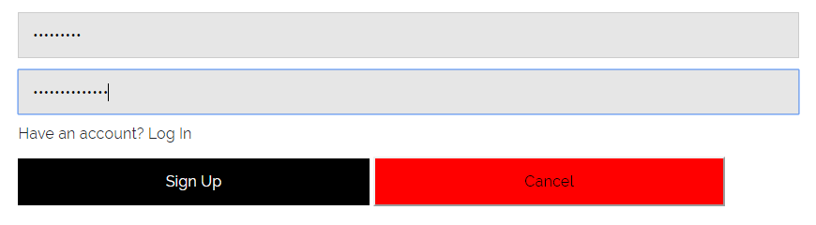

Fig.8.8.1

After Testing

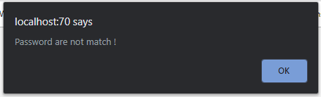

Fig.8.8.2

|  |  |  |  |  |
| --- | --- | --- | --- | --- |
| **Unit Test 9** | | **Test Case:** Testing Customer Registering process in Register Page. | **Designed by:** Pyae Thuta | |
| **Data Source:** Register Page | | **Objective**: Test Successful registering. | **Tester**: Pyae Thuta | |
| **Test Case** | **Description** | **Test Procedure** | **Expected Result** | **Actual Results** |
| 8.9 | Testing if message box is shown and Home page is reached when user input all text box with correct data. | “Sign Up” button is clicked when all text boxes are filled with correct data. | Show success massage box and reach home page. | See Fig.8.9.2 & 8.9.3 |

Before Testing

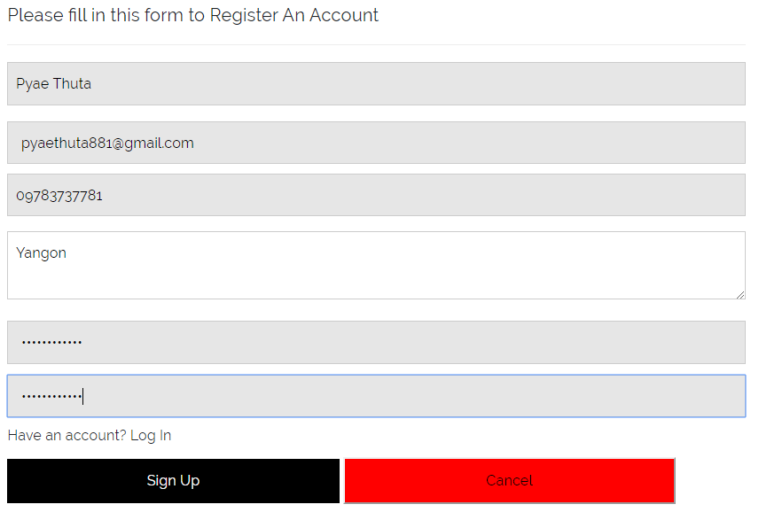

Fig.8.9.1

After Testing

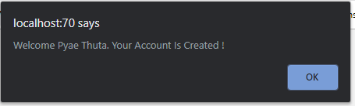

Fig.8.9.2

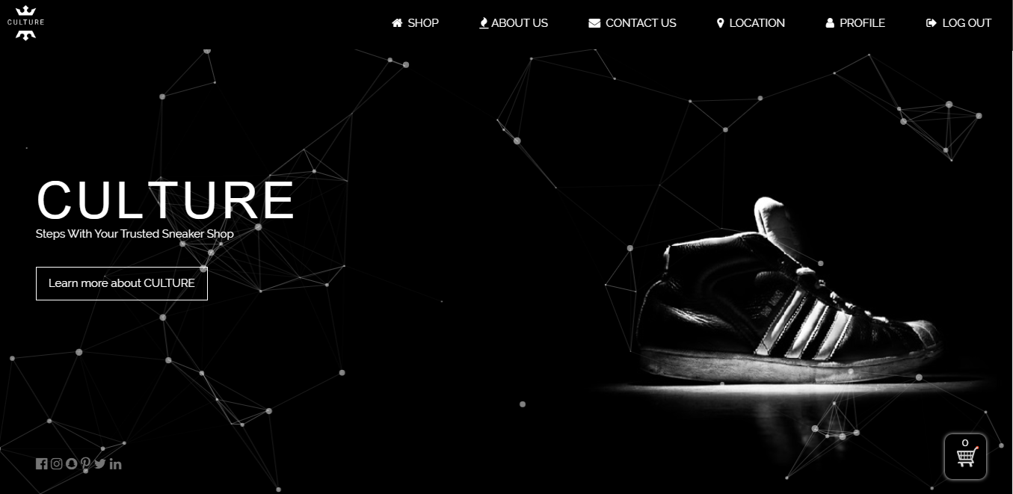

Fig.8.9.3

**Module 9: Login & Logout Process**

|  |  |  |  |
| --- | --- | --- | --- |
| Test Script | Description | Date | Tester |
| 9.1 | Test “Email” Text box. | April 13, 2020 | Pyae Thuta |
| 9.2 | Test “Password” Text box. | April 13, 2020 | Pyae Thuta |
| 9.3 | Test “Log in” button with unavailable email. | April 13, 2020 | Pyae Thuta |
| 9.4 | Test “Log in” button with wrong password. | April 13, 2020 | Pyae Thuta |
| 9.5 | Test “Log in” button with correct information. | April 13, 2020 | Pyae Thuta |
| 9.6 | Test “Log Out” button. | April 13, 2020 | Pyae Thuta |

Test Script (1)

|  |  |  |  |  |
| --- | --- | --- | --- | --- |
| **Unit Test 1** | | **Test Case:** Shopping Cart Function | **Designed by:** Pyae Thuta | |
| **Data Source:** Login Page | | **Objective**: Test “Email” Text box. | **Tester**: Pyae Thuta | |
| **Test Case** | **Description** | **Test Procedure** | **Expected Result** | **Actual Results** |
| 9.1 | Testing if alert is shown when “Email” test box is not filled with data. | Click “Log In” button when “Email” test box is not filled with data. | Show “Please Fill out of this field” alert. | See Fig.9.1.2 |

Before Testing

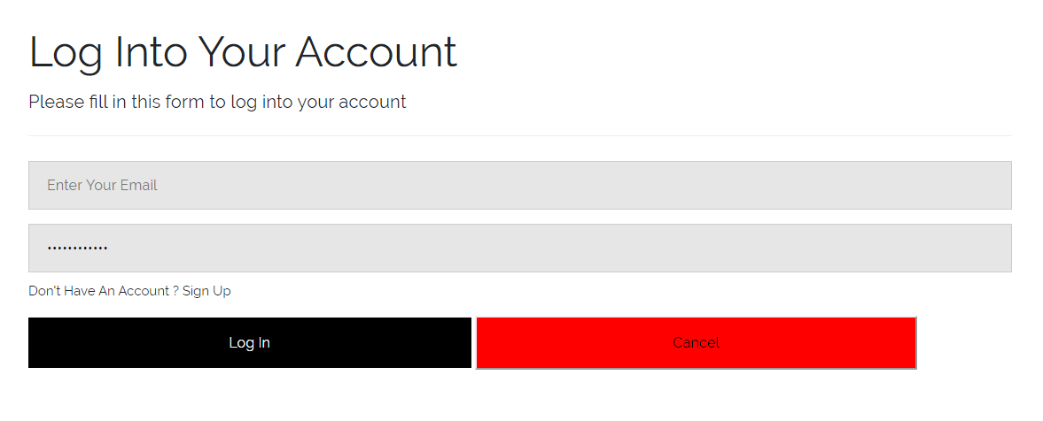

Fig.9.1.1

After Testing

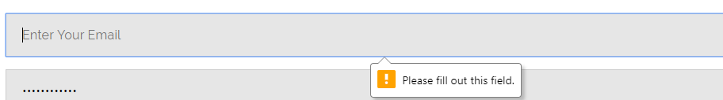

Fig.9.1.2

Test Script (2)

|  |  |  |  |  |
| --- | --- | --- | --- | --- |
| **Unit Test 2** | | **Test Case:** Shopping Cart Function | **Designed by:** Pyae Thuta | |
| **Data Source:** Login Page | | **Objective**: Test “Password” Text box. | **Tester**: Pyae Thuta | |
| **Test Case** | **Description** | **Test Procedure** | **Expected Result** | **Actual Results** |
| 9.2 | Testing if alert is shown when “Password” test box is not filled with data. | Click “Log In” button when “Password” test box is not filled with data. | Show “Please Fill out of this field” alert. | See Fig.9.2.2 |

Before testing

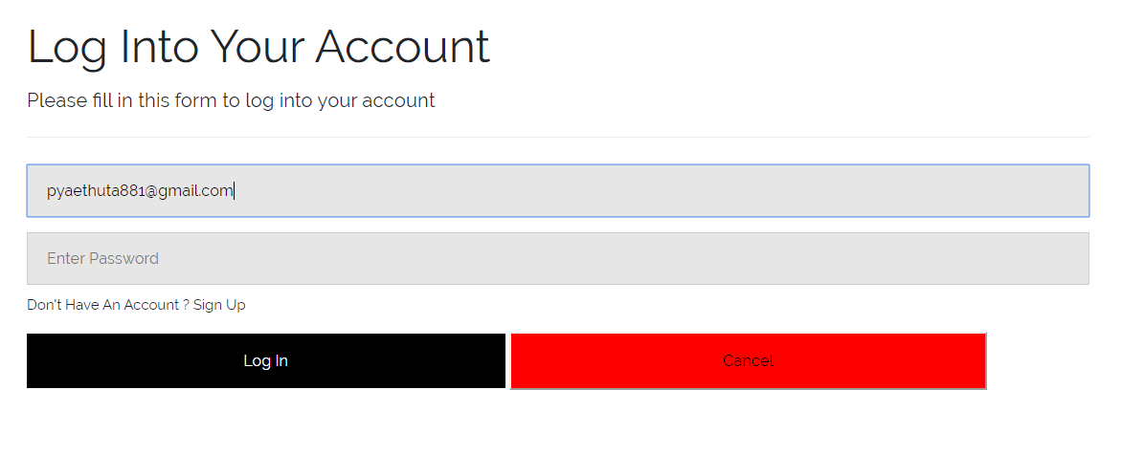

Fig.9.2.1

After testing



Fig.9.2.2

Test Script (3)

|  |  |  |  |  |
| --- | --- | --- | --- | --- |
| **Unit Test 3** | | **Test Case:** Shopping Cart Function | **Designed by:** Pyae Thuta | |
| **Data Source:** Login Page | | **Objective**: Test “Log in” button with unavailable email. | **Tester**: Pyae Thuta | |
| **Test Case** | **Description** | **Test Procedure** | **Expected Result** | **Actual Results** |
| 9.3 | Testing if alert is shown when “Email” is not unavailable. | Click “Log In” button when “Email” test box is filled with unavailable email. | Error message is shown. | See Fig.9.3.2 |

Before Testing

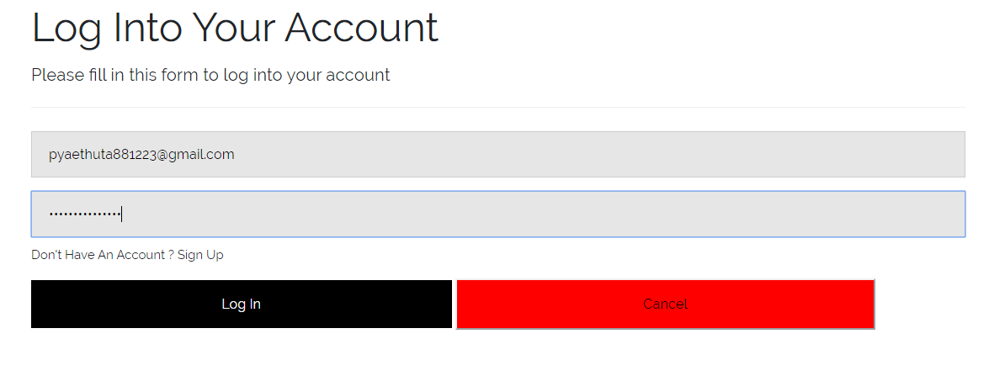

Fig.9.3.1

After testing

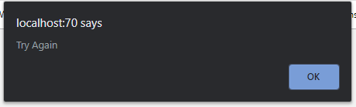

Fig.9.3.2

Test Script (4)

|  |  |  |  |  |
| --- | --- | --- | --- | --- |
| **Unit Test 4** | | **Test Case:** Shopping Cart Function | **Designed by:** Pyae Thuta | |
| **Data Source:** Login Page | | **Objective**: Test “Log in” button with wrong password. | **Tester**: Pyae Thuta | |
| **Test Case** | **Description** | **Test Procedure** | **Expected Result** | **Actual Results** |
| 9.4 | Testing if alert is shown when “Password” is not correct. | Click “Log In” button when “Password” test box is filled with wrong data. | Error message is shown. | See Fig.9.4.2 |

Before Testing

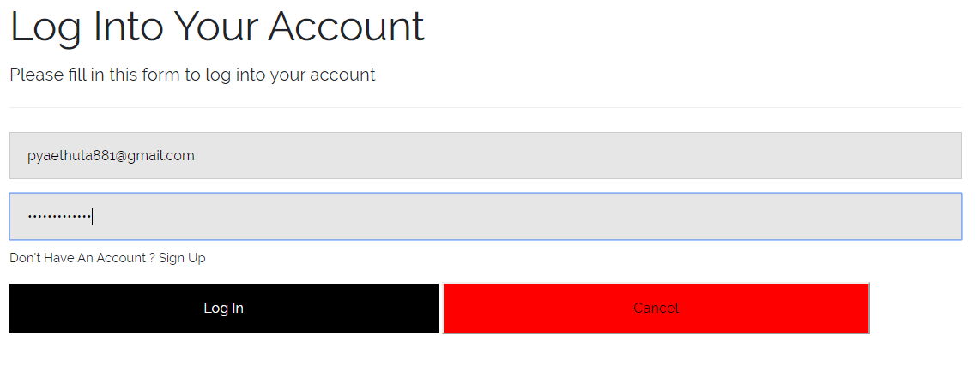

Fig.9.4.1

After Testing

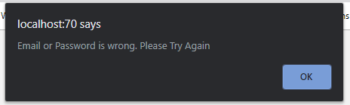

Fig.9.4.2

Test Script (5)

|  |  |  |  |  |
| --- | --- | --- | --- | --- |
| **Unit Test 5** | | **Test Case:** Shopping Cart Function | **Designed by:** Pyae Thuta | |
| **Data Source:** Login Page | | **Objective**: Test “Log in” button with correct information. | **Tester**: Pyae Thuta | |
| **Test Case** | **Description** | **Test Procedure** | **Expected Result** | **Actual Results** |
| 9.5 | Testing if message box is shown and home page is reached when email and password are correct. | Click “Log In” button when text boxes are filled with correct data. | Message box is shown and Home page is reached. | See Fig.9.5.2  &  Fig.9.5.3 |

Before Testing

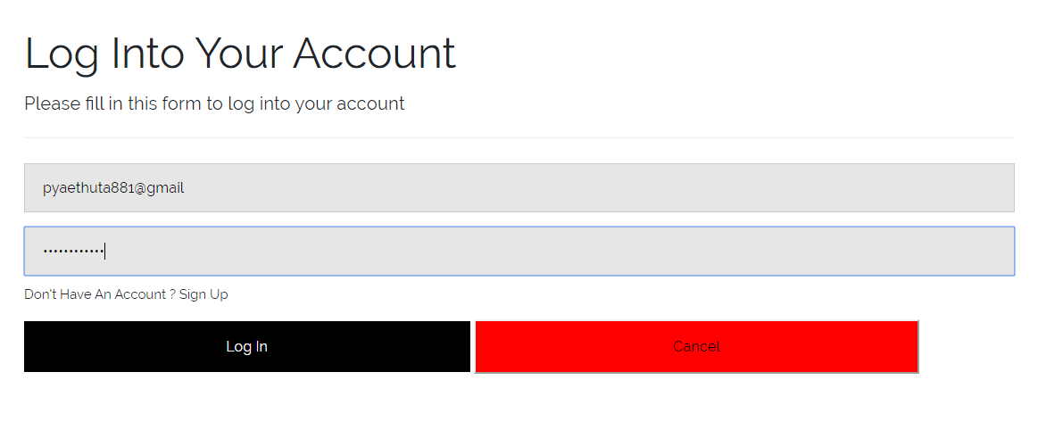

Fig.9.5.1

After Testing

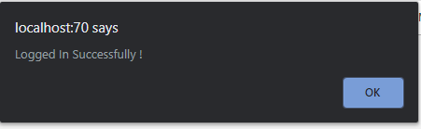

Fig.9.5.2

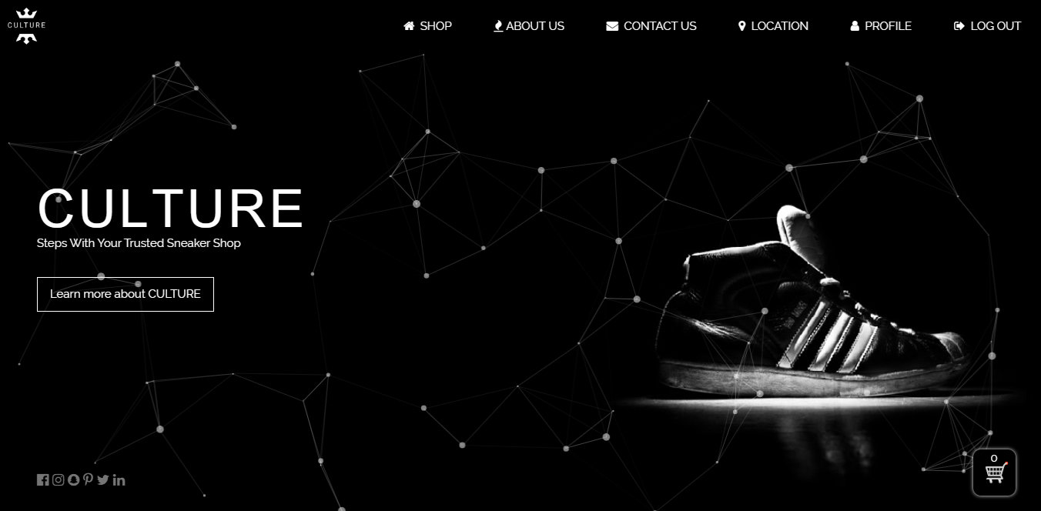

Fig.9.5.3

**Module 10: Search Product process**

|  |  |  |  |
| --- | --- | --- | --- |
| Test Script | Description | Date | Tester |
| 10.1 | Test sneaker search text box | April 13, 2020 | Pyae Thuta |
| 10.2 | Test successful sneaker search process | April 13, 2020 | Pyae Thuta |
| 10.3 | Test Show All button | April 13, 2020 | Pyae Thuta |
| 10.4 | Test product not found | April 13, 2020 | Pyae Thuta |

Test Script (1)

|  |  |  |  |  |
| --- | --- | --- | --- | --- |
| **Unit Test 1** | | **Test Case:** Product Search process in home page | **Designed by:** Pyae Thuta | |
| **Data Source:** Home page | | **Objective**: To test product search process | **Tester**: Pyae Thuta | |
| **Test Case** | **Description** | **Test Procedure** | **Expected Result** | **Actual Results** |
| 10.1 | Test sneaker search text box | 'Search' button is clicked when “Search Sneaker” text box is blanked. | Show ‘Please fill out this field’ message. | See Fig.10.1.2 |

Before Testing

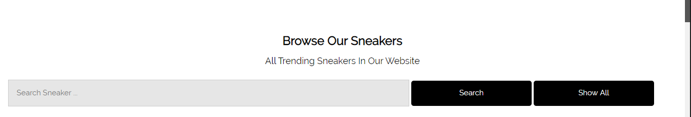

Fig.10.1.1

After Testing

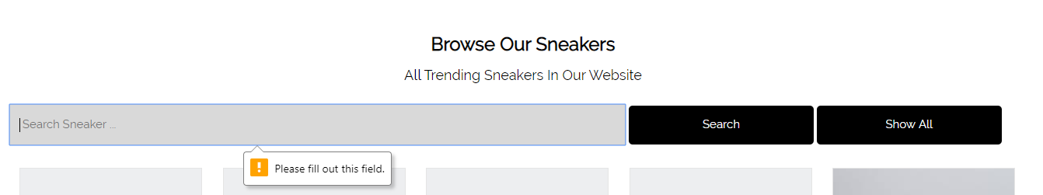

Fig.10.1.2

Test Script (2)

|  |  |  |  |  |
| --- | --- | --- | --- | --- |
| **Unit Test 2** | | **Test Case:** Product Search process in home page | **Designed by:** Pyae Thuta | |
| **Data Source:** Home page | | **Objective**: To test product search process | **Tester**: Pyae Thuta | |
| **Test Case** | **Description** | **Test Procedure** | **Expected Result** | **Actual Results** |
| 10.2 | Test successful sneaker search process | 'Search' button is clicked when “Search Sneaker” text box is filled with text “Adidas”. | The products related with “Adidas” are shown. | See Fig.10.2.2 |

Before Testing

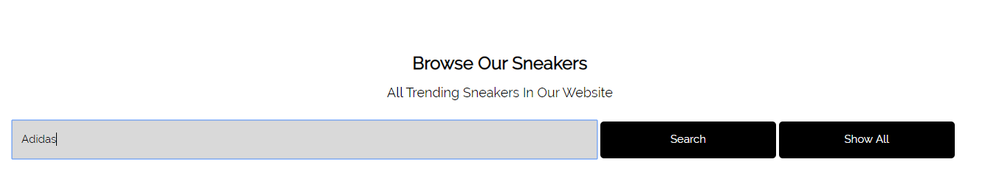

Fig.10.2.1

After Testing

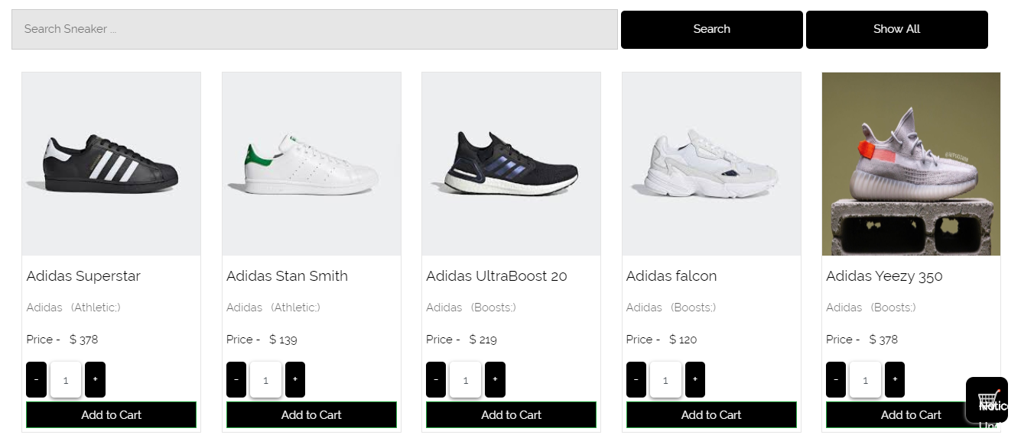

Fig.10.2.2

Test Script (3)

|  |  |  |  |  |
| --- | --- | --- | --- | --- |
| **Unit Test 3** | | **Test Case:** Product Search process in home page | **Designed by:** Pyae Thuta | |
| **Data Source:** Home page | | **Objective**: To test product search process | **Tester**: Pyae Thuta | |
| **Test Case** | **Description** | **Test Procedure** | **Expected Result** | **Actual Results** |
| 10.3 | Test Show all button | “Show all” button is clicked after searching for products. | All products are shown again. | See Fig.10.3.2 |

Before Testing



Fig.10.3.1

After testing

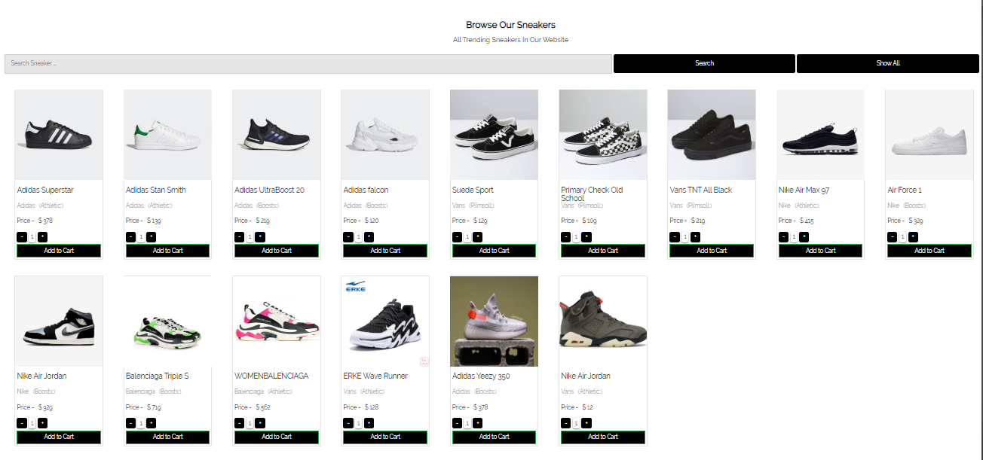

Fig.10.3.2

Test Script (4)

|  |  |  |  |  |
| --- | --- | --- | --- | --- |
| **Unit Test 4** | | **Test Case:** Product Search process in home page | **Designed by:** Pyae Thuta | |
| **Data Source:** Home page | | **Objective**: To test product search process | **Tester**: Pyae Thuta | |
| **Test Case** | **Description** | **Test Procedure** | **Expected Result** | **Actual Results** |
| 10.4 | Test product not found | “Search” button is clicked after filling the text box with unavailable product name. | No data found alert is shown instead of products. | See Fig.10.4.2 |

Before Testing

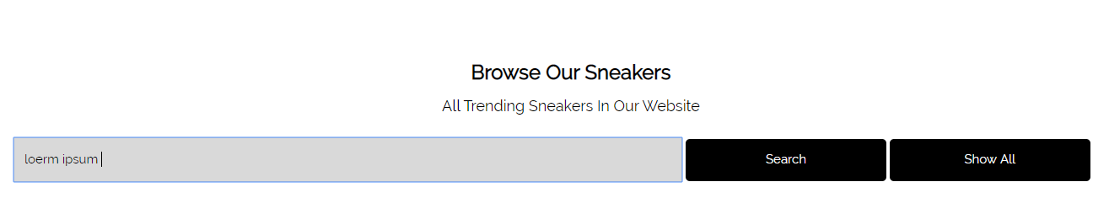

Fig.10.4.1

After Testing

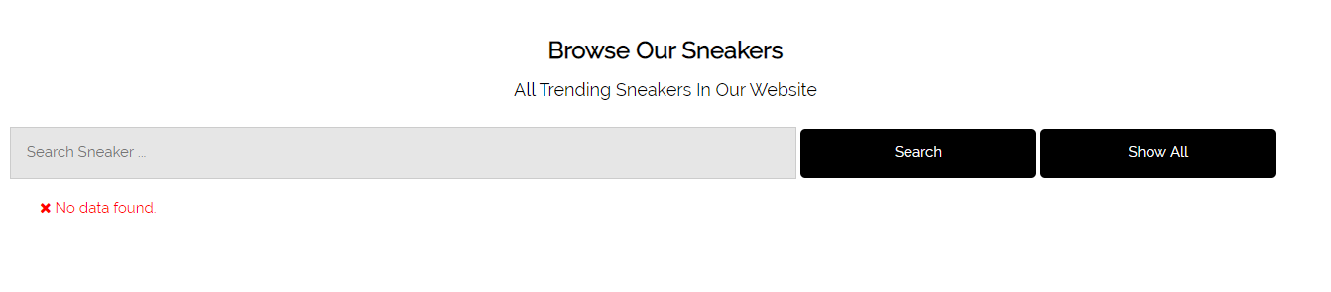

Fig.10.4.2

**Module 11: Add to cart process**

|  |  |  |  |
| --- | --- | --- | --- |
| Test Script | Description | Date | Tester |
| 11.1 | Test “Log In” page is reached when add to cart button is clicked without logging in. | April 29, 2020 | Pyae Thuta |
| 11.2 | Test quantity increase when “Add to Cart” button is clicked. | April 29, 2020 | Pyae Thuta |
| 11.3 | Test the message box is shown when the product is added to cart more than one time. | April 29, 2020 | Pyae Thuta |
| 11.4 | Test the product quantity is added when click on plus sign of the number box. | April 29, 2020 | Pyae Thuta |
| 11.5 | Shopping cart page is reached when “Go to Cart” button is clicked. | April 29, 2020 | Pyae Thuta |

Test Script (1)

|  |  |  |  |  |
| --- | --- | --- | --- | --- |
| **Unit Test 1** | | **Test Case:** Add to cart process in home page. | **Designed by:** Pyae Thuta | |
| **Data Source:** Home page | | **Objective**: To test Add to Cart process | **Tester**: Pyae Thuta | |
| **Test Case** | **Description** | **Test Procedure** | **Expected Result** | **Actual Results** |
| 11.1 | Test “Log In” page is reached when add to cart button is clicked without logging in. | Click “Add to cart” button without logging in. | Message box is shown and Log in page is reach. | See Fig.11.1.2 & Fig.11.1.3 |

Before Testing

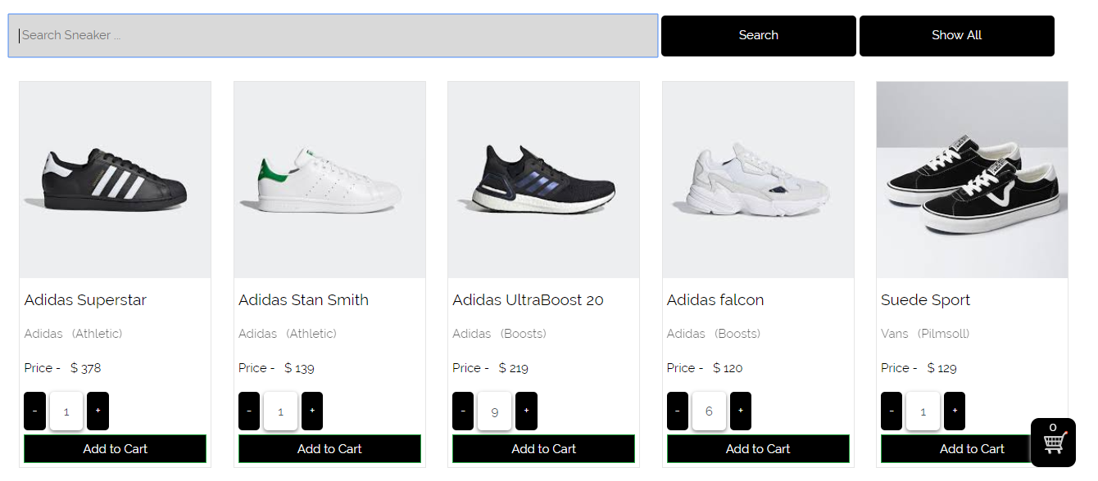

Fig.11.1.1

After Testing

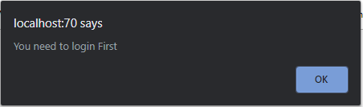

Fig.11.1.2

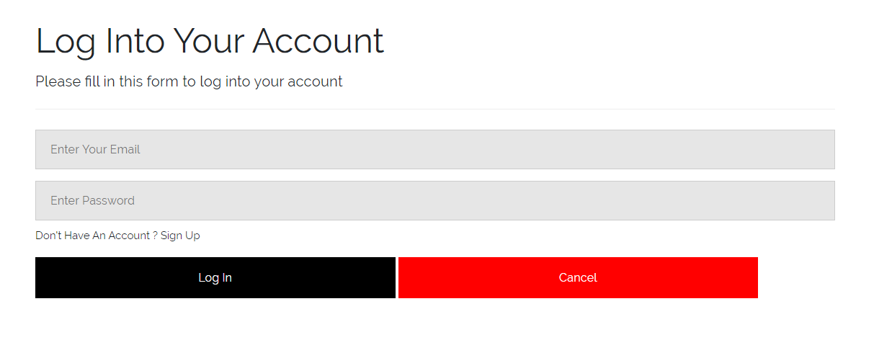

Fig.11.1.3

Test Script (2)

|  |  |  |  |  |
| --- | --- | --- | --- | --- |
| **Unit Test 2** | | **Test Case:** Add to cart process in home page. | **Designed by:** Pyae Thuta | |
| **Data Source:** Home page | | **Objective**: To test Add to Cart process | **Tester**: Pyae Thuta | |
| **Test Case** | **Description** | **Test Procedure** | **Expected Result** | **Actual Results** |
| 11.2 | Test quantity increase when “Add to Cart” button is clicked. | Click “Add to cart” button after logging in. | Number of items in the cart is increased. | See Fig.11.2.2 |

Before Testing

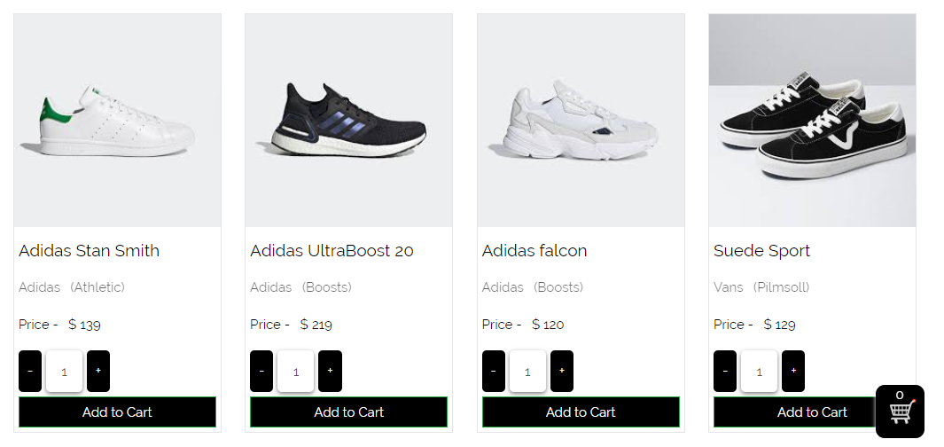

Fig.11.2.1

After Testing

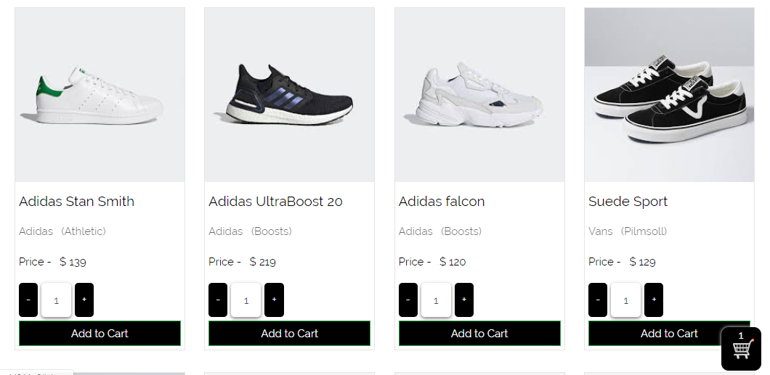

Fig.11.2.2

Test Script (3)

|  |  |  |  |  |
| --- | --- | --- | --- | --- |
| **Unit Test 3** | | **Test Case:** Add to cart process in home page. | **Designed by:** Pyae Thuta | |
| **Data Source:** Home page | | **Objective**: To test Add to Cart process | **Tester**: Pyae Thuta | |
| **Test Case** | **Description** | **Test Procedure** | **Expected Result** | **Actual Results** |
| 11.3 | Test the message box is shown when the product is added to cart more than one time. | Click “Add to cart” button for product that is already added to cart. | The message box is shown and item quantity is not increased. | See Fig.11.3.2 |

Before Testing



Fig.11.3.1

After Testing

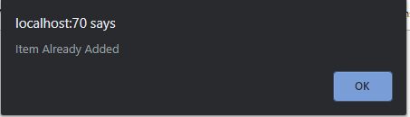

Fig.11.3.2

Test Script (4)

|  |  |  |  |  |
| --- | --- | --- | --- | --- |
| **Unit Test 4** | | **Test Case:** Add to cart process in home page. | **Designed by:** Pyae Thuta | |
| **Data Source:** Home page | | **Objective**: To test Add to Cart process | **Tester**: Pyae Thuta | |
| **Test Case** | **Description** | **Test Procedure** | **Expected Result** | **Actual Results** |
| 11.4 | Test the product quantity is added when click on plus sign of the number box. | Click “+” sign of number text box in product display page. | The quantity of product is increased. | See Fig.11.4.2 |

Before Testing

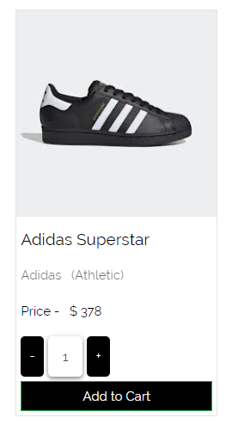

Fig.11.4.1

After testing

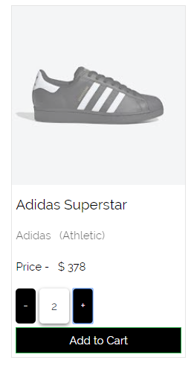

Fig.11.4.2

Test Script (5)

|  |  |  |  |  |
| --- | --- | --- | --- | --- |
| **Unit Test 5** | | **Test Case:** Add to cart process in home page. | **Designed by:** Pyae Thuta | |
| **Data Source:** Home page | | **Objective**: To test Add to Cart process | **Tester**: Pyae Thuta | |
| **Test Case** | **Description** | **Test Procedure** | **Expected Result** | **Actual Results** |
| 11.5 | Shopping cart page is reached when “Go to Cart” button is clicked. | Click “Go to cart” button after logging in | The shopping cart page is reached. | See Fig.11.5.2 |

Before testing

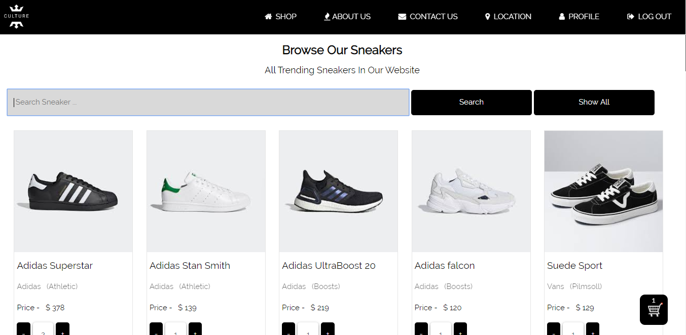

Fig.11.5.1

After Testing

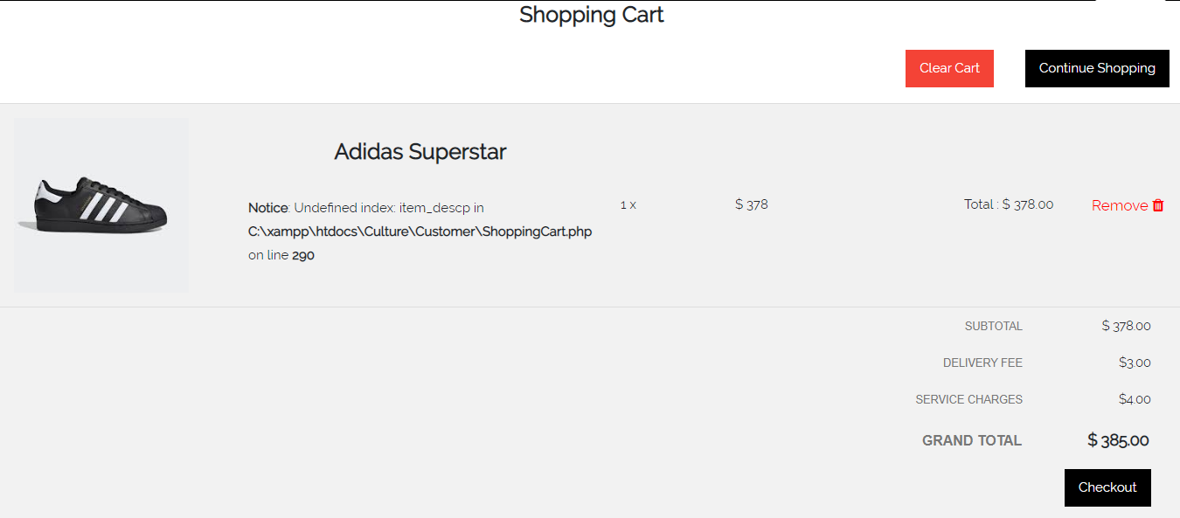

Fig.11.5.2

**Module 12: Shopping Cart Function**

|  |  |  |  |
| --- | --- | --- | --- |
| Test Script | Description | Date | Tester |
| 12.1 | Test “Remove” Button in the shopping cart page. | April 29, 2020 | Pyae Thuta |
| 12.2 | Test if Subtotal and Grand Total amount is decreased in Shopping Cart page when a product is removed | April 29, 2020 | Pyae Thuta |
| 12.3 | Test “Continue Shopping” button in the shopping cart page. | April 29, 2020 | Pyae Thuta |
| 12.4 | Test if new product is added to Shopping Cart page when “Add to Cart” button is clicked in the Home page. | April 29, 2020 | Pyae Thuta |
| 12.5 | Test if Subtotal and Grand Total amount is increased in Shopping Cart page when “Add to Cart” button is clicked in the Home page. | April 29, 2020 | Pyae Thuta |
| 12.6 | Test “Clear Cart” Button in the shopping cart page. | April 29, 2020 | Pyae Thuta |
| 12.7 | Test “Check Out” button in shopping cart page. | April 29, 2020 | Pyae Thuta |

Test Script (1)

|  |  |  |  |  |
| --- | --- | --- | --- | --- |
| **Unit Test 1** | | **Test Case:** Shopping Cart Function | **Designed by:** Pyae Thuta | |
| **Data Source:** Shopping Cart Page | | **Objective**: To test shopping cart function in the Shopping cart page | **Tester**: Pyae Thuta | |
| **Test Case** | **Description** | **Test Procedure** | **Expected Result** | **Actual Results** |
| 12.1 | Test “Remove” Button in the shopping cart page. | Click “Remove” button beside any product in Shopping Cart Page. | The Product is removed from the cart. | See Fig.12.1.2 |

Before Testing

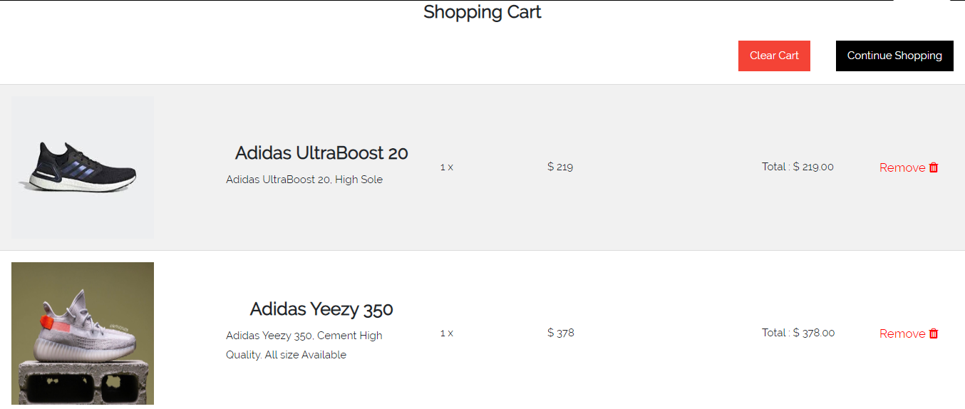

Fig.12.1.1

After Testing

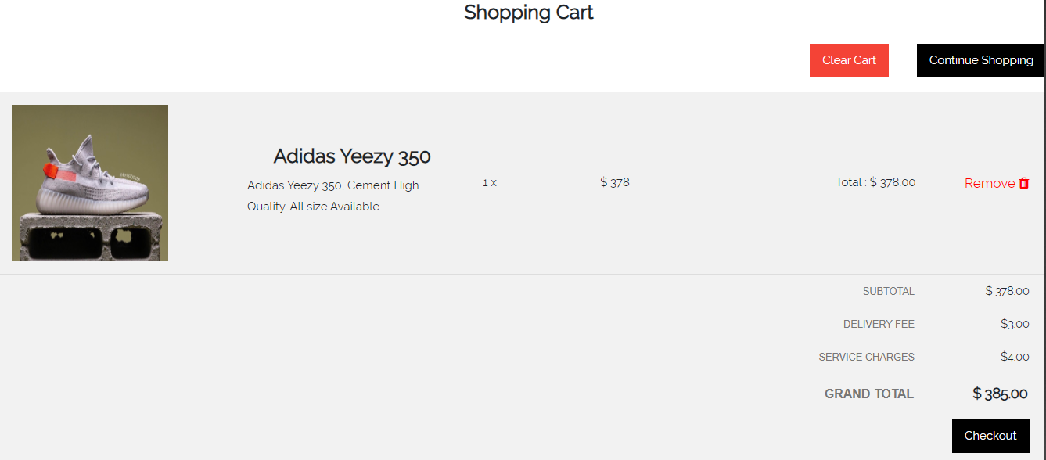

Fig. 12.1.2

Test Script (2)

|  |  |  |  |  |
| --- | --- | --- | --- | --- |
| **Unit Test 2** | | **Test Case:** Shopping Cart Function | **Designed by:** Pyae Thuta | |
| **Data Source:** Shopping Cart Page | | **Objective**: To test shopping cart function in the Shopping cart page | **Tester**: Pyae Thuta | |
| **Test Case** | **Description** | **Test Procedure** | **Expected Result** | **Actual Results** |
| 12.2 | Test if Subtotal and Grand Total amount is decreased in Shopping Cart page when a product is removed. | Click “Remove” button beside any product in Shopping Cart Page. | The Product is removed from the cart and the Subtotal and Grand Total is decreased. | See Fig.12.2.2 |

Before Testing

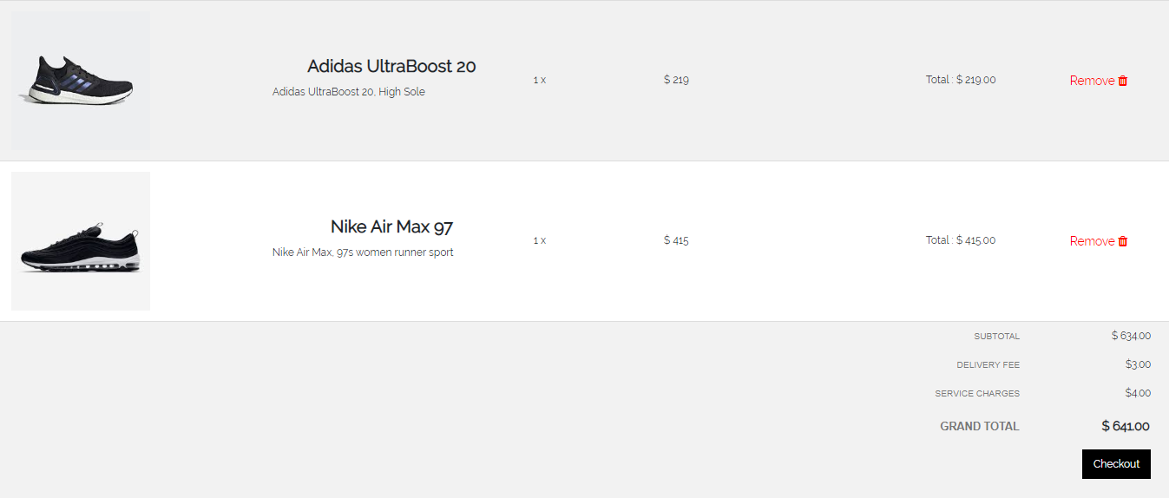

Fig.12.2.1

After Testing

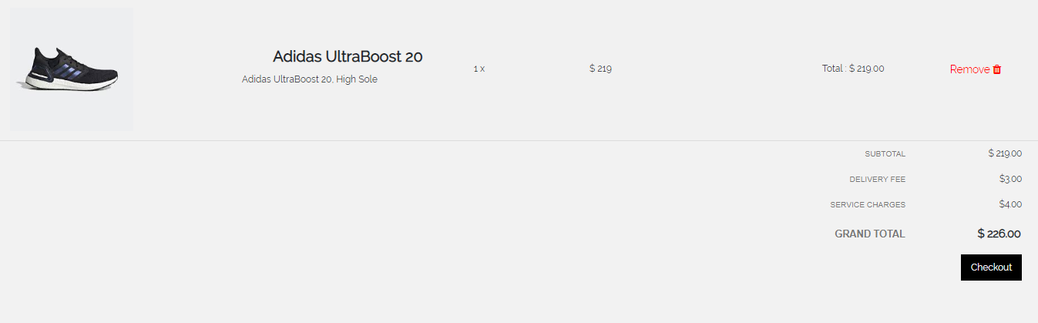

Fig.12.2.2

Test Script (3)

|  |  |  |  |  |
| --- | --- | --- | --- | --- |
| **Unit Test 3** | | **Test Case:** Shopping Cart Function | **Designed by:** Pyae Thuta | |
| **Data Source:** Shopping Cart Page | | **Objective**: To test shopping cart function in the Shopping cart page | **Tester**: Pyae Thuta | |
| **Test Case** | **Description** | **Test Procedure** | **Expected Result** | **Actual Results** |
| 12.3 | Test “Continue Shopping” button in the shopping cart page. | Click “Continue Shopping” button at Top-Right corner in Shopping Cart Page. | Product section in Home Page is reached. | See Fig.12.3.2 |

Before Testing

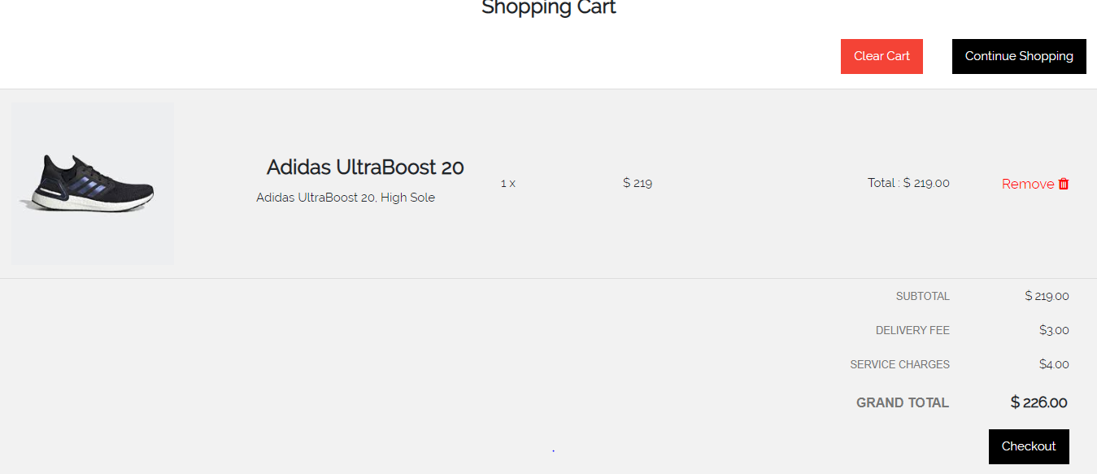

Fig.12.3.1

After Testing

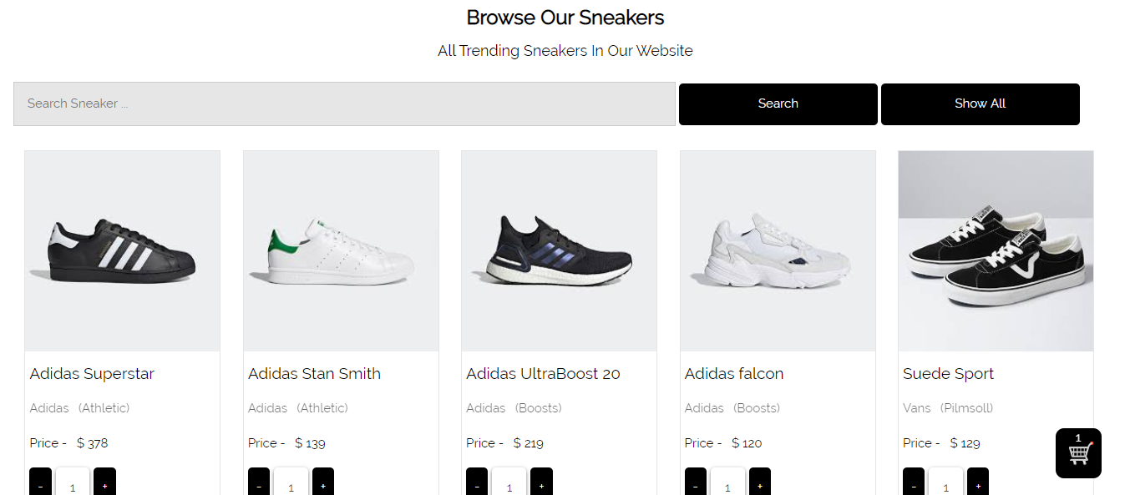

Fig.12.3.2

Test Script (4)

|  |  |  |  |  |
| --- | --- | --- | --- | --- |
| **Unit Test 4** | | **Test Case:** Shopping Cart Function | **Designed by:** Pyae Thuta | |
| **Data Source:** Shopping Cart Page & Home Page | | **Objective**: To test shopping cart function in the Shopping cart page | **Tester**: Pyae Thuta | |
| **Test Case** | **Description** | **Test Procedure** | **Expected Result** | **Actual Results** |
| 12.4 | Test if new product is added to Shopping Cart page when “Add to Cart” button is clicked in the Home page. | Click “Add to Cart” button in Home Page and check Shopping cart page. | New product is added in the Shopping Cart Page. | See Fig.12.4.3 |

**Before Testing**



Fig.12.4.1

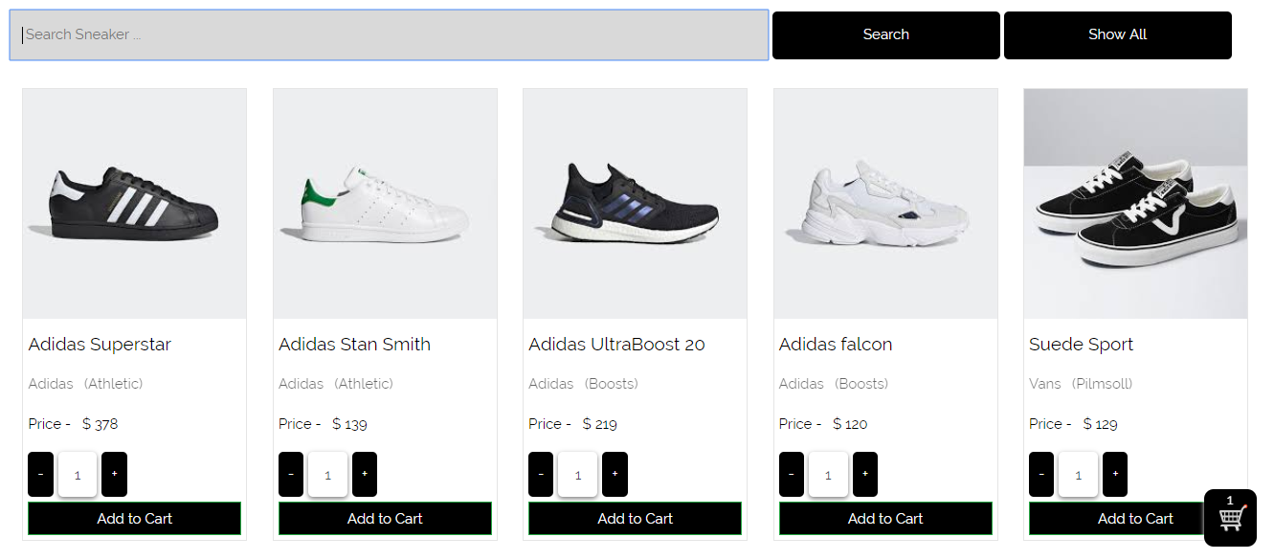

Fig.12.4.2

**After Testing**

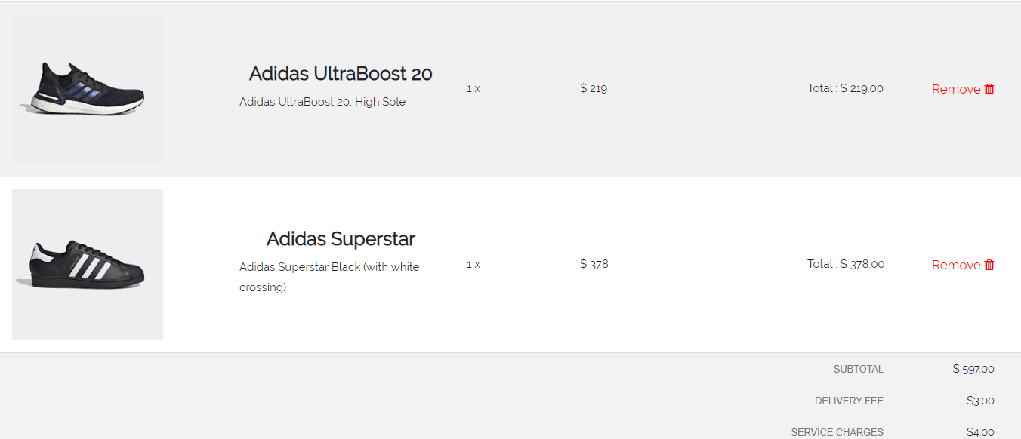

Fig.12.4.3

Test Script (5)

|  |  |  |  |  |
| --- | --- | --- | --- | --- |
| **Unit Test 5** | | **Test Case:** Shopping Cart Function | **Designed by:** Pyae Thuta | |
| **Data Source:** Shopping Cart Page | | **Objective**: To test shopping cart function in the Shopping cart page | **Tester**: Pyae Thuta | |
| **Test Case** | **Description** | **Test Procedure** | **Expected Result** | **Actual Results** |
| 12.5 | Test if Subtotal and Grand Total amount is increased in Shopping Cart page when “Add to Cart” button is clicked in the Home page. | Click “Remove” button beside any product and check price in Shopping cart page. | The Subtotal and Grand Total is decreased. | See Fig.12.5.2 |

Before testing

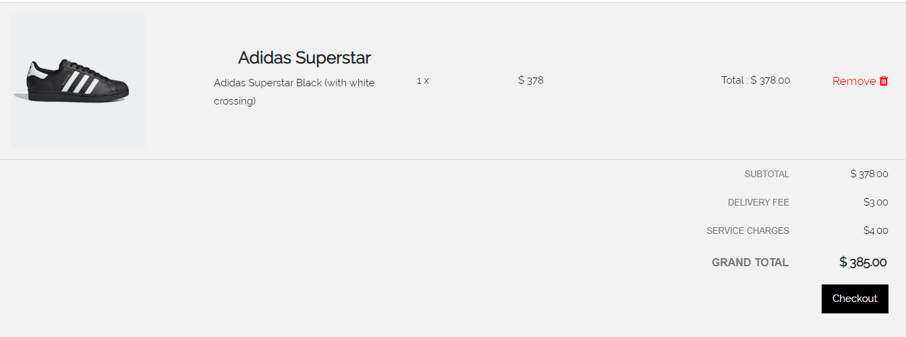

Fig.12.5.1

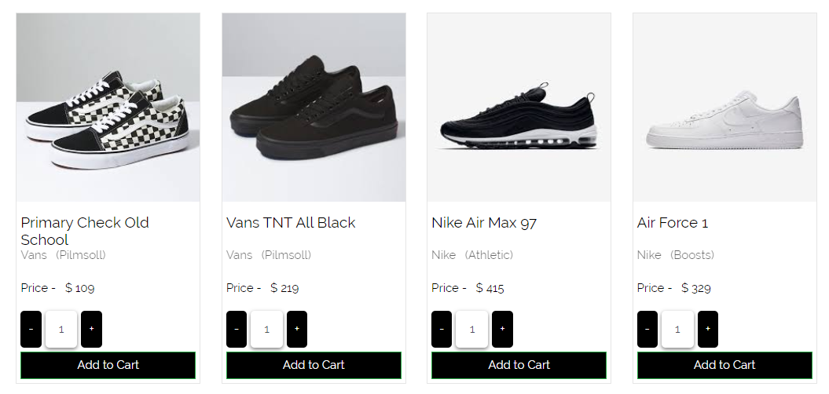

Fig.12.5.2

After Testing

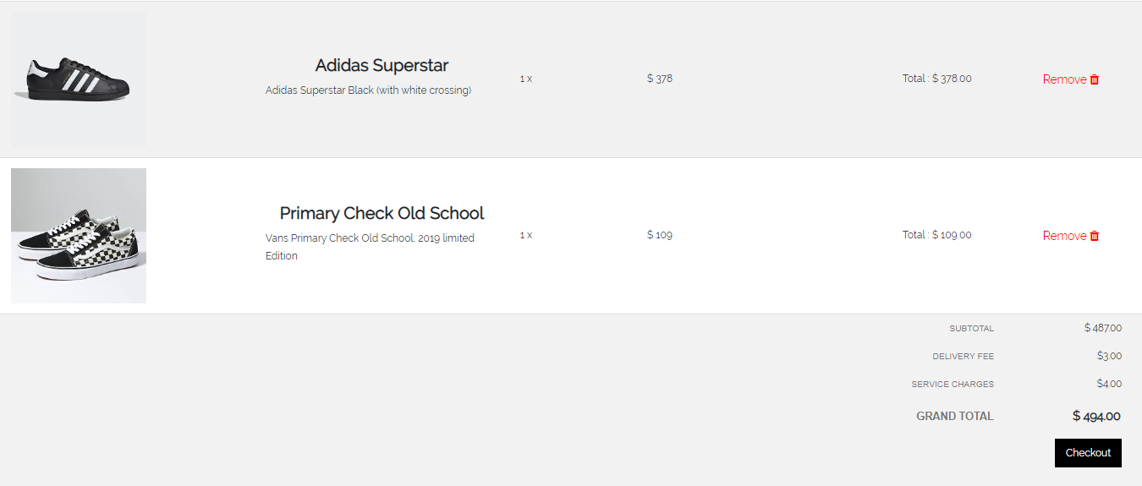

Fig.12.5.3

Test Script (6)

|  |  |  |  |  |
| --- | --- | --- | --- | --- |
| **Unit Test 6** | | **Test Case:** Shopping Cart Function | **Designed by:** Pyae Thuta | |
| **Data Source:** Shopping Cart Page | | **Objective**: To test shopping cart function in the Shopping cart page | **Tester**: Pyae Thuta | |
| **Test Case** | **Description** | **Test Procedure** | **Expected Result** | **Actual Results** |
| 12.6 | Test “Clear Cart” Button in the shopping cart page. | Click “Clear” button at the top of Shopping Cart Page. | All products are removed from the cart and home page is reached. | See Fig.12.6.2 & 12.6.3 |

Before testing

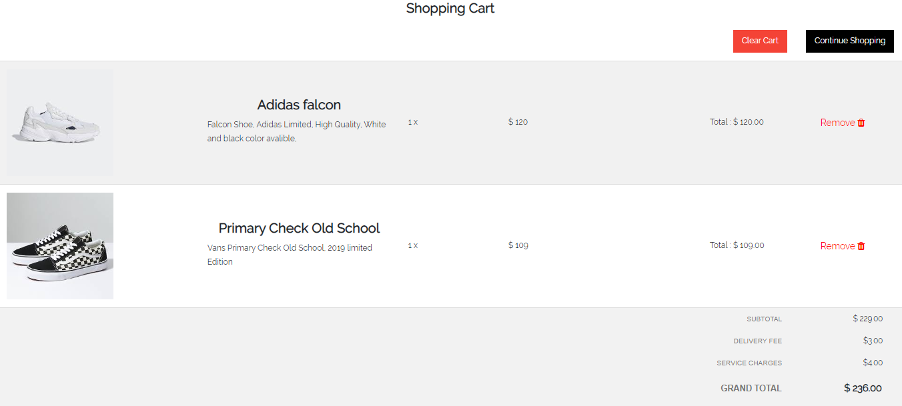

Fig.12.6.1

After testing

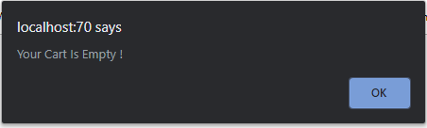

Fig.12.6.2

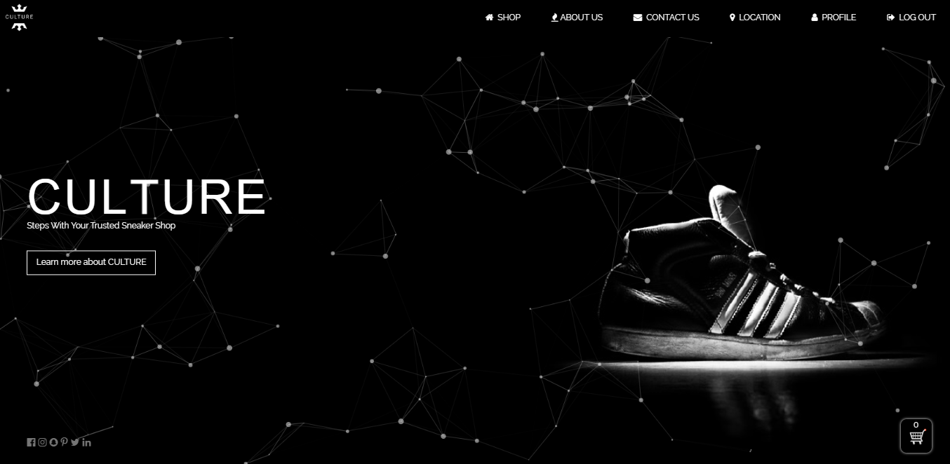

Fig.12.6.3

Test Script (7)

|  |  |  |  |  |
| --- | --- | --- | --- | --- |
| **Unit Test 7** | | **Test Case:** Shopping Cart Function | **Designed by:** Pyae Thuta | |
| **Data Source:** Shopping Cart Page | | **Objective**: To test shopping cart function in the Shopping cart page | **Tester**: Pyae Thuta | |
| **Test Case** | **Description** | **Test Procedure** | **Expected Result** | **Actual Results** |
| 12.7 | Test “Check Out” button in shopping cart page. | Click “Check Out” button at the bottom of Shopping Cart Page. | Check Out page is reached | See Fig.12.7.2 |

Before Testing

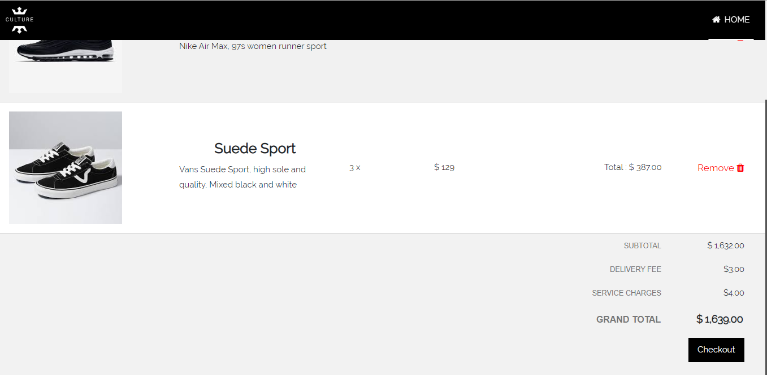

Fig.12.7.1

After Testing

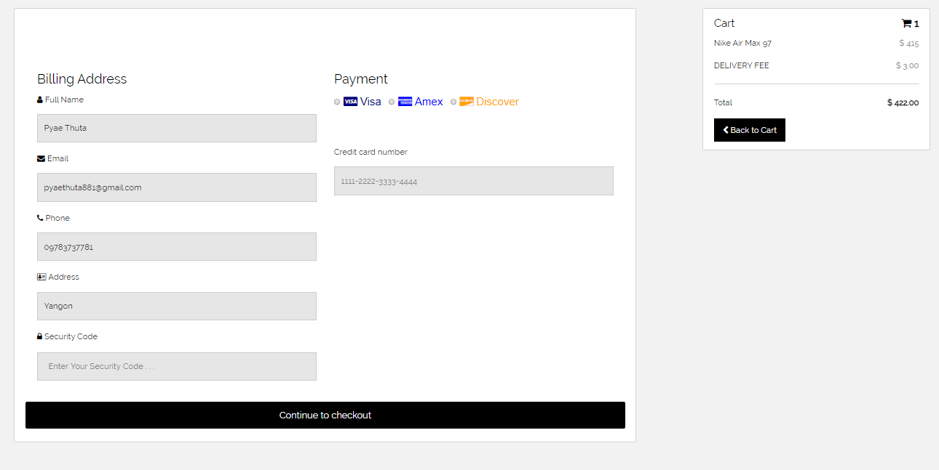

Fig.12.7.2

**Module 13: Check Out Process**

|  |  |  |  |
| --- | --- | --- | --- |
| Test Script | Description | Date | Tester |
| 13.1 | Test “Name” Text box. | April 30, 2020 | Pyae Thuta |
| 13.2 | Test “Email” Text box. | April 30, 2020 | Pyae Thuta |
| 13.3 | Test “Phone Number” Text box. | April 30, 2020 | Pyae Thuta |
| 13.4 | Test “Address” Text box. | April 30, 2020 | Pyae Thuta |
| 13.5 | Test “Security Code” Text box. | April 30, 2020 | Pyae Thuta |
| 13.6 | Test “Payment” radio button. | April 30, 2020 | Pyae Thuta |
| 13.7 | Test “Card Number” text box. | April 30, 2020 | Pyae Thuta |
| 13.8 | Test “Back To cart” button. | April 30, 2020 | Pyae Thuta |
| 13.9 | Test “Check Out” button. | April 30, 2020 | Pyae Thuta |
| 13.10 | Test if data are saved into database. | April 30, 2020 | Pyae Thuta |

Test Script (1)

|  |  |  |  |  |
| --- | --- | --- | --- | --- |
| **Unit Test 1** | | **Test Case:** Shopping Cart Function | **Designed by:** Pyae Thuta | |
| **Data Source:** CheckOutForm Page | | **Objective**: To test “Name” Text box. | **Tester**: Pyae Thuta | |
| **Test Case** | **Description** | **Test Procedure** | **Expected Result** | **Actual Results** |
| 13.1 | Testing if alert is shown when “Customer Name” Text box is not filled with data. | Clicked “Continue to Checkout” button and “Customer Name” Text box is not filled with data. | “Please Fill out of this field” alert is shown. | See Fig.13.1.2 |

Before Testing

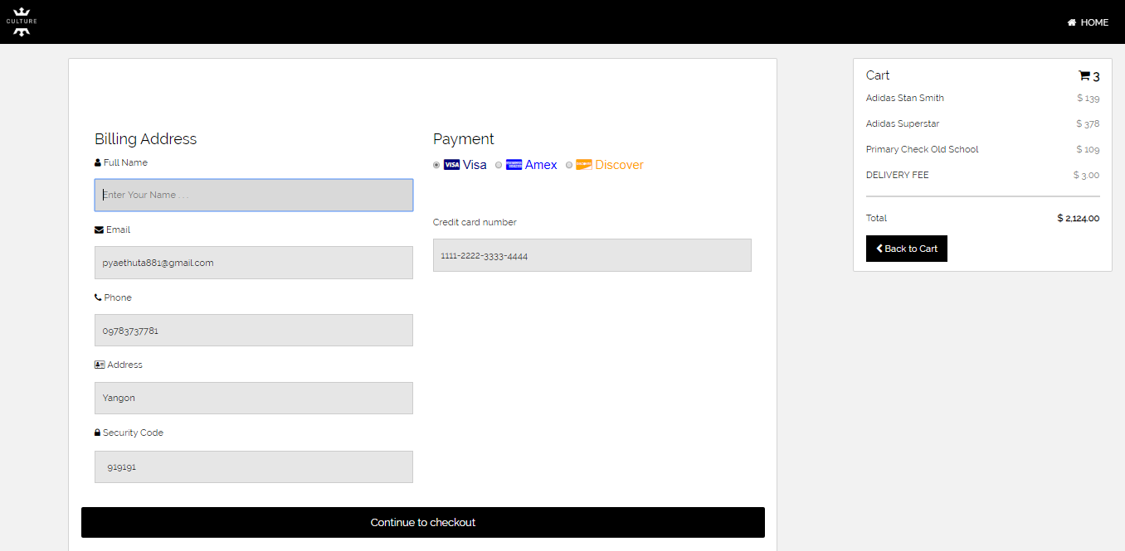

Fig.13.1.1

After testing

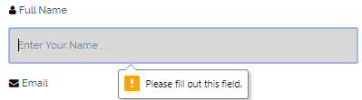

Fig.13.1.2

Test Script (2)

|  |  |  |  |  |
| --- | --- | --- | --- | --- |
| **Unit Test 2** | | **Test Case:** Shopping Cart Function | **Designed by:** Pyae Thuta | |
| **Data Source:** CheckOutForm Page | | **Objective**: Test “Email” Text box. | **Tester**: Pyae Thuta | |
| **Test Case** | **Description** | **Test Procedure** | **Expected Result** | **Actual Results** |
| 13.2 | Testing if alert is shown when “Email” Text box is not filled with data. | Clicked “Continue to Checkout” button and “Email” Text box is not filled with data. | “Please Fill out of this field” alert is shown. | See Fig.5.2.2 |

Before Testing

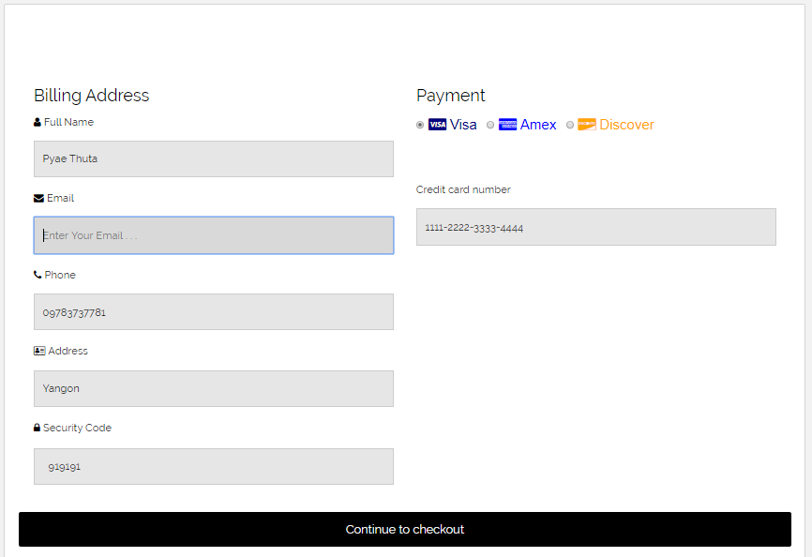

Fig.13.2.1

After testing

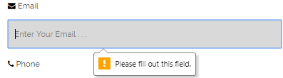

Fig.13.2.2

Test Script (3)

|  |  |  |  |  |
| --- | --- | --- | --- | --- |
| **Unit Test 3** | | **Test Case:** Shopping Cart Function | **Designed by:** Pyae Thuta | |
| **Data Source:** CheckOutForm Page | | **Objective**: Test “Phone Number” Text box. | **Tester**: Pyae Thuta | |
| **Test Case** | **Description** | **Test Procedure** | **Expected Result** | **Actual Results** |
| 13.3 | Testing if alert is shown when “Phone Number” Text box is not filled with data. | Clicked “Continue to Checkout” button and “Phone Number” Text box is not filled with data. | “Please Fill out of this field” alert is shown. | See Fig.13.3.2 |

Before Testing

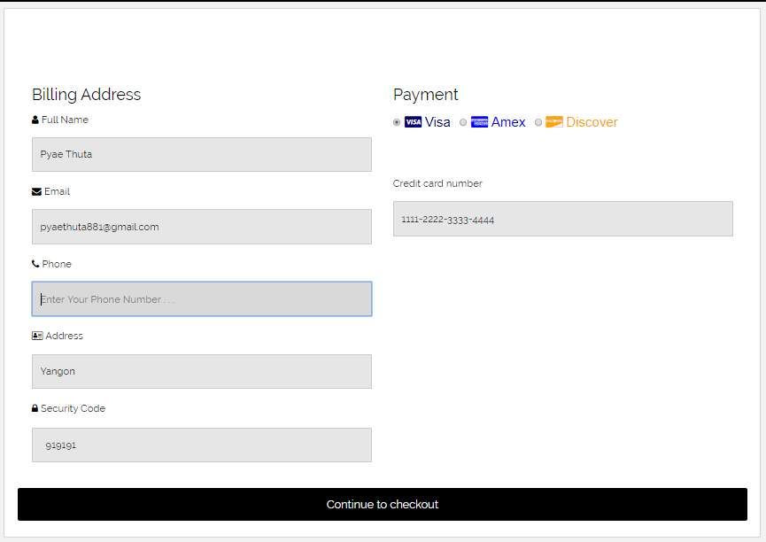

Fig.13.3.1

After Testing

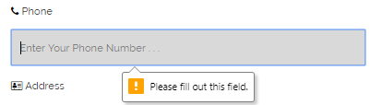

Fig.13.3.2

Test Script (4)

|  |  |  |  |  |
| --- | --- | --- | --- | --- |
| **Unit Test 4** | | **Test Case:** Shopping Cart Function | **Designed by:** Pyae Thuta | |
| **Data Source:** CheckOutForm Page | | **Objective**: Test “Address” Text box. | **Tester**: Pyae Thuta | |
| **Test Case** | **Description** | **Test Procedure** | **Expected Result** | **Actual Results** |
| 13.4 | Testing if alert is shown when “Address” Text box is not filled with data. | Clicked “Continue to Checkout” button and “Address” Text box is not filled with data. | “Please Fill out of this field” alert is shown. | See Fig.13.4.2 |

Before Testing

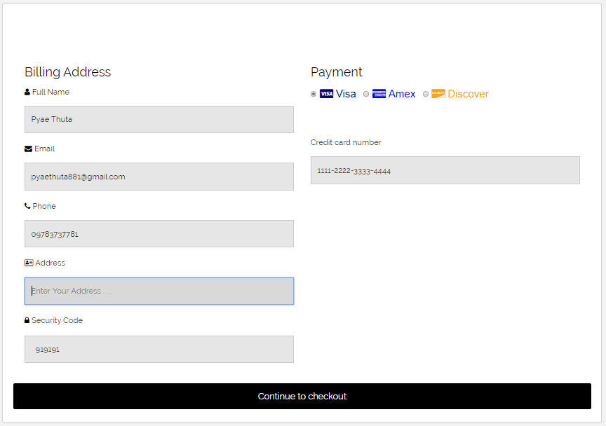

Fig.13.4.1

After Testing

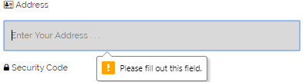

Fig.13.4.2

Test Script (5)

|  |  |  |  |  |
| --- | --- | --- | --- | --- |
| **Unit Test 5** | | **Test Case:** Shopping Cart Function | **Designed by:** Pyae Thuta | |
| **Data Source:** CheckOutForm Page | | **Objective**: Test “Security Code” Text box. | **Tester**: Pyae Thuta | |
| **Test Case** | **Description** | **Test Procedure** | **Expected Result** | **Actual Results** |
| 13.5 | Testing if alert is shown when “Security Code” Text box is not filled with data. | Clicked “Continue to Checkout” button and “Security Code” Text box is not filled with data. | “Please Fill out of this field” alert is shown. | See Fig.13.5.2 |

Before Testing

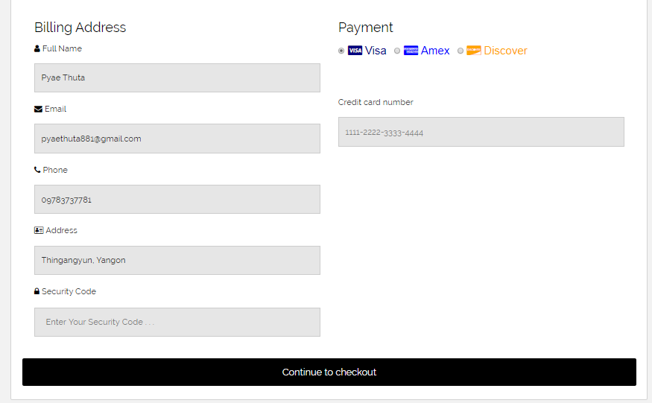

Fig.13.5.1

After testing

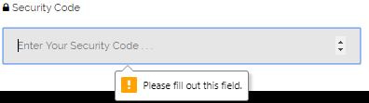

Fig.13.5.2

Test Script (6)

|  |  |  |  |  |
| --- | --- | --- | --- | --- |
| **Unit Test 6** | | **Test Case:** Shopping Cart Function | **Designed by:** Pyae Thuta | |
| **Data Source:** CheckOutForm Page | | **Objective**: Test “Payment” radio button. | **Tester**: Pyae Thuta | |
| **Test Case** | **Description** | **Test Procedure** | **Expected Result** | **Actual Results** |
| 13.6 | Testing if alert is shown when “Payment” Radio button is not selected. | Clicked “Continue to Checkout” button and “Payment” Radio button is not selected. | “Please Select One of These Option” alert is shown. | See Fig.13.6.2 |

Before Testing

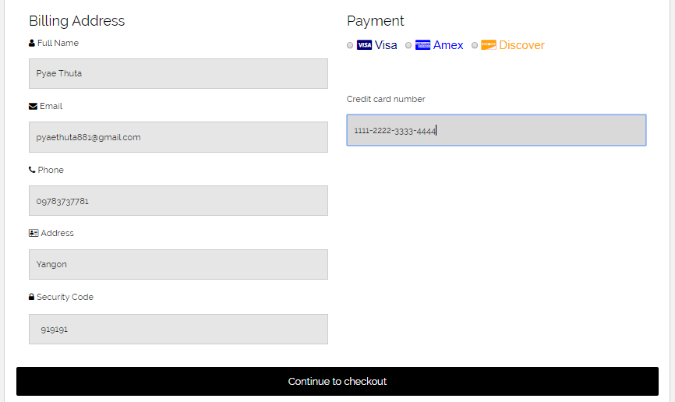

Fig.13.6.1

After testing



Fig.13.6.2

Test Script (7)

|  |  |  |  |  |
| --- | --- | --- | --- | --- |
| **Unit Test 7** | | **Test Case:** Shopping Cart Function | **Designed by:** Pyae Thuta | |
| **Data Source:** CheckOutForm Page | | **Objective**: Test “Card Number” text box. | **Tester**: Pyae Thuta | |
| **Test Case** | **Description** | **Test Procedure** | **Expected Result** | **Actual Results** |
| 13.7 | Testing if alert is shown when “Card Number” Radio button is not selected. | Clicked “Continue to Checkout” button and “Card Number” Radio button is not selected. | “Please fill out this field” alert is shown. | See Fig.13.7.2 |

After Testing

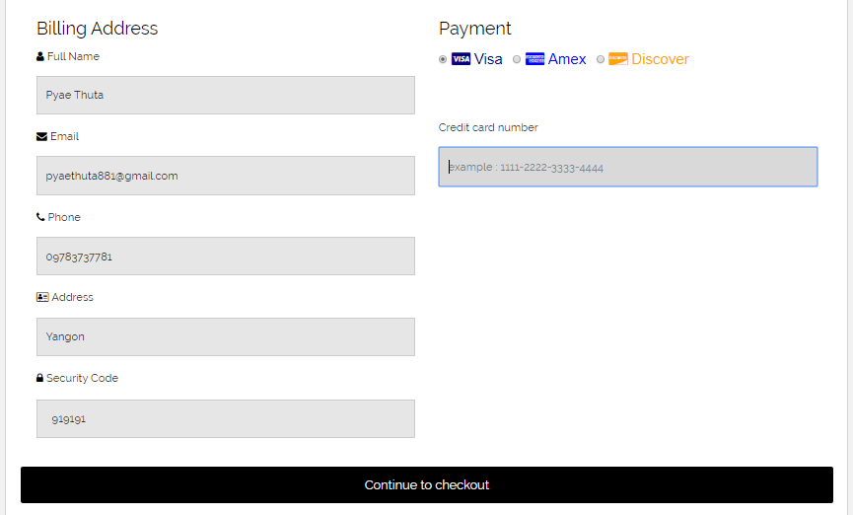

Fig.13.7.1

After testing

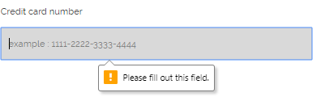

Fig.13.7.2

Test Script (8)

|  |  |  |  |  |
| --- | --- | --- | --- | --- |
| **Unit Test 8** | | **Test Case:** Shopping Cart Function | **Designed by:** Pyae Thuta | |
| **Data Source:** CheckOutForm Page | | **Objective**: Test “Back To cart” button. | **Tester**: Pyae Thuta | |
| **Test Case** | **Description** | **Test Procedure** | **Expected Result** | **Actual Results** |
| 13.8 | Testing if “Shopping Cart Page” is reached when “Back To cart” button is clicked. | Click “Back To cart” button. | Shopping cart page is reached. | See Fig.13.8.2 |

Before testing

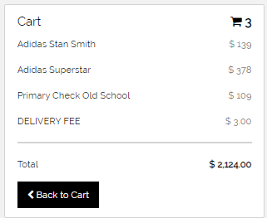

Fig.13.8.1

After Testing

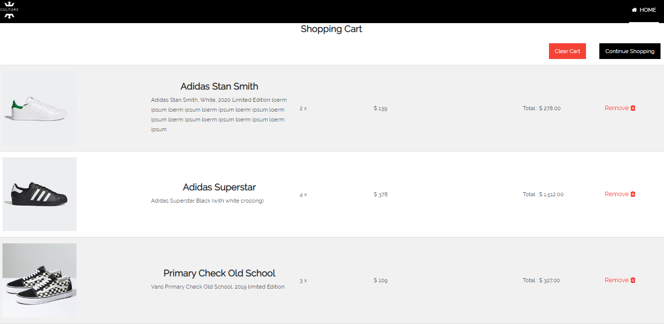

Fig.13.8.2

Test Script (9)

|  |  |  |  |  |
| --- | --- | --- | --- | --- |
| **Unit Test 9** | | **Test Case:** Shopping Cart Function | **Designed by:** Pyae Thuta | |
| **Data Source:** CheckOutForm Page | | **Objective**: Test “Check Out” button. | **Tester**: Pyae Thuta | |
| **Test Case** | **Description** | **Test Procedure** | **Expected Result** | **Actual Results** |
| 13.9 | Testing if “Message box” is shown and home page is reached when “Check out” button is clicked. | Click “Check Out” button. | Message box is shown and Home page is reached. | See Fig.13.9.2 & Fig.13.9.3 |

Before Testing

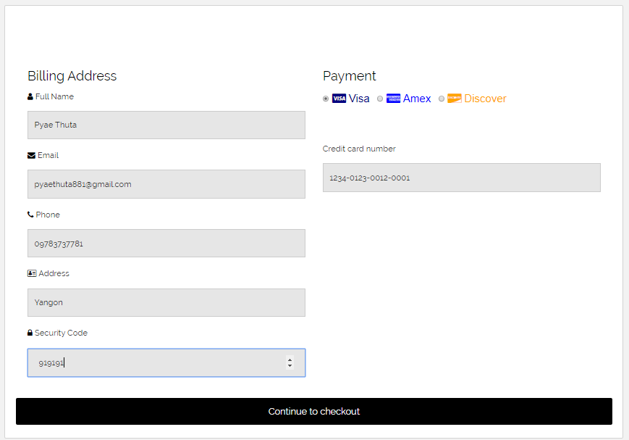

Fig.13.9.1

After Testing

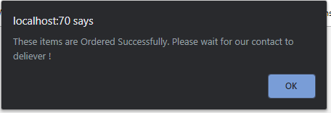

Fig.13.9.2

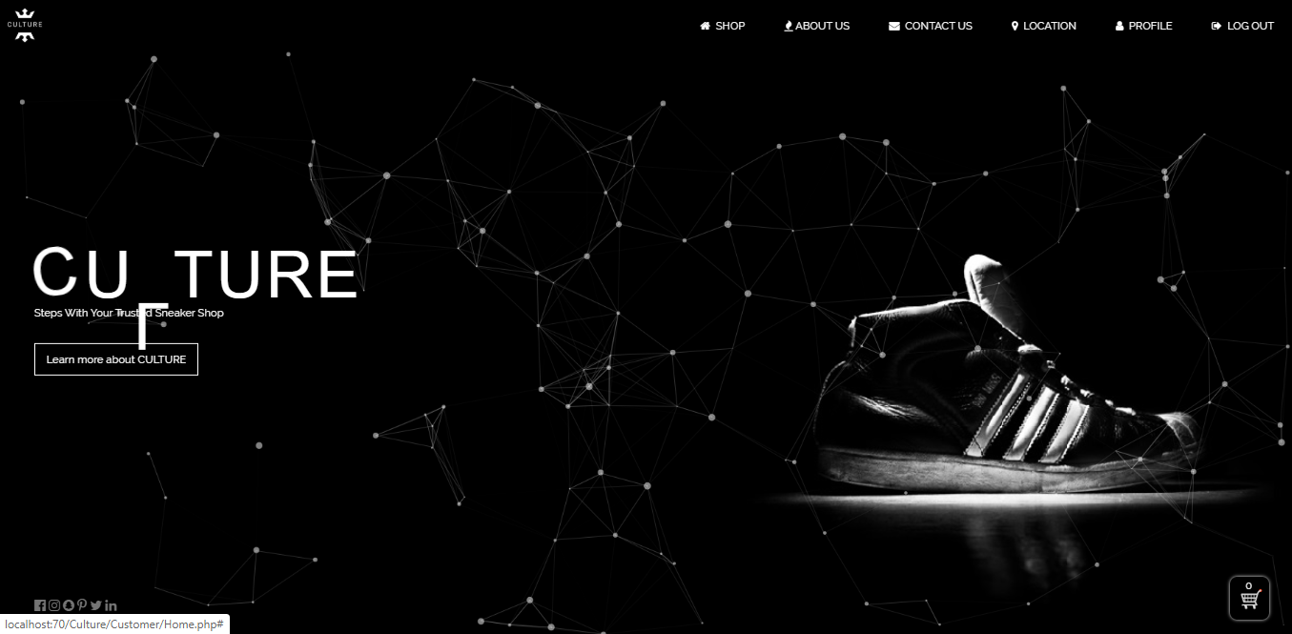

Fig.13.9.3

Test Script (10)

|  |  |  |  |  |
| --- | --- | --- | --- | --- |
| **Unit Test 10** | | **Test Case:** Shopping Cart Function | **Designed by:** Pyae Thuta | |
| **Data Source:** CheckOutForm Page | | **Objective**: Test if data are saved into database. | **Tester**: Pyae Thuta | |
| **Test Case** | **Description** | **Test Procedure** | **Expected Result** | **Actual Results** |
| 13.10 | Testing if data are saved into database after “Check Out” button is clicked. | Click “Check Out” button and check database. | Data are successfully saved into database. | See Fig.13.10.1 & Fig.13.10.2 |



Fig.13.10.1

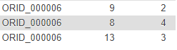

Fig.13.10.2

**Module 14: Update account and Printing Voucher Process**

|  |  |  |  |
| --- | --- | --- | --- |
| Test Script | Description | Date | Tester |
| 14.1 | Test “User Name” text box | April 30, 2020 | Pyae Thuta |
| 14.2 | Test “Email” Text box. | April 30, 2020 | Pyae Thuta |
| 14.3 | Test “Phone Number” Text box. | April 30, 2020 | Pyae Thuta |
| 14.4 | Test “Address” Text box. | April 30, 2020 | Pyae Thuta |
| 14.5 | Test “Update” button. | April 30, 2020 | Pyae Thuta |
| 14.6 | Test “Show Voucher” button. | April 30, 2020 | Pyae Thuta |
| 14.7 | Test “Print” button. | April 30, 2020 | Pyae Thuta |

Test Script (1)

|  |  |  |  |  |
| --- | --- | --- | --- | --- |
| **Unit Test 1** | | **Test Case:** Update account and Printing Voucher Process | **Designed by:** Pyae Thuta | |
| **Data Source:** Profile Page | | **Objective**: Test “User Name” text box | **Tester**: Pyae Thuta | |
| **Test Case** | **Description** | **Test Procedure** | **Expected Result** | **Actual Results** |
| 14.1 | Testing if alert is shown is “User Name” text box is not fill with data. | Click “Update” button when “User Name” text box is not fill with data. | Show “Please Fill Out of This Field” message. | See Fig.14.1.2 |

Before Testing

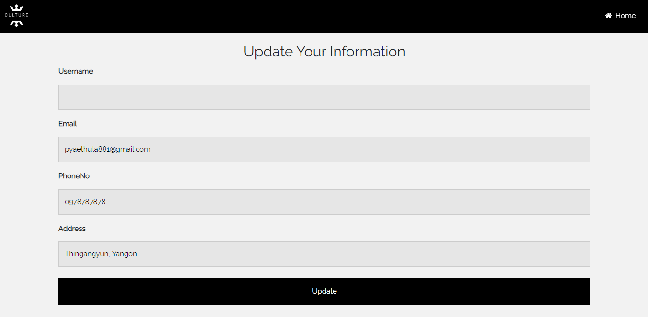

Fig.14.1.1

After Testing

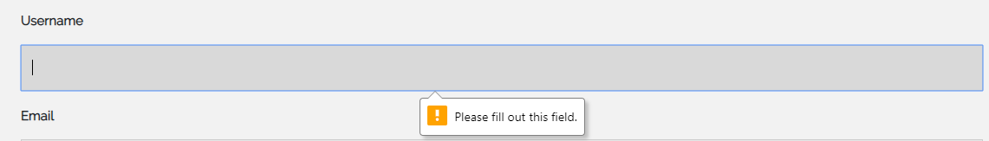

Fig.14.1.2

Test Script (2)

|  |  |  |  |  |
| --- | --- | --- | --- | --- |
| **Unit Test 2** | | **Test Case:** Update account and Printing Voucher Process | **Designed by:** Pyae Thuta | |
| **Data Source:** Profile Page | | **Objective**: To Test “Emai” text box. | **Tester**: Pyae Thuta | |
| **Test Case** | **Description** | **Test Procedure** | **Expected Result** | **Actual Results** |
| 14.2 | Testing if “Email” text box is not able to be focused. | Try to focus on “Email” text box. | “Email” text box is not able to be focused. | See Fig.14.2.1 |

Testing for Test case (14.2)



Test Script (3)

|  |  |  |  |  |
| --- | --- | --- | --- | --- |
| **Unit Test 3** | | **Test Case:** Update account and Printing Voucher Process | **Designed by:** Pyae Thuta | |
| **Data Source:** Profile Page | | **Objective**: Test “Phone No” text box | **Tester**: Pyae Thuta | |
| **Test Case** | **Description** | **Test Procedure** | **Expected Result** | **Actual Results** |
| 14.3 | Testing if alert is shown is “Phone No” text box is not fill with data. | Click “Update” button when “Phone No” text box is not fill with data. | Show “Please Fill Out of This Field” message. | See Fig.14.3.2 |

Before Testing

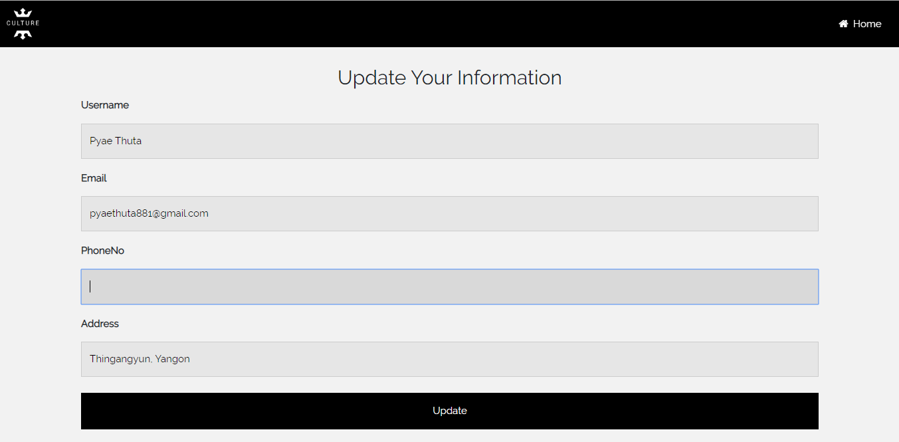

Fig.14.3.1

After Testing

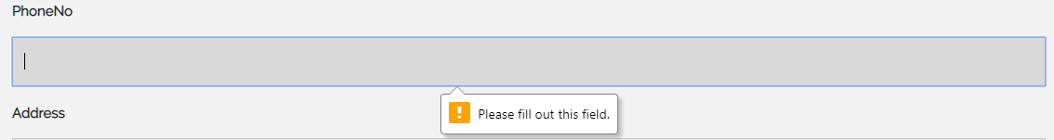

Fig.14.3.2

Test Script (4)

|  |  |  |  |  |
| --- | --- | --- | --- | --- |
| **Unit Test 4** | | **Test Case:** Update account and Printing Voucher Process | **Designed by:** Pyae Thuta | |
| **Data Source:** Profile Page | | **Objective**: Test “Address” text box | **Tester**: Pyae Thuta | |
| **Test Case** | **Description** | **Test Procedure** | **Expected Result** | **Actual Results** |
| 14.4 | Testing if alert is shown is “Address” text box is not fill with data. | Click “Update” button when “Address” text box is not fill with data. | Show “Please Fill Out of This Field” message. | See Fig.14.4.2 |

Before Testing

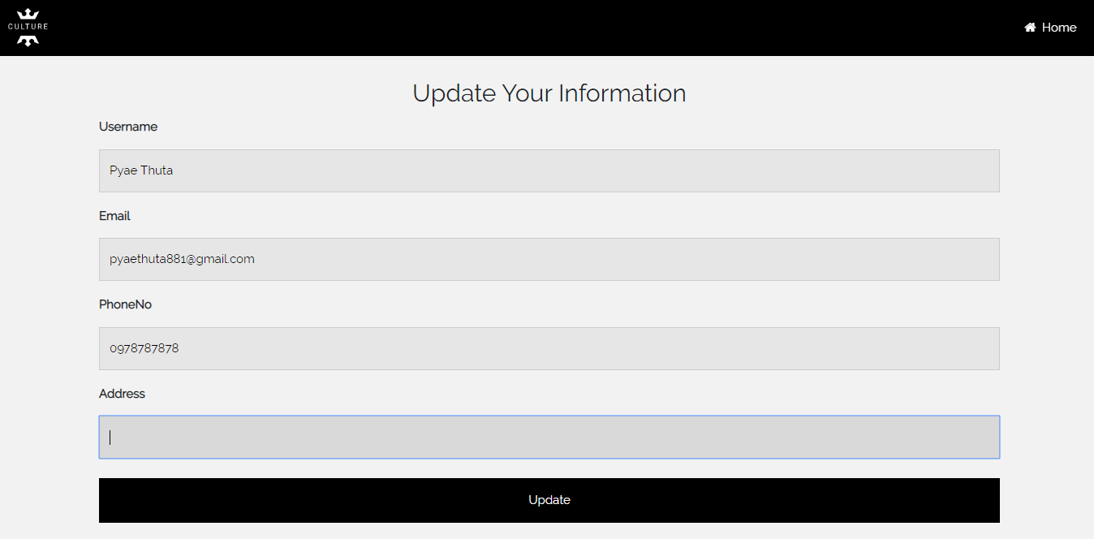

Fig.14.4.1

After Testing

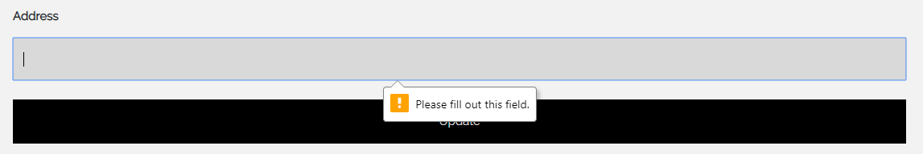

Fig.14.4.2

Test Script (5)

|  |  |  |  |  |
| --- | --- | --- | --- | --- |
| **Unit Test 5** | | **Test Case:** Update account and Printing Voucher Process | **Designed by:** Pyae Thuta | |
| **Data Source:** Profile Page | | **Objective**: Test “Update” button. | **Tester**: Pyae Thuta | |
| **Test Case** | **Description** | **Test Procedure** | **Expected Result** | **Actual Results** |
| 14.5 | Testing if message box is shown when “Update” button is clicked. | Click “Update” button when all text boxes are filled with data. | Show successful message box. | See Fig.14.5.2 |

Before Testing

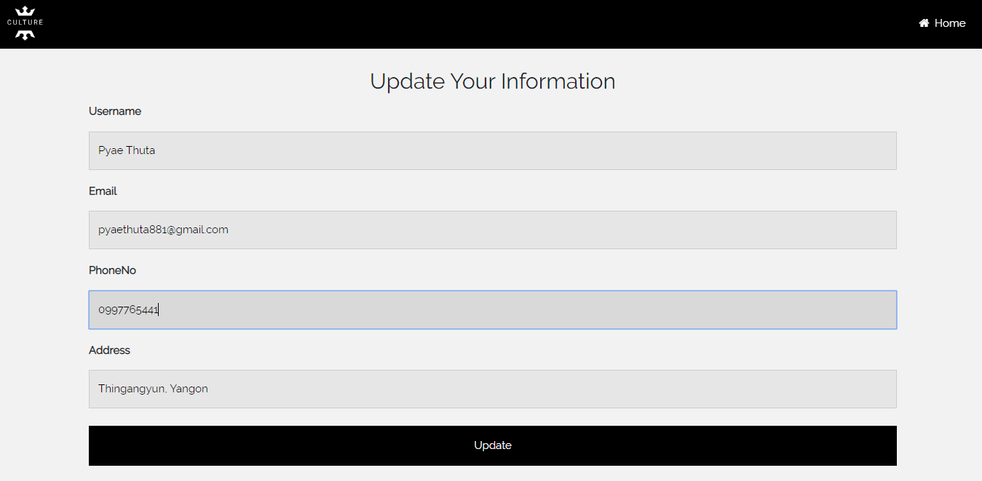

Fig.14.5.1

After Testing

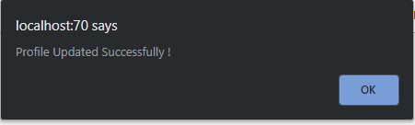

Fig.14.5.2

Test Script (6)

|  |  |  |  |  |
| --- | --- | --- | --- | --- |
| **Unit Test 6** | | **Test Case:** Update account and Printing Voucher Process | **Designed by:** Pyae Thuta | |
| **Data Source:** Profile Page | | **Objective**: Test “Show Voucher” button. | **Tester**: Pyae Thuta | |
| **Test Case** | **Description** | **Test Procedure** | **Expected Result** | **Actual Results** |
| 14.6 | Testing if Voucher page is reached when “Show Voucher” button is clicked. | Click ““Show Voucher” button. | Voucher page is reached. | See Fig.14.6.2 |

Before Testing

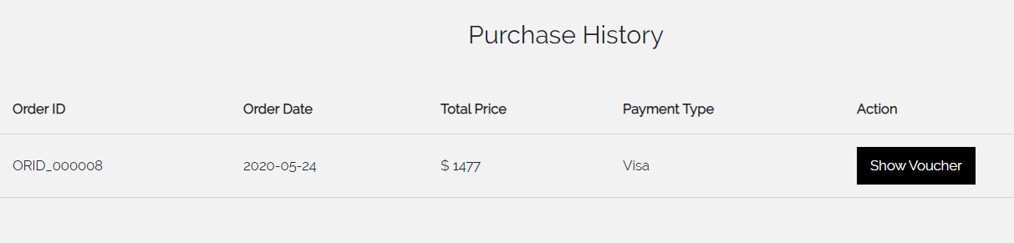

Fig.14.6.1

After Testing

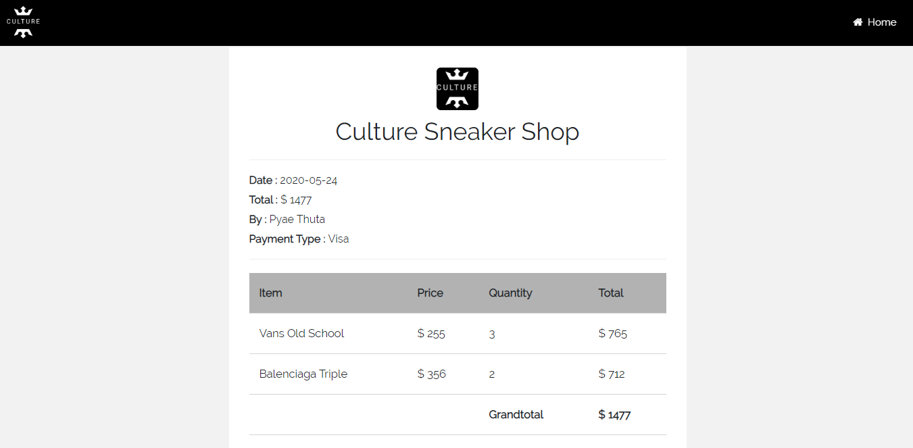

Fig.14.6.2

Test Script (7)

|  |  |  |  |  |
| --- | --- | --- | --- | --- |
| **Unit Test 7** | | **Test Case:** Update account and Printing Voucher Process | **Designed by:** Pyae Thuta | |
| **Data Source:** Voucher Page | | **Objective**: Test “Print” button. | **Tester**: Pyae Thuta | |
| **Test Case** | **Description** | **Test Procedure** | **Expected Result** | **Actual Results** |
| 14.7 | Testing if print box is shown when “Print” button is clicked. | Click “Print” button. | Print box is shown. | See Fig.14.7.2 |

Before Testing

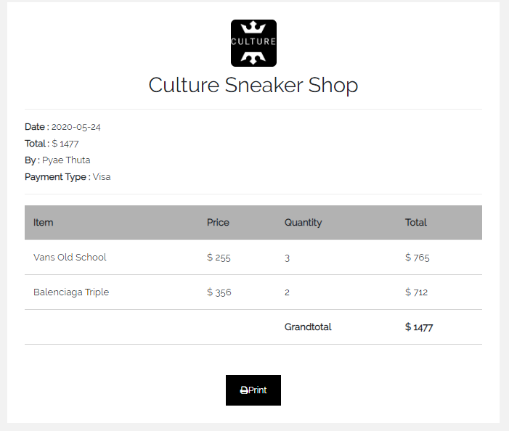

14.7.1

After testing

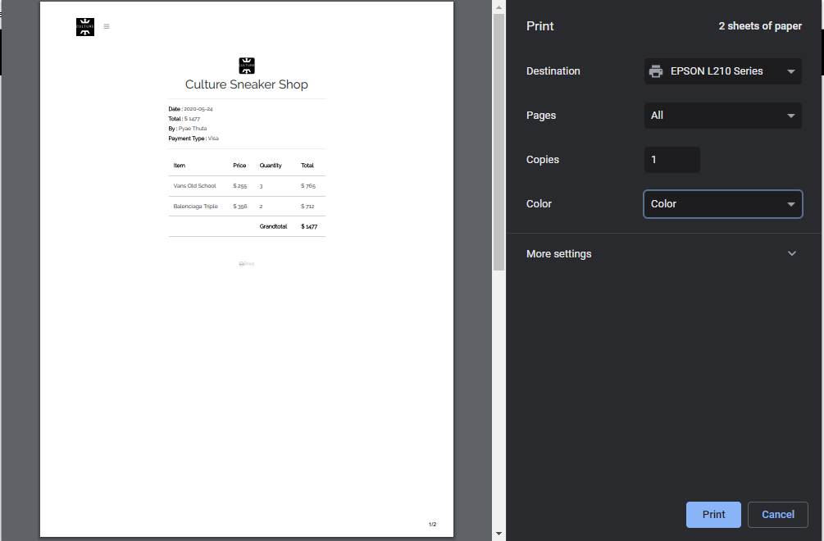

14.7.2

### Timebox 3: Managing Delivery Process Time Box Development

Test Script (2)

|  |  |  |  |  |
| --- | --- | --- | --- | --- |
| **Unit Test 2** | | **Test Case:** Edit Order Process | **Designed by:** Pyae Thuta | |
| **Data Source:** Edit Order Page | | **Objective**: Test “Manage” button. | **Tester**: Pyae Thuta | |
| **Test Case** | **Description** | **Test Procedure** | **Expected Result** | **Actual Results** |
| 15.2 | Testing if manage delivery page is reached when “Manage” button is clicked. | Click “Manage” button beside the order. | Manage Delivery page is reached. | See Fig.15.2.2 |

Before Testing



Fig.15.2.1

After testing



Fig.15.2.2

**Module 16: Manage Delivery Process**

|  |  |  |  |
| --- | --- | --- | --- |
| Test Script | Description | Date | Tester |
| 16.1 | Test “Delivery Date” text box. | May 13, 2020 | Pyae Thuta |
| 16.2 | Test “Confirm Delivery” button. | May 13, 2020 | Pyae Thuta |

Test Script (1)

|  |  |  |  |  |
| --- | --- | --- | --- | --- |
| **Unit Test 1** | | **Test Case:** Manage Delivery Process | **Designed by:** Pyae Thuta | |
| **Data Source:** Manage Delivery Page | | **Objective**: Test “Delivery Date” text box. | **Tester**: Pyae Thuta | |
| **Test Case** | **Description** | **Test Procedure** | **Expected Result** | **Actual Results** |
| 16.1 | Testing if alert is shown if “Delivery Date” text box is not filled with data. | Click “Confirm Delivery” button when “Delivery Date” text box is not filled with data. | Show “Please fill out of this field” message. | See Fig.16.1.2 |

Before Testing

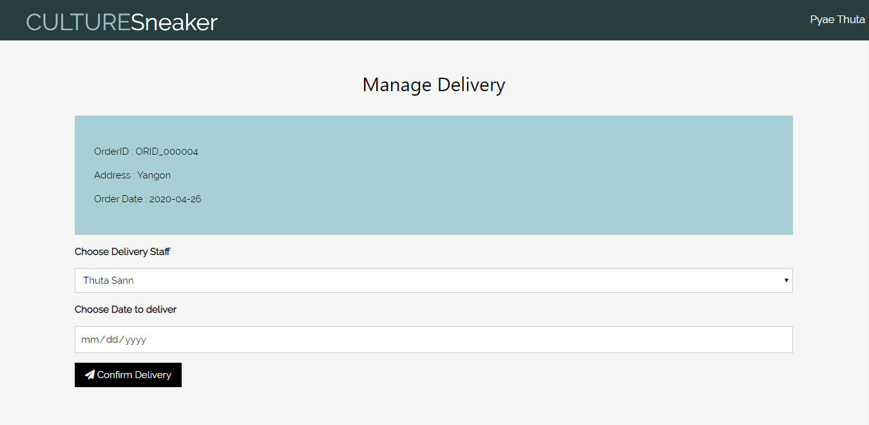

Fig.16.1.1

After Testing

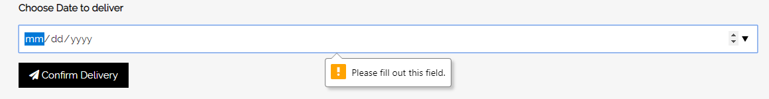

Fig.16.1.2

Test Script (2)

|  |  |  |  |  |
| --- | --- | --- | --- | --- |
| **Unit Test 2** | | **Test Case:** Manage Delivery Process | **Designed by:** Pyae Thuta | |
| **Data Source:** Manage Delivery Page | | **Objective**: Test “Confirm Delivery” button. | **Tester**: Pyae Thuta | |
| **Test Case** | **Description** | **Test Procedure** | **Expected Result** | **Actual Results** |
| 16.2 | Testing if alert is shown when “Confirm Delivery” button is clicked. | “Confirm Delivery” button is clicked with sufficient information. | Show Successful message. | See Fig.16.2.2 |

Before Testing

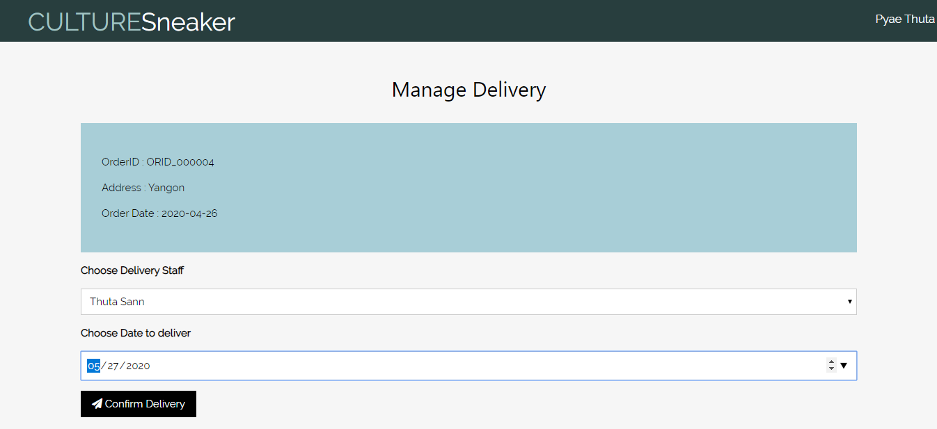

Fig.16.2.1

After Testing

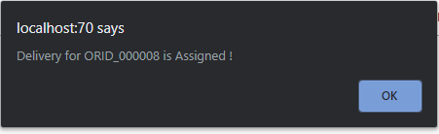

Fig.16.2.1

## Section E: Interview Scripts

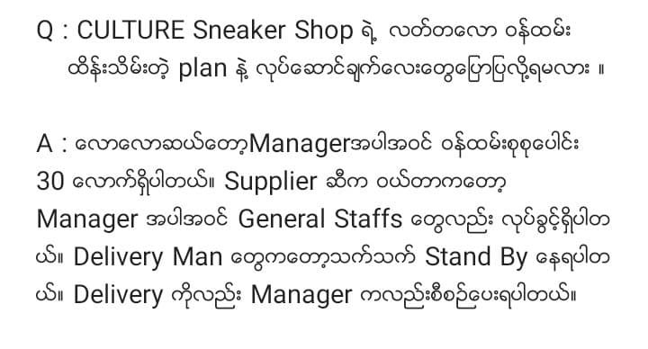

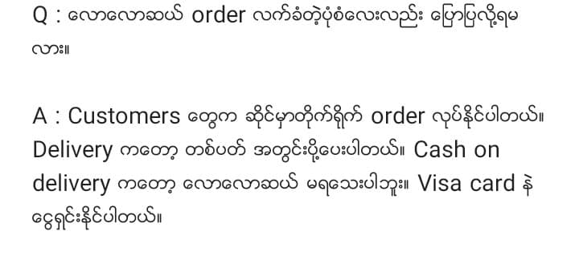

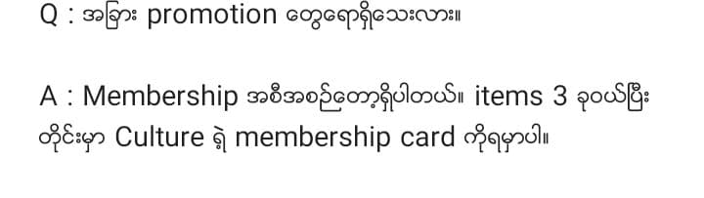

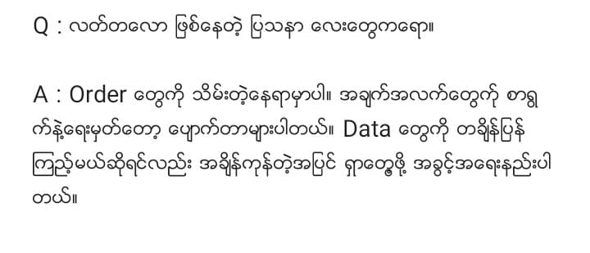

# References

## References List

Anon., 2002. *Norton 360 with lifelock ultimate plus.* [Online]   
Available at: https://us.norton.com/products/norton-360-lifelock-ultimate-plus

Anon., 2019. *Python Introduction.* [Online]   
Available at: https://www.w3schools.com/python/python_intro.asp

Anon., 2019. *Python VS PHP.* [Online]   
Available at: https://www.probytes.net/blog/python-vs-php-which-is-better/

Anon., 2019. *Waterfall Model.* [Online]   
Available at: https://airbrake.io/blog/sdlc/waterfall-model

Anon., 2019. *What is Agile Methodology.* [Online]   
Available at: https://www.wrike.com/project-management-guide/faq/what-is-agile-methodology-in-project-management/

Anon., 2020. *SEVEN LEGAL ISSUES SMALL BUSINESSES FACE.* [Online]   
Available at: https://nevadasmallbusiness.com/legal-issues-small-businesses-face/

Anon., 2020. *SQL Server pricing.* [Online]   
Available at: https://www.microsoft.com/en-us/sql-server/sql-server-2017-pricing

Anon., 2020. *W3Schools How To.* [Online]   
Available at: https://www.w3schools.com/howto/default.asp  
[Accessed 1 April 2020].

Anon., 2020. *What are Ethical Issues?.* [Online]   
Available at: https://www.myaccountingcourse.com/accounting-dictionary/ethical-issues#What_Does_Ethical_Issues_Mean

Anon., 2020. *WHAT IS SOCIAL RESPONSIBILITY?.* [Online]   
Available at: https://asq.org/quality-resources

Buehring, S., 2019. *The DSDM principles: A visual guide.* [Online]   
Available at: https://www.knowledgetrain.co.uk/agile/the-dsdm-principles

Kukhnavets, P., 2019. *The difference between Agile and Waterfall.* [Online]   
Available at: https://hygger.io/blog/the-difference-between-agile-and-waterfall/

Lysis, 2019. *Techwalla.* [Online]   
Available at: https://www.techwalla.com/articles/microsoft-access-vs-sql-server